**Analysing Donald Trump's Facebook Communication: Trends, Topics, and Audience Engagement**

**Abstract:**

This research project entails analysing Donald Trump’s Facebook statuses to find his online communication trends and how he engages his audience during a specific period. We therefore used data visualisation, natural language processing techniques and sentiment analysis with a view to understand Trump’s posting habits, detect the most dominant issues and examine moods in his statements.

Attributes such as status type, publication time, reaction metrics (likes, loves, wows, hahas, sads, and angry) and status update text are all included in the dataset used for this research. The project is seeking valuable insights about Trump’s social media presence as well as how his audience reacts to his posts by making use of sophisticated research methods.

The aim of this executive summary is to provide a brief overview of the objectives pursued under the project, an outline of methodologies employed in order to achieve these goals plus the key findings which were established through analysis. The next sections describe the results from detailed analysis and interpretation based on this dataset and encompassing all Trump’s Facebook activities explaining how they affect his online audience.

**Introduction:**

The aim of this project is to analyse Donald Trump’s Facebook status updates using various techniques such as topic modelling, sentiment analysis, and visualisation of reactions over time. The Trump post dataset used in this project includes the following information: types of statuses, publication time, number of reactions, and status message.

**Methods and Results:**

**Distribution of Types of Statuses:** This countplot was used to show how many different types there are for each kind of status.

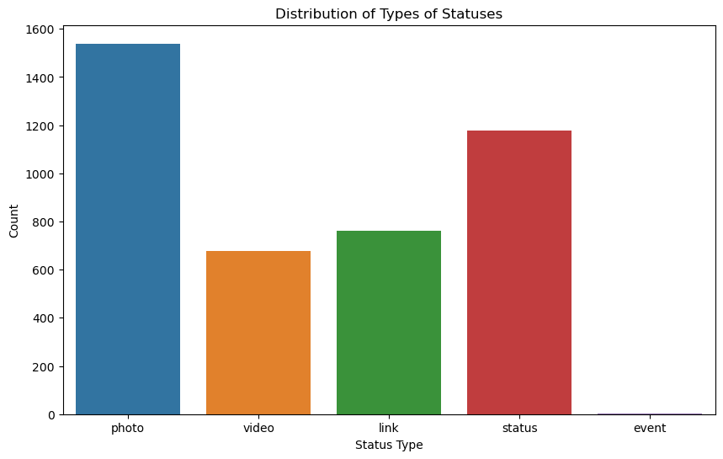

**Fig 1.1. Distribution of types of statuses**

**Progression of Reactions Over Time:** In order to look at any patterns that might exist or trends going on among them, we plot the progression of reactions—likes, loves, wows, hahas, sads, angrys—over time.

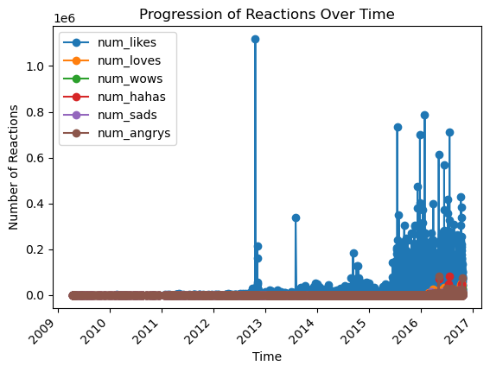

**Fig 1.2. Progression of reaction over time**

**Text Preprocessing and Topic Modeling**: We tokenized and preprocessed the status messages by removing stop words, converting to lowercase, and lemmatizing. Then, we trained an LDA model to identify the top topics present in the status messages.

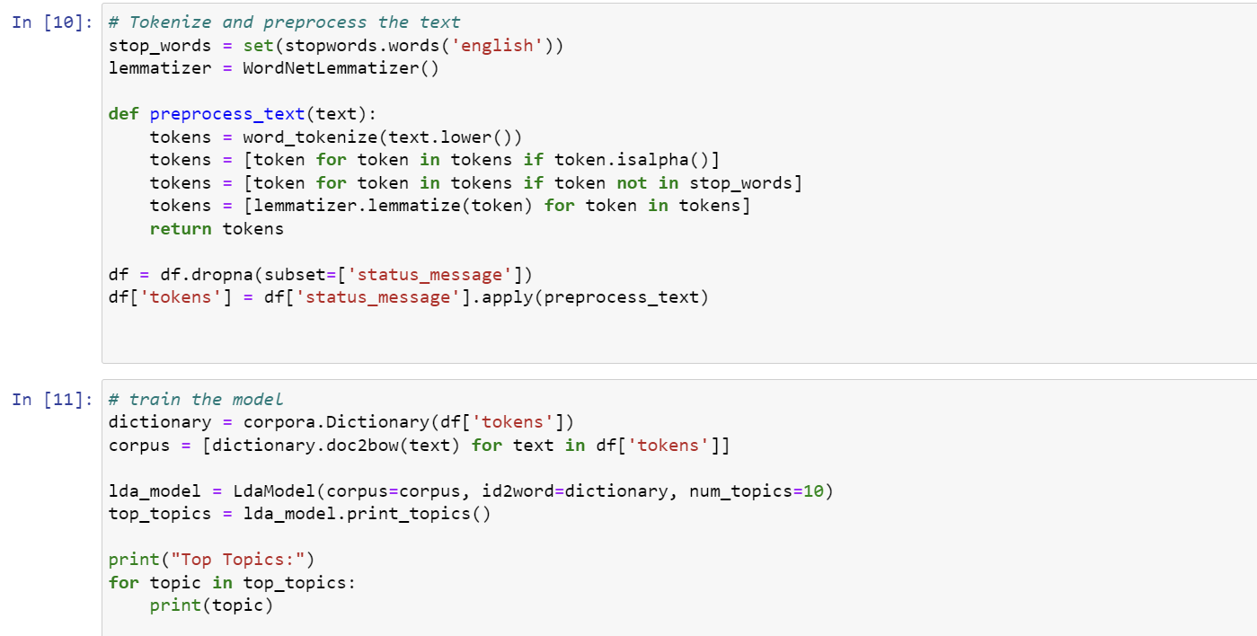

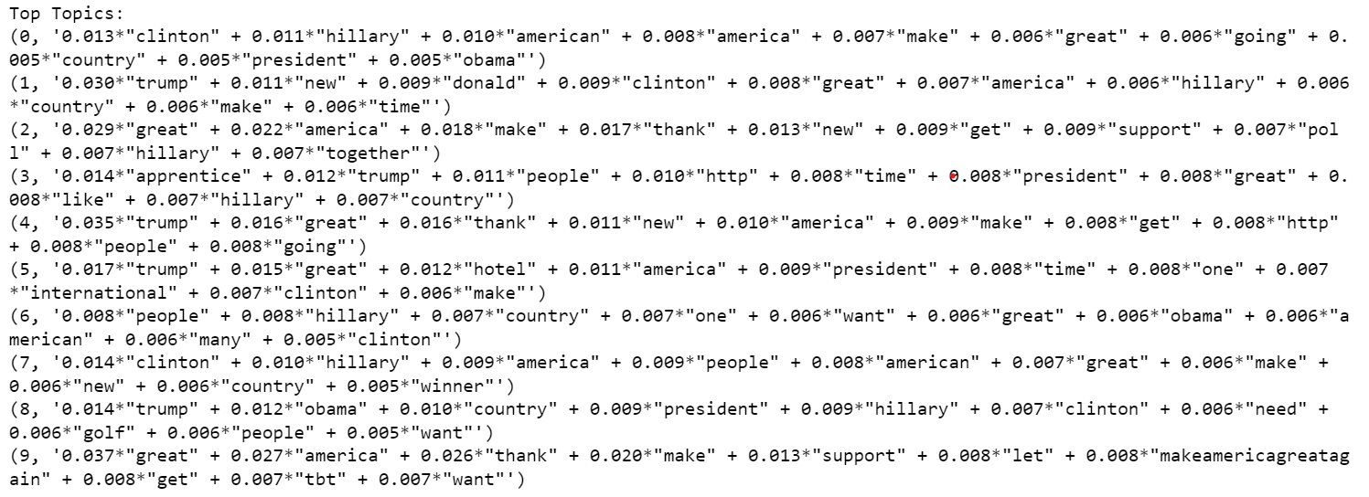

**Fig 1.3. Text processing and Topic Modeling**

**Sentiment Analysis:** We calculated the sentiment polarity of each status message using TextBlob and computed the mean sentiment polarity for the entire dataset.

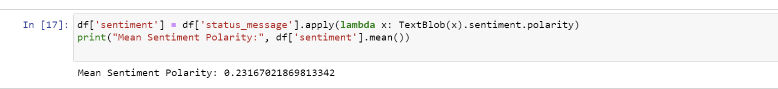

**Fig 1.4. Mean Sentiment Polarity**

**Top Themes by Shares and Reactions:** top themes by shares and reactions were found by sorting the dataset based on the number of shares and reactions.

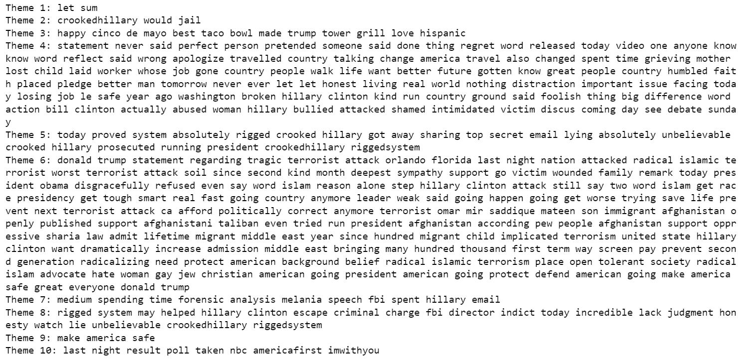

**Fig 1.5. Top themes by shares**

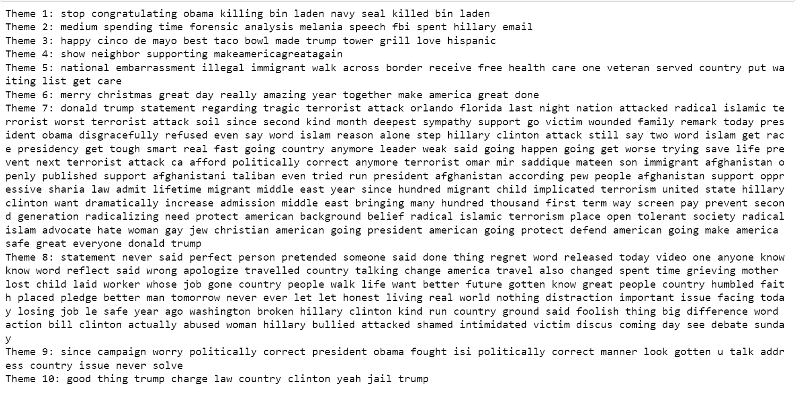

**Fig 1.6. Top themes by reaction**

**Conclusions:**

The analysis provided insights into the nature of Donald Trump's Facebook posts. Despite encountering challenges such as missing data and data preprocessing complexities, we successfully extracted valuable information regarding different types of statuses which were shared over time, trends in sentiments captured from those texts within a given period while also, top themes by shares or reactions were also found.

**Future Research Considerations**:

Future research could focus on more in-depth sentiment analysis, exploring correlations between sentiment and other variables, such as engagement metrics or external events. Additionally, further investigation into the identified topics could provide deeper insights into the content and themes of Trump's Facebook posts.