## AI_LAB_6

Kola Deepti (120cs0151)

## Find the shortest path to Node ‘A’ for the following AND-OR graph using the AO* algorithm. Below the Node given is the heuristic value, i.e., h(n). Edge length is considered as one.

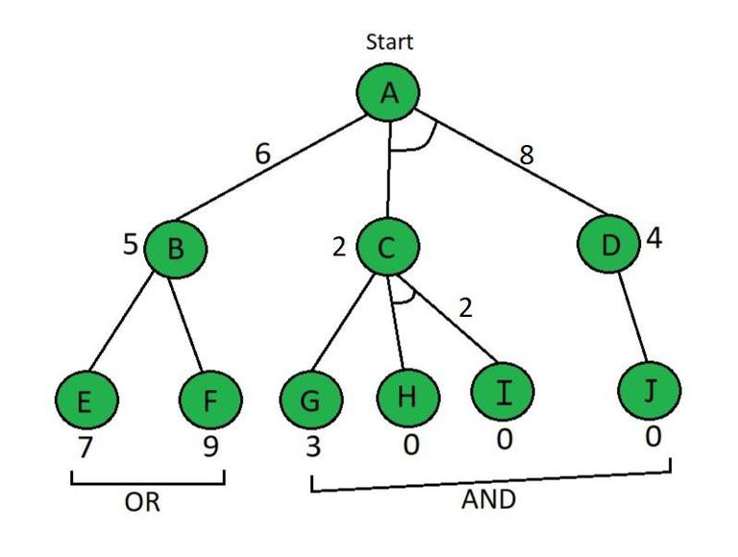

Code:

# Cost to find the AND and OR path

def Cost(H, condition, weight = 1):

    cost = {}

    if 'AND' in condition:

        AND_nodes = condition['AND']

        Path_A = ' AND '.join(AND_nodes)

        PathA = sum(H[node]+weight for node in AND_nodes)

        cost[Path_A] = PathA

    if 'OR' in condition:

        OR_nodes = condition['OR']

        Path_B =' OR '.join(OR_nodes)

        PathB = min(H[node]+weight for node in OR_nodes)

        cost[Path_B] = PathB

    return cost

# Update the cost

def update_cost(H, Conditions, weight=1):

    Main_nodes = list(Conditions.keys())

    Main_nodes.reverse()

    least_cost= {}

    for key in Main_nodes:

        condition = Conditions[key]

        print(key,':', Conditions[key],'-->', Cost(H, condition, weight))

        c = Cost(H, condition, weight)

        H[key] = min(c.values())

        least_cost[key] = Cost(H, condition, weight)

    return least_cost

# Print the shortest path

def shortest_path(Start,Updated_cost, H):

    Path = Start

    if Start in Updated_cost.keys():

        Min_cost = min(Updated_cost[Start].values())

        key = list(Updated_cost[Start].keys())

        values = list(Updated_cost[Start].values())

        Index = values.index(Min_cost)

        # FIND MINIMIMUM PATH KEY

        Next = key[Index].split()

        # ADD TO PATH FOR OR PATH

        if len(Next) == 1:

            Start =Next[0]

            Path += '<--' +shortest_path(Start, Updated_cost, H)

        # ADD TO PATH FOR AND PATH

        else:

            Path +='<--('+key[Index]+') '

            Start = Next[0]

            Path += '[' +shortest_path(Start, Updated_cost, H) + ' + '

            Start = Next[-1]

            Path += shortest_path(Start, Updated_cost, H) + ']'

    return Path

# H = {'A': -1, 'B': 5, 'C': 2, 'D': 4, 'E': 7, 'F': 9, 'G': 3, 'H': 0, 'I':0, 'J':0}

H = {'A': -1, 'B': 4, 'C': 2, 'D': 3, 'E': 6, 'F': 8, 'G': 2, 'H': 0, 'I':0, 'J':0}

Conditions = {

'A': {'OR': ['B'], 'AND': ['C', 'D']},

'B': {'OR': ['E', 'F']},

'C': {'OR': ['G'], 'AND': ['H', 'I']},

'D': {'OR': ['J']}

}

# weight

weight = 1

# Updated cost

print('Updated Cost :')

Updated_cost = update_cost(H, Conditions, weight=1)

least_cost_to_root = Updated_cost['A']

min_cost_to_root = min(least_cost_to_root.values())

# print('*'*75)

print('Shortest Path :\n',shortest_path('A', Updated_cost,H))

# Print the least cost to reach the root node

print("Least cost at Node ('A') is ", min_cost_to_root)

Output:

