# Assignment 8 (Prolog)

### Kola Deepti , 120CS0151

## Exercise 1

Write a program to put facts indicating that a lion, a tiger, and a cow are animals into the database and record that two (lion and tiger) are carnivores. Save your program to a disk file and load it. Check that the database is correct using the **listing**.

animal(lion).

animal(tiger).

animal(cow).

carnivore(lion).

carnivore(tiger).

Enter goals to test whether:

(a) there is such an animal as a tiger in the database



(b) a cow and a tiger are both in the database (a conjunction of two goals)

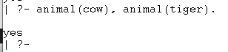

(c) a lion is an animal and also a carnivore

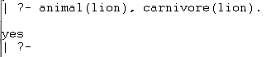

(d) a cow is an animal and also a carnivore.

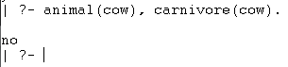

(e) list all animals which are also carnivores.

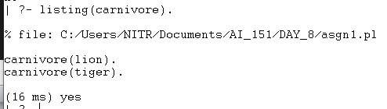

## Exercise 2

**Type the following program into a file and load it into Prolog.**

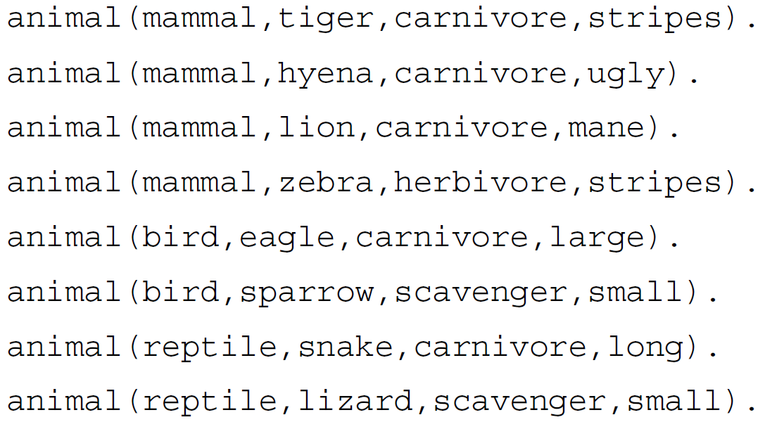

**Code:**

animal(mammal,tiger,carnivore,stripes).

animal(mammal,hyena,carnivore,ugly).

animal(mammal,lion,carnivore,mane).

animal(mammal,zebra,herbivore,stripes).

animal(bird,eagle,herbivore,large).

animal(bird,sparrow,scavenger,small).

animal(reptile,snake,carnivore,long).

animal(reptile,lizard,scavenger,small).

**a) All the mammals**

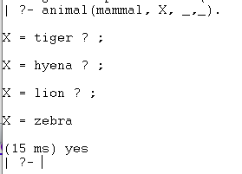

**b) all the carnivores that are mammals.**

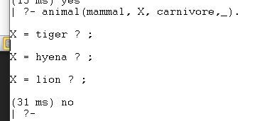

**c)** **all the mammals with stripes.**

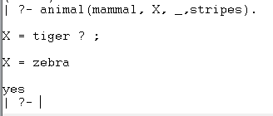

**d)** **whether there is a reptile that has a mane?**

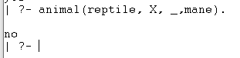

## Exercise 3

**The law says that it is a crime for an American to sell weapons to hostile nations. The country Nono, an enemy of America, has some missiles, and all of its missiles were sold to it by Colonel West, who is American. Is West a criminal?**

**Code:**

criminal(X):- american(X), weapon(Y), sells(X,Y,Z), hostile(Z).

owns(Nono,m1).

missile(m1).

sells(west, X, Nono):- missile(X), owns(Nono,X).

weapon(X):- missile(X).

hostile(X) :- enemy(X,american).

american(west).

enemy(Nono, american).

