Assignment 5
Kola Deepti(120CS0151)

1. Implement TCP Congestion control and retransmission algorithms.
2. Analyse the performance of your implementation and calculate old and new congestion window, plot the graphs using gnu plot in png form(use .cwnd file for ploting).

Code:

#include <fstream>
#include "ns3/core-module.h"
#include "ns3/network-module.h"
#include "ns3/internet-module.h"
#include "ns3/point-to-point-module.h"
#include "ns3/applications-module.h"
#include "ns3/stats-module.h"

using namespace ns3;

NS_LOG_COMPONENT_DEFINE ("SeventhScriptExample");

// ===========================================================================
//
// node 0 node 1
// +----------------+ +----------------+
// | ns-3 TCP | | ns-3 TCP |
// +----------------+ +----------------+
// | 10.1.1.1 | | 10.1.1.2 |
// +----------------+ +----------------+
// | point-to-point | | point-to-point |
// +----------------+ +----------------+
// | |
// +---------------------+
// 5 Mbps, 2 ms

class MyApp : public Application
{
public:
MyApp ();
virtual ~MyApp ();

/**
* Register this type.
* \return The TypeId.
*/
static TypeId GetTypeId (void);
void Setup (Ptr<Socket> socket, Address address, uint32_t packetSize, uint32_t nPackets, DataRate dataRate);

private:
virtual void StartApplication (void);
virtual void StopApplication (void);

void ScheduleTx (void);
void SendPacket (void);

Ptr<Socket> m_socket;
Address m_peer;
uint32_t m_packetSize;
uint32_t m_nPackets;
DataRate m_dataRate;
EventId m_sendEvent;
bool m_running;
uint32_t m_packetsSent;
};

MyApp::MyApp ()
: m_socket (0),
m_peer (),
m_packetSize (0),
m_nPackets (0),
m_dataRate (0),
m_sendEvent (),
m_running (false),
m_packetsSent (0)
{
}

MyApp::~MyApp ()
{
m_socket = 0;
}

/* static */
TypeId MyApp::GetTypeId (void)
{
static TypeId tid = TypeId ("MyApp")
.SetParent<Application> ()
.SetGroupName ("Tutorial")
.AddConstructor<MyApp> ()
;
return tid;
}

void
MyApp::Setup (Ptr<Socket> socket, Address address, uint32_t packetSize, uint32_t nPackets, DataRate dataRate)
{
m_socket = socket;
m_peer = address;
m_packetSize = packetSize;
m_nPackets = nPackets;
m_dataRate = dataRate;
}

void
MyApp::StartApplication (void)
{
m_running = true;
m_packetsSent = 0;
if (InetSocketAddress::IsMatchingType (m_peer))
{
m_socket->Bind ();
}
else
{
m_socket->Bind6 ();
}
m_socket->Connect (m_peer);
SendPacket ();
}

void
MyApp::StopApplication (void)
{
m_running = false;

if (m_sendEvent.IsRunning ())
{
Simulator::Cancel (m_sendEvent);
}

if (m_socket)
{
m_socket->Close ();
}
}

void
MyApp::SendPacket (void)
{
Ptr<Packet> packet = Create<Packet> (m_packetSize);
m_socket->Send (packet);

if (++m_packetsSent < m_nPackets)
{
ScheduleTx ();
}
}

void
MyApp::ScheduleTx (void)
{
if (m_running)
{
Time tNext (Seconds (m_packetSize * 8 / static_cast<double> (m_dataRate.GetBitRate ())));
m_sendEvent = Simulator::Schedule (tNext, &MyApp::SendPacket, this);
}
}

static void
CwndChange (Ptr<OutputStreamWrapper> stream, uint32_t oldCwnd, uint32_t newCwnd)
{
NS_LOG_UNCOND (Simulator::Now ().GetSeconds () << "\t" << newCwnd);
*stream->GetStream () << Simulator::Now ().GetSeconds () << "\t" << oldCwnd << "\t" << newCwnd << std::endl;
}

static void
RxDrop (Ptr<PcapFileWrapper> file, Ptr<const Packet> p)
{
NS_LOG_UNCOND ("RxDrop at " << Simulator::Now ().GetSeconds ());
file->Write (Simulator::Now (), p);
}

int
main (int argc, char *argv[])
{
bool useV6 = false;

CommandLine cmd (__FILE__);
cmd.AddValue ("useIpv6", "Use Ipv6", useV6);
cmd.Parse (argc, argv);

NodeContainer nodes;
nodes.Create (2);

PointToPointHelper pointToPoint;
pointToPoint.SetDeviceAttribute ("DataRate", StringValue ("5Mbps"));
pointToPoint.SetChannelAttribute ("Delay", StringValue ("2ms"));

NetDeviceContainer devices;
devices = pointToPoint.Install (nodes);

Ptr<RateErrorModel> em = CreateObject<RateErrorModel> ();
em->SetAttribute ("ErrorRate", DoubleValue (0.00001));
devices.Get (1)->SetAttribute ("ReceiveErrorModel", PointerValue (em));

InternetStackHelper stack;
stack.Install (nodes);

uint16_t sinkPort = 8080;
Address sinkAddress;
Address anyAddress;
std::string probeType;
std::string tracePath;
if (useV6 == false)
{
Ipv4AddressHelper address;
address.SetBase ("10.1.1.0", "255.255.255.0");
Ipv4InterfaceContainer interfaces = address.Assign (devices);
sinkAddress = InetSocketAddress (interfaces.GetAddress (1), sinkPort);
anyAddress = InetSocketAddress (Ipv4Address::GetAny (), sinkPort);
probeType = "ns3::Ipv4PacketProbe";
tracePath = "/NodeList/*/$ns3::Ipv4L3Protocol/Tx";
}
else
{
Ipv6AddressHelper address;
address.SetBase ("2001:0000:f00d:cafe::", Ipv6Prefix (64));
Ipv6InterfaceContainer interfaces = address.Assign (devices);
sinkAddress = Inet6SocketAddress (interfaces.GetAddress (1,1), sinkPort);
anyAddress = Inet6SocketAddress (Ipv6Address::GetAny (), sinkPort);
probeType = "ns3::Ipv6PacketProbe";
tracePath = "/NodeList/*/$ns3::Ipv6L3Protocol/Tx";
}

PacketSinkHelper packetSinkHelper ("ns3::TcpSocketFactory", anyAddress);
ApplicationContainer sinkApps = packetSinkHelper.Install (nodes.Get (1));
sinkApps.Start (Seconds (0.));
sinkApps.Stop (Seconds (20.));

Ptr<Socket> ns3TcpSocket = Socket::CreateSocket (nodes.Get (0), TcpSocketFactory::GetTypeId ());

Ptr<MyApp> app = CreateObject<MyApp> ();
app->Setup (ns3TcpSocket, sinkAddress, 1040, 1000, DataRate ("1Mbps"));
nodes.Get (0)->AddApplication (app);
app->SetStartTime (Seconds (1.));
app->SetStopTime (Seconds (20.));

AsciiTraceHelper asciiTraceHelper;
AnimationInterface anim("lab5.xml");
Ptr<OutputStreamWrapper> stream = asciiTraceHelper.CreateFileStream ("seventh.cwnd");
ns3TcpSocket->TraceConnectWithoutContext ("CongestionWindow", MakeBoundCallback (&CwndChange, stream));

PcapHelper pcapHelper;
Ptr<PcapFileWrapper> file = pcapHelper.CreateFile ("seventh.pcap", std::ios::out, PcapHelper::DLT_PPP);
devices.Get (1)->TraceConnectWithoutContext ("PhyRxDrop", MakeBoundCallback (&RxDrop, file));

// Use GnuplotHelper to plot the packet byte count over time
GnuplotHelper plotHelper;

// Configure the plot. The first argument is the file name prefix
// for the output files generated. The second, third, and fourth
// arguments are, respectively, the plot title, x-axis, and y-axis labels
plotHelper.ConfigurePlot ("seventh-packet-byte-count",
"Packet Byte Count vs. Time",
"Time (Seconds)",
"Packet Byte Count");

// Specify the probe type, trace source path (in configuration namespace), and
// probe output trace source ("OutputBytes") to plot. The fourth argument
// specifies the name of the data series label on the plot. The last
// argument formats the plot by specifying where the key should be placed.
plotHelper.PlotProbe (probeType,
tracePath,
"OutputBytes",
"Packet Byte Count",
GnuplotAggregator::KEY_BELOW);

// Use FileHelper to write out the packet byte count over time
FileHelper fileHelper;

// Configure the file to be written, and the formatting of output data.
fileHelper.ConfigureFile ("seventh-packet-byte-count",
FileAggregator::FORMATTED);

// Set the labels for this formatted output file.
fileHelper.Set2dFormat ("Time (Seconds) = %.3e\tPacket Byte Count = %.0f");

// Specify the probe type, trace source path (in configuration namespace), and
// probe output trace source ("OutputBytes") to write.
fileHelper.WriteProbe (probeType,
tracePath,
"OutputBytes");

Simulator::Stop (Seconds (20));
Simulator::Run ();
Simulator::Destroy ();

return 0;
}

Code output:
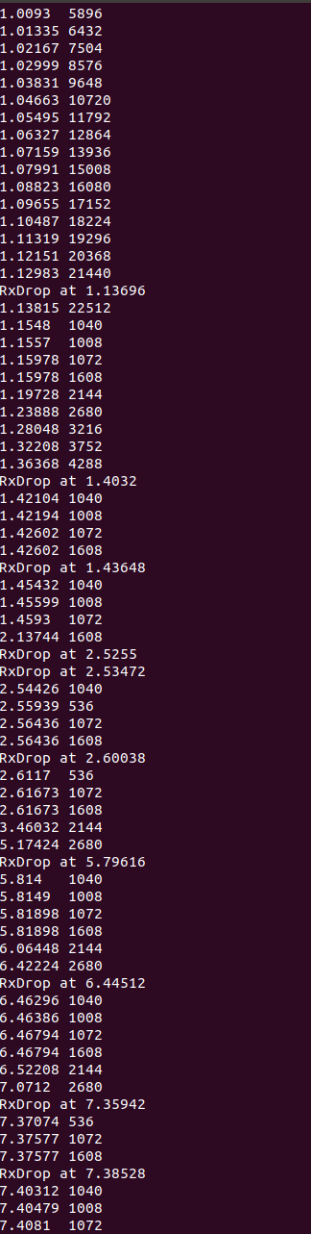

Net Anim:
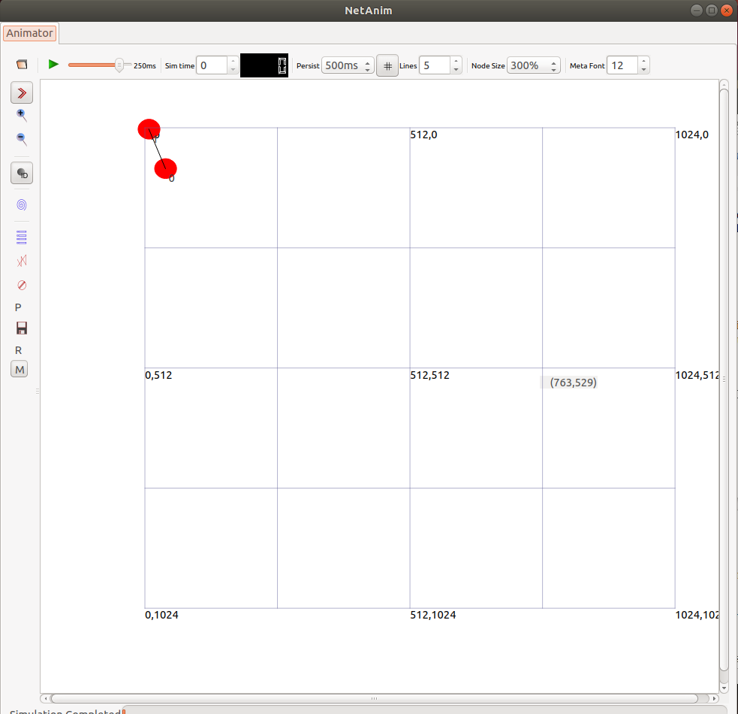

TraceMatrix:
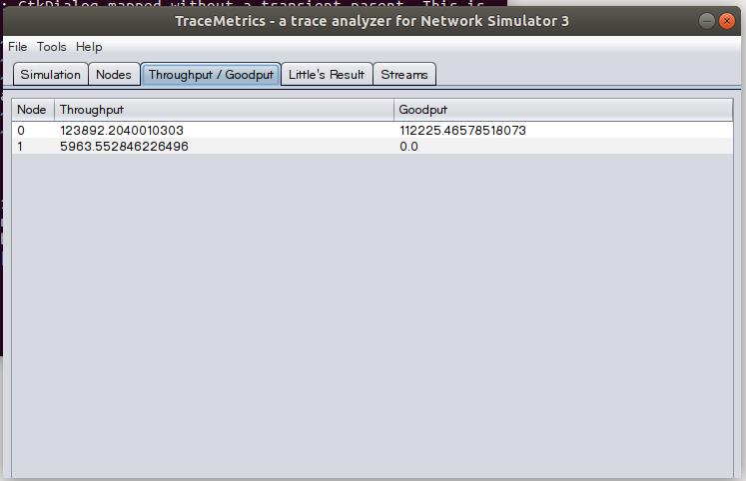
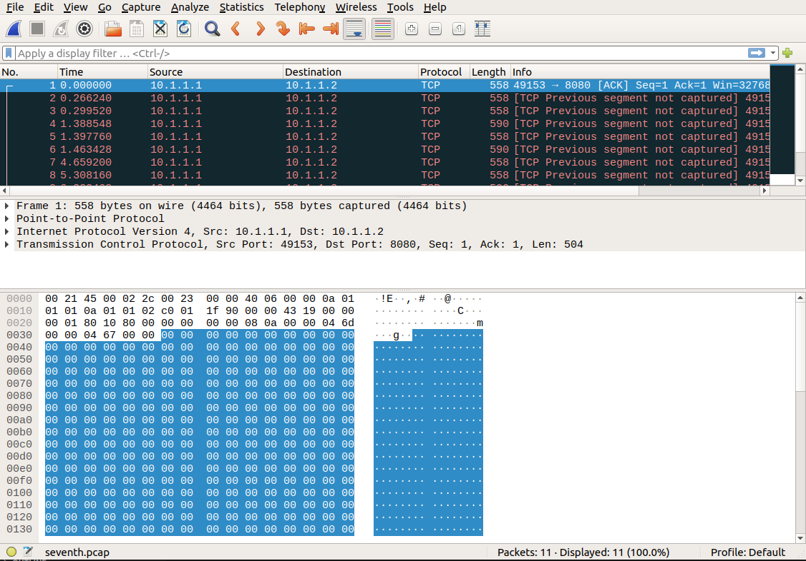
Wireshark (.pcap file)

.cwnd file:
1.00419 0 5360
1.0093 5360 5896
1.01335 5896 6432
1.02167 6432 7504
1.02999 7504 8576
1.03831 8576 9648
1.04663 9648 10720
1.05495 10720 11792
1.06327 11792 12864
1.07159 12864 13936
1.07991 13936 15008
1.08823 15008 16080
1.09655 16080 17152
1.10487 17152 18224
1.11319 18224 19296
1.12151 19296 20368
1.12983 20368 21440
1.13815 21440 22512
1.1548 22512 1040
1.1557 1040 1008
1.15978 1008 1072
1.15978 1072 1608
1.19728 1608 2144
1.23888 2144 2680
1.28048 2680 3216
1.32208 3216 3752
1.36368 3752 4288
1.42104 4288 1040
1.42194 1040 1008
1.42602 1008 1072
1.42602 1072 1608
1.45432 1608 1040
1.45599 1040 1008
1.4593 1008 1072
2.13744 1072 1608
2.54426 1608 1040
2.55939 1040 536
2.56436 536 1072
2.56436 1072 1608
2.6117 1608 536
2.61673 536 1072
2.61673 1072 1608
3.46032 1608 2144
5.17424 2144 2680
5.814 2680 1040
5.8149 1040 1008
5.81898 1008 1072
5.81898 1072 1608
6.06448 1608 2144
6.42224 2144 2680
6.46296 2680 1040
6.46386 1040 1008
6.46794 1008 1072
6.46794 1072 1608
6.52208 1608 2144
7.0712 2144 2680
7.37074 2680 536
7.37577 536 1072
7.37577 1072 1608
7.40312 1608 1040
7.40479 1040 1008
7.4081 1008 1072
7.42064 1072 1608
8.15282 1608 536
8.15785 536 1072
8.15785 1072 1608
8.71856 1608 2144

.plt file:
set terminal pdf
set output "lab5.pdf"
set title "Congestion control and retransmission"
set xlabel "time"
set ylabel "packets"
plot "seventh.cwnd" using 1:2 with lines title "old congestion window" lw 2, "seventh.cwnd" using 1:3 with lines title "new congestion window" lw 2

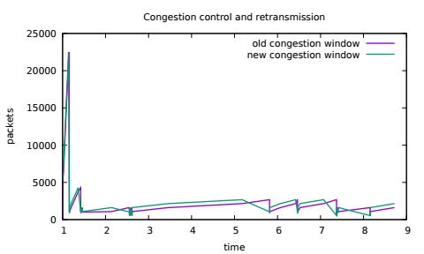
GNU plot

