Software Requirements Specification
for
University Department Information System (UDIS)
Version 1.0 approved
Prepared by Kola Deepti (120CS0151)
National Institute of Technology Rourkela
Date created: 17th Jan 2023
Table of Contents
Table of Contents ii
Revision History ii
1. Introduction 1
1.1 Purpose 1
1.2 Document Conventions 1
1.3 Intended Audience and Reading Suggestions 1
1.4 Product Scope 1
1.5 References 1
2. Overall Description 2
2.1 Product Perspective 2
2.2 Product Functions 2
2.3 User Classes and Characteristics 2
2.4 Operating Environment 2
2.5 Design and Implementation Constraints 2
2.6 User Documentation 2
2.7 Assumptions and Dependencies 3
3. External Interface Requirements 3
3.1 User Interfaces 3
3.2 Hardware Interfaces 3
3.3 Software Interfaces 3
3.4 Communications Interfaces 3
4. System Features 4
4.1 System Feature 1 4
4.2 System Feature 2 (and so on) 4
5. Other Non-functional Requirements 4
5.1 Performance Requirements 4
5.2 Safety Requirements 5
5.3 Security Requirements 5
5.4 Software Quality Attributes 5
5.5 Business Rules 5
6. Other Requirements 5
Appendix A: Glossary 5
Appendix B: Analysis Models 5
Appendix C: To Be Determined List 6

Revision History
Name | Date | Reason For Changes | Version

Introduction

Purpose
The University Department Information System software’s purpose is to eliminate the lot of book keeping activities to record details of various students, the new registrations , their grades(semester-wise) and also the software should be able to keep track of the inventories of the department. It should also allow updation of data.

This software should also take care of the Department information system keeps track of the Department accounts and research projects.

Intended Audience and Reading Suggestions
There are different types of intended audience for this document, such as developers, testers, documentation writers and most importantly the users. We have divided the rest of the document into different subsections. We suggest that you begin with understanding the definitions,
acronyms and abbreviations, then sequentially go through contents, overview section and proceeding through the detailed description sections that is most pertinent.

Product Scope
This software system will be a University Information system for a the members of the department of an organization.
This system will be designed to maximize the administrative, academic and overall productivity of each and every department by providing tools to assist in automating the technical procedures and processes, which would otherwise have to be performed manually.

By maximizing the users work eﬃciency and production the system will meet the users needs while remaining easy to understand and use. It is a user-friendly portal to interact, manage, access and edit the information.

References
https://www.studocu.com/row/document/nahda-university/computer-science/srs-for-university-management-system/27752841

Overall Description

Product Perspective
The product will be a standalone application and may be run on multiple systems within an
Internet network. The product will require a keyboard, mouse and monitor to interface with
the users. The minimum hardware requirements for the product are specified in this document.

Product Functions
Staff (Technical and Non-Technical) Information

Examination Management
Admission Management

University Department Information System

Accounts Management
Registration Management

User Classes and Characteristics
The target audience for UDIS product is the college Administrator /students /faculty/ staﬀ (Technical/ Non-technical).

The users for this system are:
- Administrator The Super user of the system. Mainly focuses on administrative and
academic related issues.
- Student A user with limited access rights such as to view grade card and messages.
- Staﬀ A user of the system who has more access rights than a normal user, such as to add, update or delete the data.
- Users for specific task.
- Accountant: For university funds management
- Registrar: For maintaining the registrations

Operating Environment
The UDIS is expected to be deployed in a real environment to manage the DBMS inside the university. The centralized database is used to store the information. The user only within the university (members of university staff) can use this management system. Users outside form the college cannot access the management system. This application is developed for windows operating system that can be run on Windows XP and above.

The database is used in different departments within a branch of the college. The database used to store the information is the centralized database. The software we have developed will be installed on different computer systems within a college and software will be connected to a centralized database through LAN within a college and then the user can interact with the system and can store the data and other users can get access the stored through a centralized database.

Design and Implementation Constraints
<Describe any items or issues that will limit the options available to the developers. These might include: corporate or regulatory policies; hardware limitations (timing requirements, memory requirements); interfaces to other applications; specific technologies, tools, and databases to be used; parallel operations; language requirements; communications protocols; security considerations; design conventions or programming standards (for example, if the customer’s organization will be responsible for maintaining the delivered software).>

User Documentation
<List the user documentation components (such as user manuals, on-line help, and tutorials) that will be delivered along with the software. Identify any known user documentation delivery formats or standards.>

Assumptions and Dependencies
A number of factors that may aﬀect the requirements speciﬁed in the SRS include:
- It is assumed that only one person from the different department will have the access to module that is only heads of administration, academics.
- The complaints and the feedback given by the students and other members of the organization are assumed to be reliable.
- The schedule for the exam, the registration window will be open for only few days only
after that these pages will be inactive until next exams or registration period.
- Apportioning of requirements:
In the case that the project is delayed, there are some requirements that could be transferred to the next version of the application. Those requirements are to be developed in
the third release.

External Interface Requirements

User Interfaces

A ﬁrst-time user of the web portal should see the log-in page when he/she opens the portal. It will have two options, one for the student (with limited access) and another for the admin. If the user has not registered, he/she should be able to do that on the log-in page. It will also have a remember me button. If the user is not a ﬁrst-time user, he/she should be able to see the dashboard which contains diﬀerent domains like academics, Hostel, Proﬁle, Mess, Accounts, fees structure etc. A news bulletin, some general information, list of holidays and diﬀerent timetables will also be visible on this page. Every user should have a proﬁle page where they can edit their e-mail address, phone number and password and other personal details

Hardware Interfaces
Hardware Platform:
- PIII or above with
- RAM of 512 or above MB
- Hard Disk 20GB or above GB

Software Interfaces
Software Platform (Browser):
- Mozilla Fire-Fox v12.0 or higher
- Google Chrome v27.0.1453.116m or higher.
- Internet Explorer v9.0.195 or higher.

Communications Interfaces
The communication between the client and the server will be done through internet.

System Features
This section includes the requirements that specify all the fundamental actions of the software system.

Admission management
<Don’t really say “System Feature 1.” State the feature name in just a few words.>
4.1.1 Description and Priority
After logging into the portal as admin there will be an option of adding new student to the portal. There the admin can add the name, address, department, admission id and add that student to generate a roll number.
Now the new students are added into the student database.
4.1.2 Stimulus/Response Sequences
Login portal(login as admin) -> Add new student -> fill details and submit
|
Submit <-Update or change the data <-
4.1.3 Functional Requirements
<Itemize the detailed functional requirements associated with this feature. These are the software capabilities that must be present in order for the user to carry out the services provided by the feature, or to execute the use case. Include how the product should respond to anticipated error conditions or invalid inputs. Requirements should be concise, complete, unambiguous, verifiable, and necessary. Use “TBD” as a placeholder to indicate when necessary information is not yet available.>

<Each requirement should be uniquely identified with a sequence number or a meaningful tag of some kind.>

REQ-1:
REQ-2:

Accounts management:
4.1.1 Description and Priority
After logging into the portal as admin there will be an option of adding new items purchased and to upload the GST bill of the same to the portal. There the admin can add the name of the item, use, department to where it’s going and the main thing is to see if the item is in budget or not.
Now the bills are added into the item database.
4.1.2 Stimulus/Response Sequences
Login portal(login as admin) -> Add new item -> fill details and submit
|
Submit <-Update or change the data <-
4.1.3 Functional Requirements
<Itemize the detailed functional requirements associated with this feature. These are the software capabilities that must be present in order for the user to carry out the services provided by the feature, or to execute the use case. Include how the product should respond to anticipated error conditions or invalid inputs. Requirements should be concise, complete, unambiguous, verifiable, and necessary. Use “TBD” as a placeholder to indicate when necessary information is not yet available.>

<Each requirement should be uniquely identified with a sequence number or a meaningful tag of some kind.>

REQ-1:
REQ-2:

Other Nonfunctional Requirements

Performance Requirements
Performance should not be an issue because all of our server queries involve small pieces of data. Changing screens will require very little computation and thus will occur very quickly. Server updates should only take a few seconds as long as the phone can maintain a steady signal.

Safety Requirements
<Specify those requirements that are concerned with possible loss, damage, or harm that could result from the use of the product. Define any safeguards or actions that must be taken, as well as actions that must be prevented. Refer to any external policies or regulations that state safety issues that affect the product’s design or use. Define any safety certifications that must be satisfied.>

Security Requirements
Administrator and Users with valid credentials will be able to log in to Portal. Administrator will have access to the database structures at back-end. Administrator will have the rights for modiﬁcations as well as any Updation work for the datasets and website. Access to the various subsystems will be protected by a user log in screen that requires a user name and password. To be updated in future.

Software Quality Attributes
<Specify any additional quality characteristics for the product that will be important to either the customers or the developers. Some to consider are: adaptability, availability, correctness, flexibility, interoperability, maintainability, portability, reliability, reusability, robustness, testability, and usability. Write these to be specific, quantitative, and verifiable when possible. At the least, clarify the relative preferences for various attributes, such as ease of use over ease of learning.>

Business Rules
<List any operating principles about the product, such as which individuals or roles can perform which functions under specific circumstances. These are not functional requirements in themselves, but they may imply certain functional requirements to enforce the rules.>

Other Requirements
<Define any other requirements not covered elsewhere in the SRS. This might include database requirements, internationalization requirements, legal requirements, reuse objectives for the project, and so on. Add any new sections that are pertinent to the project.>
Appendix A: Glossary
<Define all the terms necessary to properly interpret the SRS, including acronyms and abbreviations. You may wish to build a separate glossary that spans multiple projects or the entire organization, and just include terms specific to a single project in each SRS.>

Appendix B: Analysis Models
<Optionally, include any pertinent analysis models, such as data flow diagrams, class diagrams, state-transition diagrams, or entity-relationship diagrams.>
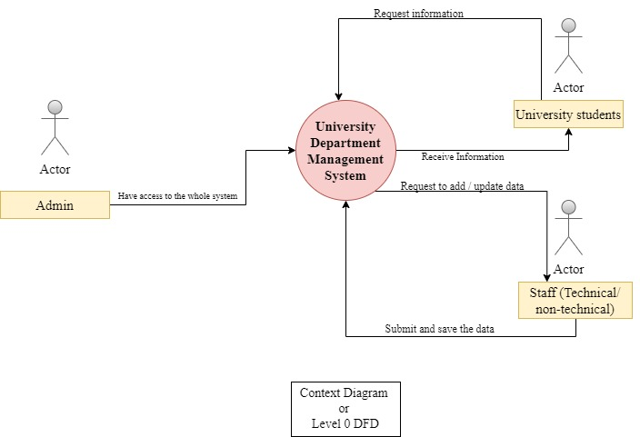
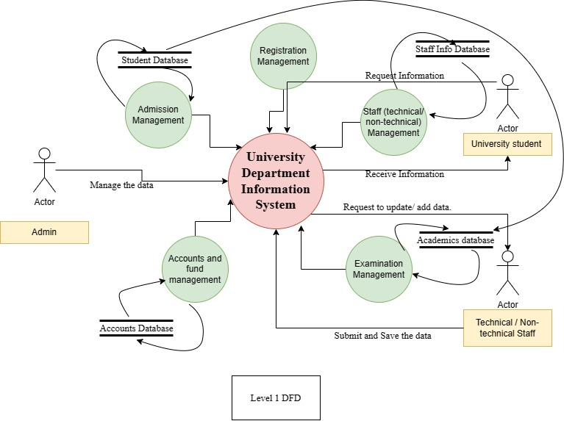

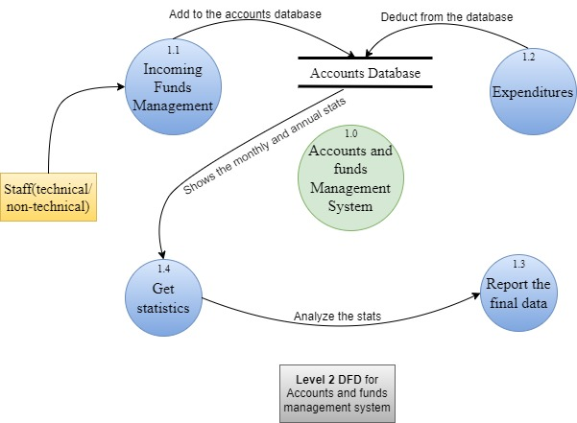

Appendix C: To Be Determined List
<Collect a numbered list of the TBD (to be determined) references that remain in the SRS so they can be tracked to closure.>

