**NEURALINK**

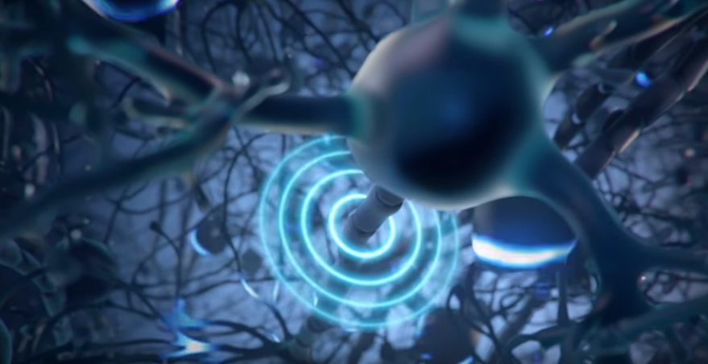

The brain sends messages to other parts of the body by using an elaborate, complex system of neurons. Neurons communicate with each other using chemical signals called neurotransmitters, from the axon of one neuron in response to an electrical spike called an action potential. These action potentials produce an electric field that can be detected by placing electrodes nearby, essentially allowing information represented by a neuron to be recorded [5].

[5]

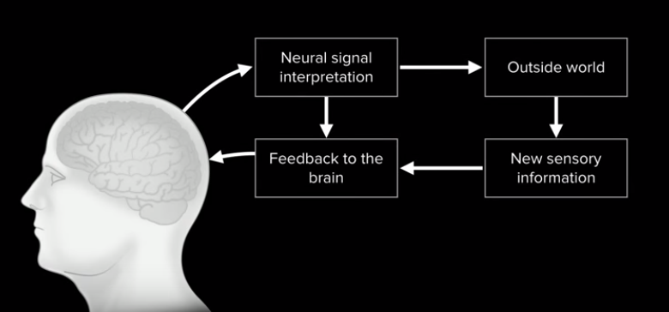

Machine

[5]

Neuralink hopes to use this technology to allow people to control devices like mobile phones and Bluetooth mice and keyboards, and eventually robotic limbs.

In addition, the diagram above shows how Neuralink can also provide users with haptic feedback to specific parts of the body, sending impulses to the brain that simulate what happens when a certain stimulus occurs [5].

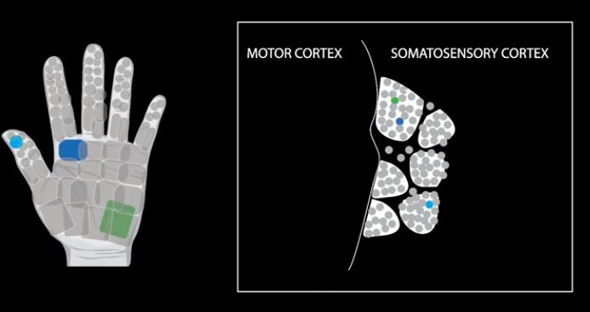

[5]

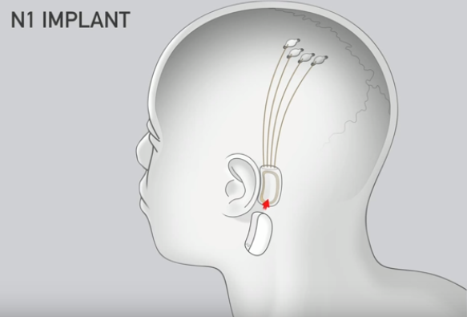

The technology contains four sensors: three in motor areas and one in a somatosensory area. These sensors are connected to a chip behind the ear by ultra-thin wires tunneled under the scalp [3]. The chip is connected wirelessly to a wearable device called a link, containing a Bluetooth radio and battery that activates the implant [5].

[5]

[5]