**MONGO-DB QUERIES**

* Retrieve the books which contains the title as ‘JAVA’ (case insensitive)

Query: **db.books.find({“book_title”:{$regex: /java/i}})**

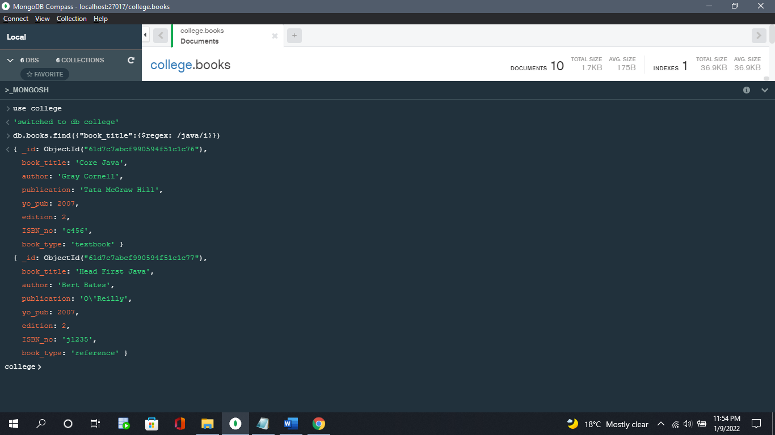

* Retrieve the books which contains the title as ‘JAVA’ and year of publication greater than 2015

Query: **db.books.find({$and:[{"book_title":{$regex: /java/i}},{"yo_pub":{$gt:2015}}]})**

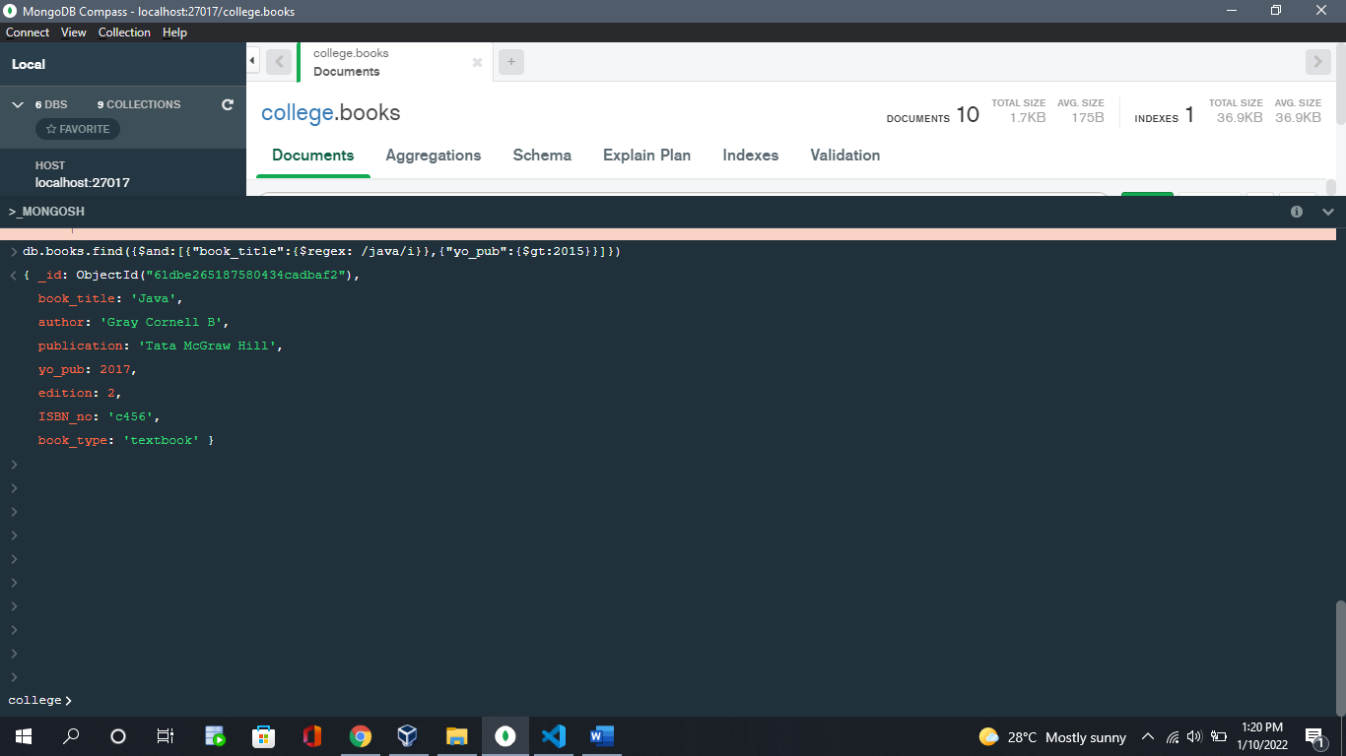

* Retrieve the name of the author who has published 2 or more than 2 books

Query: **db.books.aggregate([{“$group”:{“_id”: “$author”, “count”: {“$sum” :1 }}},{“$match”: {count: {“$gte”:2}}}])**

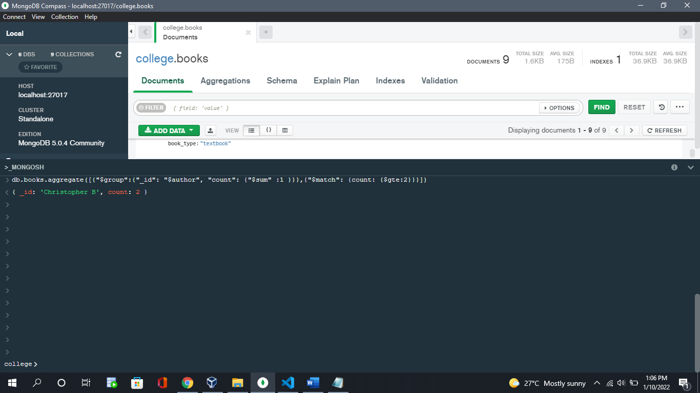

* Retrieve the books whose edition is in between 3rd and 4th

Query: **db.books.find({$and:[{“edition”:{$gte:3}},{“edition”:{$lte:4}}]})**

