ACCURACY OUTCOMES-

1. VARYING THE NUMBER OF EPOCHS

NO OF EPOCHS=10

ACCURACY = 96.32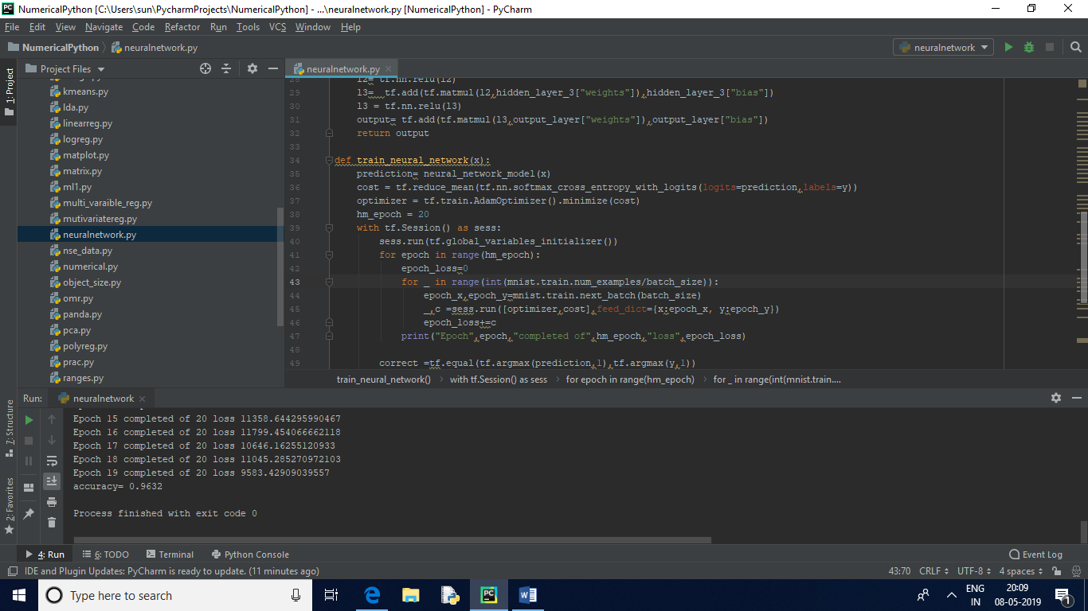

NO OF EPOCHS =20

ACCURACY=95.41

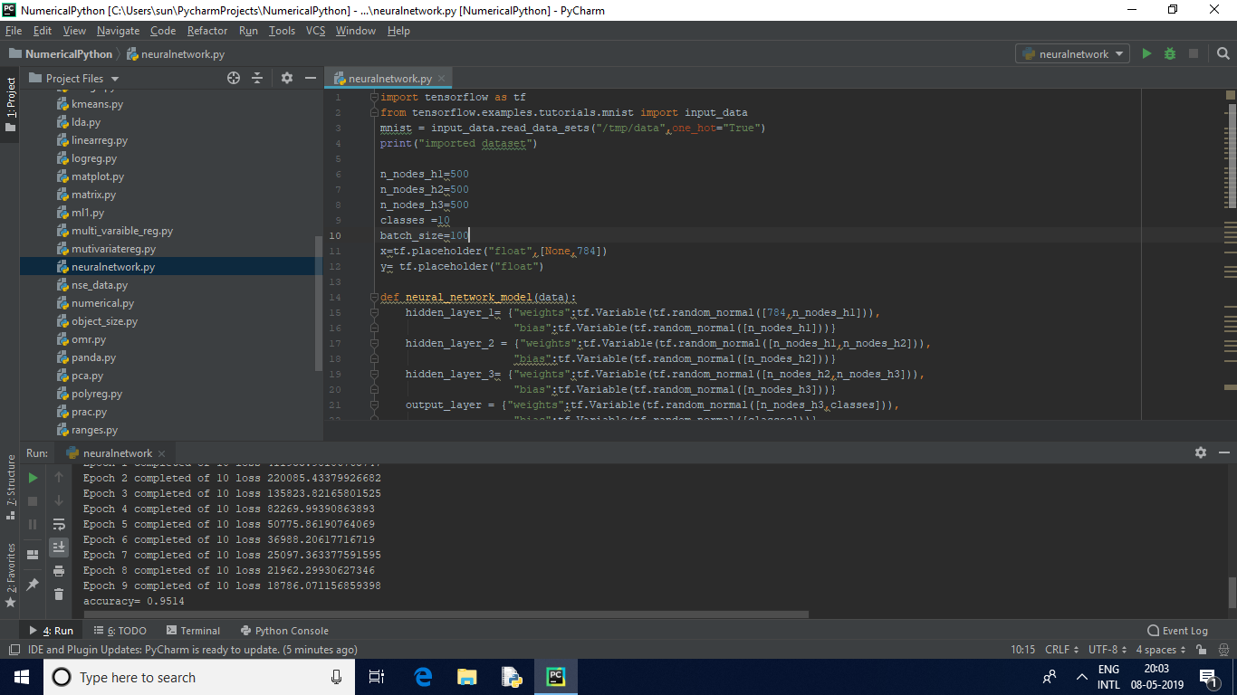

Possible overfitting as we increase the number of epochs hence accuracy decreases