Automation of Virtual Route Reflector Topologies on OpenStack using the Command Line Interface

Oct 2014

Deepti Chandra

Table of Contents
White Paper 1
Executive Summary 3
Introduction 3
OpenStack Architecture 4
Interaction of OpenStack Services 6
OpenStack programming interfaces 8
Workflow of Virtual Machine creation on OpenStack 9
Python script for vRR topology automation 28
Advantages 33
Limitations 33
Conclusion 33
References 33

Executive Summary
This paper provides an overview of the OpenStack Command Line Interface (CLI) architecture for the creation of virtual machines and a baseline topology. Additionally, it demonstrates the use of a tool that can create a vRR topology. It can be used for quick and easy deployments during initial rollouts for internal testing and customer demonstrations, reducing the learning curve overhead. The detailed procedure and the theoretical reasons are described here.

Introduction
With the increase in virtual infrastructure deployments, there has been an increase in the setup of scaled test beds that can mirror production networks for effective testing and initial field rollouts. New hypervisors/orchestration mechanisms often come with an associated overhead of getting up to speed with new technologies and relevant terminology, all of which can increase the time and effort put into testing. In large customer networks, where topologies consist of multiple virtual machines, using a graphical interface is not a feasible solution for provisioning or management of network infrastructure. Graphical user interfaces (GUIs) provide intuitive and conceptual ways to manage virtual environments, but they generally don't scale well for large or repetitive tasks. Activities such as mass provisioning and configuring of virtual machines (VMs) are best suited for automation. The method described here explores one of the many scripting interfaces for OpenStack and how it can be utilized to eliminate many of those caveats.

OpenStack Architecture

OpenStack is an open source cloud operating system to enable the creation of scalable private, public, and hybrid computing clouds. It consists of different components or services that are designed to work together to facilitate the operation of the entire infrastructure. Application Programming Interfaces (APIs) allow the different services to interact with each other as also facilitate cloud end users to interact with the infrastructure.

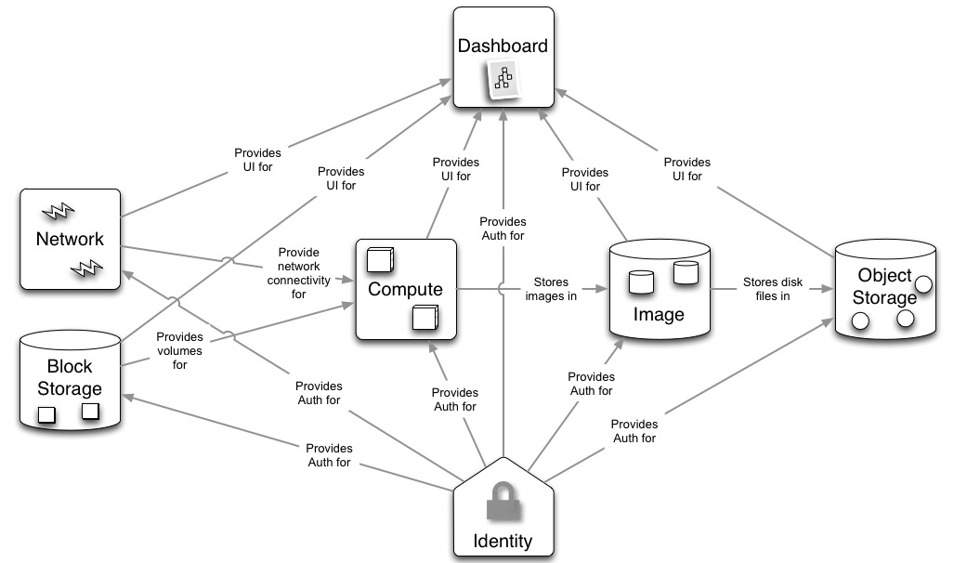
Figure 1 – OpenStack Architecture

The different base services can be briefly described as:
- Horizon (Dashboard service) Provides a Graphical/Web front-end for the OpenStack infrastructure
- Nova (Compute service) Provides computing resources useful for virtual machine creation
- Neutron (Network Service) Provides network services for the virtual environment
- Swift (Object Storage Service) Provides Object Storage with inherent redundancy and scalability
- Cinder (Block Storage Service) Provides block storage volumes, persistent storage
- Glance (Image Repository Service) Provides image management for the virtual environment
- Keystone (Identity Service) Provides authentication. Keystone provided tokens are inspected by all other services before any request is executed
- Heat (Orchestration) Provides a template based orchestration for describing a cloud application by executing appropriate OpenStack API calls to generate running cloud applications.
- Ceilometer (Telemetry) Provides billing and usage monitoring through efficient collection of metering data for tracking CPU usage, network costs etc. across OpenStack

Interaction of OpenStack services

Different services interact with each other via the REST API for provisioning a virtual machine. Please refer^{[1]} for details on the same.
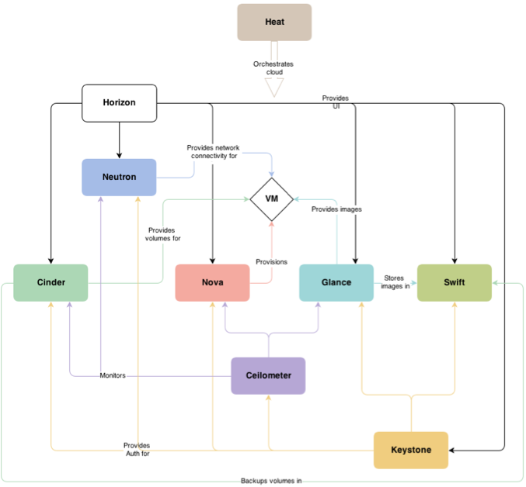
Figure 2 – Interaction between OpenStack services

OpenStack programming interfaces

There are different tools available to interact with OpenStack namely:
- Software Development Kits (SDKs) A SDK in a preferred language can be used to create applications of user choice. OpenStack offers a number of SDKs in Java, Ruby, .NET etc. to name a few.
- Command Line Interfaces (CLI) Each OpenStack project provides a command-line client, which enables you to access the project API through easy-to-use commands, which can be run manually on the target or included in scripts for interacting with OpenStack. Internally, each command uses cURL command-line tools, which embed API requests. OpenStack APIs are REST APIs, and use the HTTP protocol. They include methods, URIs, media types, and response codes.
- Application Programming Interfaces (APIs) An API offers a way to use the capabilities of a service by using predefined functions. It is most often used as an alternative when a SDK in a preferred language is not available. OpenStack offers numerous APIs cURL, REST etc. to name a few. From an operation perspective, it is the management and control plane for a cloud infrastructure built using OpenStack components.
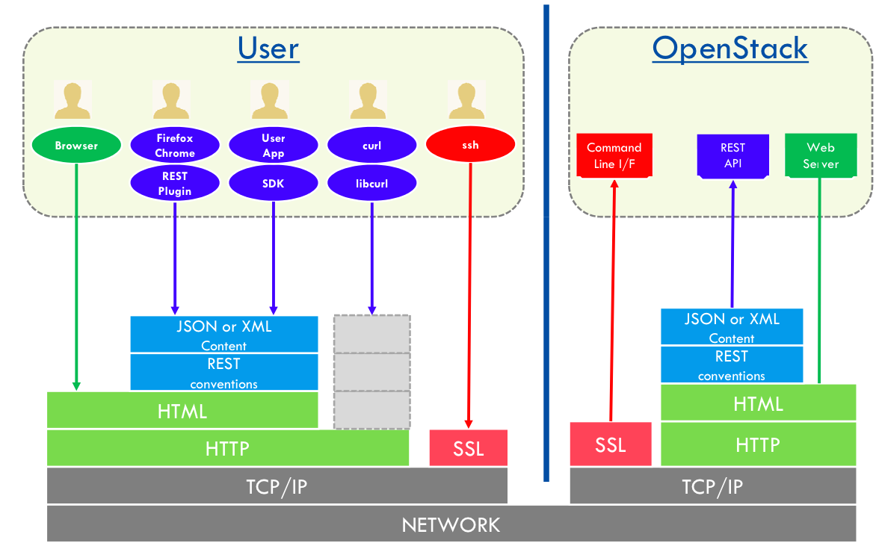
Figure 3 – OpenStack programming interfaces

Workflow of Virtual Machine creation on OpenStack

The process of a VM instantiation for VRR using the OpenStack Command Line Interface involves the steps as described below. These steps illustrate VM creation within one tenant (admin). The Python tool in the next section demonstrates the same in 2 separate tenants thus achieving resource isolation.

- Composing credentials
- Registering an image
- Creating a flavor
- Creating Networks/Subnets
- Creating a VRR instance
- Creating a Router
- Setting the Router as an external gateway
- Assigning floating IPs
- Adding security group rules

Composing credentials
Appropriate user credentials are required for authentication to go through successfully for every command execution.
There are 2 ways of doing this:
Sourcing the keystonerc file
‘keystonerc’ is a file that is used for exporting keystone credentials to environment variables so that they don’t have to be passed every time keystone is used. To use the file run ‘source keystonerc’ and commands can be run without passing the credentials on every execution. Please note that the exported environment variables will be visible only on the terminal that uses the ‘keystonerc’ file.
Sample contents of a keystonerc file include:
export ADMIN_TOKEN=(token)
export OS_USERNAME=(username)
export OS_TENANT_NAME=(tenant-name)
export OS_PASSWORD=(password)
export OS_AUTH_URL=http://(ip_address_of_keystone):5000/v2.0

Passing credentials with every command
Alternatively, you can choose to pass credentials on the command line for every command execution.
Sample syntax:
--os-username admin --os-password <admin-password> --os-tenant-name <admin tenant-name> --os-auth-url http://<ip_address_of_keystone>:5000/v2.0/

Registering an image
For an instance to be able to use an image, it needs to be available in the glance registry.
For a VRR image, the steps below are required:

Import (create) the image into glance

Sample syntax:
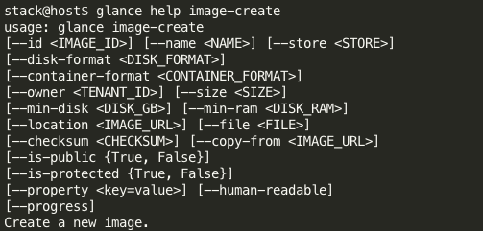

Usage:
glance image-create --name <image-name=VRR-image> --disk-format=qcow2 --container-format=bare --file=<image-location=/home/regress/VRR-images/jinstall64-vrr-13.3I20140115_1040_brkreddy-domestic.qcow2>

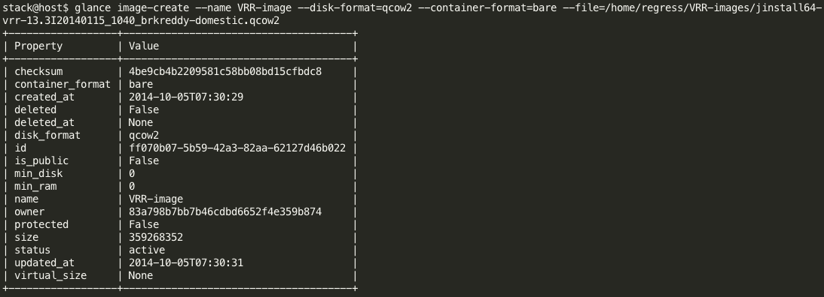

Update the image
Currently libvirt will determine the disk/cdrom/vif device models based on the configured hypervisor type (libvirt_type in /etc/nova/nova.conf). For the sake of optimal performance, it will default to using virtio for both disk and VIF (NIC) models. This is a problem with Junos ( FreeBSD )-based images which currently lack virtio drivers. Hence this step is required so that we can have correct virtual disk and virtual NICs to ensure correct boot up and connections.^{[2]}
Sample syntax:
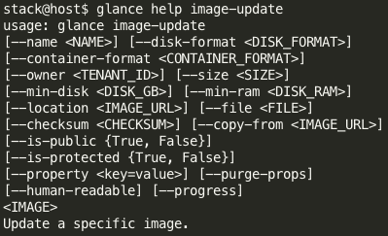

Usage:
glance image-update --property hw_disk_bus=ide --property hw_cdrom_bus=ide --property hw_vif_model=e1000 <image-name=VRR-image>

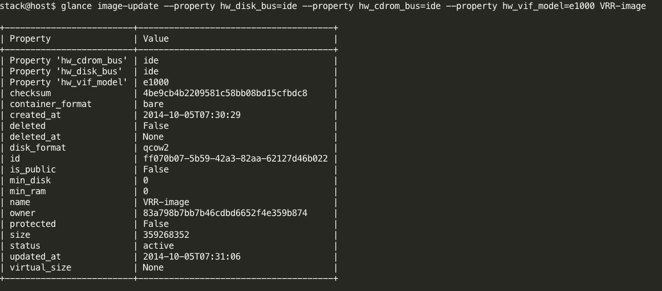

Verification:
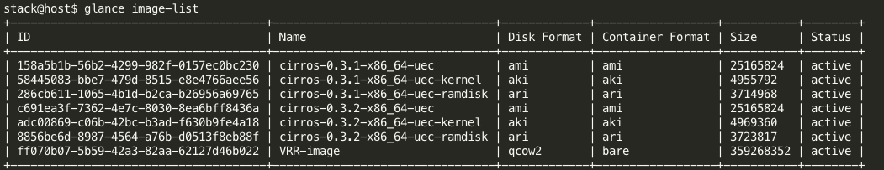

Creating a flavor
Flavor defines the hardware parameters for a VM. These virtual hardware templates called "flavors" in OpenStack, define sizes for RAM, disk, number of cores, and so on. The default install provides five flavors – ‘m1.<tiny, small, medium, large, xlarge>’. For VRR, please create a flavor using the parameters as illustrated below.

Sample syntax:
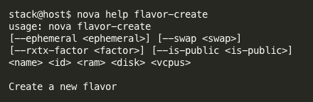

Usage:
nova flavor-create --is-public true <flavor-name=VRR-flavor> <flavor-id=6> <ram=16384> <disk=10> <vcpus=1>

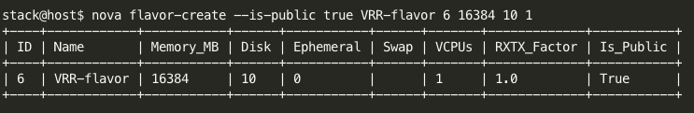

Verification:
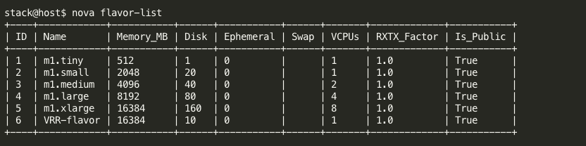

Creating Networks/Subnets
The user can create networks/subnets for internal and external communication to which the NICs of the instance to be created can be attached.

Sample syntax:
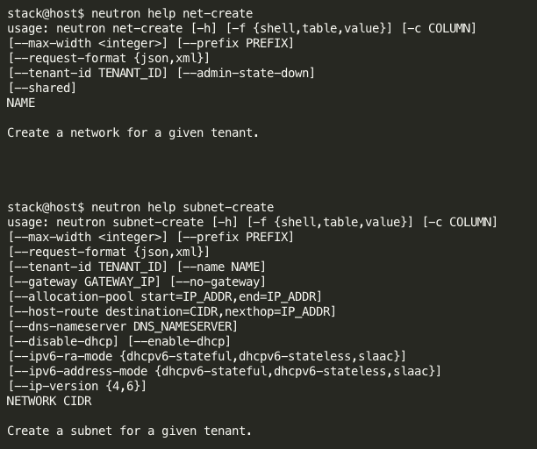

Usage:
neutron net-create <private/internal-network-name=private-network>
neutron subnet-create --name <subnet-name=private-subnet> <network-name=private-network> 10.0.0.0/24
neutron net-create <public/external-network-name-public-network> --router:external=True
neutron subnet-create public-network 192.168.239.90/25 --name public-subnet --enable_dhcp=False --allocation-pool start=192.168.239.64,end=192.168.239.65 --gateway=192.168.239.126

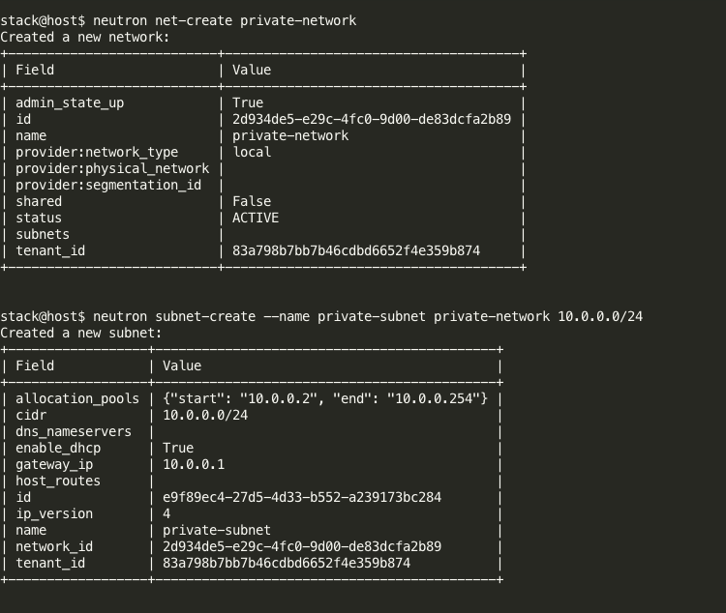

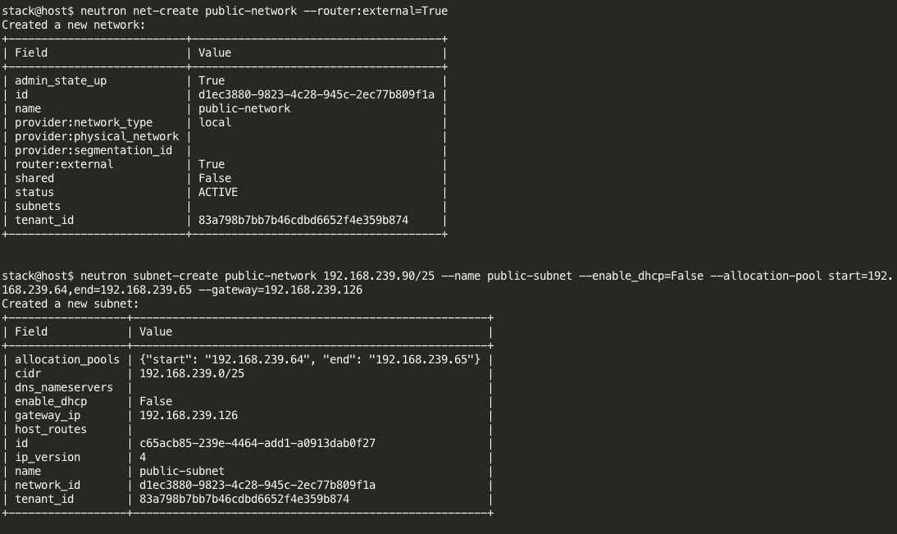

Verification:
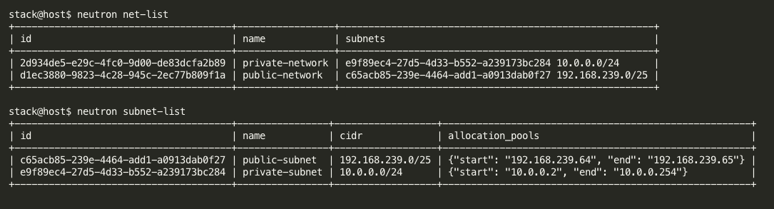

Creating a VRR instance
A virtual machine is referred to as an “instance” in OpenStack. After the creation of the image, flavor, networks etc the instance can then be booted up.

Sample syntax:
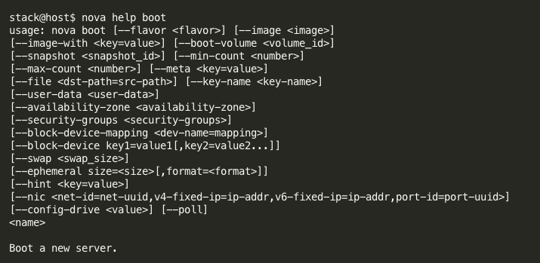

Usage:

nova boot --image <image-name=VRR-image> --flavor <flavor-id=6> --nic <net-id=2d934de5-e29c-4fc0-9d00-de83dcfa2b89> <instance-name="VRR-1">

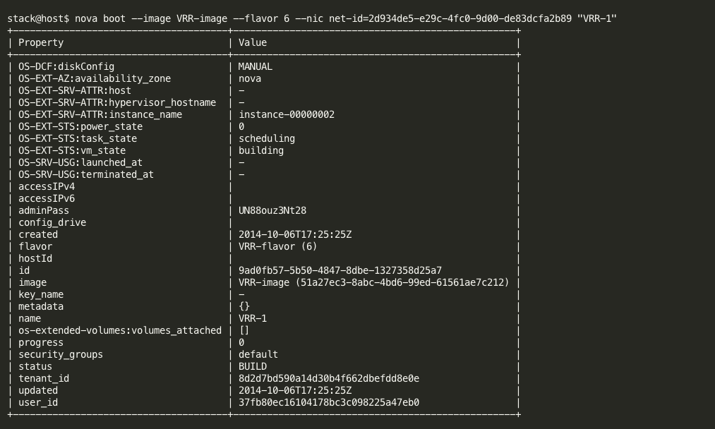

Verification:
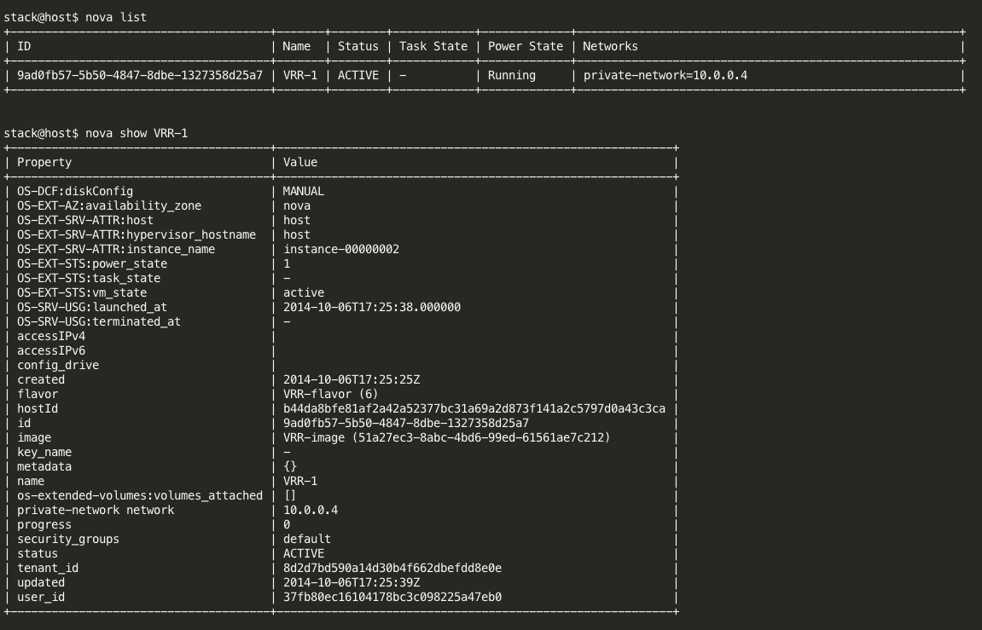

Creating a Router
The Layer-3 networking extension enables OpenStack Networking API users to route packets between subnets, forward packets from internal networks to external ones, and access instances from external networks through floating IPs.
The OpenStack Networking layer-3 extension defines these resources:
- router: A logical entity that forwards packets across internal subnets and NATs them on external networks through an appropriate external gateway. A router has an interface for each subnet with which it is associated. By default, the IP address of such interface is the subnet's gateway IP. Also, whenever a router is associated with a subnet, a port for that router interface is added to the subnet's network.

- floatingip: Represents an external IP address that is mapped to an OpenStack Networking port and, optionally, a specific IP address on a private OpenStack Networking network. A floating IP enables access to an instance on a private network from an external network. Floating IPs can only be defined on networks where the router:external attribute (by the external network extension) is set to True.

Sample syntax:
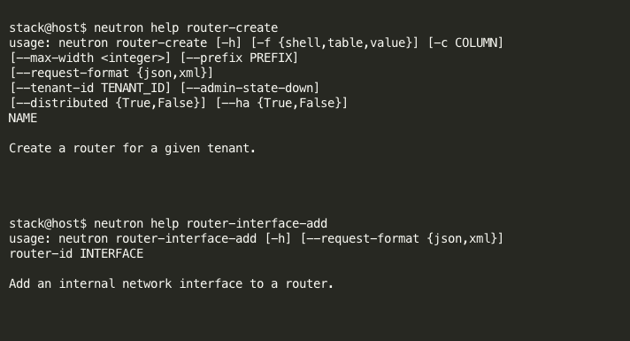

Usage:
neutron router-create <router-name=GWR>
neutron router-interface-add <router-id=b93033e7-e825-40fa-811f-df72d3cd230d> <subnet-id=0aee53b8-dd69-4ed3-a83c-0b715ef3acd0>
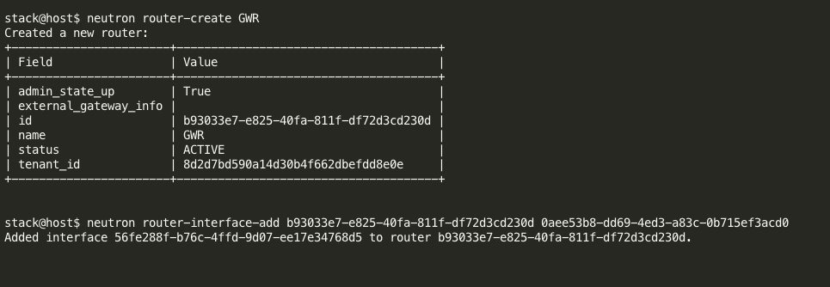

Verification:
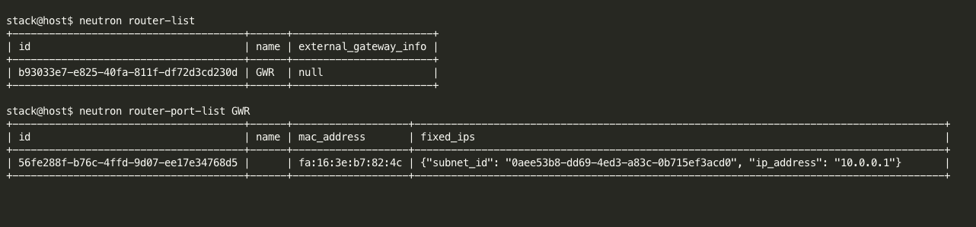

Setting the Router as an external gateway
Allows specifying a given router to be an external gateway.
Sample syntax:
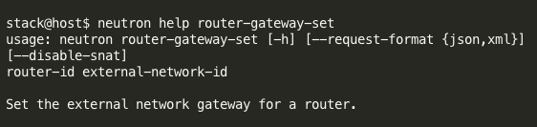
Usage:
neutron router-gateway-set <router-id=b93033e7-e825-40fa-811f-df72d3cd230d> <public/external-nw-id=119d6ee2-9946-44d9-810b-4c94e9c0f7b4>

Assigning floating IPs
OpenStack instances receive a private IP address through which they can reach each other and through which hosts can reach them. In order to access these instances from the external network the instances will need to be allocated a "floating IP." Floating IP address and a private IP address can be used at the same time on a single network-interface. The private IP address is likely to be used for accessing the instance by other instances in the private network while the floating IP address would be used for accessing the instance from a public network.

Sample syntax:
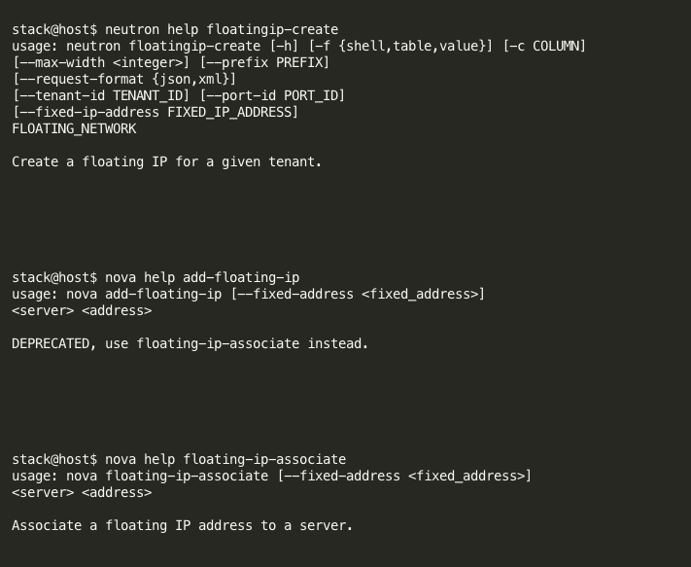

Usage:

neutron floatingip-create <public/external-network-name=public-network>
nova add-floating-ip <instance-name=VRR-1> <floatingip=192.168.239.106>

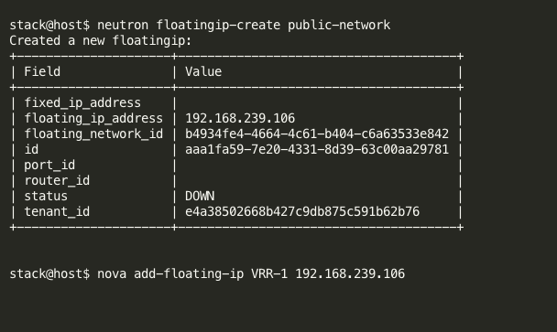

Verification:
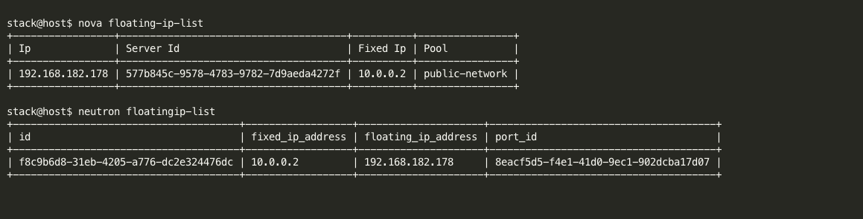

Adding security group rules
To allow ssh and ping traffic to the created VM, security rules for the same need to be added.

Sample syntax:
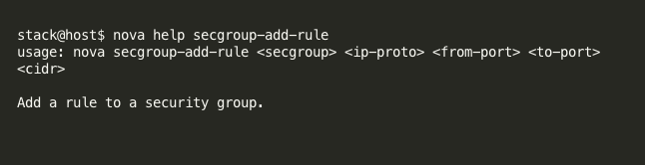

Usage:
nova secgroup-add-rule <security-group-name=default> tcp 22 22 0.0.0.0/0
nova secgroup-add-rule <security-group-name=default> icmp -1 -1 0.0.0.0/0

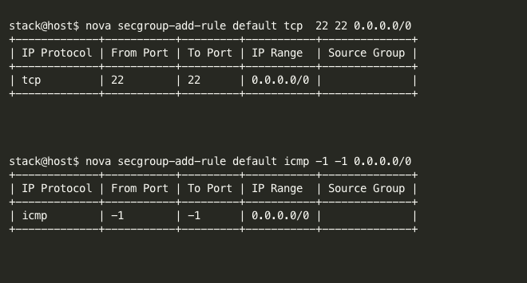

Verification:
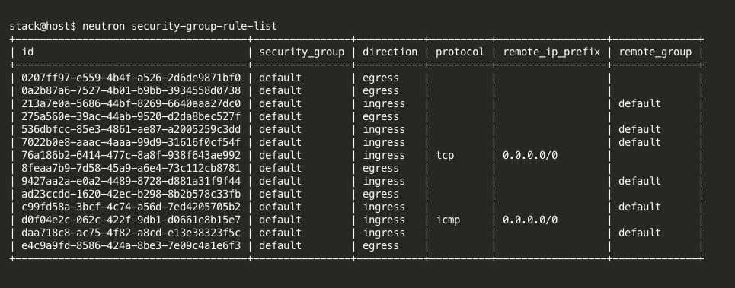

Python script for vRR topology automation
Due to the learning curve associated with the use of OpenStack as also the lack of clarity on the availability of some operations being available from the Horizon Dashboard, end users are looking for a transparent easy to use tool that can quickly spin-off a ready to use topology that can be utilized for deployment and testing. A local standalone tool has been developed in Python that helps automate the creation of a virtual environment.
This tool simulates the static baseline VRR test bed with the objective of bringing it up quickly which can help expedite testing and customer demonstrations. Script is available here: https://github.com/deeptic/Virtualization-Automation/blob/master/vRR-Automate-OpenStack.py

Below is a summary of the algorithm the script uses to accomplish this objective:
- Get input from the user required for creating the VM topology for VRR. A log file is also created to capture all session logs.
- The script demonstrates the use of resource isolation by having the ‘admin’ user create a separate ‘Guest-Topology’ tenant and ‘guest-user’.
- The ‘guest-user’ thus created would be able to influence elements only in its own tenant.
- Registration of the vRR image is gone for the guest tenant.
- A private flavor for creating a vRR instance is created for the guest tenant.
- External network is then created that is visible to the admin and guest tenants.
- Instances are created with multiple NICs for communication with the management and internal/external network.
- The vRR instances are then booted up.
- A router is created for communication between the external networks and the instances with ports added to the existing subnets within the guest tenant.
- The created router is also set up to be the external-gateway for the guest tenant.
- Floating IPs are then assigned to all the vRR instances in the guest tenant.
- Security group rules are added to the ‘default’ group to further allow ssh and ping traffic.

The end result is vRRs are powered on and ready for use, with the connections that emulate the vRR baseline topology as demonstrated below.
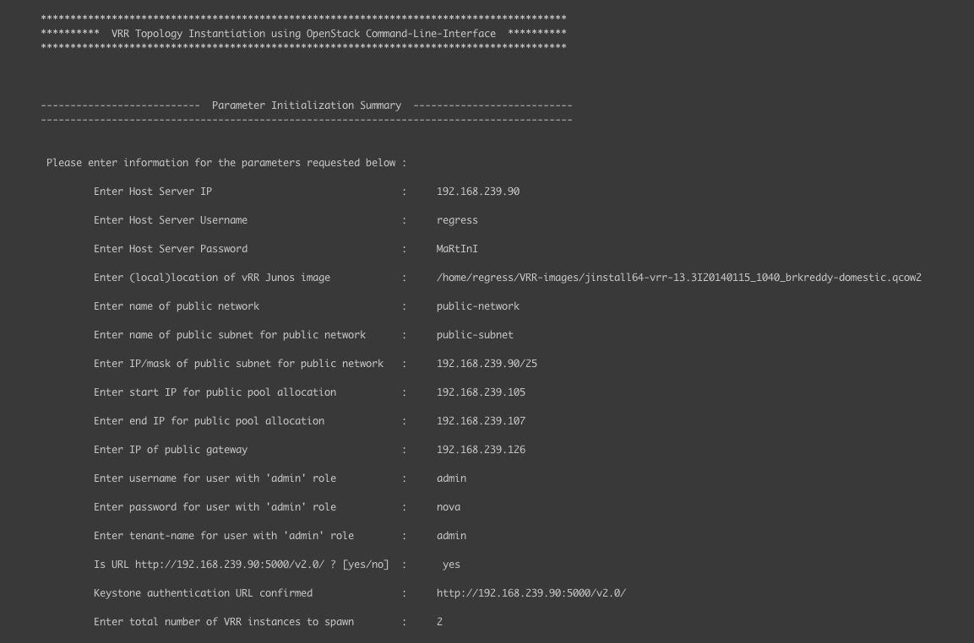
Figure 4-a – Python tool initialization

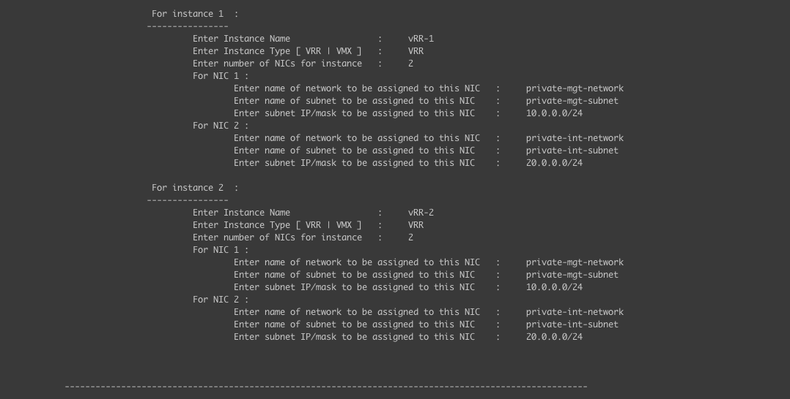
Figure 4-b – Python tool initialization

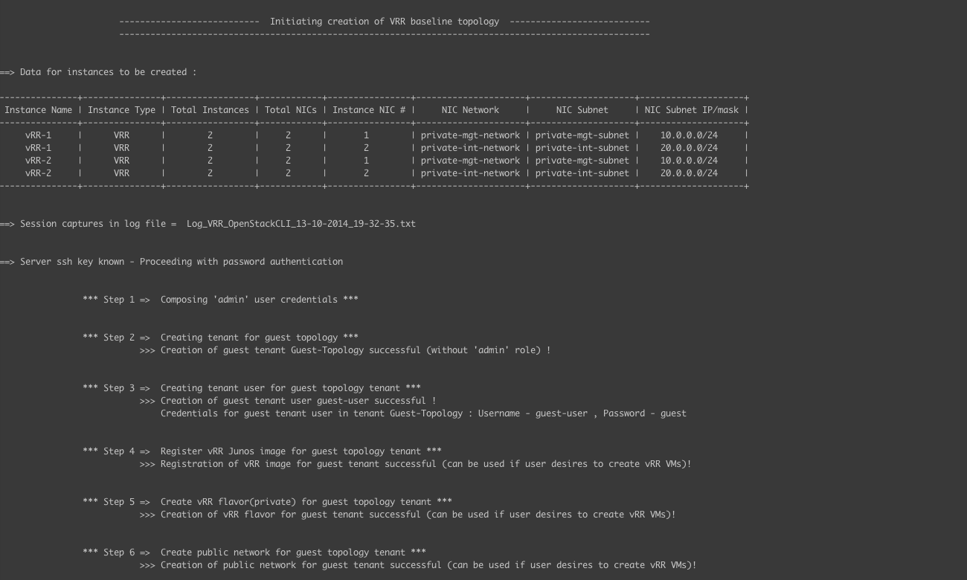
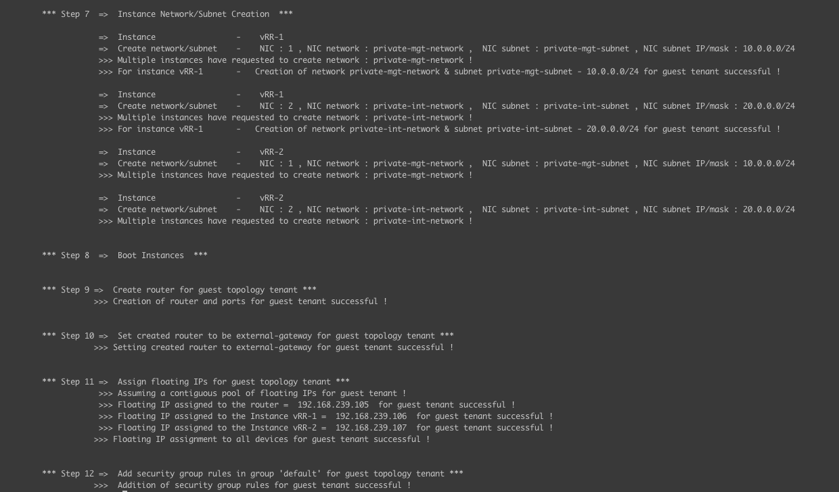
Figure 5 – Python tool execution

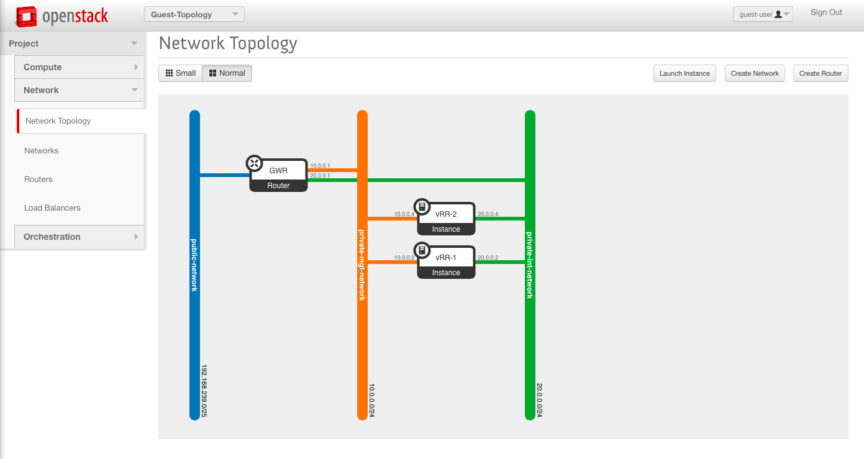
Figure 6 – vRR topology created for the ‘Guest-Topology’ tenant

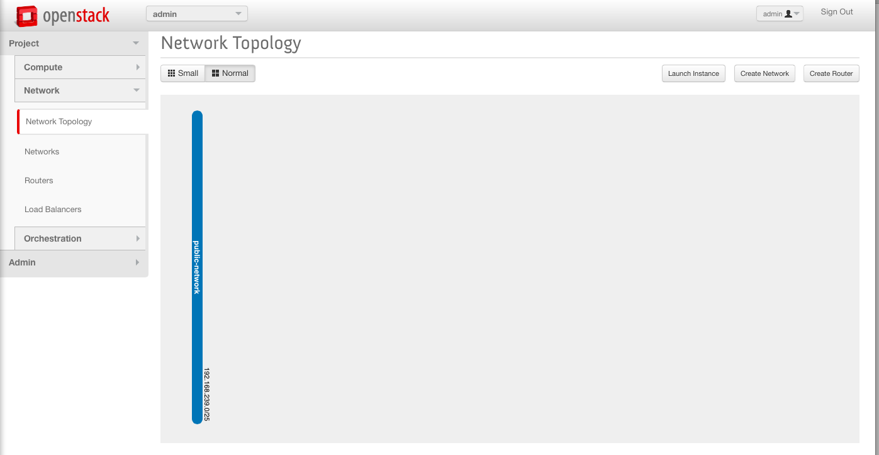
Figure 7 – vRR topology isolation as seen by the ‘admin’ tenant

Advantages
- Leveraging command-line interface for virtual environment facilitates easy automation and management
- Enhanced flexibility to achieve powerful operations
- Scalable solution
- Allows for integration of VM and Junos automation
- Easy rollout of test beds useful for customer demonstrations and testing teams
- Tool can be uplifted to incorporate support for more dynamic topologies and network scripts

Limitations
Understanding use cases of taking advantage of this approach in a testing environment. The tool is a starting point on how system calls & APIs can be leveraged to integrate virtual infrastructure usage with Junos, which would be essential in network environments.

Conclusion
The benefits of Network Function Virtualization have been enumerated numerous times with those ranging from cost benefits to new product deployments. Customers are looking at solutions that would be in line with production networks in terms of scalability and complexity. Automation is a critical component of network provisioning and management. With the integration of virtual and network functions, automation also needs to leverage the same functionality. Command-line tools and APIs serve a beneficial purpose and can be customized to involve their use for not only virtual infrastructure specific operations but also for network related functions.

References
OpenStack Documentation

