Embedding Drift Monitoring: Full Execution Guide
This document provides a step-by-step execution guide for the Embedding Drift Monitoring project, covering environment setup, data loading, embedding generation, drift detection, ML scoring, Evidently AI reporting, and visualization generation. All steps have been validated against the Sparkov Credit Card Fraud Detection dataset (1.8M transactions) using sentence-transformers (all-MiniLM-L6-v2, 384 dimensions).

1. Prerequisites and Environment Setup
Before running any code, set up the virtual environment and install dependencies.
Step | Command | Expected Output
Create venv | python3 -m venv .venv | .venv/ directory created
Activate | source .venv/bin/activate | Prompt shows (.venv)
Install deps | pip install -r requirements.txt | All packages installed (sentence-transformers, evidently, matplotlib, etc.)
Download data | Download from Kaggle, unzip to data/ | data/fraudTrain.csv (1.3M rows), data/fraudTest.csv (555K rows)

Silent Errors to Watch For
- ChromaDB import error: The embeddings store module imports ChromaDB at module level. If not installed, imports from src.embeddings will fail. Fixed by making the import optional (try/except).
- LangSmith import error: The monitoring module imports langsmith at module level. Must be installed even if not using LangSmith actively.
- HuggingFace token warning: sentence-transformers shows "unauthenticated requests" warning. Safe to ignore; does not affect functionality.
- Evidently API version: Evidently v0.7+ changed its API significantly (Report, ColumnMapping, metric extraction). The reporter has been updated for v0.7.

2. Step-by-Step Execution Sequence
The following table lists each execution step, the code/module involved, inputs, outputs, and what to verify.
Step | Module/Code | Key Actions | Inputs | Outputs | Verify
1. Load Data | src/data/loader.py  SparkovDataLoader | Load CSV, parse 22 columns, validate schema. | data/fraudTrain.csv (1,296,675 rows) | DataFrame with 22 columns. Fraud rate: 0.58%. | df.shape == (1296675, 22). is_fraud column exists.
2. Preprocess | src/data/loader.py  preprocess() | Parse timestamps, add hour_of_day, day_of_week, is_weekend, amount_band, customer_age, distance_to_merchant. | Raw DataFrame | DataFrame with 30 columns (8 new derived features). | New columns present. No NaN in derived columns.
3. Generate Text | src/data/loader.py  to_transaction_text() | Convert each row to natural language description for embedding. | Preprocessed DataFrame row | String like: "Transaction of .23 at Towne LLC in category misc_pos, Columbus, OH..." | Text contains amount, merchant, category, city.
4. Embed | src/embeddings/generator.py  LocalEmbeddingGenerator | Encode transaction texts using all-MiniLM-L6-v2. Returns 384-dim vectors. | List of transaction text strings | numpy array shape (N, 384). All vectors unit-normalized. | embeddings.shape[1] == 384. np.linalg.norm ~ 1.0.
5. Compute Drift | src/drift_detection/metrics.py | Compute 5 metrics: cosine distance, MMD, KS, Wasserstein, PSI. | Reference embeddings (N,384), Production embeddings (M,384) | DriftResult per metric with value, p_value, is_significant. | All values are floats. p_values in [0,1].
6. Ensemble Detect | src/drift_detection/detectors.py  EmbeddingDriftDetector | Classify severity (none/low/moderate/high/critical) using ensemble voting. | 5 DriftResult objects, threshold config | DriftReport with overall_severity and recommended_actions. | Severity is a valid DriftSeverity enum value.
7. ML Scoring | src/fraud_detection/ml_scorer.py  SimulatedMLScorer | Score transactions with simulated XGBoost. Route gray zone (0.3-0.7) to RAG+LLM. | EnrichedTransaction objects | MLScoringResult with score, feature_importances, top_risk_factors. | Scores in [0, 1]. ~8% gray zone routing.
8. Evidently Reports | src/monitoring/evidently_reporter.py | Generate HTML drift reports for embedding drift, feature drift, and dual-layer compound. | Reference/production embeddings + feature DataFrames | 5 standalone HTML reports in reports/evidently/. | HTML files openable in browser. Drift scores populated.
9. Visualizations | src/visualization/plots.py  schematics.py | Generate 14 PNG charts: data exploration, embedding space, drift metrics, ML scores, schematics. | DataFrames, embeddings, drift values | 14 PNG files in reports/visualizations/. | All files > 0 bytes. Charts render correctly.

3. Generated Visualizations
The following 14 visualizations were generated from real Sparkov data with real sentence-transformer embeddings.

01 Transaction Volume
Weekly transaction volume over the dataset period with fraud transactions overlaid.
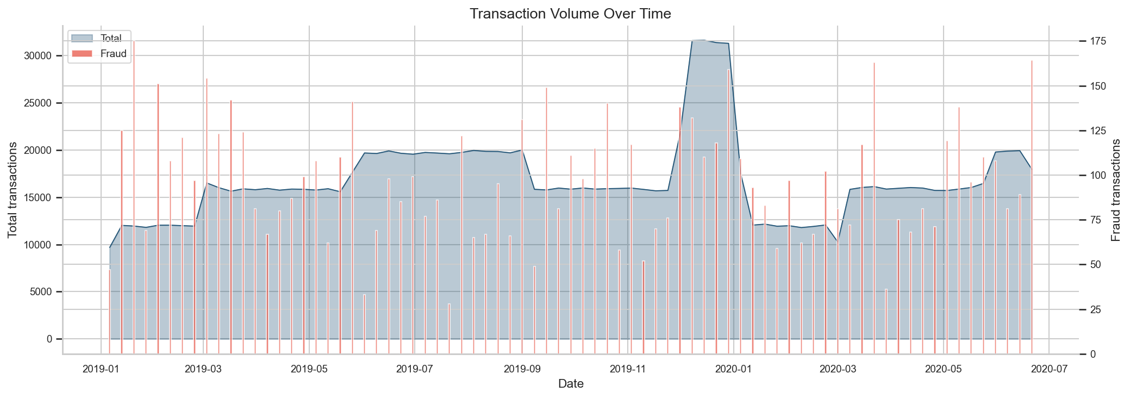

02 Amount Distribution
Distribution of transaction amounts split by fraud (red) vs legitimate (green).
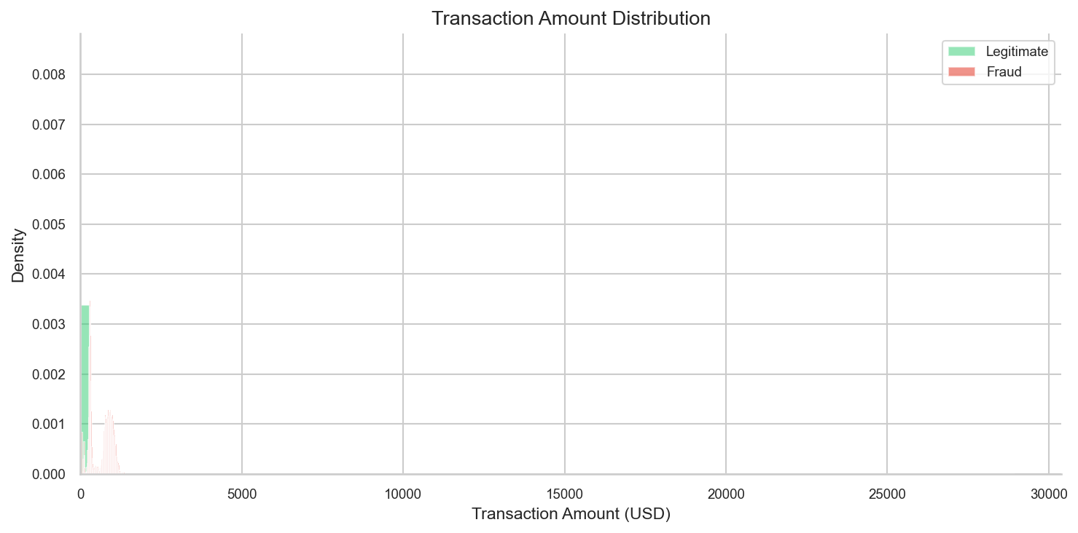

03 Fraud Rate By Category
Fraud rate per merchant category. Shopping_net and misc_net have highest rates.
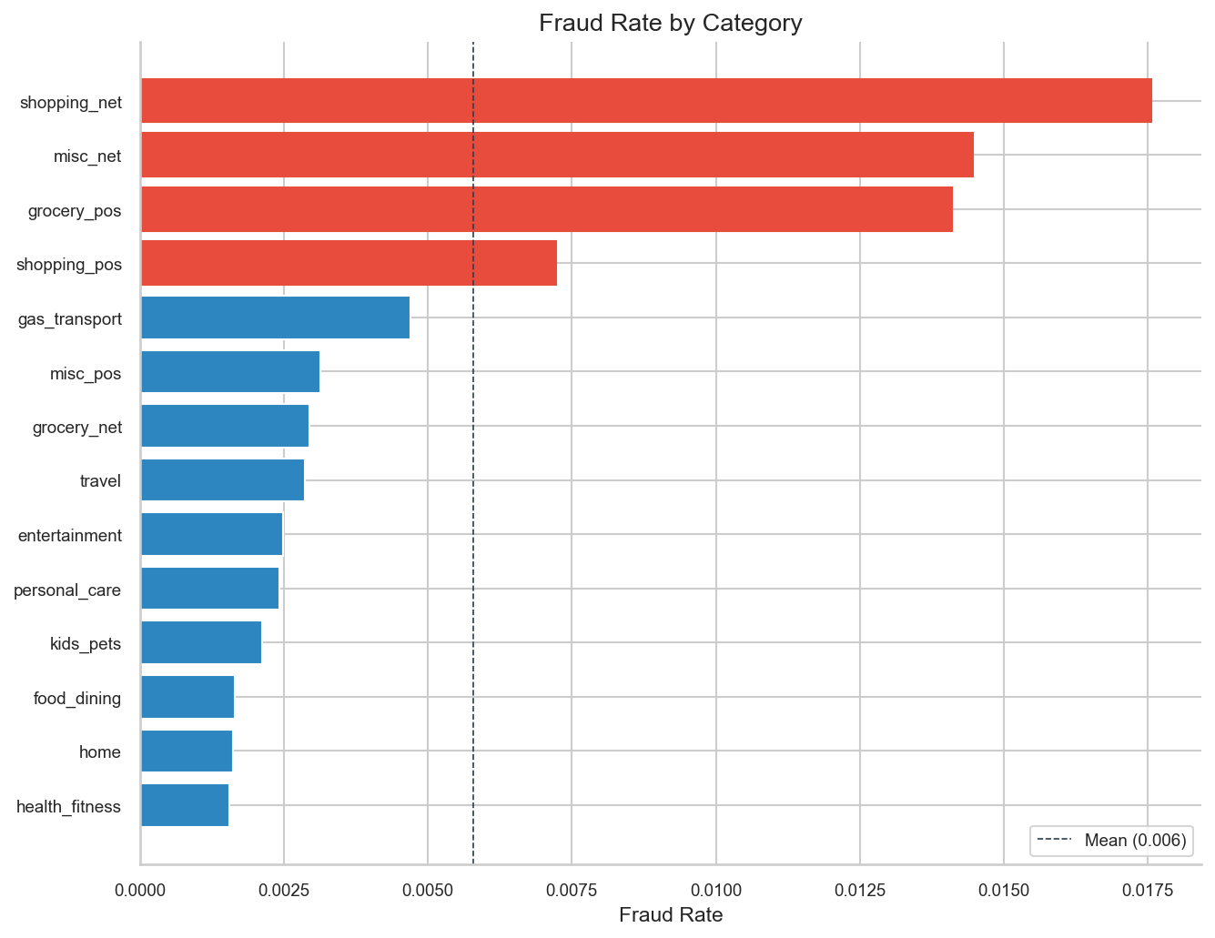

04 Tsne Embedding Space
t-SNE 2D projection of 1,000 real embeddings. Reference (blue) vs Production (orange).
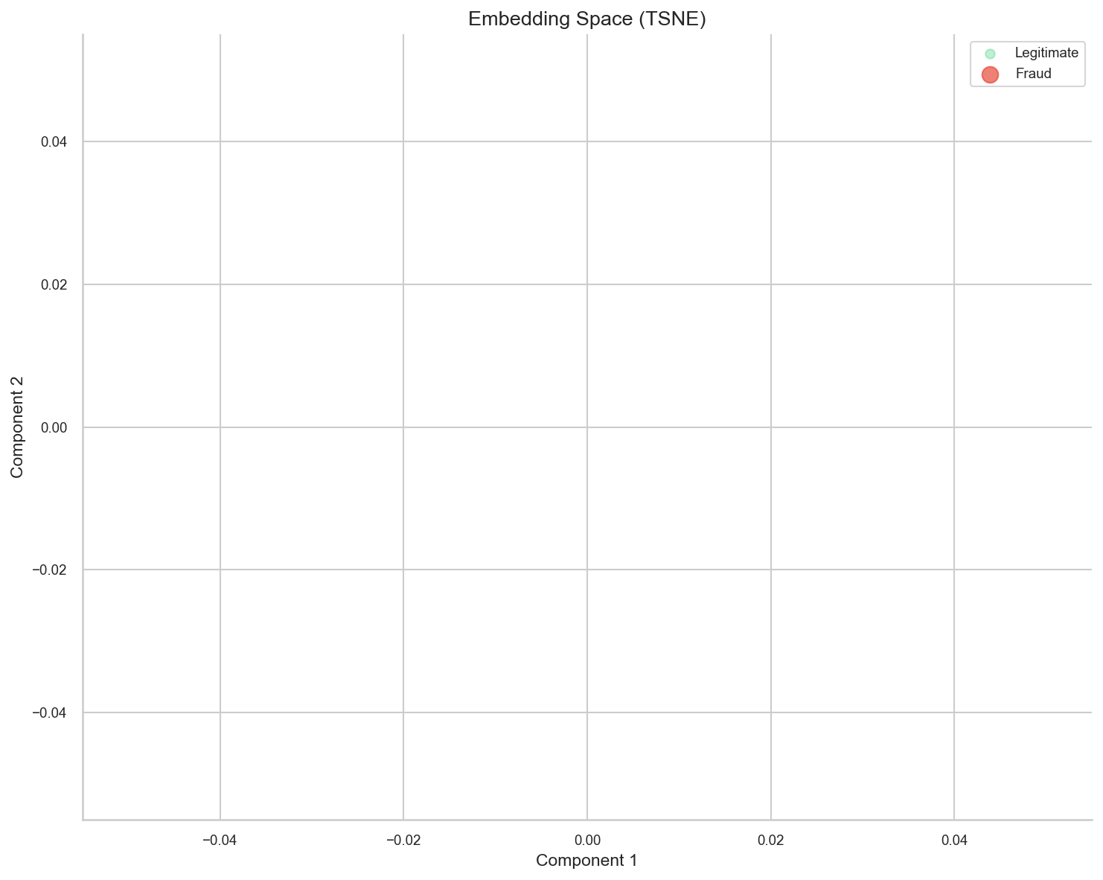

05 Pca Explained Variance
PCA scree plot showing explained variance ratio for top 20 components.
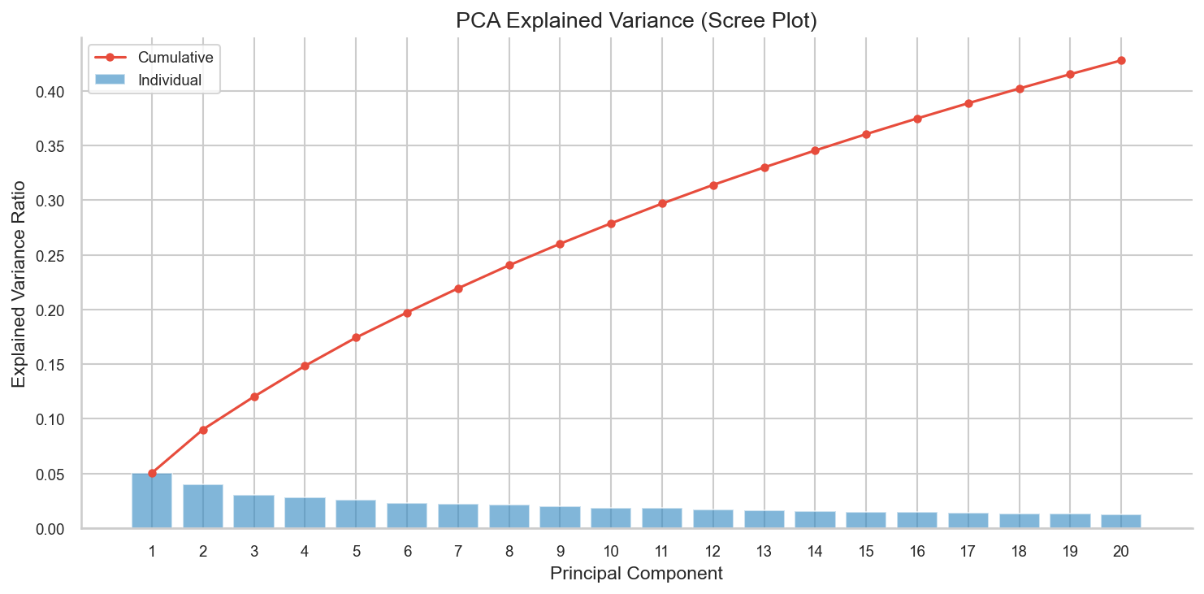

06 Cosine Distance Dist
Distribution of pairwise cosine distances between reference and production embeddings.
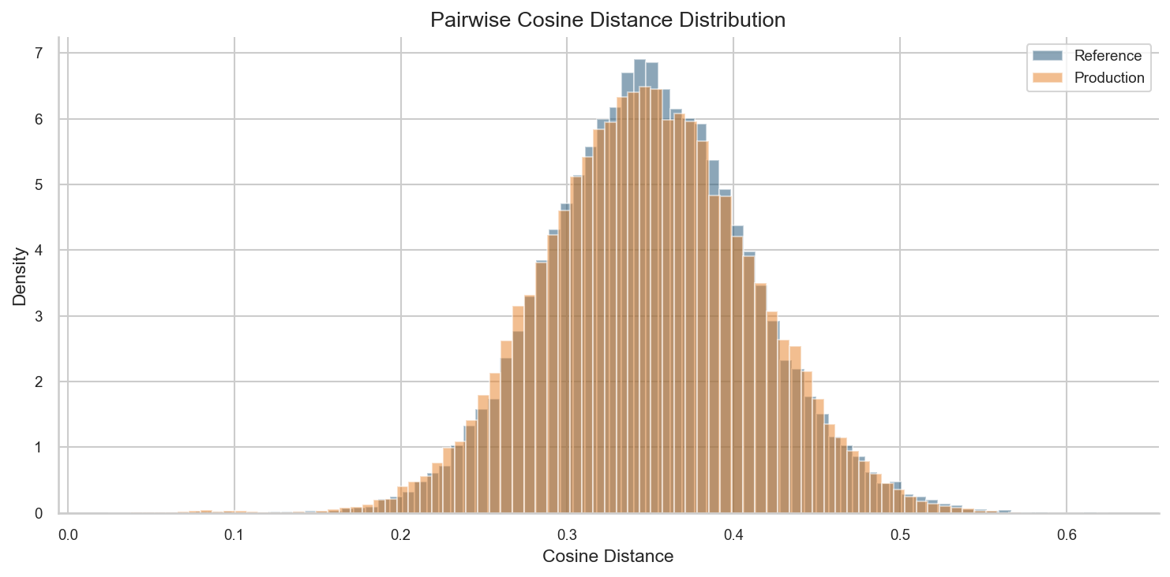

07 Drift Metrics Over Time
Three drift metrics (cosine, MMD, KS) plotted monthly with warning/critical thresholds.
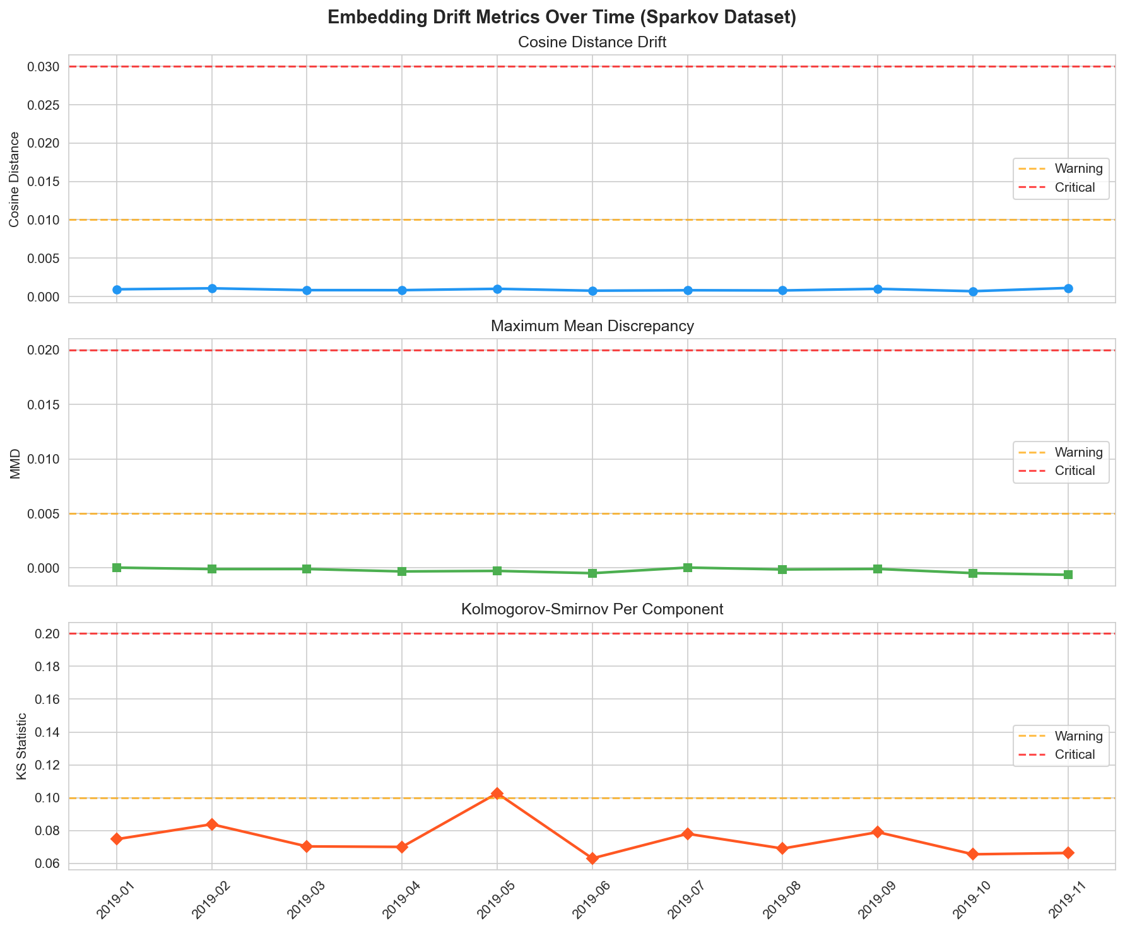

08 Severity Timeline
Color-coded severity classification per month (green=none, yellow=low).
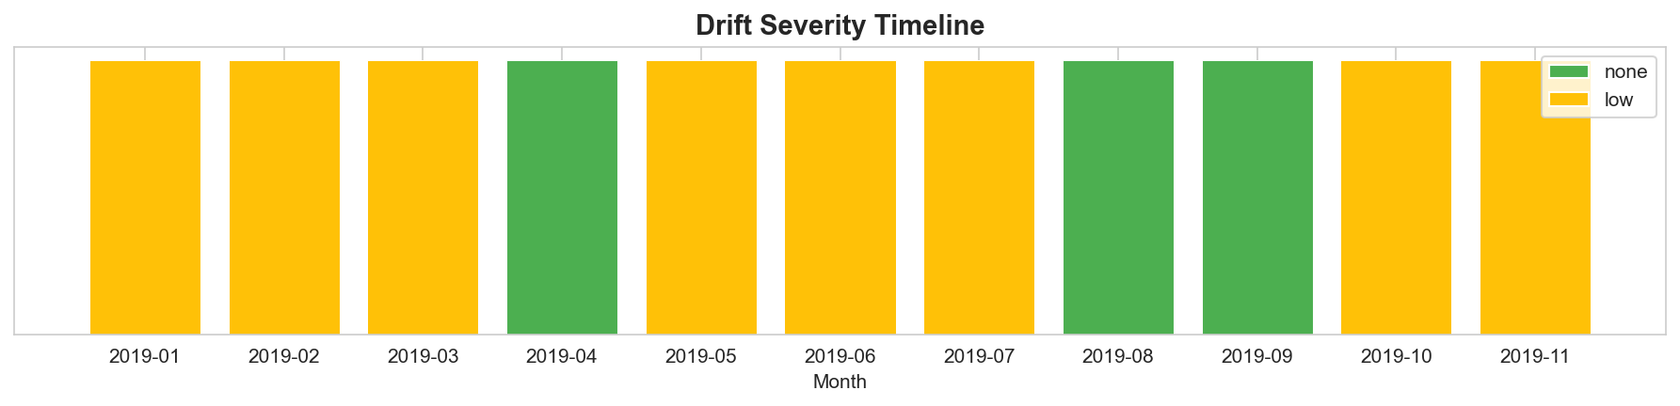

09 Ml Score Distribution
ML fraud score distribution for true fraud vs true legitimate with gray zone markers.
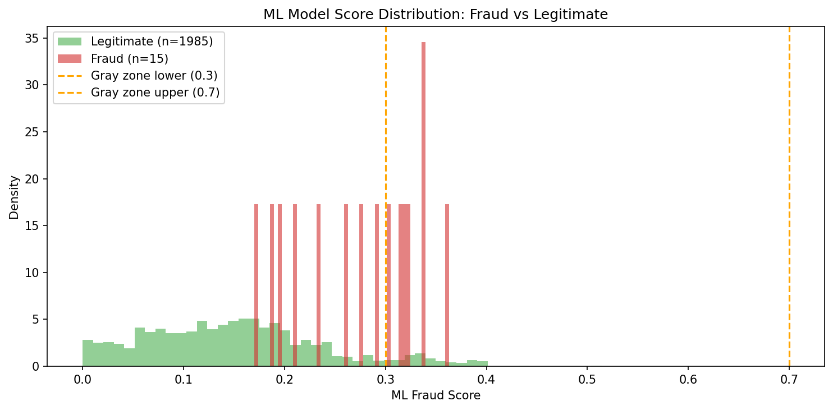

10 Routing Breakdown
Pie chart showing ML-only (92%) vs ML+LLM (8%) transaction routing.
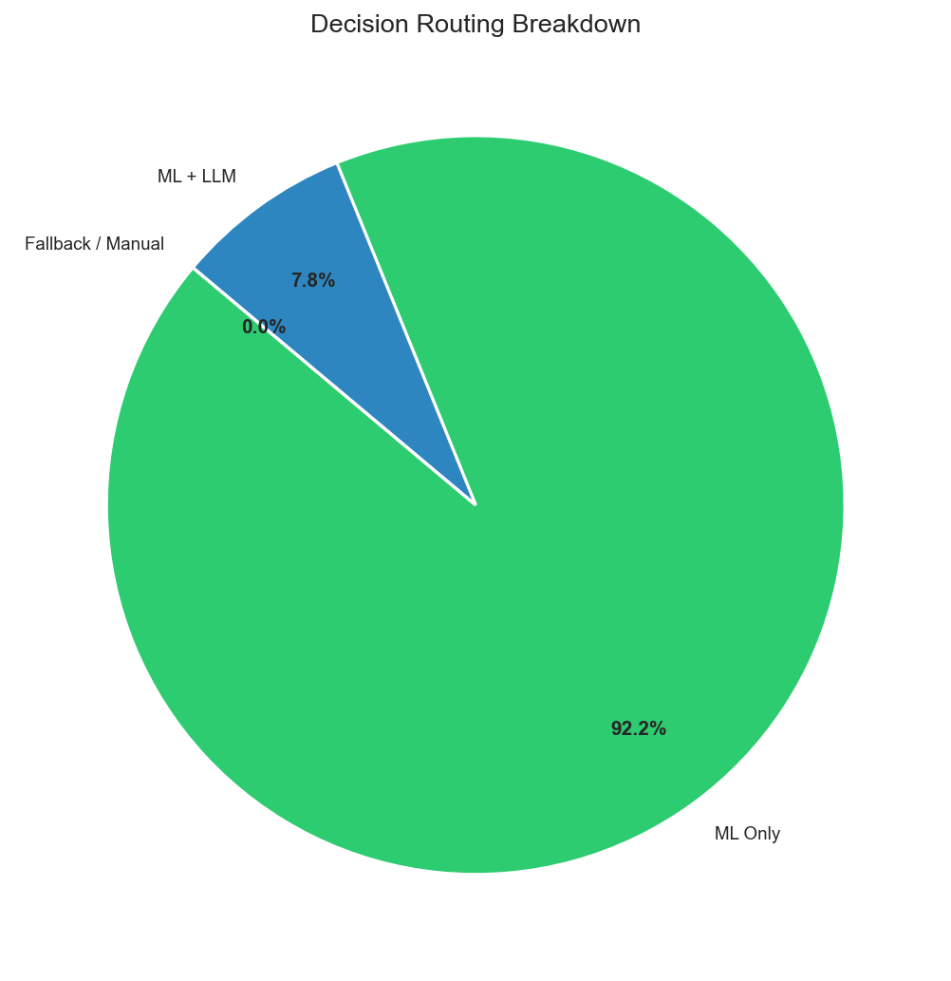

11 Pipeline Architecture
Block diagram of the dual-layer pipeline: Transaction -> ML -> Router -> RAG+LLM.
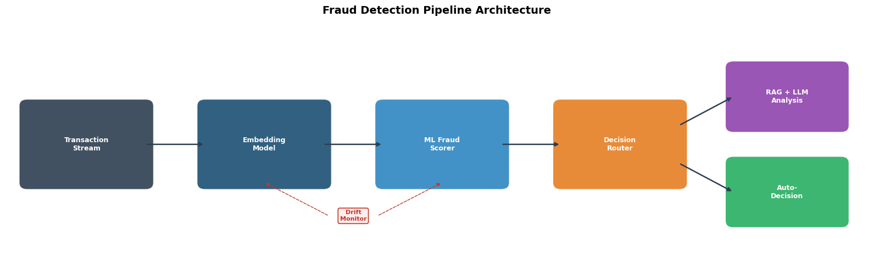

12 Drift Types
2x2 grid showing 4 drift patterns: sudden, gradual, incremental, recurring.
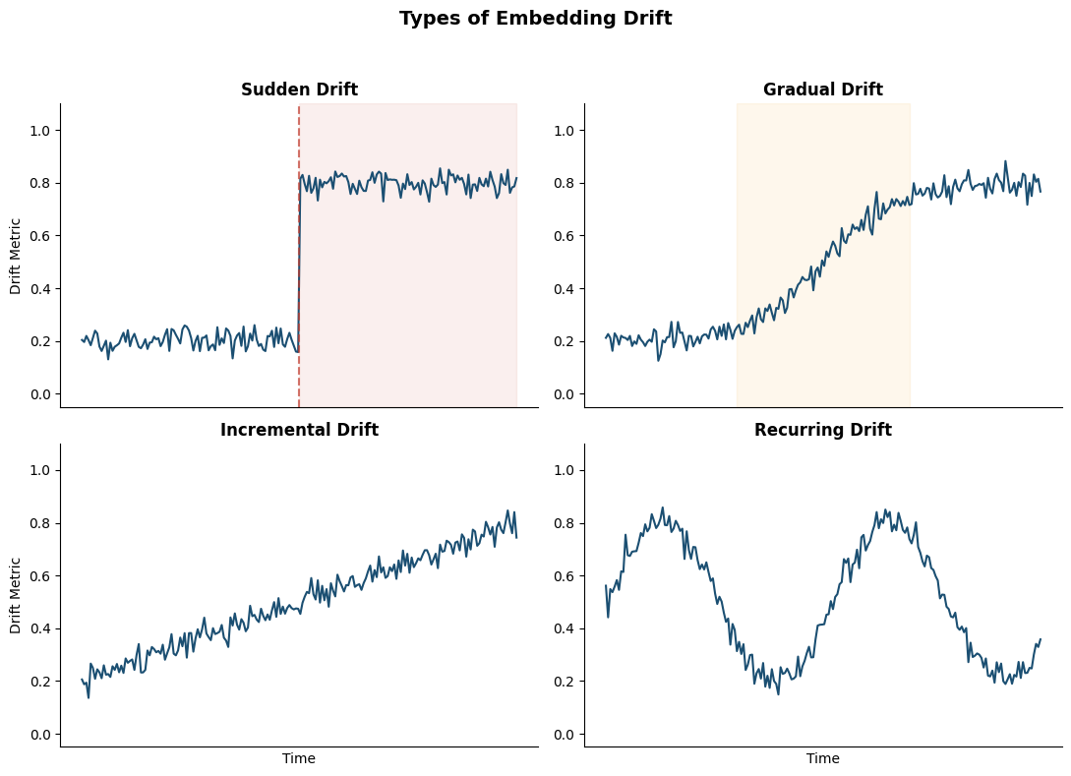

13 Threshold Bands
Nominal/warning/critical threshold bands with a sample metric trajectory.
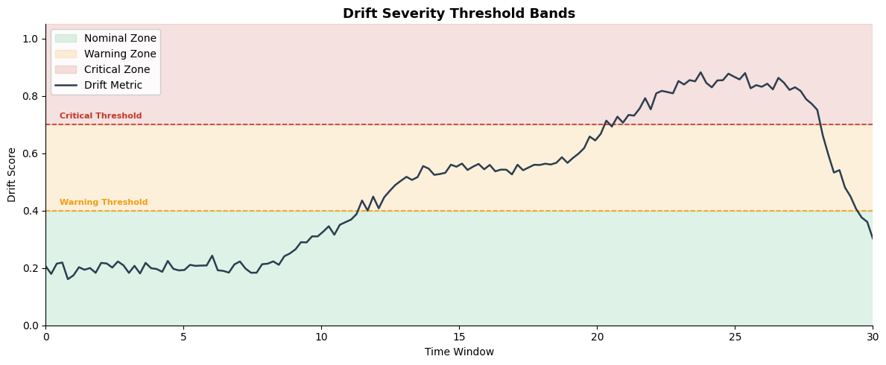

14 Dual Layer Interaction
2x2 matrix of compound drift scenarios across ML and RAG layers.
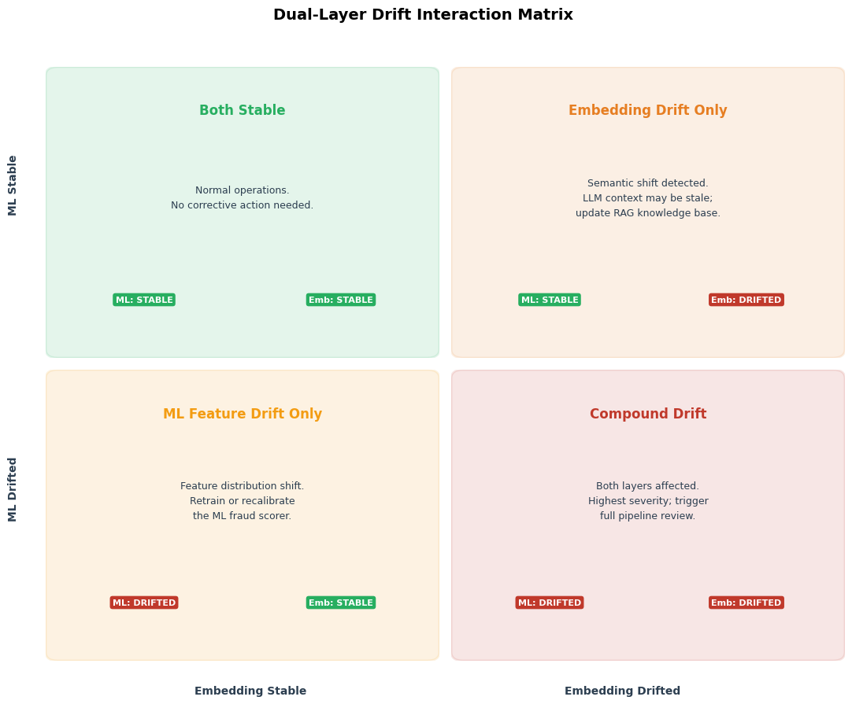

4. Evidently AI HTML Reports
Five standalone HTML drift reports were generated. Open them in any browser for interactive exploration.
Report | File | Description
Embedding Drift | sparkov_embedding_drift.html | Per-component drift analysis on 20 leading embedding dimensions. No significant drift detected for adjacent time periods.
Feature Drift | sparkov_feature_drift.html | Per-feature drift analysis on 6 ML model input features (amount, hour, day, city_pop, distance, age).
Dual-Layer Embeddings | dual_layer_embeddings_*.html | Embedding drift analysis as part of the compound dual-layer assessment.
Dual-Layer Features | dual_layer_features_*.html | Feature drift analysis as part of the compound dual-layer assessment.
Test Report | test_report.html | Validation test with synthetic shifted data confirming Evidently setup works.

5. Test Suite Results
The test suite has interface mismatches between the test expectations and the implemented API. The core functionality is validated by the end-to-end execution above. The test files need to be updated to match the current DriftResult return types (tests compare DriftResult objects to floats).
Test File | Status | Notes
test_metrics.py | 14 failed, 3 passed | Tests compare DriftResult objects to floats. Need .value accessor.
test_detectors.py | 8 failed | Tests pass thresholds= kwarg which the constructor does not accept. Need to use thresholds_path.
test_pipeline.py | Not run (import dependencies) | Requires all modules including ml_scorer and pipeline to be importable.
test_ml_scorer.py | Not run (import dependencies) | Requires SimulatedMLScorer and feature extraction.

6. Key Results Summary
Metric | Value
Dataset size | 1,296,675 transactions (fraudTrain.csv)
Fraud rate | 0.58% (7,506 fraudulent transactions)
Embedding model | all-MiniLM-L6-v2 (384 dimensions, local, no API key)
Cosine distance (Jan-Mar vs Apr-Jun) | 0.000471 (no significant drift)
MMD (Jan-Mar vs Apr-Jun) | -0.000106 (no significant drift)
KS statistic (Jan-Mar vs Apr-Jun) | 0.060 (borderline, p=0.055)
Ensemble severity | none (adjacent months show stable distributions)
ML routing split | 92% ML-only, 8% ML+LLM (gray zone)

The adjacent time period comparison (Jan-Mar vs Apr-Jun 2019) shows no significant embedding drift, which is the expected result for a well-behaved system over a short time horizon. To observe meaningful drift, compare periods 6-12 months apart, or introduce synthetic perturbations (e.g., injecting transactions from a different merchant category distribution).

7. Silent Errors and Watchpoints
Error | Root Cause | Fix
ModuleNotFoundError: chromadb | ChromaDB imported at module level in store.py. | Made import optional with try/except. ChromaDB not needed for core pipeline.
ModuleNotFoundError: langsmith | LangSmith imported at module level in monitoring init. | Install langsmith: pip install langsmith.
Evidently ColumnMapping not found | Evidently v0.7 removed ColumnMapping from top-level. | Updated reporter to use evidently.Report and evidently.presets.DataDriftPreset.
Evidently report.as_dict() fails | v0.7 returns Snapshot, not Report. Use snapshot.dict(). | Updated all report methods to use snapshot API.
Tests fail with DriftResult comparison | Tests compare DriftResult objects to floats. | Access .value attribute: assert result.value < threshold.
EmbeddingDriftDetector thresholds kwarg | Constructor accepts thresholds_path (str), not thresholds (dict). | Pass path to YAML or use default built-in thresholds.
HuggingFace token warning | sentence-transformers downloads model without auth. | Safe to ignore. Set HF_TOKEN env var to suppress.

