**NAAN MUDHALVAN**

Project title :

Public Health Awareness

TEAM MEMBERS:

Deepti Ishwar - 2021103008

Rajalakshmi S - 2021103038

Kanishka S - 2021103018 P

PROJECT DESCRIPTION :

PHASE 4 : Development On The Public Health Awareness Data Set

OBJECTIVE :

STEPS :

in google colab notebook:

* Open the Google drive
* Load the Data Set

Descriptive Analysis :

* Frequency
* Proposition
* Summary Statistics & Reports
* Corelation
* Graph Representation

Descriptive Analysis :

Frequency:

Code :

# Frequency of treatement :

response_counts = id['treatment'].value_counts()

print(response_counts)

Output:

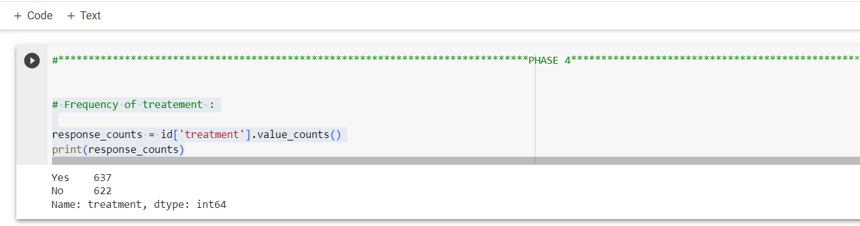

Preposition

Code:

#Proposition :

response_proportions = id['treatment'].value_counts(normalize=True)

print(response_proportions)

Output:

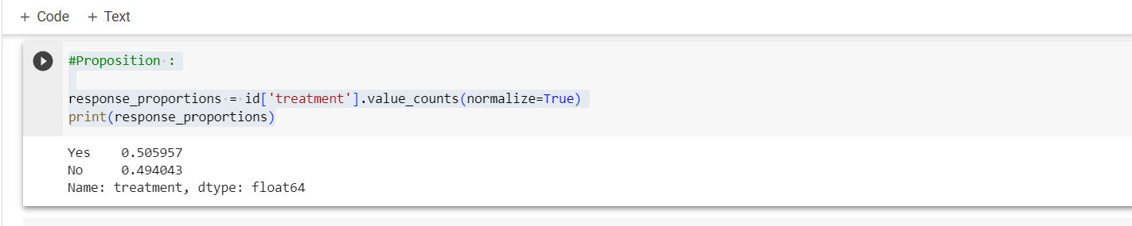

PROCESS & CLEANSING THE DATASET:

CODE:

id.shape

OUTPUT:

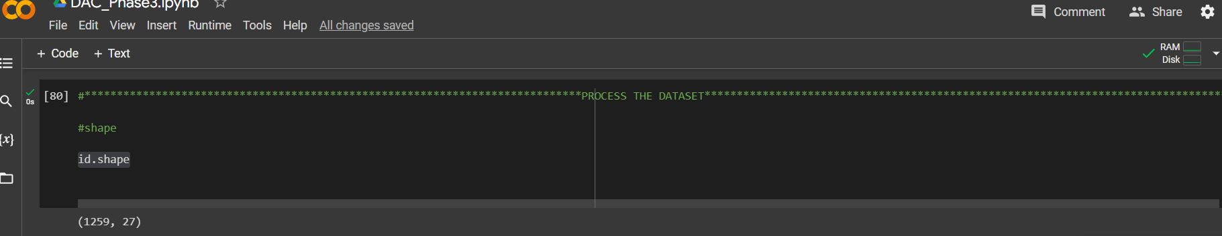

CODE :

#information

id.info()

OUTPUT:

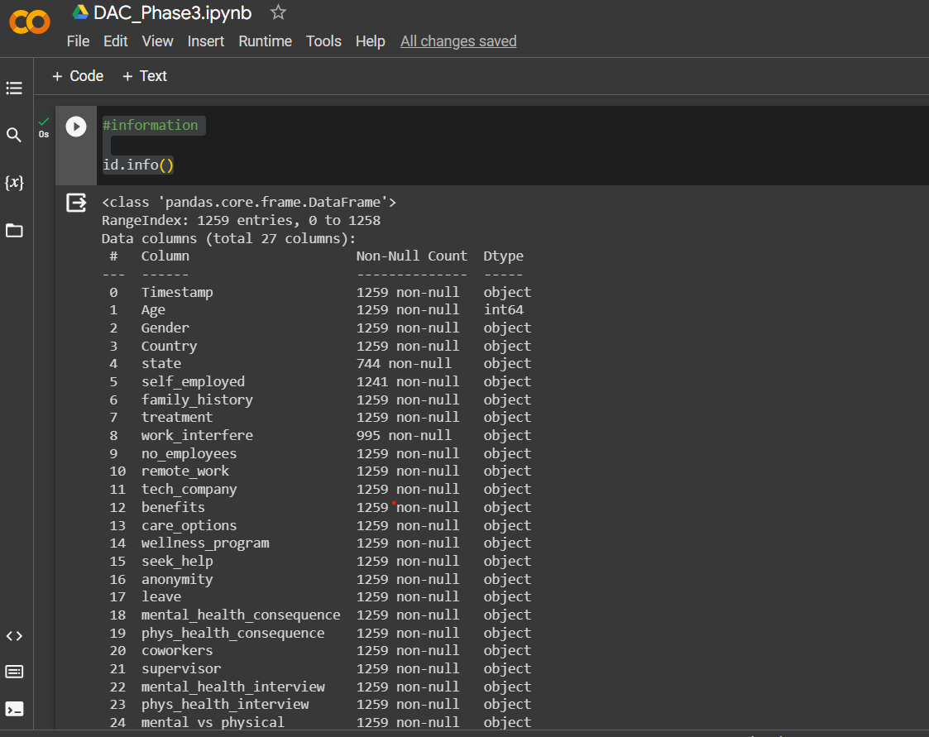

CODE :

#describe

id.describe()

OUTPUT: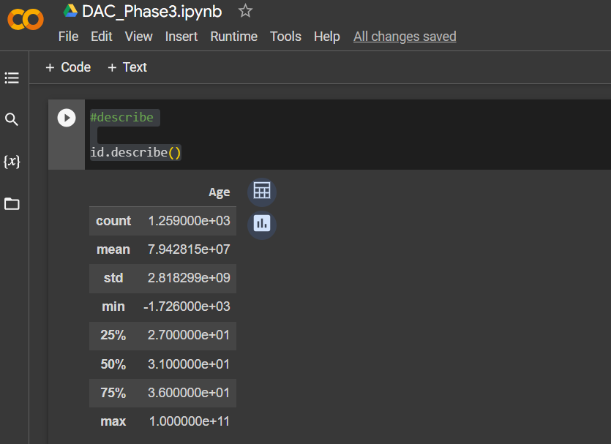

CODE :

import pandas as pd

data = id.drop_duplicates()

data.to_csv("cleaned_dataset.csv", index=False)

print(data.describe())

OUTPUT: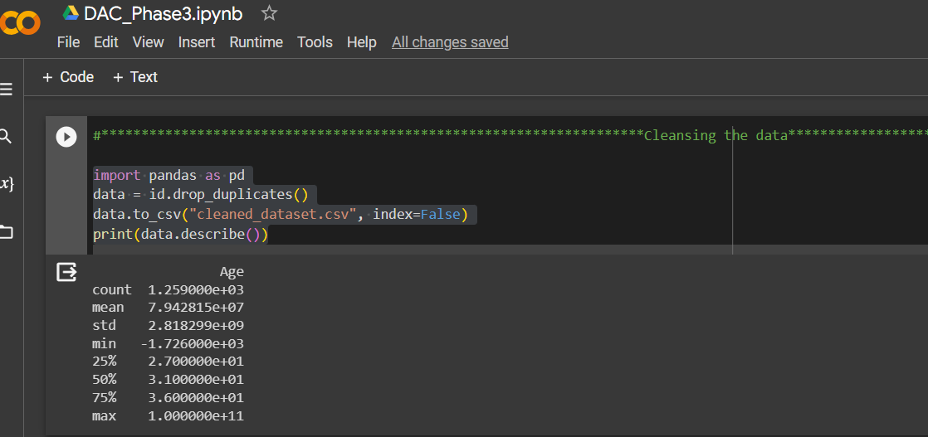

CODE :

#PLOTTING:

import seaborn as sns

import matplotlib.pyplot as plt

sns.countplot(x="Age",data=dt)

plt.figure(figsize=(10,6))

plt.show()

OUTPUT:

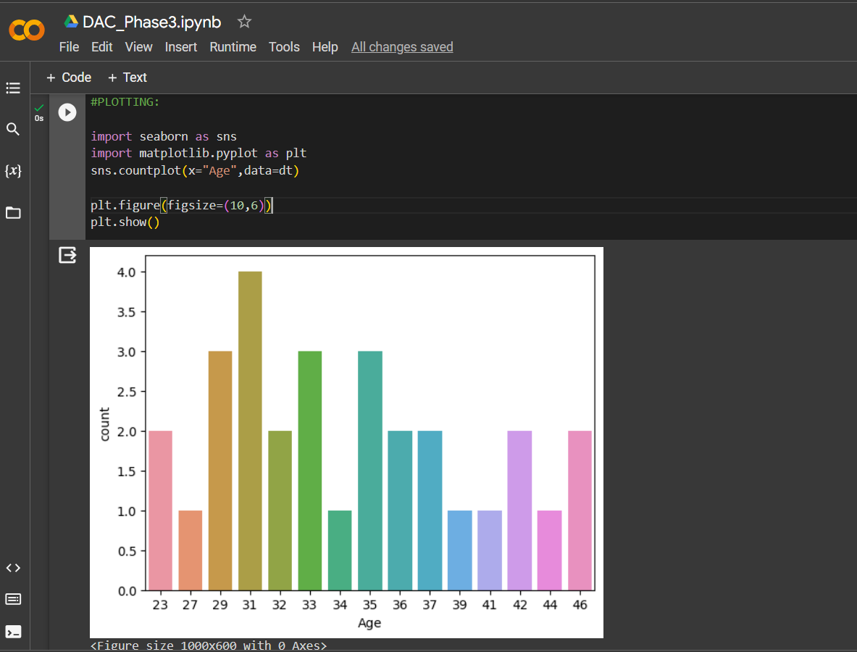

ACCURACY :

CODE :

#logistic regression

from sklearn.datasets import make_classification

from sklearn.model_selection import train_test_split

from sklearn.metrics import accuracy_score

from sklearn.linear_model import LogisticRegression

nb_samples = 1000

x, y = make_classification(n_samples=nb_samples, n_features=2, n_informative=2, n_redundant=0, n_clusters_per_class=1)

xtrain, xtest, ytrain, ytest = train_test_split(x, y, test_size=0.2, random_state=42)

model = LogisticRegression()

model.fit(xtrain, ytrain)

#Accuracy of the data

print(accuracy_score(ytest, model.predict(xtest)))

OUTPUT :

