NAAN MUDHALVAN

Project title :

Public Health Awareness

TEAM MEMBERS:

Deepti Ishwar - 2021103008

Rajalakshmi S - 2021103038

Kanishka S - 2021103018P

PROJECT OBJECTIVES :

* + - Assess Effectiveness
    - Identify Strengths and Weaknesses
    - Optimize Resource Allocation
    - Adapt to Changing Needs
    - Share Best Practices
    - Gather Feedback

DESIGN THINKING PROCESS:

* + - Understand the context
    - Define
    - Generate Ideas
    - Create Solution
    - Evaluate Solution
    - Feedback and Refinement
    - Implementation

ANALYSIS OBJECTIVE :

Specify the main objectives of the analysis, including what you aimed to achieve and improve in the public health campaign.

DATA COLLECTION :

**Dataset Link: [https://www.kaggle.com/datasets/osmi/mental-health-in-tech-survey](https://www.kaggle.com/datasets/osmi/mental-health-in-tech-survey" \t "_blank)**

ANALYSING PLATFORM :

Google colab – Python

DATA VISUALIZATION :

Matplotlib

Seabor

Phase 3:

STEPS :

* + - Cleansing
    - Accuracy
    - Process the Dataset

Accuracy :

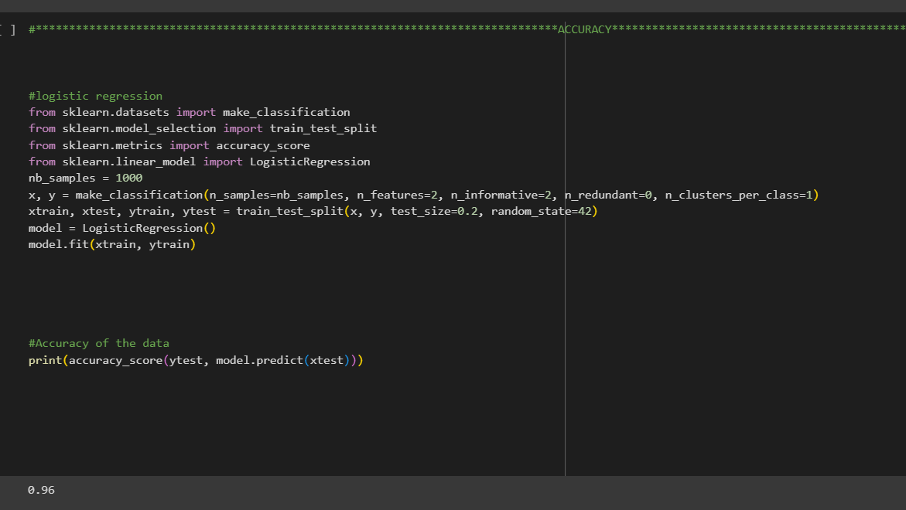

Process the Dataset :

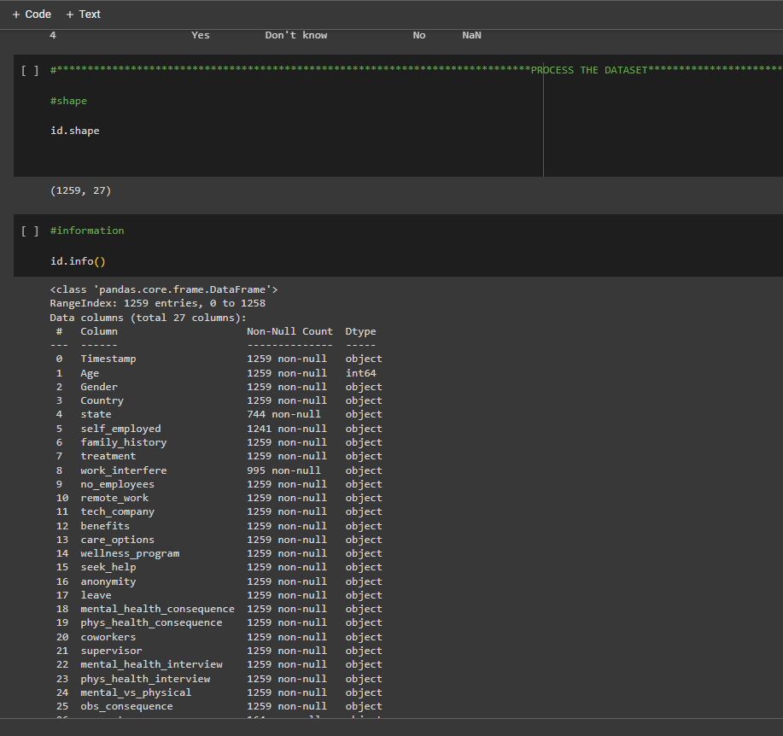

Cleansing :

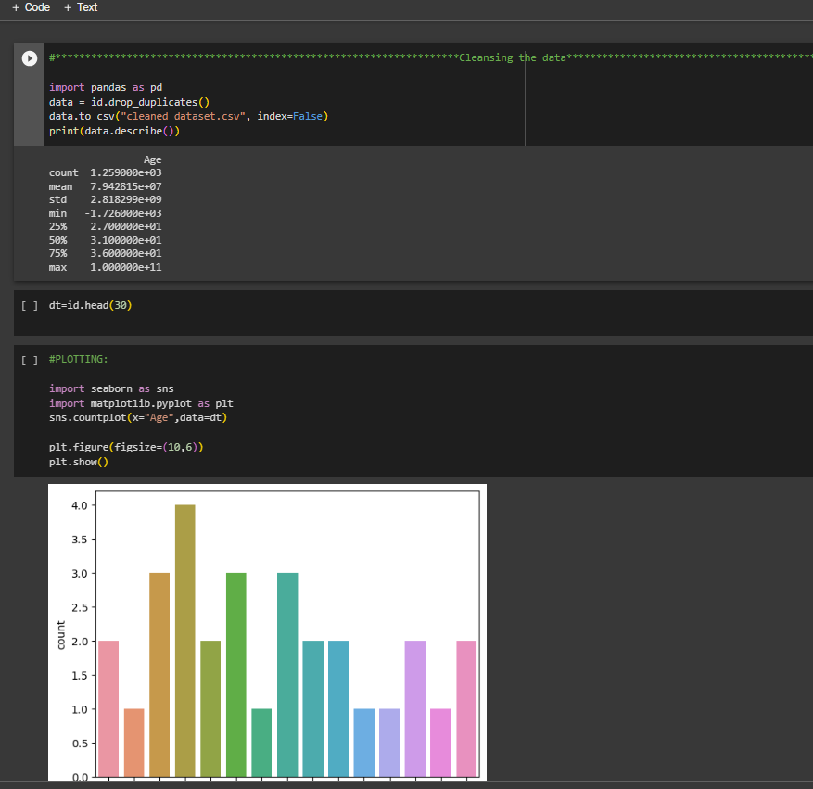

Phase 4 :

Steps :

* Frequency
* Proposition
* Summary Statistics & Reports
* Corelation
* Graph Representation

Frequency & Proposition :

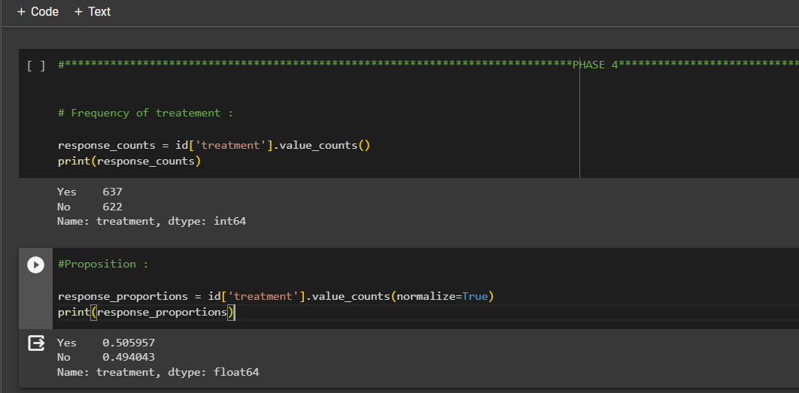

Graph Representation :

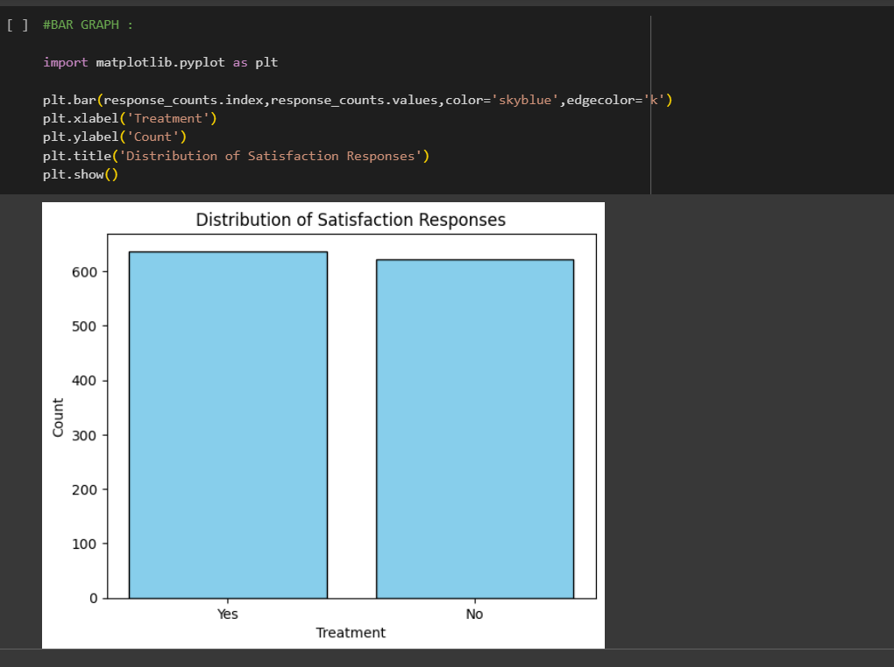

Summary Statistics :

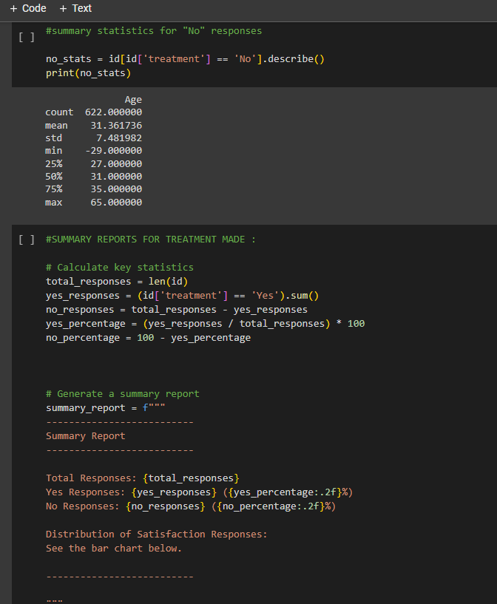

Correlation:

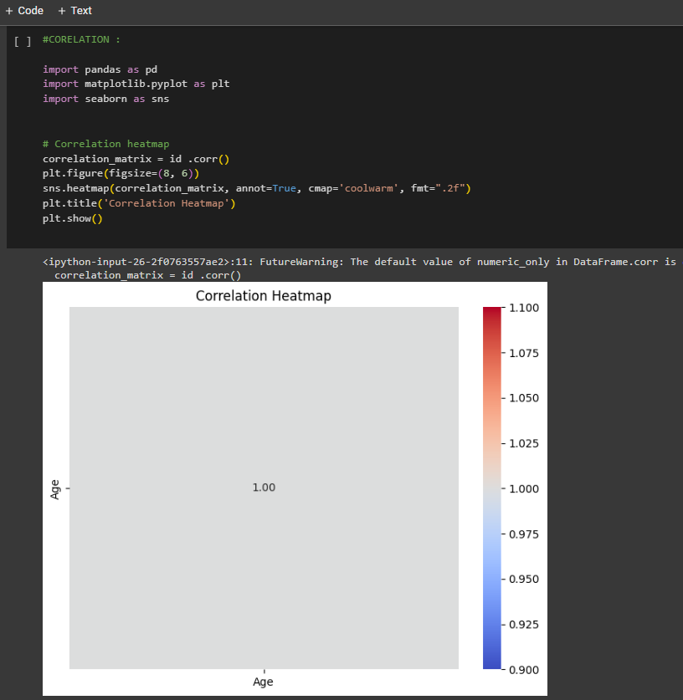

Conclusion :

Wrap up by offering some closing reflections that emphasize the importance of public health awareness initiatives and their capacity to instigate positive transformations within the community..