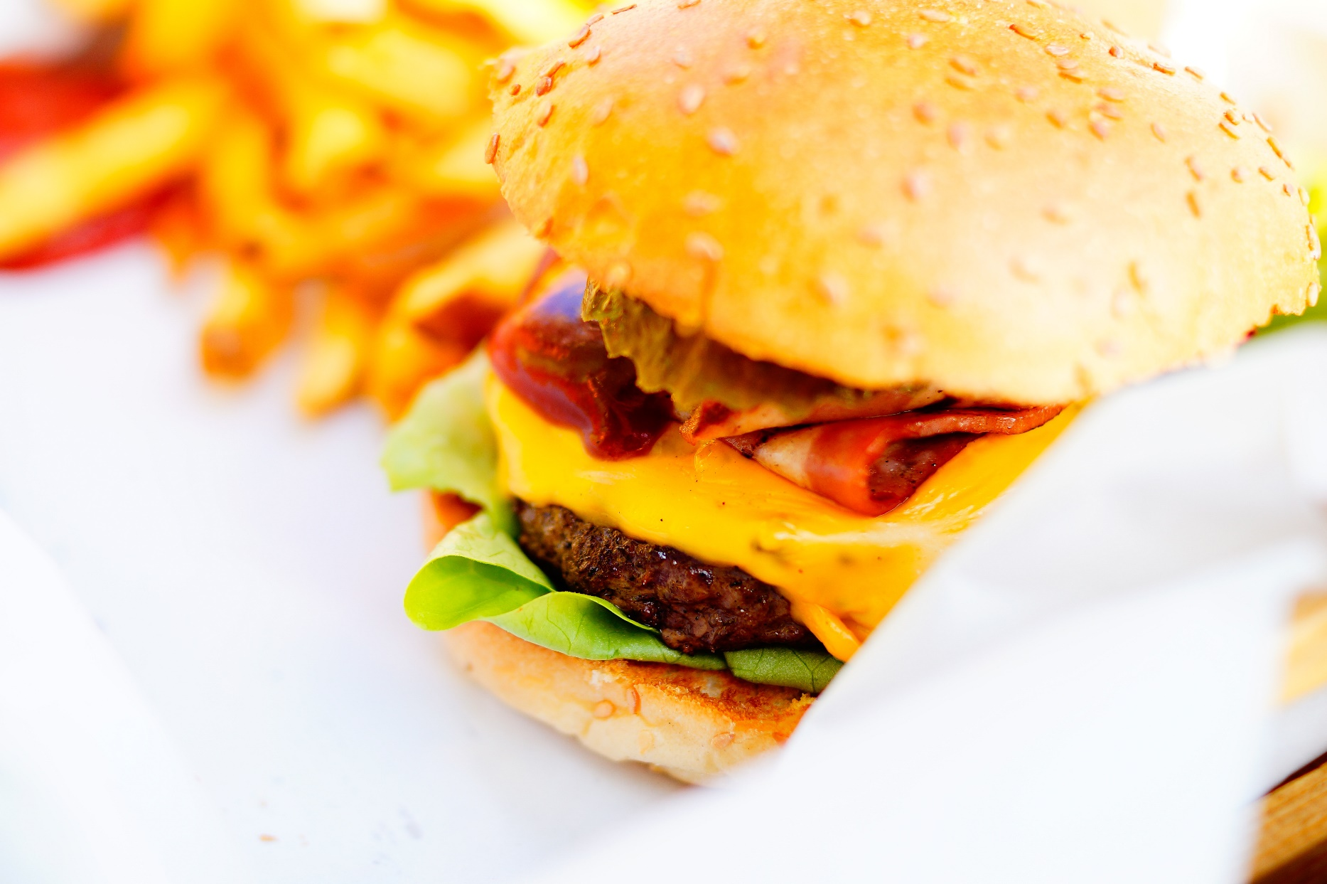

|  |
| --- |
| McDonalds Report - 2019  2019 |
|  |
| May 6  McDonalds,  Authored by: Deepti Lobo Contact: +91 8722901118 lobo.deepti@gmail.com |



**CONTENTS**

Description 3

Known Facts 3

Food Category Based on Variety 4

Outliers 5

Highest Correlation 7

Maximum % of Cholestrol 8

Sodium Intake 10

Saturated Fat 10

# Description

McDonalds is an American fast food company with operations in more than 100 countries and revenues exceeding $20 billion. McDonalds offers a menu that includes fries, the Big Mac, chicken sandwiches, chicken nuggets, hamburgers, salads, wraps, desserts, soft drinks, and other beverages. However, to ensure that it connects with the international markets, McDonald’s offers locally relevant food menus as well.

1. Which food categories have the highest and lowest varieties? (A visualization supporting your answer would be very much appreciated)
2. Which all variables have an outlier?
3. Which variables have the highest correlation? Plot them and tell the value.
4. Which category contributes to the maximum % of Cholesterol in a diet (% daily value)?
5. Which item contributes maximum to the Sodium intake?
6. Which 4 food items contains the most amount of Saturated Fat?

# Known Facts

The decision-making criteria which McDonalds, is considering was based on the comparative study of the food category provided by McDonalds. They have selected 9 categories, from 260 food items and subjected them to same test and provided the nutrition information datasets attached below.

 

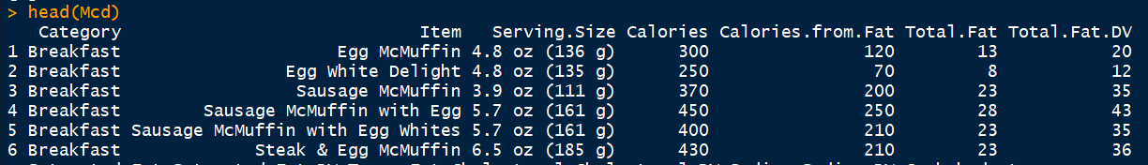

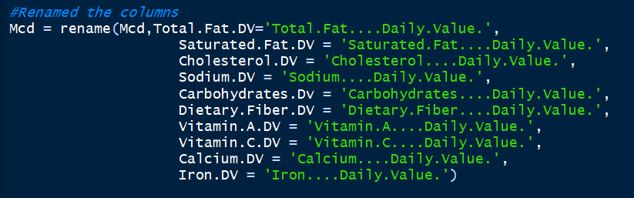

**Q1: Which food categories have the highest and lowest varieties? (A visualization supporting your answer would be very much appreciated)**

# Analysis:

McDonalds has 9 food categories, which consists of 260 items. Based on the data, we can conclude that,

Highest: Coffee & Tea with a variety of greater than 75.

Lowest: Salads have a variety less than 25.

# Data Visualization:

Performing a statistical analysis of the food category data provided by McDonalds.

# 

# Code Snippet:

# 

**Q2. Which all variables have an outlier?**

Analysis:

The outliers for the below categories have been plotted using boxplot.

1. Calories – The breakfast, chicken & fish and coffee & tea categories have the most outliers.
2. Total Fat – Most of the categories have outliers, with breakfast being the highest.
3. Cholesterol - The beef & pork, chicken & fish, beverages and coffee & tea categories have the outliers.
4. Sodium - The beef & pork and chicken & fish categories have the outliers.
5. Carbohydrates - The breakfast, chicken & fish, beverages, snacks & sides and coffee & tea categories have the outliers.
6. Dietary Fiber - The beverages, chicken & fish, desserts and snacks & sides have the outliers.

**Data Visualization:**

A boxplot has been plotted for the above nutrition information’s.

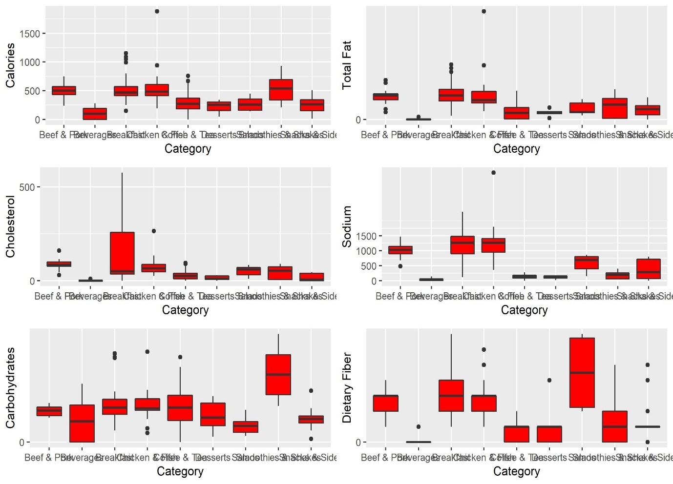

Code Snippet:

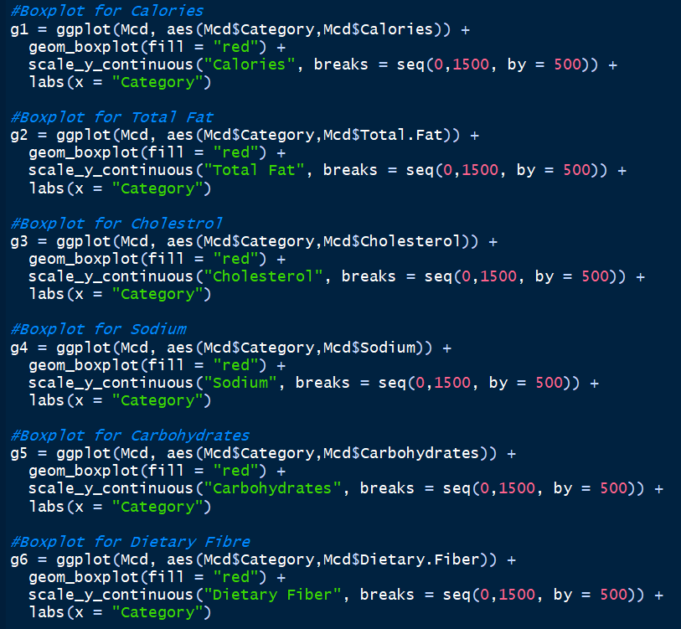

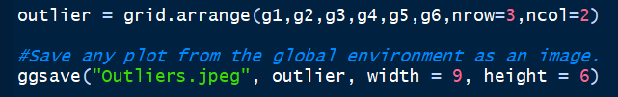

**Q3. Which variables have the highest correlation? Plot them and tell the value.**

**Analysis:**

From the correlation chart, we can estimate the correlation based on the colors. Red being the highest, having the max value as 1.0 and blue being the lowest, having the min value as -1.0.

**Data Visualization:**

A correlation graph has been plotted against the nutrition information provided.

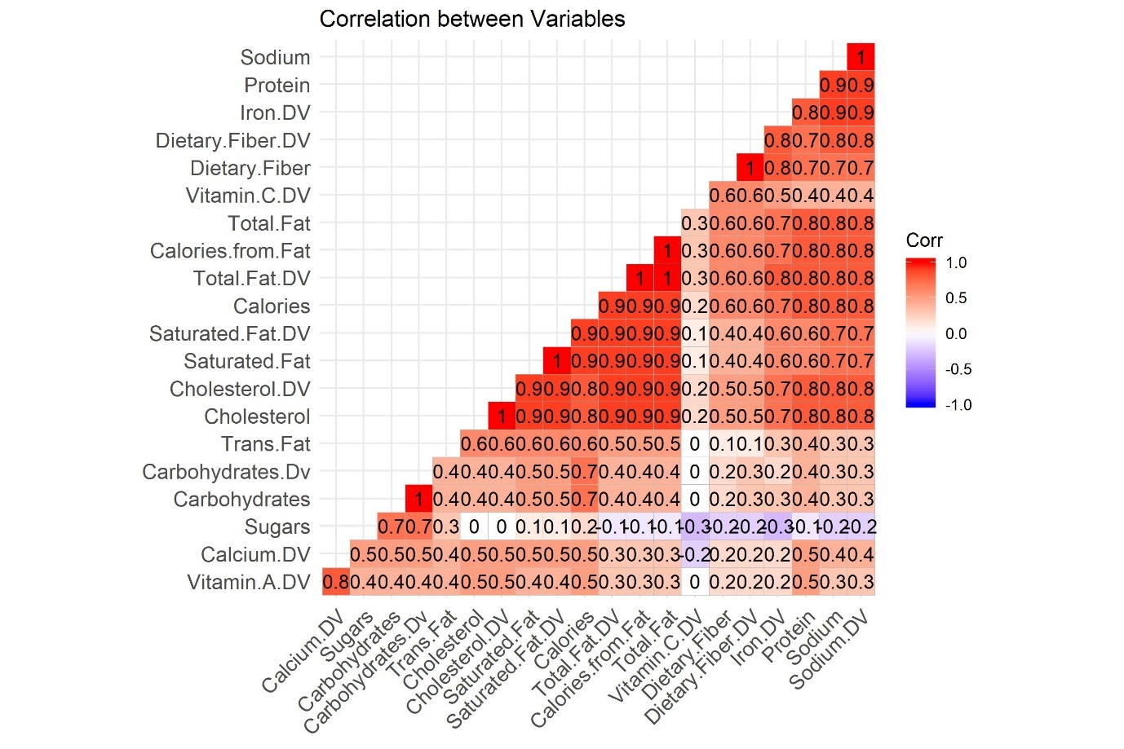

**Code Snippet:**

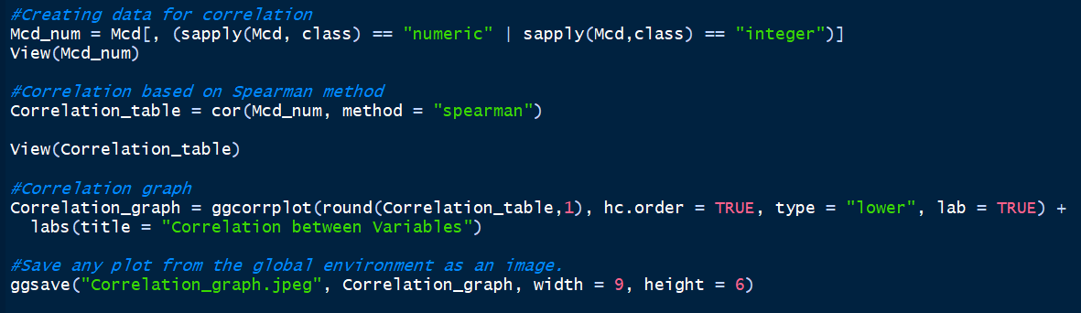

**Q4. Which category contributes to the maximum % of Cholesterol in a diet (% daily value)?**

**Analysis:**

From the above pie chart, we can understand, that Breakfast has the maximum amount of cholesterol 44.75%.

|  |  |
| --- | --- |
| Category | Percentage of Fat |
| Beef & Pork | 9.08 |
| Beverages | 0.10 |
| Breakfast | 44.75 |
| Chicken & Fish | 14.24 |
| Coffee & Tea | 18.63 |
| Desserts | 0.71 |
| Salads | 2.17 |
| Smoothies & Shakes | 8.62 |
| Snacks & Sides | 1.69 |

**Data Visualization:**

A pie chart has been plotted against the categories provided.

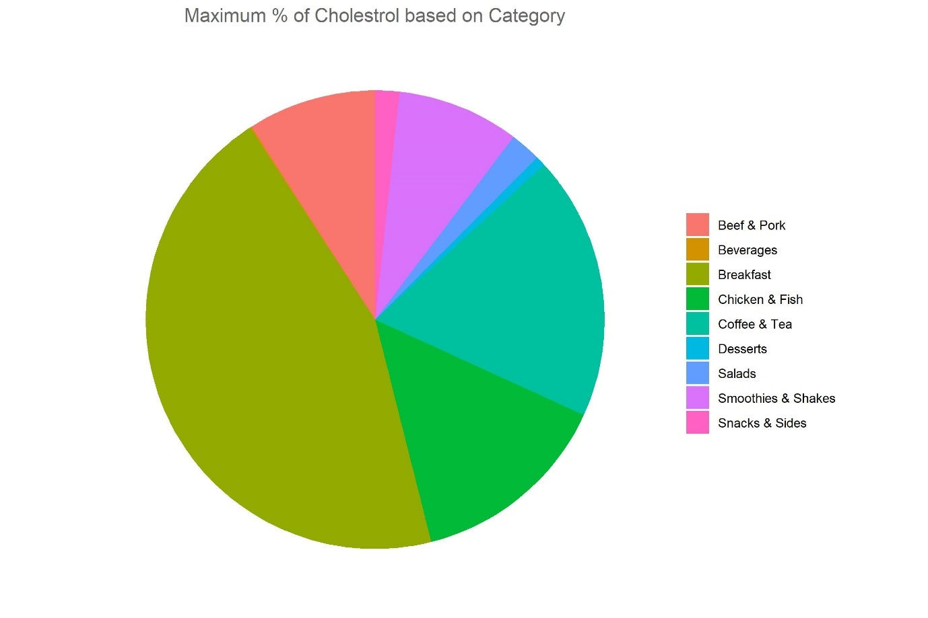

**Code Snippet:**

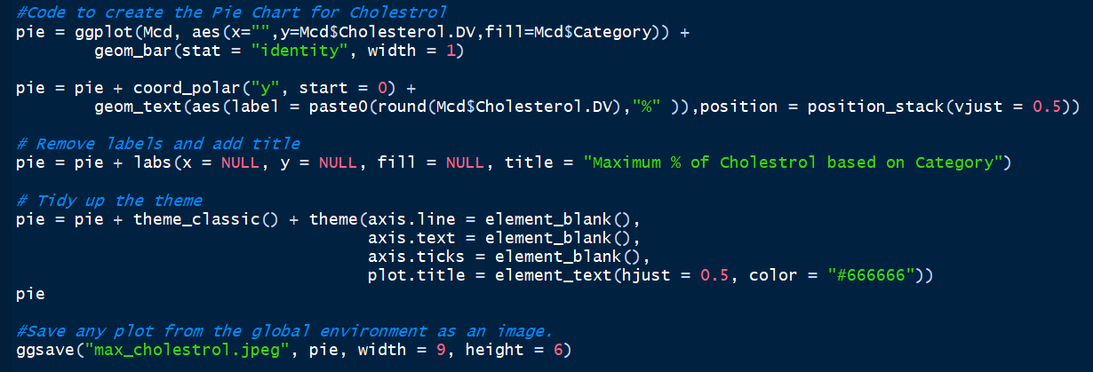

**Q5. Which item contributes maximum to the Sodium intake?**

**Analysis:**

An estimate can be made that Chicken McNuggests(40 piece) has the highest sodium content.

**Data Visualization:**

A table has been made to show items having the highest sodium content.

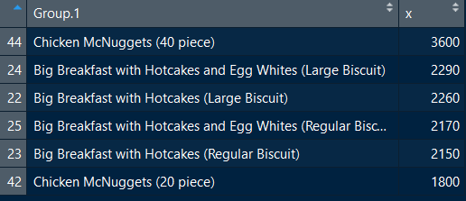

**Code Snippet:**

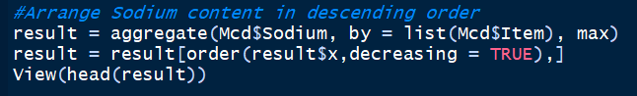

**Q6. Which 4 food items contains the most amount of Saturated Fat?**

**Analysis:**

A table has been made to display the items having the highest saturated fat content.

**Data Visualization:**

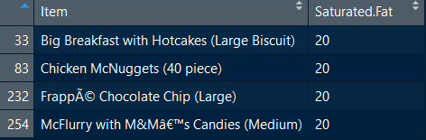

**Code Snippet:**

