**Landon Anderson, CCISO, CISA, CISM**

[**Laanderson4422@gmail.com**](mailto:Laanderson4422@gmail.com) **| 813-786-4750**

<https://www.linkedin.com/in/landonanderson>

ISSO|Risk Management|BISO | GRC | PCI DSS | CISO | Project Management

Information Security Manager and Business Controls Professional with over ten years of expertise in supporting Enterprise Risk Management to enhance the Information Security vision, strategy, and programs that protect all business information and technology assets. With over ten years of experience in the cybersecurity field, I have a broad and deep knowledge of information security governance, compliance, risk management, and best practices, such as ISO 27001, NIST, and ITIL. Guiding organizations to prepare for Enterprise Governance, PCI DSS assessments, and 3rd Party Risk Assessments. Skilled in conducting audits, risk assessments, and investigations related to iFrame usage. My passion for leading dedicated IT risk management and information security teams assures mentorship, guidance, and support with collaborating internal and external stakeholders to execute a robust information security strategy across application, infrastructure, and data realms.

AREAS OF EXPERTISE

**Security/Compliance Frameworks**:

* Payment Card Industry Data Security Standard Compliance (PCI DSS)
* FedRamp
* HITRUST
* Gramm-Leach-Billey Act (GLBA)
* NIST Cyber Security Framework (CSF)
* NIST 800-53
* Federal Financial Institutions Examination Council (FFIEC)
* Sarbanes-Oxley Act (SOX)
* ISO 27001:2022

**Security Tools**:

* Vulnerability Scanners - Tenable Nessus | QualysGuard | Rapid 7 Nexpose | Azure Security Center
* Firewall Analyzers – FireMon | Skybox | Nipper | SolarWinds Firewall Browser
* SIEM Solutions – IBM Qradar | SolarWinds LEM | Splunk
* Endpoint Protection – ManageEngine Desktop Central |Crowdstrike | TrendMicro Deep Security
* File Integrity Monitoring - TripWire | Splunk

**IAM**

* Okta | Azure AD

**IDS/IPS**

* Adlumin | AlienVault

**Cloud**

* Azure | AWS | SaaS | IaaS | PaaS

**Firewalls**

* Cisco ASA |Palo Alto | VMware NSX |SonicWALL |Firewall Management – Palo Alto Panorama

**Security Strategy**:

* Vulnerability Management |Information Security Policy | Risk Management | Cryptography | Executive Reporting

**GRC Tools**

* RSA Archer| SDElements | RiskLens | ServiceNow | LogicManager | Hyperproof

PROFESSIONAL EXPERIENCE

**JVT Advisors| Senior – IT Compliance Auditor 01/2023-Present**

Collaborates with a team of security consultants to provide the client with a prioritized roadmap of controls to implement to achieve PCI DSS compliance for level one PCI DSS Service Providers.

* Performed Information Security projects with clients such as Bank of America, Drummond Community Bank, Bankwest, and Lending Club to name a few.
* Performs detailed security inspections of Linux and Windows Server configurations to ensure compliance with PCI DSS v.4.0 requirements.
* Performed ISO 27001 gap assessments to help clients align their information security policies to achieve certification.
* Develops processes and procedures to help quickly identify non-compliant systems, reducing remediation time across the company.
* Managed Key Management, Encryption of Data-at-Rest, and Encryption of data in

motion projects with clients such as Bank of America, Drummond Community Bank,

Bankwest, and Lending Club to name a few.

* Performed detailed security inspections of Linux and Windows Server configurations to

ensure compliance with PCI DSS v.4.0 requirements.

* Managed Encryption of Data-at-Rest project for policy alignment in reducing risk of

sensitive data exposure.

* Maintained brand reputation by minimizing impact of non-compliance with Privacy and

Data compliance regulations.

* Managed Encryption Policy Cleanup with a CTM Policy Cleanup to reduce and

standardize access across 25% of encrypted sensitive file shares.

* Managed a created process to identify coverage gaps and provide remediation to

catalog data owners for ITSM integrations.

* Managed Encryption of data in-motion project to encrypt sensitive data in reducing risk

of sensitive data exposure when transferring data within and outside of the

organization.

* Analyze information security threats, vulnerabilities, and current trends. Assess potential impact on the organization’s risk posture.
* Cross-functional coordination with IT, executive, and board level leadership; advise and drive an appropriate level of security across the organization.
* Facilitate cyber awareness training for the entire organization.
* Develop, implement, and track a strategic, comprehensive enterprise-wide Information Security and Information Technology (IT) Risk Management program to ensure Personally Identifiable Information (PII) and critical asset data is owned, controlled, and managed.
* Conduct Risk Assessment multiple organizations against NIST Cybersecurity Framework (CSF) driving senior management and board-level awareness to gain budgetary support to develop the program.
* Develop and maintain risk registers for information security.
* Leveraged technology by aggregating operational risk data to increase the Operational Risk Management value to the C-Suite and stakeholders.
* Managed compliance automation/repository tools (Ostrich Cyber Risk, Hyperproof, AuditBoard, and Align-Ascend) for SOC 2, PCI DSS, and CSA STAR audits.
* Drive risk treatment efforts and board-level understanding of risk posture for the business.
* Achieved transparency with the product lifecycle by building awareness of operational risks from product development through product end of life.
* Author and maintain information security policies, standards, and guidelines.
* Develop and maintain 3rd Party Vendor Risk Management Program.

**Fifth Third Bank | Officer, Technology Risk Manager 06/2022-01/2023**

Spearheaded audit initiatives, partnering with senior management (CIO and CTO), information security, and product owners to manage and analyze data, ensuring comprehensive compliance with company policies, best practice, and PCI-DSS requirements.

**Accomplishments**

* Managed the PCI Compliance Program and Portfolio. Increased the PCI Portfolio by Level one assessments by 120%. Directed the increase of our PCI SAQ Portfolio by 250%.
* Developed a centralized tracking mechanism for monitoring and managing enterprise vulnerabilities.
* Managed user life cycles, IFrame activities, and integrating application requirements in a shared services framework focused on provisioning, de-provisioning, entitlements, and role-based access control.
* Developed and implemented controls and procedures to mitigate compliance risks associated with iFrame.
* Provided support in responding to regulatory inquiries or requests related to iFrame compliance.
* Managed the following IAM activities: ID administration, provisioning, governance/auditing, IAM reporting, IAM tool operations.
* Deployed cyber threat intelligence research and development activities to stay current with new vulnerabilities.
* Collaborated with system owners to ensure vulnerability remediation deadlines according to organizational policy.
* Managed compliance automation/repository tools (Ostrich Cyber Risk, Hyperproof, AuditBoard, and Align-Ascend) for SOC 2, PCI DSS, and CSA STAR audits.
* Performed ISO 27001 gap assessments to help clients align their information security policies to achieve certification.

**FIS Global | Technology Risk Consultant 09/2018 - 06/2022**

Advises clients business verticals such as banking and retail on the design and implementation of systems and processes to meet security and compliance objects such as HITRUST, PCI DSS, NIST CSF, and FFIEC.

**Accomplishments**

* Collaborates with clients to develop and implement automated system configuration processes that reduce vulnerabilities and cost of remediation by 80%.
* Performs risk and gap analysis assessments and provides customized heatmaps to assist clients with security and compliance initiatives.
* Prepares, executes, and reports on audit subsets of NIST SP 800-53 cybersecurity controls to include interviews, document reviews, and testing of systems to support PCI DSS validation activities.
* Knowledgeable on NIST Cybersecurity Framework and how the Identify, Protect, Detect, Respond, and Recover categories comprise and facilitate an information security program.
* Managed compliance automation/repository tools (Hyperproof, AuditBoard, and Align-Ascend) for SOC 2, PCI DSS, HITRUST, and CSA STAR audits.
* Performed ISO 27001 gap assessments to help clients align their information security policies to achieve certification.

**IT Authorities | Technology Risk Consultant 06/2016 – 09/2018**

Advised a team of security consultants to provide the client with a prioritized roadmap of controls to implement and achieve PCI DSS compliance.

**Accomplishments**

* Performed PCI DSS gap assessments to help clients prepare for upcoming compliance assessments.
* Develops concise, tailored cybersecurity awareness content, improving targeted end-user base cyber hygiene.
* Performed ISO 27001 gap assessments to help clients align their information security policies to achieve certification.
* Managed compliance automation/repository tools (Hyperproof, AuditBoard, and Align-Ascend) for HITRUST, SOC 2, PCI DSS, and CSA STAR audits.
* Develops Just-In-Time cybersecurity awareness content for emerging threats to reduce operational risk to tailored audiences.
* Partnered with clients to implement processes and procedures to satisfy PCI DSS Self-Assessment Questionnaires (SAQs).

**Adecco | Security Analyst 03/2015 - 06/2016**

Ensured all systems security operations and maintenance activities were adequately documented and updated, as necessary. Implemented system security measures following established procedures to ensure confidentiality, integrity, availability, authentication, and non-repudiation.

**Accomplishments**

* Removed over 15,000 security vulnerabilities in just one month by implementing a vulnerability management program to address system security flaws around the enterprise.

**United Parcel Service | Information Security Manager 02/2008 – 03/2015**

**Accomplishments**

* Continuously matured internal policies, procedures, and controls, empowering the advancement of company assessment and compliance efforts to meet stringent regulatory standards.
* Maintained appropriate security measures and mechanisms to guard against unauthorized access to ensure confidentiality, integrity, and availability of protected data.
* Monitoring and analyzing iFrame-related data to identify potential compliance risks and issues.
* Investigating and resolving any compliance incidents or breaches related to iFrame usage.
* Spearheaded Information Security Compliance projects to ensure policy adherence, adequate training programs and periodic security audits (internal and external).
* Evaluated and recommended new information security technologies and countermeasures against threats to information or privacy.
* Partnered with the client to prepare for GLBA, PCI DSS, and SOX compliance audits, executing a wide range of internal security assessments gap analyses, shaping strategic remediation for uncovered issues.

**Certifications**

* 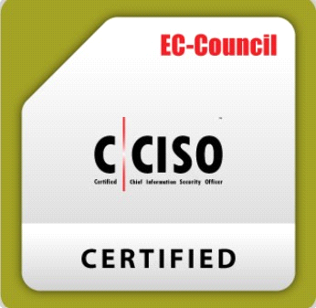EC-Council – Certified Chief Information Security Officer | Certification Number: ECC8762341509
* 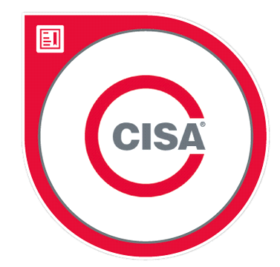 ISACA - Certified Information Systems Auditor | Certification Number:221961737
* 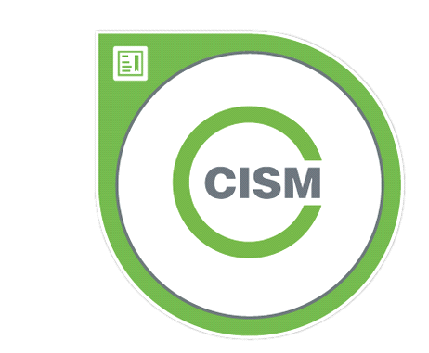ISACA - Certified Information Security Manager | Certification Number:221968051

**Membership**

* ISACA – West Florida Chapter