**AWS – Lambda Functions**

**Use case: File Transfer & archival solution for Test System**

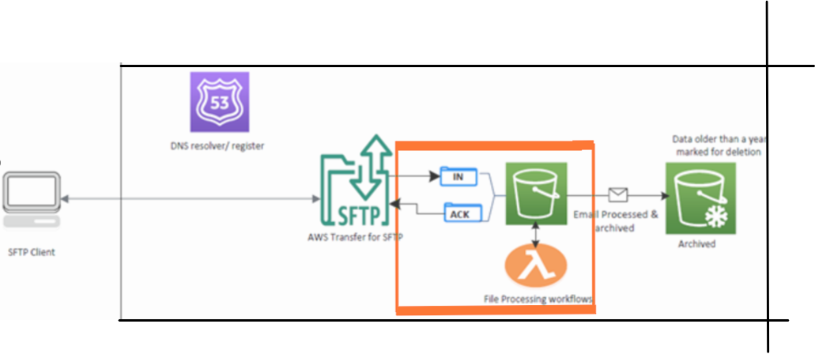

Architecture for the solution. (Deployment of services constituted inside the orange box)

Deploying a Lambda Function for unzipping the uploaded zipped files (from the Client through AWS Transfer for SFTP) and converting those in XML format.

**Service Provisioning**

Creating a lambda function from scratch with Python 3.9 as Runtime language with a custom role with S3 access (r/w)

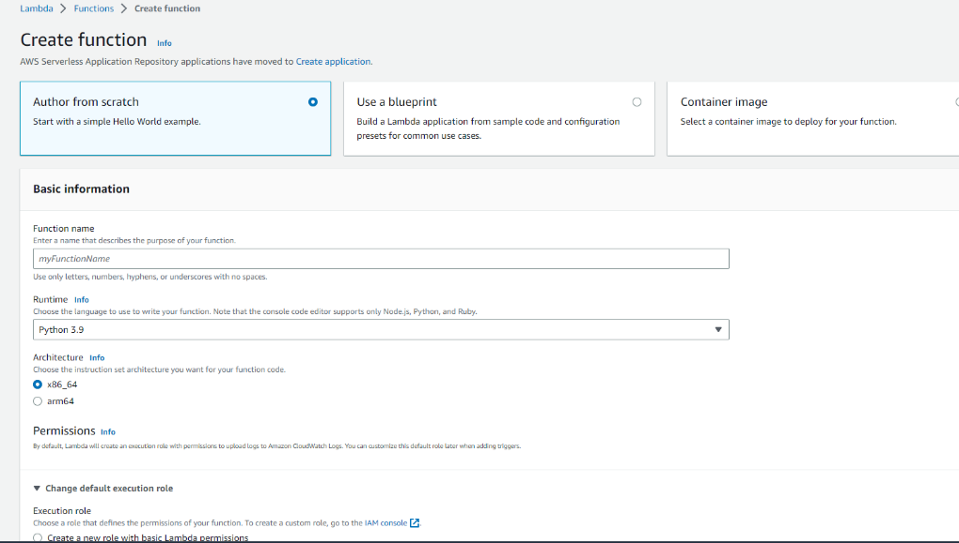

**Custom Role**

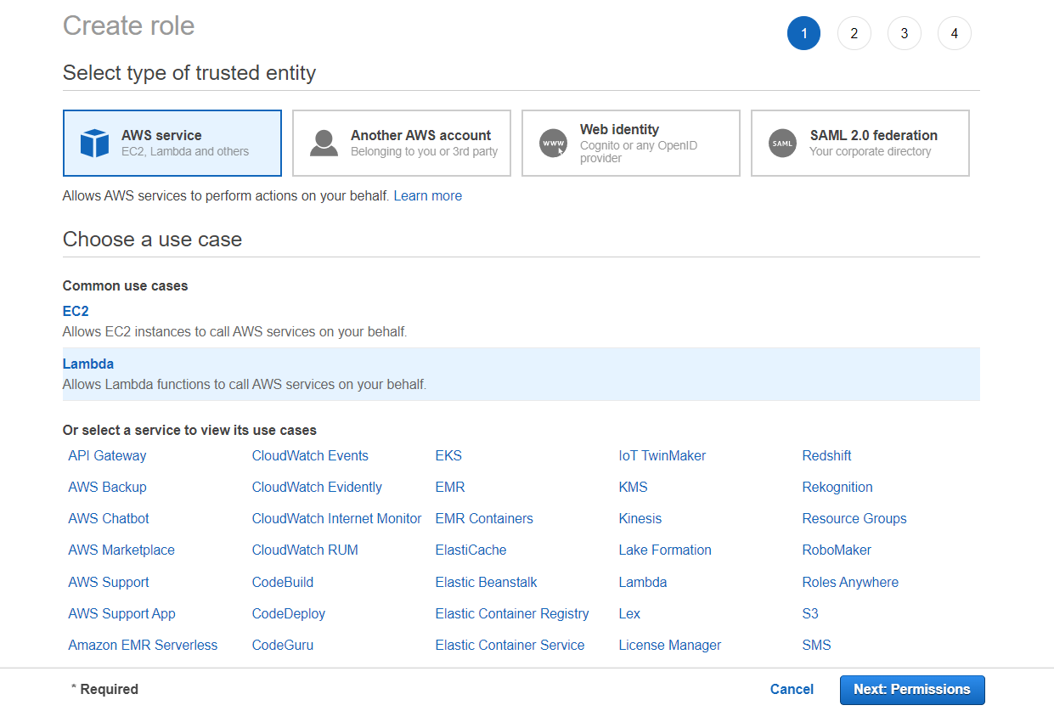

**Attaching Permissions**

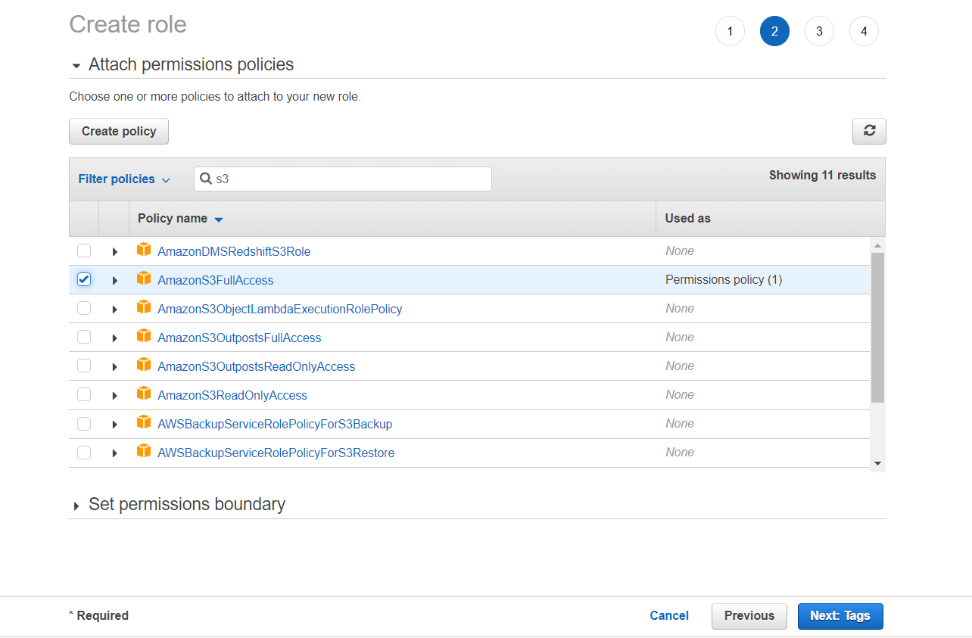

**Note: Minimum access can be given (i.e., only read/write)

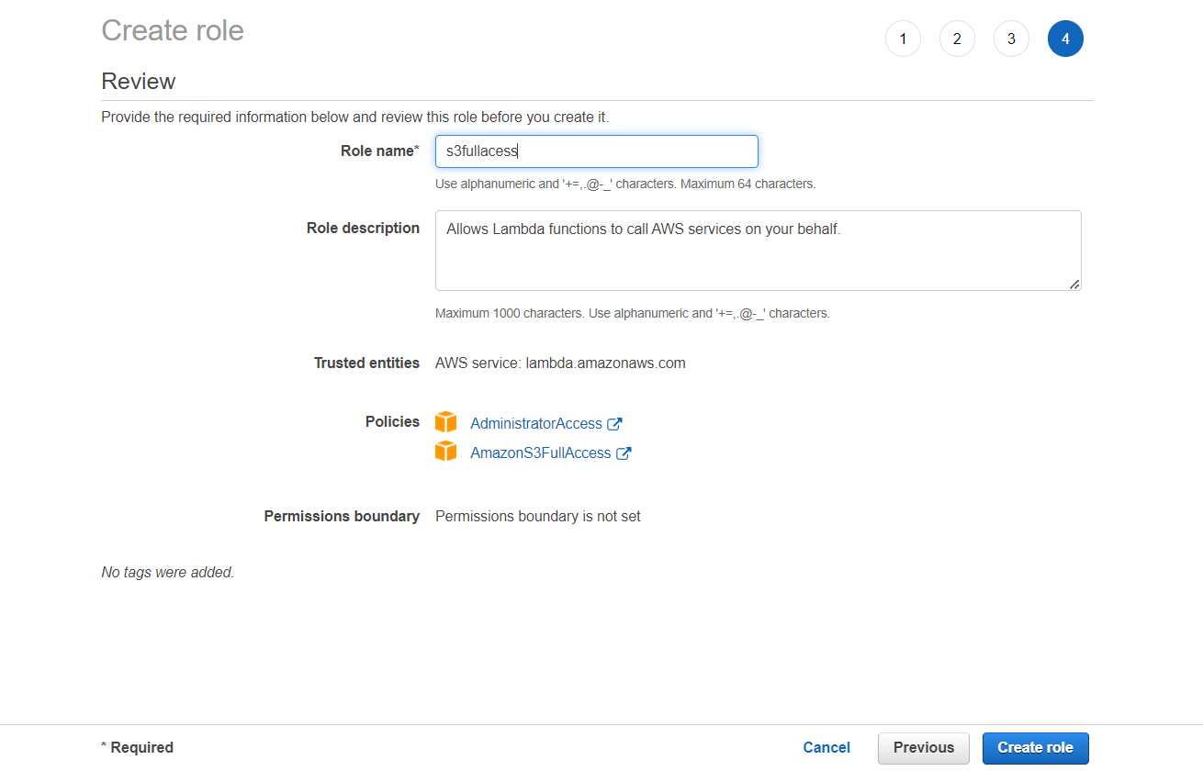

**Adding Trigger to the Function**

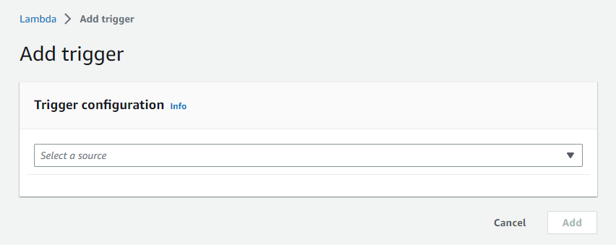

**Configuring Trigger**

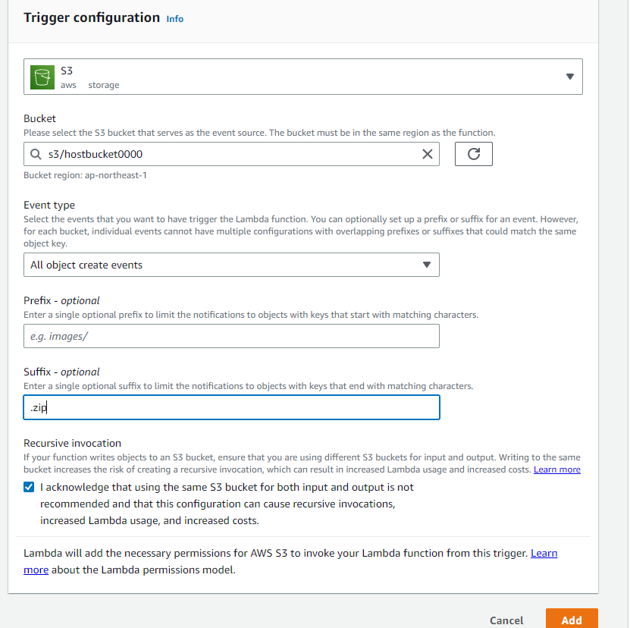

**Testing the Code**

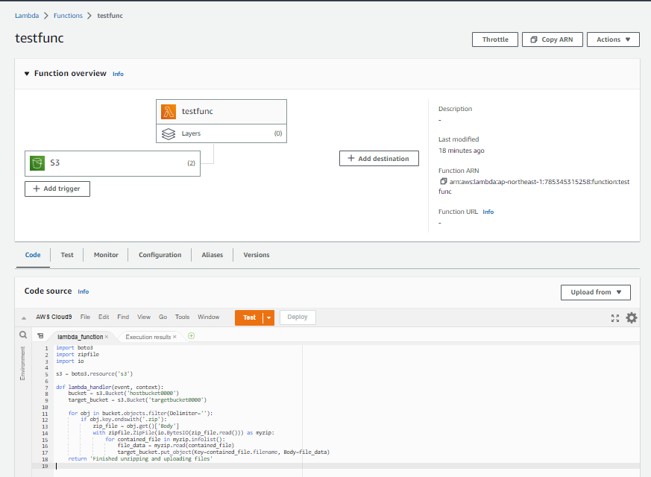

**Code**: Extracting zip file from Host s3 to Target s3 bucket

import boto3

import zipfile

import io

s3 = boto3.resource('s3')

def lambda_handler(event, context):

bucket = s3.Bucket('hostbucket0000')

target_bucket = s3.Bucket('targetbucket0000')

for obj in bucket.objects.filter(Delimiter=''):

if obj.key.endswith('.zip'):

zip_file = obj.get()['Body']

with zipfile.ZipFile(io.BytesIO(zip_file.read())) as myzip:

for contained_file in myzip.infolist():

file_data = myzip.read(contained_file)

target_bucket.put_object(Key=contained_file.filename, Body=file_data)

return 'Finished unzipping and uploading files.’

**Output**

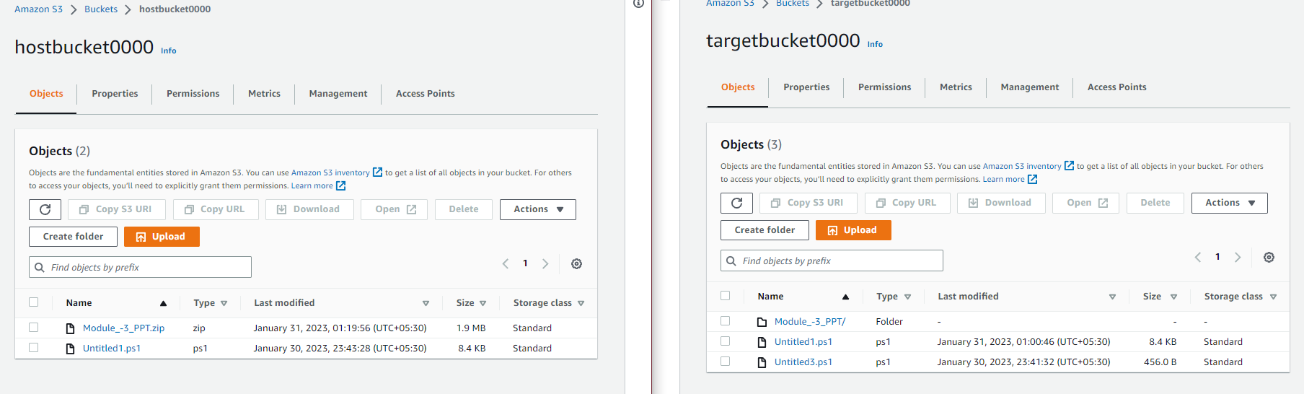

**Code:** Extracting and writing to File Type as XML

import boto3

import zipfile

import io

import xml.etree.ElementTree as ET

s3 = boto3.resource('s3')

def lambda_handler(event, context):

bucket = s3.Bucket('hostbucket0000')

target_bucket = s3.Bucket('targetbucket0000')

for obj in bucket.objects.filter(Delimiter=''):

if obj.key.endswith('.zip'):

zip_file = obj.get()['Body']

with zipfile.ZipFile(io.BytesIO(zip_file.read())) as myzip:

root = ET.Element("root")

files = ET.SubElement(root, "files")

for contained_file in myzip.infolist():

ET.SubElement(files, "file", name=contained_file.filename).text = contained_file.filename

tree = ET.ElementTree(root)

xml_data = ET.tostring(root).decode()

xml_name = obj.key[:-4] + '.xml'

target_bucket.put_object(Key=xml_name, Body=xml_data)

return 'Finished writing names inside the zipped file to XML file'

**Note: Editing out the code for extraction of zip file and adding code to write the names inside the zipped folder to a XML file (using etree.ElementTree). [The new XML file name being kept as old file + .xml (obj.key[:-4] + '.xml')]

**Output** : Files are converted to XML

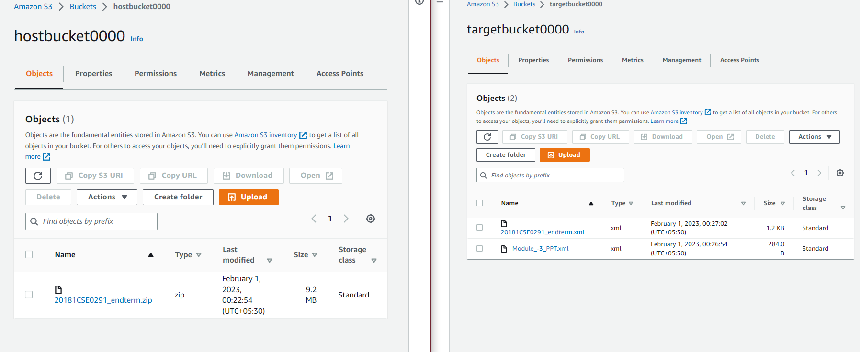

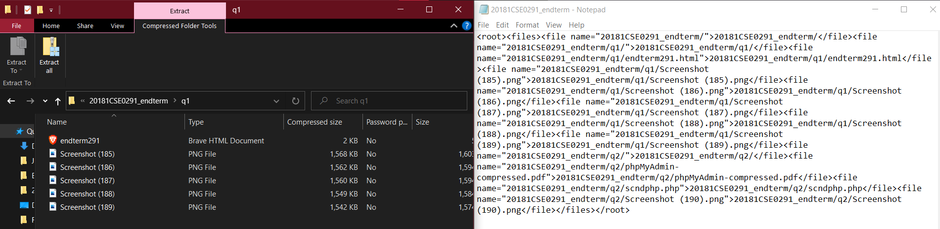

Additionally,

**Storing the Access logs**

*Steps:*

S3

* Select Bucket
* Select Properties

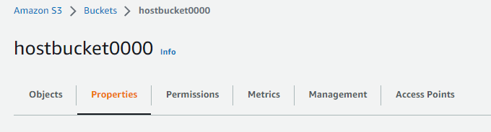

* Server access Login



* Add the destination for logs

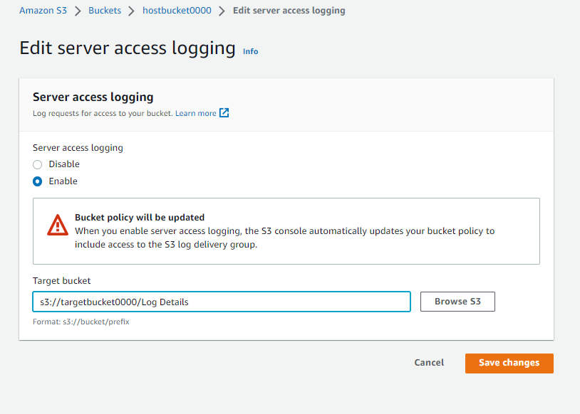

[ Workaround: Either a single S3 bucket can be configured [i.e... source_bucket : source_bucket] to get the desired outcome or data can be transferred to multiple buckets [i.e.. source_bucket : dest_bucket]. Provisioning of s3 buckets can be based according to Business requirement.]