**Azure – Logic Apps**

**Use Case**: Logic Apps to Generate Daily Reports for Resources created in last 24 hours.

**High Level Diagram**

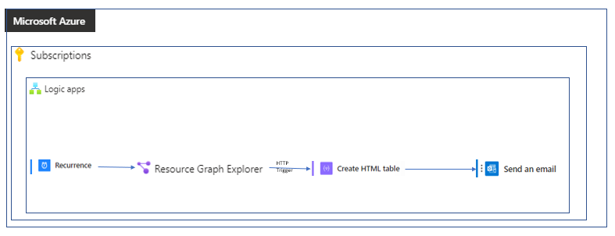

**Deployments**

**Logic Apps**

Give the name for your Logic App along with a Resource Group and select the region,

based on your requirement you can select the appropriate plan**.

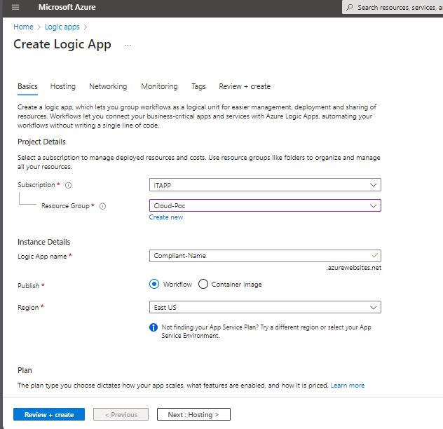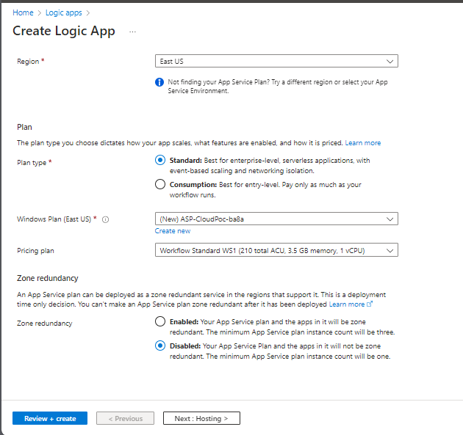

Click on Review and Create

**Configuring**

* Open your new Logic App.
* Click on the Logic App Designer on the left blade.
* Create a trigger, set the recurring schedule as per requirement.

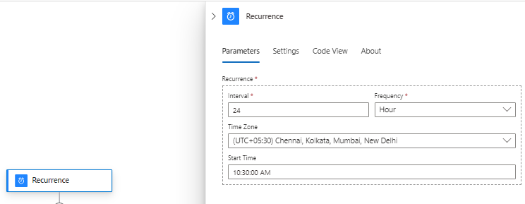

* Refer to this doc [Tutorial: Automate Running Your Resource Graph Queries within Logic Apps - Azure Resource Graph | Microsoft Learn](https://learn.microsoft.com/en-us/azure/governance/resource-graph/tutorials/logic-app-calling-arg#configure-and-run-your-logic-app)
* You can go ahead and copy this code in ‘code view’ [left blade], this will create a HTML trigger.

{

"definition": {

"$schema": "https://schema.management.azure.com/providers/Microsoft.Logic/schemas/2016-06-01/workflowdefinition.json#",

"actions": {

"HTTP_2": {

"inputs": {

"authentication": {

"type": "ManagedServiceIdentity"

},

"body": {

"query": "Paste you Azure Resource graph query here"

},

"headers": {

"Content-Type": "application/json"

},

"method": "POST",

"queries": {

"api-version": "2021-03-01"

},

"uri": "https://management.azure.com/providers/Microsoft.ResourceGraph/resources"

},

"runAfter": {},

"type": "Http"

}

},

"contentVersion": "1.0.0.0",

"outputs": {},

"parameters": {},

"triggers": {

"Recurrence": {

"recurrence": {

"frequency": "Minute",

"interval": 1440

},

"type": "Recurrence"

} } },

"parameters": {}

}

* Now, after pasting you query you can ADD AN ACTION by clicking on ‘’ plus symbol.
* Select Parse JSON, set the content to HTTP Body and you can enter your data schema or use the sample payload.

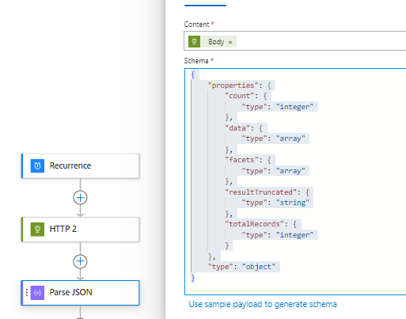

* Add a new action as Outlook (Send an Email[V2]) after setting up ‘Create HTML table’ and ‘Compose’.

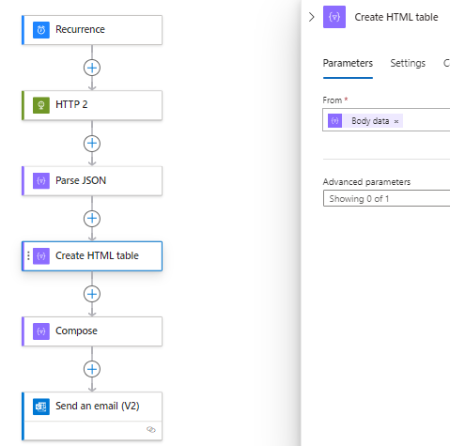

* Set up the content as Body of the previous action/trigger in each action.

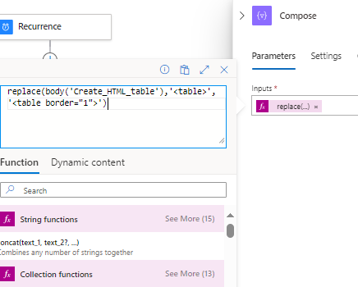

* While configuring compose you can insert this expression to give your HTML table borders

replace(body('Create_HTML_table'),'<table>','<table border="1">')

* Either you can set-up Organization Emails with ‘Office 365 outlook’ or just Outlook if the personal mail is to be notified [other mail platforms can be used such as google, sendgrid etc].
* PF the ARGE query for resource created in last 24 hours.

resourcechanges

| extend changeTime = todatetime(properties.changeAttributes.timestamp), SKU = tostring(split(properties.targetResourceId,"/")[6]),Service = tostring(split(properties.targetResourceId,"/")[7]),Name = tostring(split(properties.targetResourceId,"/")[8]),cType = properties.changeType, correlationId = properties.changeAttributes.correlationId,changedProperties = properties.changes, changeCount = properties.changeAttributes.changesCount, Caller = properties.changeAttributes.changedBy

| where cType == "Create" or cType == "Update"

| where changeTime > ago(24h)

| order by changeTime desc

| project changeTime,Name,cType,SKU,Service,Caller,['id'],correlationId,changeCount

* You can Click on run to test your Configuration.
* Status of the logic app can be checked in Run History and the Version option can help in promoting the various version that you have created/tested so that one can revert back at a point if time.

Please, refer to these following docs

* [Azure Resource Graph documentation | Microsoft Learn](https://learn.microsoft.com/en-us/azure/governance/resource-graph/)
* [Overview - Azure Logic Apps | Microsoft Learn](https://learn.microsoft.com/en-us/azure/logic-apps/logic-apps-overview)
* [azure-quickstart-templates/quickstarts/microsoft.logic/logic-app-sendgrid at master · Azure/azure-quickstart-templates · GitHub](https://github.com/azure/azure-quickstart-templates/tree/master/quickstarts/microsoft.logic/logic-app-sendgrid)

**Standard vs. Consumption Logic Apps

|  |  |  |
| --- | --- | --- |
| Feature | Standard (Single-tenant) | Consumption (Multi-tenant) |
| Deployment Model | Single-tenant | Multi-tenant |
| Scalability | Horizontal scaling | Automatic scaling |
| Workflows | Multiple workflows | Single workflow |
| Connectors | All Azure connectors + Custom | Limited built-in connectors |
| Pricing | Fixed monthly fee | Pay per execution |
| Use Cases | Complex integrations, security, control | Simple, cost-effective integrations |