What is exactly the attention mechanism introduced to RNN (recurrent neural network)? It would be nice if you could make it easy to understand!

Bartosz Ludwiczuk, Deep Learning for One-Shot learning is my next step
Written 3 Dec 2015

Attention mechanism are very intriguing stuff in Deep Learning community. Firstly two references:
1. [1406.6247] Recurrent Models of Visual Attention
2. [1412.7755] Multiple Object Recognition with Visual Attention
3. A Recurrent Neural Network For Image Generation
And what it all about?
Firstly image that you have a big image, say 50Mpx. And you want to localize cat here, which is rather small (say 0.5Mpx). And it is unfeasible to process all image at once, even by people, right? So we just make a search on image just by moving our eyes. This is how the attention mechanism works.
How it works in RNN network?
Each of the attention mechanism contain:
1. Read operator: read chosen patch from image
2. Glimpse sensor: extract information from patch
3. Locator: predict the next location of read operator
4. RNN: combine the previous and current responses from glimpse sensor
Main Idea:
Let assume that we are in 't' time step. From 't-1' we get the next location, where we should look (produced by locator). Then we move our sensor there and extract some information, which then RNN combine with previous outputs. After several iteration, we produce final response, like classification results.
There are two ways how it can be implemented:
1. Hard-Attention: this attention mechanism is described at [1] and extended in [2].
Some description:
- read operator: it have always fixed size, but there may be several of them. Then each image patch is downsampled to minimum size and combine into one 4D matrix
- glimpse sensor can be any NN
- locator predict x and y location of sensor
The the main problem with such system is not differential system, so we need to use Reinforce Learning there.
This is how it works (result from [2], where sequences where classified. So it moves from left to right and attend only location, which are useful for classifying such sequence.
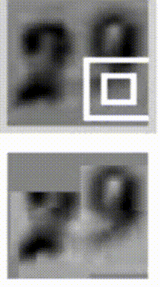

2. Soft-Attention [3]. Idea it pretty similar.
Some description:
- read operator: it have only fixed aspect ratio. In can zoom to the image and blur it if needed. Then the output is scaled to fixed size 4D matrix
- glimpse sensor can be any NN
- locator predict more than x and y parameter (like sigma for blur .etc), you will find the details in paper
New "read" operator make it differentiable, so it just use simple back-propagation. This is main pros compared to [1] and [2], because it means easier learning and it gets better results. Additional paper [3] describe how to generate images using attention mechanism.
The example show generation of images, see that the Attention (red rectangle) change its position and the size.

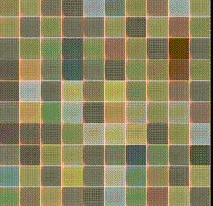
You can try to run both of mechanism in Torch:
Implementation of [1]: Torch | Recurrent Model of Visual Attention
Implementation of [3]: vivanov879/draw

