Machine Learning Based QSAR Modeling for Kinase Drug Discovery
Model Development Validation Interpretability and Applicability Domain Assessment
Research report generated from current repository artifacts on 2026-10-16

Abstract
QSAR-X was audited and evaluated without replacing its existing models. The workflow contains 20 target-specific ChEMBL kinase models and one pooled JAK-family candidate. Recomputed saved-split results give a mean internal scaffold-test R2 of 0.627 and RMSE of 0.717 pIC50 across 21 models. R2 and RMSE describe regression fit and error; they are not accuracy. No registered model passed every strict external-validation gate, so this work supports research screening only.

Keywords
QSAR; kinase inhibitors; pIC50; Morgan fingerprints; scaffold split; model validation; applicability domain; reproducibility

1 Introduction
Quantitative structure-activity relationship modeling maps a molecular representation to an experimentally defined response. A reliable model requires a stated endpoint, a defined applicability domain, transparent validation, and traceable outputs. This report evaluates the existing repository rather than creating a separate model or altering its deployed candidate artifacts.

2 Project Audit and Dataset Provenance
The repository contains curation scripts, target-specific training scripts, versioned model artifacts, scaffold assignments, cross-validation comparison tables, external-validation reports, a FastAPI service, and a React interface. Each target model is based on curated ChEMBL IC50 records transformed to pIC50 = 9 - log10(IC50 in nM). The JAK-family candidate uses a user-provided pChEMBL file and is explicitly retained as a pooled endpoint.
Audit item | Result
Registered models | 21
Target-specific ChEMBL models | 20
Pooled JAK screening model | 1
Fingerprint | Morgan radius 2, 2048 bits
Split | Scaffold-grouped development / validation / internal test
External gates passed | 0

3 Data Quality Control
The evaluator checked all clean input datasets for missing target values, duplicate canonical structures, RDKit parse failures, and exact structure leakage across saved partitions. The detailed audit CSV records each target and model checksum.
Gene | Clean structures | Missing pIC50 | Duplicate structures | Dev-test overlap
ABL1 | 2151 | 0 | 0 | 0
AKT1 | 3455 | 0 | 0 | 0
BRAF | 5384 | 0 | 0 | 0
CDK2 | 2115 | 0 | 0 | 0
EGFR | 10834 | 0 | 0 | 0
ERBB2 | 2522 | 0 | 0 | 0
FGFR1 | 3596 | 0 | 0 | 0
FLT3 | 3766 | 0 | 0 | 0
IGF1R | 2324 | 0 | 0 | 0
JAK | 10070 | 0 | 0 | 0
JAK2 | 10405 | 0 | 0 | 0
KDR | 9762 | 0 | 0 | 0
KIT | 1946 | 0 | 0 | 0
MAP2K1 | 866 | 0 | 0 | 0
MAPK14 | 4744 | 0 | 0 | 0
MET | 4193 | 0 | 0 | 0
MTOR | 4354 | 0 | 0 | 0
PDGFRA | 632 | 0 | 0 | 0
PIK3CA | 6465 | 0 | 0 | 0
RET | 3980 | 0 | 0 | 0
SRC | 3601 | 0 | 0 | 0

4 Molecular Representation and Training
The preserved production candidates use RDKit Morgan fingerprints. The target trainers compare a median baseline, Extra Trees, Random Forest, and SVR using scaffold-grouped cross-validation on the training partition; final candidate selection uses training-CV RMSE and the scaffold test is held apart from selection.

5 Internal Scaffold Test Evaluation
For each registered model, predictions were recomputed from the saved joblib artifact on saved scaffold-test rows. Bootstrap intervals quantify sampling variability of the test metrics, not per-compound uncertainty.
Gene | Model | n | R2 | RMSE | MAE | Spearman
ABL1 | SVR | 402 | 0.798 | 0.683 | 0.512 | 0.874
AKT1 | SVR | 619 | 0.668 | 0.731 | 0.566 | 0.804
BRAF | SVR | 1265 | 0.720 | 0.656 | 0.483 | 0.855
CDK2 | SVR | 615 | 0.569 | 0.843 | 0.638 | 0.758
EGFR | ExtraTrees | 2368 | 0.552 | 0.850 | 0.635 | 0.733
ERBB2 | ExtraTrees | 474 | 0.629 | 0.741 | 0.571 | 0.801
FGFR1 | SVR | 610 | 0.695 | 0.657 | 0.505 | 0.838
FLT3 | SVR | 691 | 0.608 | 0.783 | 0.607 | 0.774
IGF1R | SVR | 467 | 0.769 | 0.593 | 0.410 | 0.872
JAK | ExtraTrees | 1864 | 0.657 | 0.703 | 0.523 | 0.804
JAK2 | ExtraTrees | 2017 | 0.716 | 0.696 | 0.513 | 0.827
KDR | ExtraTrees | 1909 | 0.541 | 0.759 | 0.580 | 0.744
KIT | ExtraTrees | 348 | 0.420 | 0.750 | 0.570 | 0.630
MAP2K1 | SVR | 212 | 0.419 | 0.767 | 0.613 | 0.539
MAPK14 | SVR | 1039 | 0.546 | 0.720 | 0.550 | 0.717
MET | SVR | 784 | 0.629 | 0.647 | 0.490 | 0.809
MTOR | SVR | 786 | 0.747 | 0.603 | 0.457 | 0.853
PDGFRA | SVR | 104 | 0.409 | 0.798 | 0.615 | 0.557
PIK3CA | SVR | 1279 | 0.715 | 0.615 | 0.466 | 0.836
RET | SVR | 869 | 0.616 | 0.612 | 0.443 | 0.751
SRC | ExtraTrees | 719 | 0.733 | 0.841 | 0.610 | 0.886

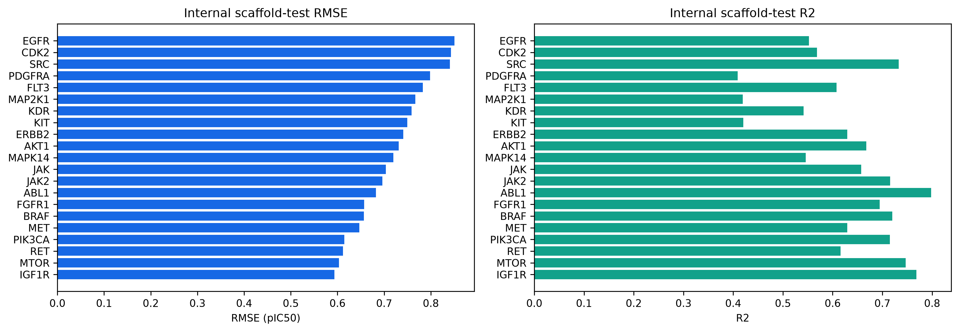
Figure 1. Recomputed internal scaffold-test performance across registered models.
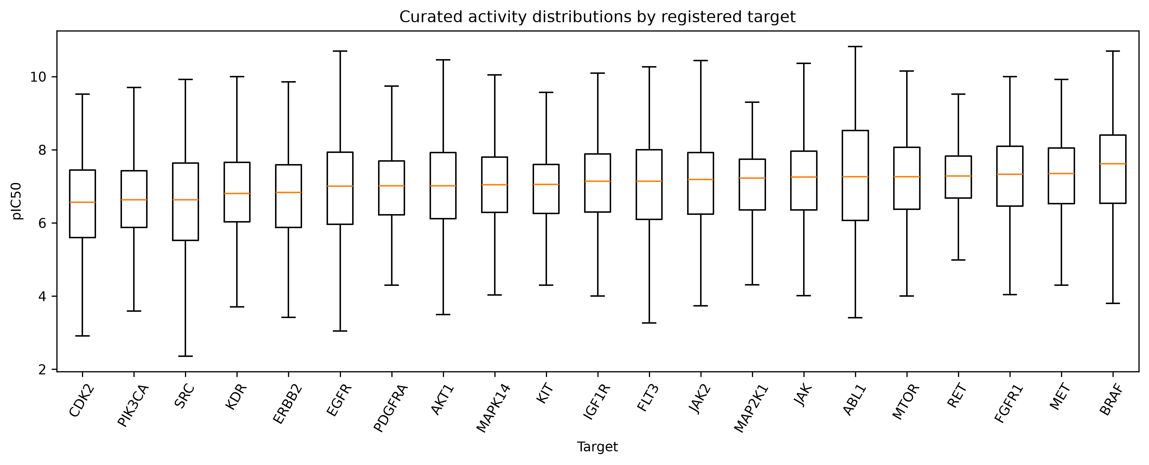
Figure 2. Curated pIC50 distributions by registered target.

6 JAK Family Model Evaluation
The JAK-family model uses 1864 saved scaffold-test compounds. Recomputed performance was R2 0.657, RMSE 0.703, MAE 0.523, and Spearman rho 0.804. This is an internal performance estimate for a pooled pChEMBL endpoint.
Evaluation | R2 | RMSE | MAE
Recorded scaffold-held-out | 0.657 | 0.703 | 0.523

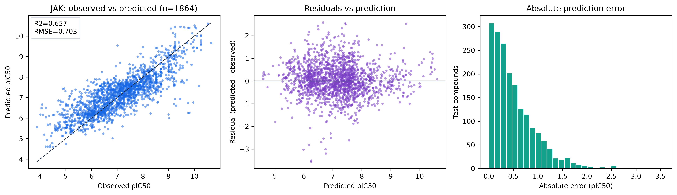
Figure 3. JAK observed-versus-predicted, residual, and absolute-error diagnostics.
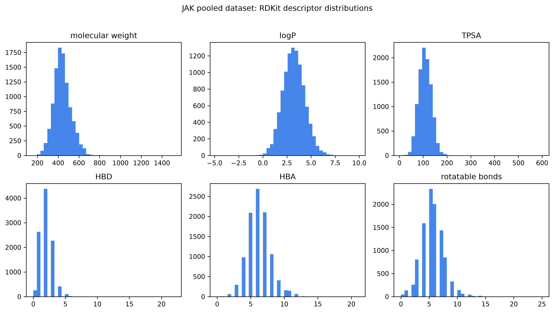
Figure 4. RDKit descriptor distributions for the pooled JAK clean dataset.
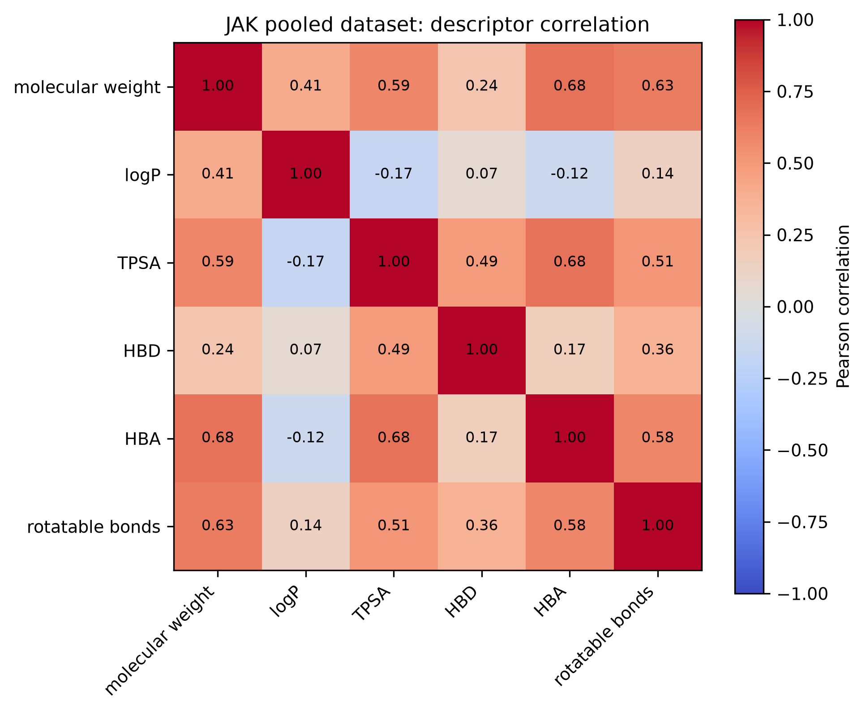
Figure 5. Descriptor correlations for the pooled JAK clean dataset.

7 Interpretability and Applicability Domain
A focused held-out permutation analysis evaluated the 20 fingerprint bits with highest native tree importance on a fixed 100-compound scaffold-test sample. This produces a local sensitivity diagnostic, not a causal molecular mechanism or a stability analysis across folds. The JAK applicability-domain analysis uses maximum Morgan Tanimoto similarity to the development set. The empirical 5th-percentile threshold is 0.627; it is an internal warning threshold, not a calibrated probability of correctness.
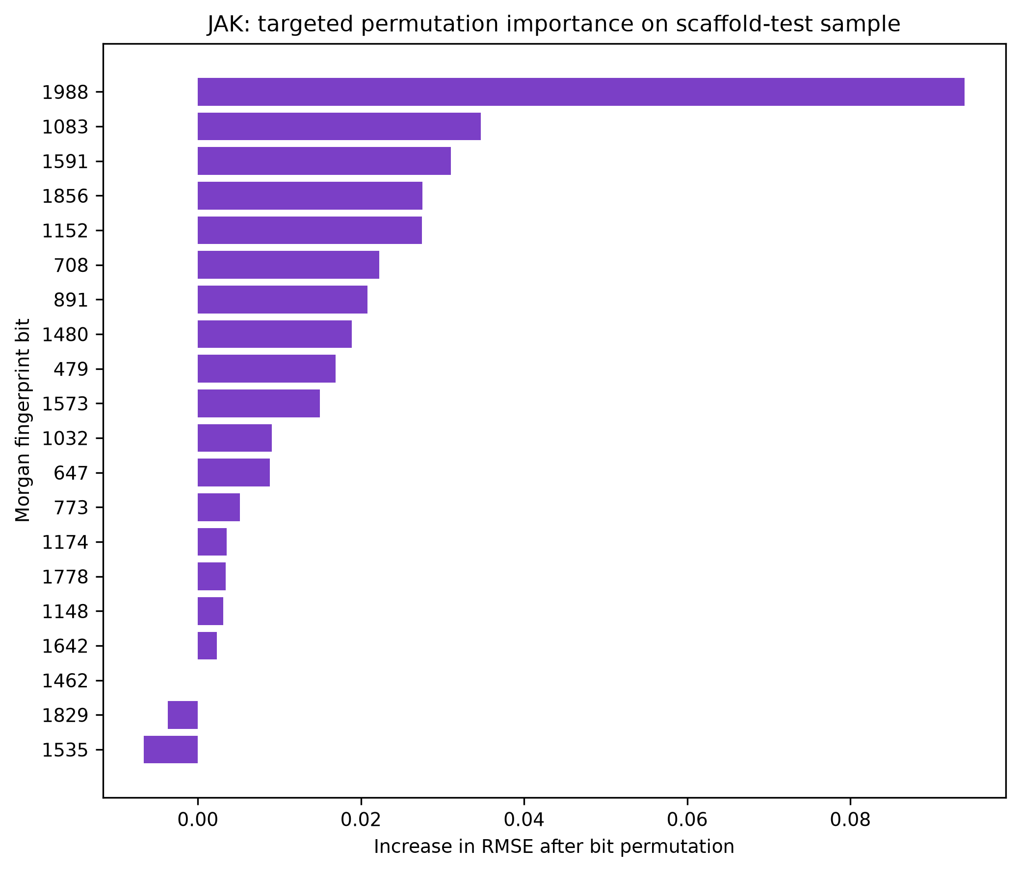
Figure 6. Targeted held-out permutation importance for the 20 highest native-importance fingerprint bits.
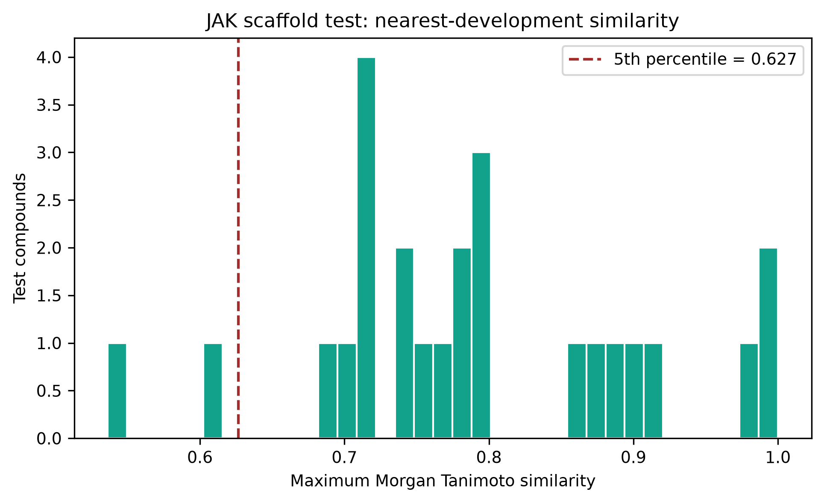
Figure 7. JAK scaffold-test nearest-neighbour similarity distribution.

8 External Validation
An independent external validation requires a compatible endpoint and units, exact activity relation, assay context, provenance, structure and publication independence, sufficient sample size, and predefined performance criteria. Current external reports are retained as evidence inventory, but no registered model passed every gate.
Gene | Source | External n | RMSE | Spearman | Gate passed
ABL1 | BindingDB REST | 139 | 1.146 | 0.556 | False
AKT1 | BindingDB REST | 91 | 0.792 | 0.608 | False
BRAF | BindingDB REST | 203 | 1.228 | 0.434 | False
CDK2 | BindingDB REST | 741 | 1.040 | 0.489 | False
EGFR | BindingDB REST | 770 | 1.665 | 0.366 | False
ERBB2 | BindingDB REST | 1497 | 1.404 | 0.215 | False
FGFR1 | BindingDB REST | 103 | 0.749 | 0.534 | False
FLT3 | BindingDB REST | 52 | 0.861 | 0.723 | False
IGF1R | BindingDB REST | 33 | 0.727 | 0.461 | False
JAK2 | PubChem BioAssay AID 1699 | 10 | 0.333 | 0.673 | False
KDR | BindingDB REST | 160 | 0.829 | 0.653 | False
KIT | BindingDB REST | 128 | 1.010 | -0.175 | False
MAP2K1 | BindingDB REST | 63 | 0.751 | 0.606 | False
MAPK14 | BindingDB REST | 245 | 1.148 | 0.435 | False
MET | BindingDB REST | 83 | 0.813 | 0.820 | False
MTOR | BindingDB REST | 28 | 0.707 | 0.722 | False
PDGFRA | BindingDB REST | 71 | 1.073 | -0.084 | False
PIK3CA | BindingDB REST | 566 | 1.202 | 0.396 | False
RET | BindingDB REST | 95 | 1.413 | 0.278 | False
SRC | BindingDB REST | 62 | 0.638 | 0.888 | False

9 Reproducibility
The analysis used seed 42, Python 3.14.2, RDKit 2026.03.6, scikit-learn 1.9.1, NumPy 2.5.3, pandas 3.0.6, and SciPy 1.18.1. Exact model SHA256 values, recomputed predictions, residuals, diagnostics, audit tables, and validation inventory are stored under results/.

10 Limitations and Conclusion
The models are useful for target-specific compound ranking within familiar chemistry, with explicit warnings for out-of-domain compounds. They do not provide clinical efficacy or safety predictions. Internal scaffold testing is stronger than a random split for chemical extrapolation but it is not a replacement for a context-matched independent assay set. The pooled JAK model cannot make isoform-specific claims. The correct current label is research screening, pending qualifying external validation and prospective experimental confirmation.

References
OECD. Guidance Document on the Validation of (Quantitative) Structure-Activity Relationship [(Q)SAR] Models. OECD Series on Testing and Assessment No. 69, 2014. https://doi.org/10.1787/9789264085442-en
RDKit documentation. The RDKit Book: Morgan and Feature Morgan fingerprints. https://www.rdkit.org/docs/RDKit_Book.html
Rogers D, Hahn M. Extended-connectivity fingerprints. Journal of Chemical Information and Modeling. 2010;50:742-754. https://doi.org/10.1021/ci100050t

