

WATER QUALITY ANALYSIS



# BATCH MEMBER

**611721205701:DEEPAK KUMAR P**

**PHASE 3 SUBMISSION DOCUMENT PROJECT TITLE:*WATER QUALITY ANALYSIS* PHASE 3:*DEVELOPMENT PART1***

**TOPIC:*LOAD PREPROCCERS DATASET IN WATER QUALITY ANALYSIS***



**WATER QUALITY ANALYSIS**

**INTRODUCTION**

+ Since the early beginning of the development of natural

sciences, collecting and assay of huge

+ amounts of data was one of the leading analytical tools. The

same goes for environmental

+ sciences and environmental engineering, which produce higher

demand for efficient and pro-

+ ductive approaches to work with continuously increasing sizes

of the collected data from a

+ huge variety of research fields every day. (Kendall and Costello 2006)

+ **The purpose of the research behind this thesis was in presenting of examples of how such**



+ **advanced tools may be used on a particular data set meant for increasing water quality in**

+ **european region. In the following chapters one will go through the presentation of the**

+ **machine learning, it’s origins and possibilities in general, explanation of the data and**

**models**

+ **used during the research, results of the application of algorithms, discussion (covering**

+ **obstacles one can face while working with this kind of models) and conclusion, which will**

+ **cover the presented material, give advices for engineers and scientists who would like to use**

+ **this models for their environmental tasks and finally and give some words about the possbile**

+ **future of the development of these tools in environmental field.**

# DATA MINING



+ Formally, the beginning of data analysis field had begun at the moment

humanity started mak-

+ ing simplest analysis of the surrounding environment by watching and

manually interacting

+ with nature. For data mining itself, there are some more or less consistent and defined events

+ in history that are associated with the birth of the discipline, such as publishing of Bayes' the-

+ orem (which describes the probability of an event, based on conditions

that might be related

+ to the event) by Thomas Bayes’ in 1763 and first regression analysis by

Adrien-Marie Legen-

+ dre and Carl Friedrich Gauss in 1805 (Figure 1.1). (Li 2015



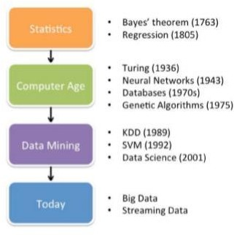

# ENVIRONMENTAL INFORMATICS



**Generally, this research may be associated with the new and currently rapidly growing field of**

**environmental informatics. Being one of the directions of the development of data sciences,**

**environmental informatics covers researches that work with**

**data about the state of Earth’s**

**biosphere (and associated spheres) and those processes affecting it. Thus, being interested in**

**reviewing and analysing more projects and articles in this field, one should consider searching**

**for information primarily in this particular area. (Frew and Dozier 2012)**

# MACHINE LEARNING



Since times of Bayes’ theorem, data mining has greatly developed

(especially since the be-

ginning of the computer age) and Machine Learning separated from

it as an independent sci-

entific field. There are two the most common definitions of this term. First is provided byArthur Samuel In 1959, who described it as a "Field of study that gives computers the ability

to learn without being explicitly programmed" (Simon 2013).



One can define also the following main steps of the analysis using machine learning models:

1. **Data Understanding – before defining the possible approaches to work with data,**

**it is necessary to analyse the raw data itself first. What kind of measurements are**

**included, is there any missing data (and in case of natural sciences research, usually there is plenty), which kind of models it is possible to apply to the data and defining the initial goal of the research**

1. **Data Preparation – merging data, imputing missing values or excluding**

**variables**

**with too many missing values, sorting data, etc.**

1. **Model Training – actually training the models and analyzing data**
2. **Results Evaluation – an important stage of the results understanding, which makes**

**possible adjustment of the models and correction of the initial research plan (Chapman, et al. 2000)**

**Additionaly, it is worth defining and explaining the main types of models one can**

**apply**



Additionaly, it is worth defining and explaining the main types of models one can apply:

1. **Supervised learning - these are methods where a given set of independent**

**variables are to be matched to one or more dependent variables. During this**

**kind**

**of analysis, model is given a “labled data”, where it can find the real values of**

**the**

**parameter it is working with for some certain measurement and values of**

**other**

**parameters for the same measurement, thus it can fit a function. These can be regression tasks (working with continuous values) and classification tasks (working with class labeled data)**

1. **Unsupervised learning - in contrast, with unsupervised methods there is no prior**

**“correct” data and the purpose of this kind of analysis is to search for the**

**underlying patterns in the data**

1. **Optimization - techniques for finding the optimal set of parameters which minimize a pre-defined cost function**

OVERFITTING



+ **Overfitting is a common problem among a vast majority of the machine learning algorithms**

+ **and it comes from the origins of these tools. While fitting a model, algorithm tries to**

+ **minimize the error function of the model, which is the difference between the estimator and**

+ **what is estimated (Lebanon 2010).**

# THREE TYPICAL TYPES OF MODEL FIT



+ **1. Predictor too inflexible – these models are underfitted, which means that the**

+ **formula describes data poorly and mean square error (MSE) is significantly high.**

+ **These models can’t provide sufficial degree of accuracy**

+ **2. Middle pictures – this model has nearly a perfect fit. The MSE is not absolutely**

+ **zero; however, this model will provide an appropriate function to the given data**

+ **and will be able to make suitable predictions based on new data (or data not**

+ **included in training set)**

+ **3. Predictor is too flexible – in these cases, we can see a typical example of**

+ **overfitting. The model is too complicated and it is able to minimize MSE nearly to**

+ **zero, so it seems to fit the training set alone perfectly. However, it will describe**

+ **random errors or noise and thus show pretty bad results on the n**



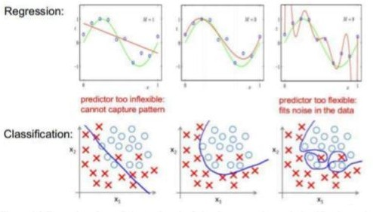

# CALCULATING ACCURACY



+ Goals of the evaluation stage can’t be effectively met

without proper ways to interpret the

+ achieved results. For different models and different types of tasks, various techniques may be

+ used for this purpose. During this research, the following

ones were used: confusion matrix,

+ root mean square error and node purity.

+ Confusion matrixes are one of the most commonly used

tools for evaluating a performance of

+ classification models. It contains information about the

actual and predicted classes.

# MATRIX AND METHODS



+ **DATA**

**The data used for this research was generated during European STREAMES (STream REAch Management, an Expert System) project, which is an international enterprise for the develop- ment of a knowledge-based environmental decision support system to assist water managers with their decision-making tasks. The core of the project itself involved the evaluation of the effect of substantial nutrient loads on the overall water quality and ecological status of stream ecosystems. Empirical data for the knowledge base come from several streams located throughout Europe and Israel, with emphasis on streams from the Mediterranean region. The- se data comprise several types of variables, including physical, chemical and biological pa- rameters. (Vellido, et al. 2007**

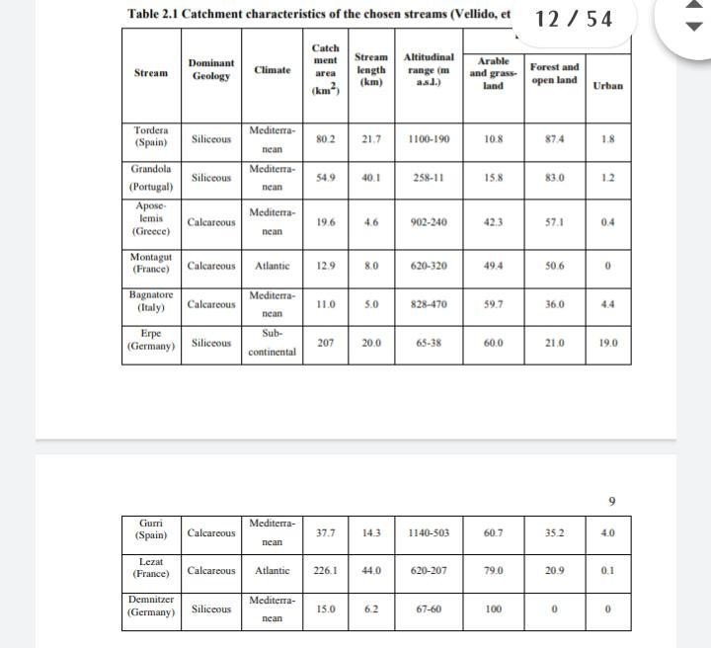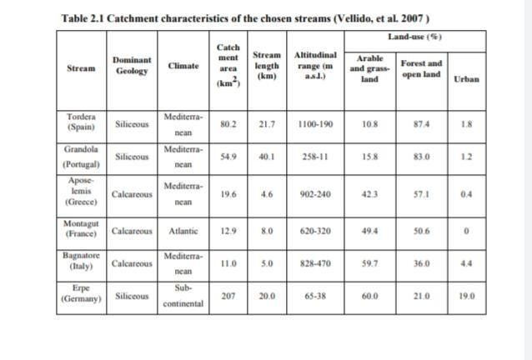

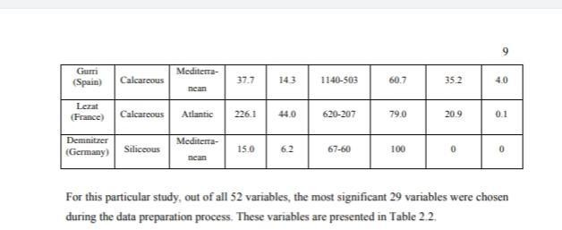

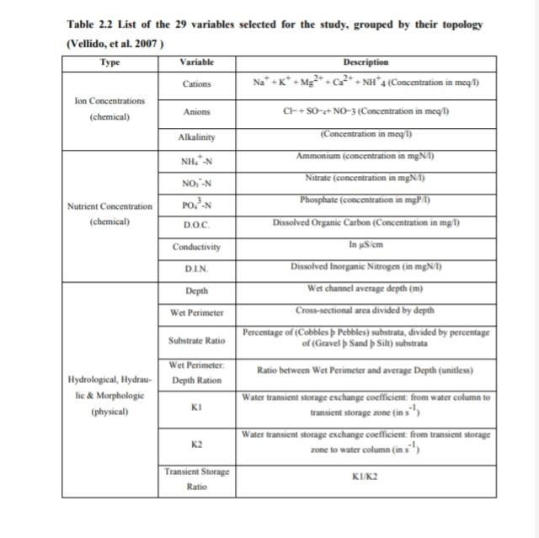



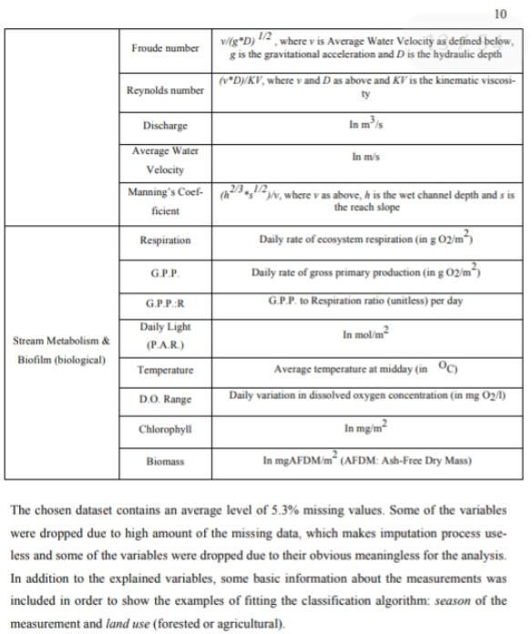

# MODEL AND SOFTWARE



+ **There is a huge variety of machine learning algorithms and tools existing nowadays. In the**

+ **following subchapters, the following algorithms used in this research are covered: support**

+ **vector machines, random forests, artificial neural networks (used for classification, regression,**

+ **variable importance tasks), k-nearest neighbours (used for data imputation) and k-means clus-**

+ **tering (used for unsupervised classification).**

# SUPPORT VECTOR MACHINE



+ **Support vector machine is one of the basic algorithms and in this research is used mostly as a**

+ **baseline in order to be able to compare the performances of the models. The core of this algo-**

+ **rithm refers to the family of linear models. The model is trained by transfering of the**

**original**

+ **vector in the space of higher dimension and search for dividing hyperplane with the**

**maximum**

+ **gap in this space. Two parallel hyperplanes are constructed on both sides of the hyperplane**

+ **separating classes. Separating hyperplane is a hyperplane that maximizes the distance to two**

+ **parallel hyperplanes. The algorithm works on the assumption that the greater the difference**

+ **and the distance between these parallel hyperplanes, the smaller the average error of the classifier**



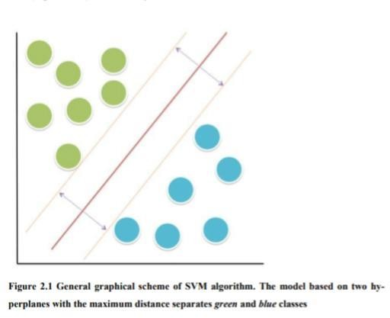

# RONDAM FOREST



|  |  |
| --- | --- |
| + | **Random forest (RF) is a relatively new model, developed by Leo Breiman and Adele Cutler** |
| + | **in the end of 90s. The general graphical scheme of the RF algorithm is sketched in Figure 2.2.** |
| + | **At each split of the observed sample data, a random subset of variables is selected and the** |
| + | **process is repeated until the specified number of decision trees is generated. Each tree is built** |
| + | **from a bootstrap sample drawn with replacement from the observed data, and the predictions** |
| + | **of all trees are finally aggregated through majority voting. A feature of RFs is the definition of** |
| + | **an out-of-bag (OOB) error, which is calculated from observations that were not used to build** |
| + | **a particular tree; it can thus be considered as an internal cross-validation error measure. This** |
| + | **is an important feature for the type of experiments carried out in this study, because it simpli-** |
| + | **fies the otherwise cumbersome cross-validation procedures that would be required if alterna-** |
| + | **tive classification methods such as, for instance, support vector machines or artificial neural** |
| + | **networks were used. (Breiman 2001, Shkurin and Vellido 2016)** |



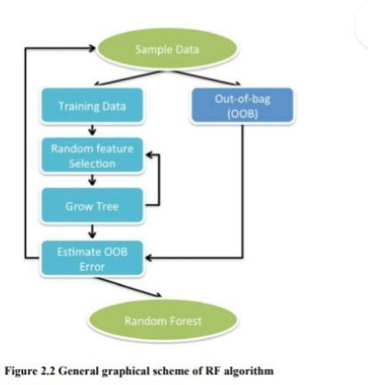

**ARTIFICIAL NEURAL NETWORK**



+ **The artificial neural networks (ANN) are one of the most popular machine learning models**

+ **nowadays, with a huge variety of possible applications, including regression, classification, image recognition etc, introduced in 1943 by neurophysiologist Warren McCulloch and math-**

+ **ematician Walter Pitts (Warren and Pitts 1943). The basic of this model is in building several**

+ **layers that are made up of a number of interconnected nodes, containing the activation func-**

+ **tion. The training set is presented to a model through input layer; one or more hidden layers**

+ **perform processing by the system of weighted connections, taking each of the inputs for cal-**

+ **culation, and finally output layer gives the fitted function**



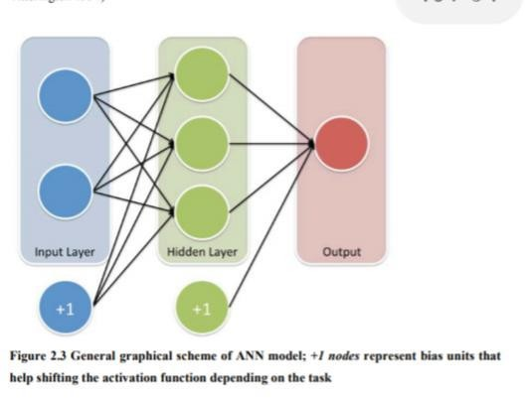

# K-MEANS CLUSTERING



+ **One of the useful analytical tools is unsupervised clusterization, where the data is classified**

+ **by the algorithm into specified amount of classes based on internal patterns. It can be used to**

+ **search for the subtypes and subclasses for researched process, value or compound. (Likas,**

+ **Vlassis and Verbeek 2003)**

+ **The data is classified firstly by setting k centroids, which will be the core to the searched clas-**

+ **ses. Then, the grouping is done by minimizing the sum of squares of distances (analogue to**

+ **MSE) between data and the corresponding cluster centroid, as shown on the Figure 2.5. At**

+ **each iteration cluster centre is recalculated until the best position is reached. (Teknomo 2007)**



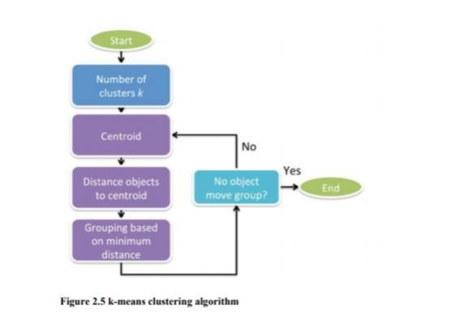

## DATA IMPUTATION



+ First of all, the data was imputed. In the original data,

missing values are presented as “0” and

+ “-1” values. After these were assigned to NA, KNN with 2,

3 and 4 neighbours were used for

+ imputation of the results. The accuracies of the models

based on these numbers of neighbours

+ for NH4, NO3 and PO4 values are presented



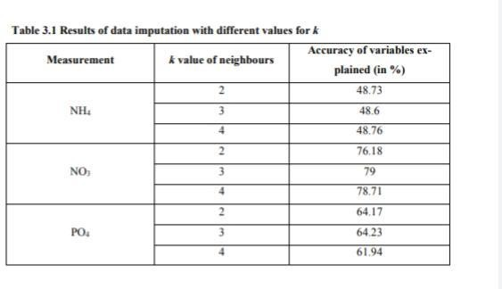

## NH4



+ For NH4, the initial model using random forest had an RMSE of 1.8449 and accuracy of

+ 48.6%. The variable importance of all the measurements were subtracted



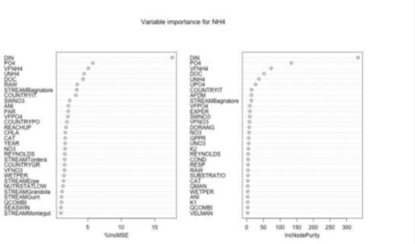



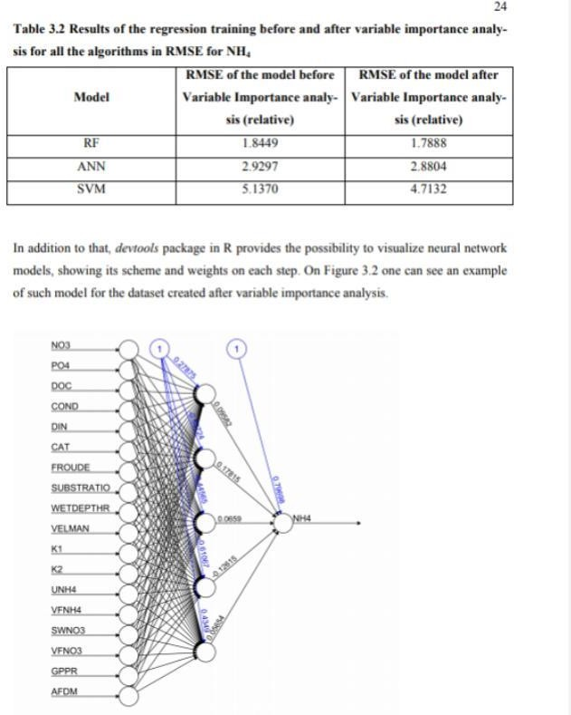

# CONCLUSION



|  |  |
| --- | --- |
| + | **Overall, the goals defined for this research were reached and the examples of the application** |
| + | **of machine learning models are presented, covering most of the aspects of the average re-** |
| + | **search working in the field of artificial intelligence for environmental sciences tasks. This** |
| + | **work also reveals the importance of consulting data scientists before starting of the monitor-** |
| + | **ing, since data sets unsuitable for requested tasks is a common problem.** |
| + | **Generally, regression models were able to show the consistent trend and overall correlation** |
| + | **between each other, even though for some of the measurements they give models of poor** |
| + | **quality. Random forests (RF) show the best performance and are advised for scientists and** |
| + | **engineers working with environmental data. Artificial neural networks (ANN) are another** |
| + | **alternative, though their performance is inferior and they are prone to overfitting. Support** |
| + | **vector machines (SVM) are the good example for the cases where a baseline model is needed,** |
| + | **being one of the basic algorithms.** |



**K-nearest neighbours (KNN) model was successfully used for data imputation and is also**

**suggested for this task for other researchers. Though, and it is worth noticing, amount of**

**neighbours used for this research (3) is not universal and another amount may be found suita-**

**ble for different data sets.**

**Classification models show good performance and are able to make highly accurate prediction**

**models for identifying season of the sample and land use of the area where it was taken.**

**Meanwhile, clusterization techniques, such as k-means clustering, may assist data**

**scientist**

**with possible algorithms to classify given data, for example defining good, average and bad**

**conditions of the water based on various chemical, biological and physical parameters.**



+ Future prospective of the development of this research

may be seen in several ways. Firstly,

+ consistent misclassification of season values between winter and spring may be studied fur-

+ ther using this data set by extracting and analysing the samples, which tend to be often mis-

+ classified. On the other hand, models generated during

this research may be used by IT stu-

+ dents for producing software meant to help

environmental specialists in analysing collected

+ water quality data.