ABSTRACT
This paper discusses the concept of a smart wearable device for children. The major advantage of this wearable over others is that it can be used in any cell phone and doesn't necessarily require an expensive smart phone and not a very tech savvy individual to operate. The purpose of this device is to help parents locate their children with ease. At the moment there are many wearable’s in the market which help track the daily activity of children and also help find the child using Wi-Fi services present on the device. But Wi-Fi and Bluetooth appear to be an unreliable medium of communication between the parent and child. Therefore, the focus of this paper is to have an SMS text enabled communication medium between the child's wearable and the parent as the environment for GSM mobile communication is almost present everywhere. The parent can send a text with specific keywords such as "LOCATION" "TEMPERATURE" "SOS" "BUZZ", etc, the wearable device will reply back with a text containing the real time accurate location of the child which upon tapping will provide directions to the child's location on Google maps app and will also provide the surrounding temperature, UV radiation index so that the parents can keep track if the temperature or UV radiation is not suitable for the child. The Prime motivation behind this project is that we know how important technology is in our lives but it can sometimes can't be trusted, and we always need to have a secondary measure at hand. The secondary measure used in this project is the people present in the surrounding of the child who could instantly react for the Child’s safety till the parents arrives or they could contact the parents and help locate them. The secondary measure implemented was using a bright SOS Light and distress alarm buzzer present on the wearable device which when activated by the parents via SMS text should display the SOS signal brightly and sound an alarm which a bystander can easily spot as a sign of distress.

Chapter 1
PREAMBLE
  - Introduction
The Internet of Things System (IoT) refers to the set of devices and systems that stay interconnected with real-world sensors and actuators to the Internet. IoT includes many different systems like smart cars, wearable devices and even human implanted devices, home automation systems and lighting controls; smart phones which are increasingly being used to measure the world around them. Similarly, wireless sensor networks that measure weather, flood defenses, tides and more. There are two key aspects to the IoT: the devices themselves and the server-side architecture that supports them. The motivation for this wearable comes from the increasing need for safety for little children in current times as there could be scenarios of the child getting lost in the major crowded areas. This project focusses on the key aspect that lost child can be helped by the people around the child and can play a significant role in the child's safety until reunited with the parents. Most of the wearables available today are focused on providing the location, activity, etc. of the child to the parents via Wi-Fi and Bluetooth. But Wi- Fi and Bluetooth seem a very unreliable source to transfer information. Therefore it is intended to use SMS as the mode of communication between the parent and child's wearable device, as this has fewer chances of failing compared to Wi-Fi and Bluetooth.
The platform on which this project will be running on is the Arduino Uno microcontroller board and the functions of sending and receiving SMS, calls and connecting to the internet which is provided by the Arduino GSM shield using the GSM network. Also, additional modules employed which will provide the current location of the child to the parents via SMS. The second measure added is SOS Light indicator that will be programmed with Arduino UNO board to display the SOS signal using Morse code.
In the scenario, a lost child can be located by the parent could send an SMS to the wearable device which would activate the SOS light feature on the wearable. Therefore alerting the people around the child that the child is in some distress and needs assistance as the SOS signal is universally known as the signal for help
needed. Additionally, the wearable comes equipped with a distress alarm buzzer which sets to active by sending the SMS keyword "BUZZ" to the wearable. Hence the buzzer is loud and can be heard by the parent from very considerable distance. Also the parents via SMS can receive accurate coordinates of the child, which can help them locate the child with pinpoint accuracy.

Chapter 2
EXISTING SYSTEM AND PROPOSED SYSTEM

  - Existing system
At the moment there are many wearable in the market which help track the daily activity of children and also help find the child using Wi-Fi and Bluetooth services present on the device. But Wi-Fi and Bluetooth appear to be an unreliable medium of communication between the parent and child.
  - Proposed System
We propose a child safety wearable device is capable of acting as a smart loT device. It provides parents with the real-time location, surrounding temperature, UV radiation index and SOS light along with Distress alarm buzzer for their child's
Surroundings and the ability to locate their child or alert bystanders in acting to rescue or comfort the child. The smart child safety wearable can be enhanced much more in the future by using highly compact Arduino modules. Arduino which can be sewed into fabrics. Also a more power efficient model will have to be created which will be capable of holding the battery for a longer time.
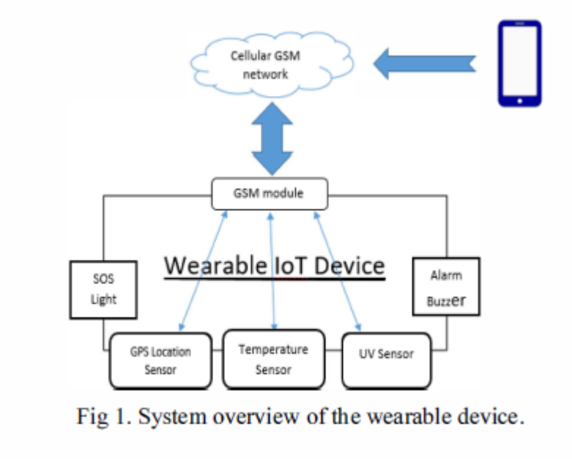
    - Feasibility Study
A feasibility study is a high-level capsule version of the entire System analysis and Design Process.
Example: The study begins by classifying the problem definition. Feasibility is to determine if it's worth doing. Once an acceptance problem definition has been generated, the analyst develops a logical model of the system. A search for alternatives is analyzed carefully. There are 3 parts in feasibility study.
Operational Feasibility
Question that going to be asked are: Will the system be used if it developed and implemented? If there was sufficient support for the project from the management and from the users? Have the users been involved in planning and development of the Project. Will the system produce poorer result in any respect or area?
Example: This system can be implemented in the organization because there is adequate support from management and users. Being developed in JAVA so that the necessary operations are carried out automatically.
Technical feasibility
Does the necessary technology exist to do what is been suggested? Does the proposed equipment have the technical capacity for using the new system? Are there technical guarantees of accuracy, reliability and data security?
Financial and Economic Feasibility
The system developed and installed will be good benefit to the organization. The system will be developed and operated in the existing hardware and software infrastructure. So there is no need of additional hardware and software for the system.
  - System Analysis
Studied in software engineering
  - System Design
Studied in software engineering
  - Objective of the project
The aims at providing parents with a sense of security for their child in today's time.

Plan of Implementation

