This document is about to set up to automatically trigger the Jenkins job if there are any changes in GitHub repo.

1. **GitHub Plugin:** Check whether the plugin installed or not, Manage Jenkins🡪Manage Plugins🡪Installed. Install the **GitHub Plugin** if it is not exists by default when Jenkins installed.

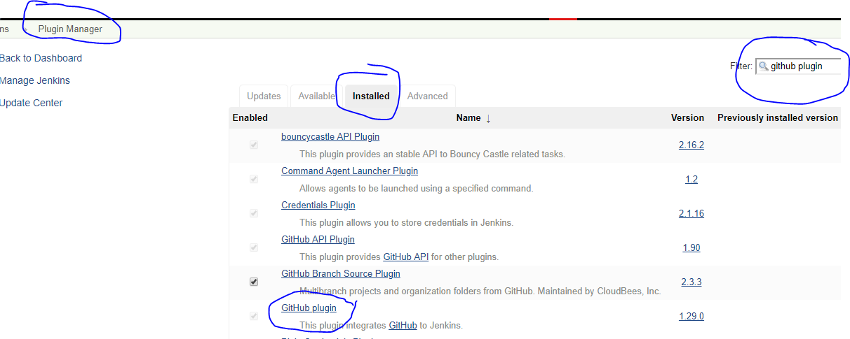

1. Go to Jenkins job which job you want to trigger automatically & check the box “GitHub hook trigger for GITScm polling”. (This option may be different for various git versions, but you will find the similar option like “Build When a change pushed to GitHub” OR “Build on GitHub” etc)

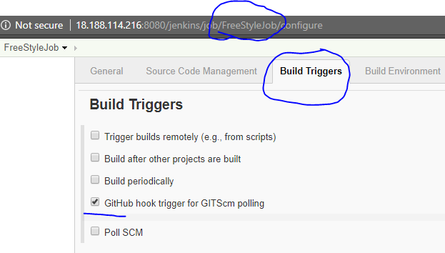

1. Go to GitHub repo settings and configure Jenkins webhook path as below.

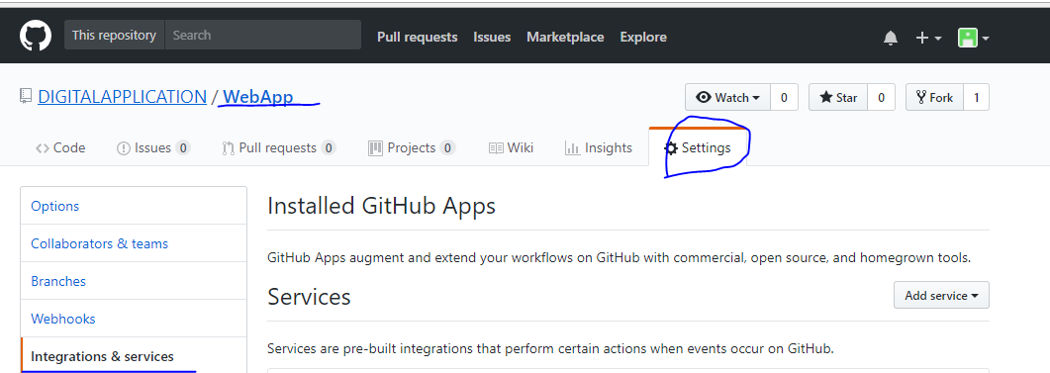

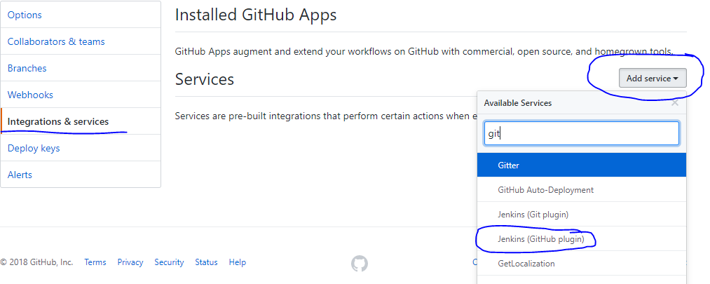

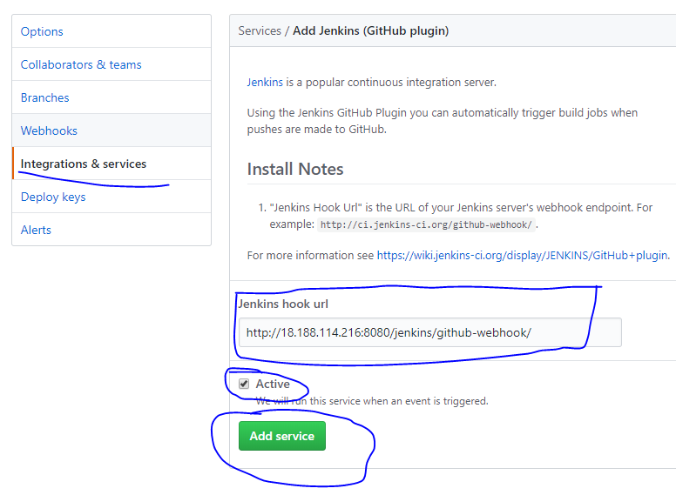

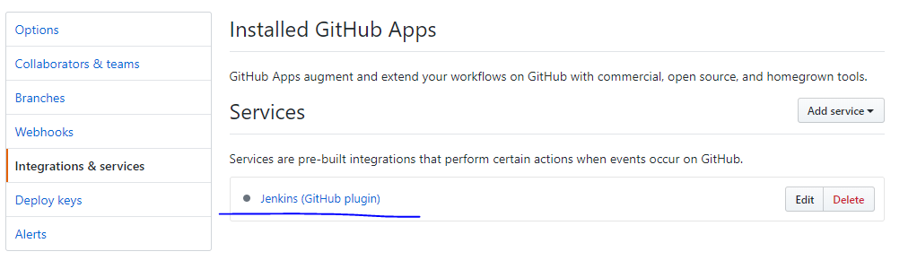

If you want test the connection:

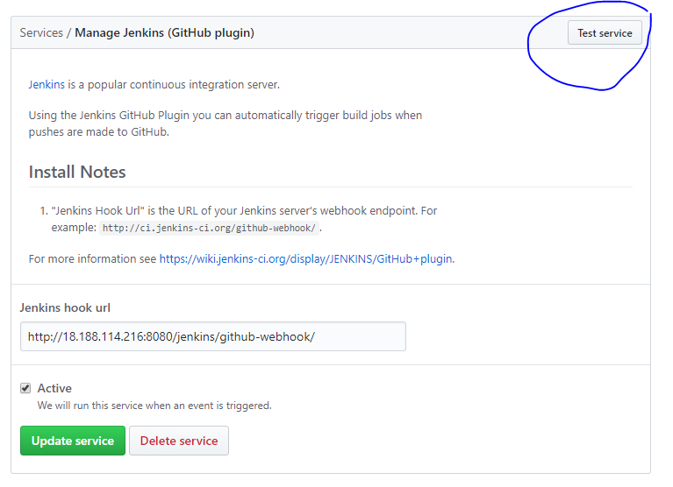

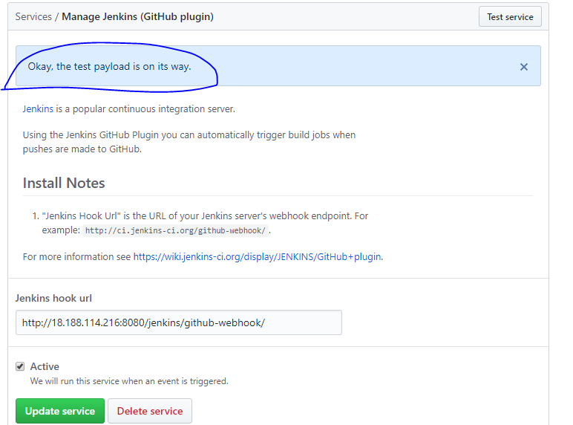

1. Update any changes on your GitHub repo. Immediately the Jenkins will be triggered by integrating your latest changes (with latest changes/code).

In the below image, you will see the username as venkatasyakm. This is not the Jenkins user name. This is github username who pushed the changes. By this, you will come to know, who did these changes and with whom changes the build triggered au8tomatically.

Also, see the highlighted line 🡪Checking out Revision **43a9871**81879f7da5a68026c122340868b5bbb0d (refs/remotes/origin/master)

If you look at the GitHub repo commit history, there you will see the short form of the full SHA commit-id as **43a9871**. And the user who committed those changes, date and time.

