VISVESVARAYA TECHNOLOGICAL UNIVERSITY
Jnanasangama, Macche, Santibastwada Road, Belagavi-590018, Karnataka

A
MINI PROJECT REPORT
on
Natural logarithm and Anti-logarithm
Submitted in partial fulfillment of the requirement for the degree of
Bachelor of Engineering
in
Electronics & Communications Engineering
By
DEEPU.K | 1DS16EC043
NISARGA D B | 1DS16EC087
RACHITA Y R | 1DS16EC101
VI semester
Under the
guidance
of
Prof. A. Rajagopal
Assistant Professor, ECE Dept., DSCE, Bengaluru

Department of Electronics & Communication Engineering
Dayananda Sagar College of Engineering
(An Autonomous College affiliated to VTU Belgaum & accredited by NBA/NAAC)
Shavige Malleshwara Hills, Kumaraswamy Layout,
Banashankari, Bengaluru-560078, Karnataka
April 2018

Mini project Report Declaration
Certified that the UG Mini project entitled, Natural log and Anti-log (Logic design)has been submitted as AAT for the subject Virtual Instrumentation-EC564 is a Bonafede work that is carried out by our team in partial fulfillment for the award of degree of Bachelor of Engineering in Electronics & Communication Engineering of the Visvesvaraya Technological University, Belagavi, Karnataka during the academic year 2017-18.
We are solely responsible for all the contents that has have been presented in it.

Students Name with USN:
DEEPU.K | 1DS16EC043
NISARGA D B | 1DS16EC087
Rachita Y R | 1DS16EC101

Date 03 /12 /2018 Place : Bengaluru -78

_______________________________________
Mini project Guide
Name & Signature
Prof A. Rajagopal

Introduction
The natural logarithm of a number is its logarithm to the base of the mathematical constant e, where e is an irrational and transcendental number approximately equal to 2.718281828459. The natural logarithm of x is generally written as ln x, log_{e} x, or sometimes, if the base e is implicit, simply log x.Parentheses are sometimes added for clarity, giving ln(x), log_{e}(x) or log(x). This is done in particular when the argument to the logarithm is not a single symbol, to prevent ambiguity.
The natural logarithm of x is the power to which e would have to be raised to equal x. For example, ln(7.5) is 2.0149..., because e^{2.0149...} = 7.5. The natural log of e itself, ln(e), is 1, because e¹ = e, while the natural logarithm of 1, ln(1), is 0, since e⁰ = 1.
The natural logarithm can be defined for any positive real number a as the area under the curve y = 1/x from 1 to a (the area being taken as negative when a < 1). The simplicity of this definition, which is matched in many other formulas involving the natural logarithm, leads to the term "natural". The definition of the natural logarithm can be extended to give logarithm values for negative numbers and for all non-zero complex numbers, although this leads to a multi-valued function: see Complex logarithm.
The natural logarithm function, if considered as a real-valued function of a real variable, is the inverse function of the exponential function, leading to the identities
Thus, the logarithm function is a group isomorphism from positive real numbers under multiplication to the group of real numbers under addition, represented as a function:
Logarithms can be defined to any positive base other than 1, not only e. However, logarithms in other bases differ only by a constant multiplier from the natural logarithm, and are usually defined in terms of the latter. For instance, the binary logarithm is the natural logarithm divided by ln(2), the natural logarithm of 2. Logarithms are useful for solving equations in which the unknown appears as the exponent of some other quantity. For example, logarithms are used to solve for the half-life decay constant, or unknown time in exponential decay problems. They are important in many branches of mathematics and the sciences and are used in finance to solve problems involving compound interest.
By Lindemann–Weierstrass theorem, the natural logarithm of any positive algebraic number other than 1 is a transcendental number.

Problem Statement
Natural logarithm can be found in many different ways like taylor’s series method , integrating area under the curve etc but Hardware implementation of logarithm using those is difficult because time complexity is too high. The problem statement is to reduce the time complexity for the computation of logarithm and anti-logarithm.
If Priority encoder method is used to compute natural logarithm time complexity will be very less when compared to other methods

Block Diagram and Explanation
Logarithm to the base 2 calculation using priority Encoder
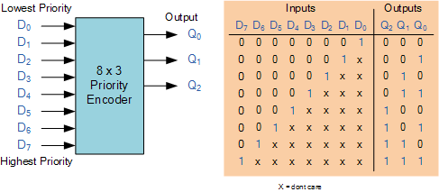
The output of the priority encoder will be the characteristic part of the log to the base 2. Lets take example of 4 , the output of priority encoder is 2 and 2 is the log to the base of 4.
To calculate mantissa of the logarithm ,the below algorithm is implemented
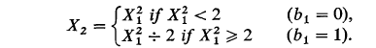
Example if the number is (X) is 1.27 then
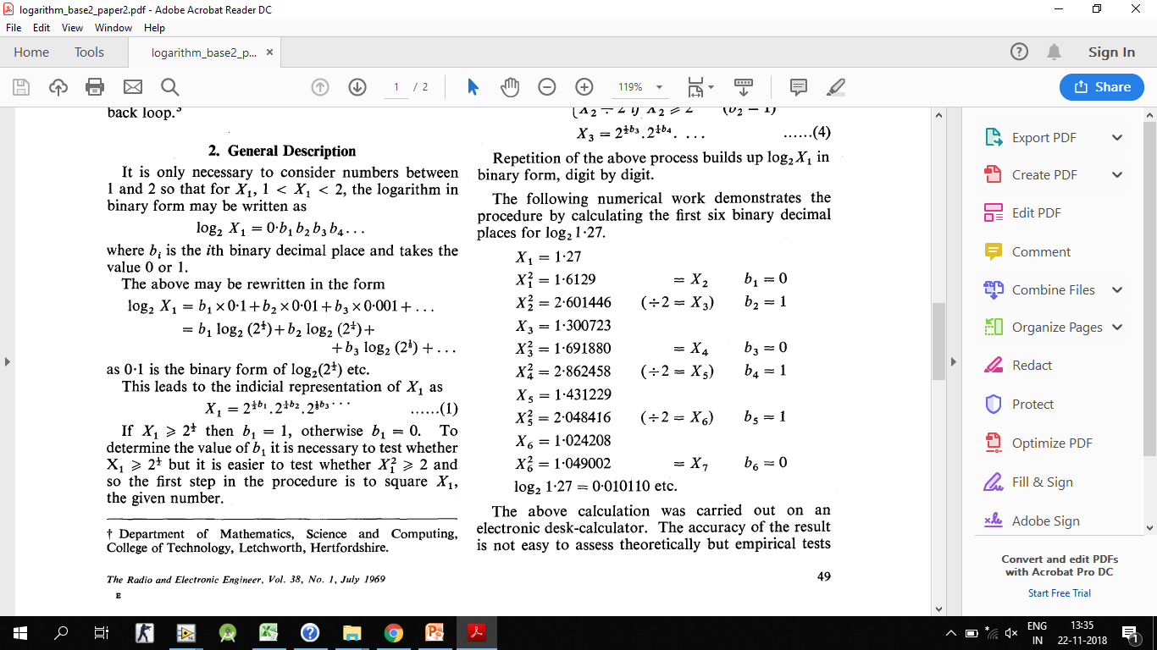
The output will be in the form of binary. Then they have to be converted to the decimal. By adding characteristic and the mantissa part log to the base 2 can be found.By multiplying the output with .6993 the natural log can be found
Labview Implementation of Natural Log
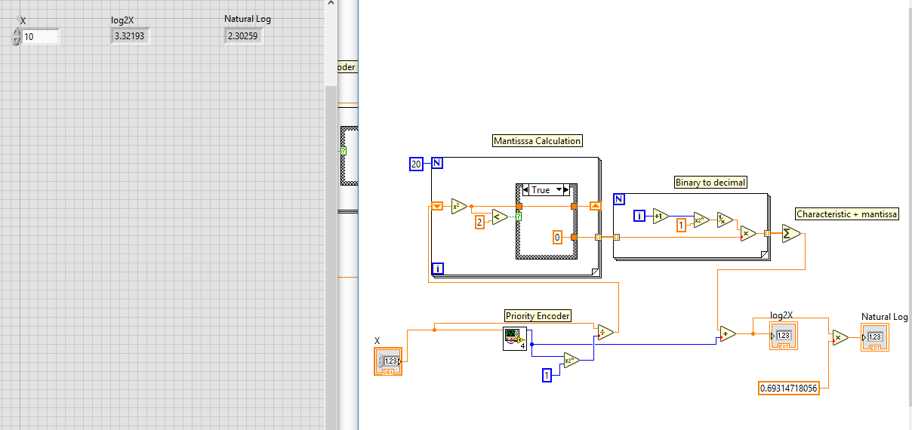
Lab view Implementation of Antilog

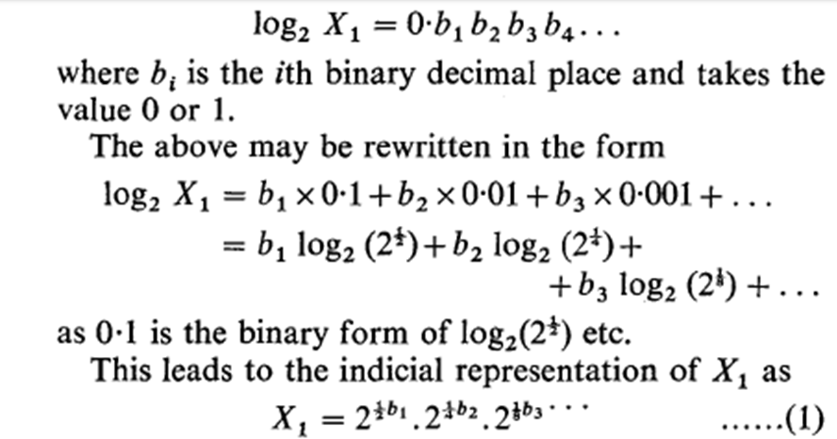
By using equation 1 antilog for base 2 numbers can be calculated.Antilog of before decimal part is calculated by decoder part and the after decimal part can be calculated by using above equation and if they are multiplied the antilog witll be output.
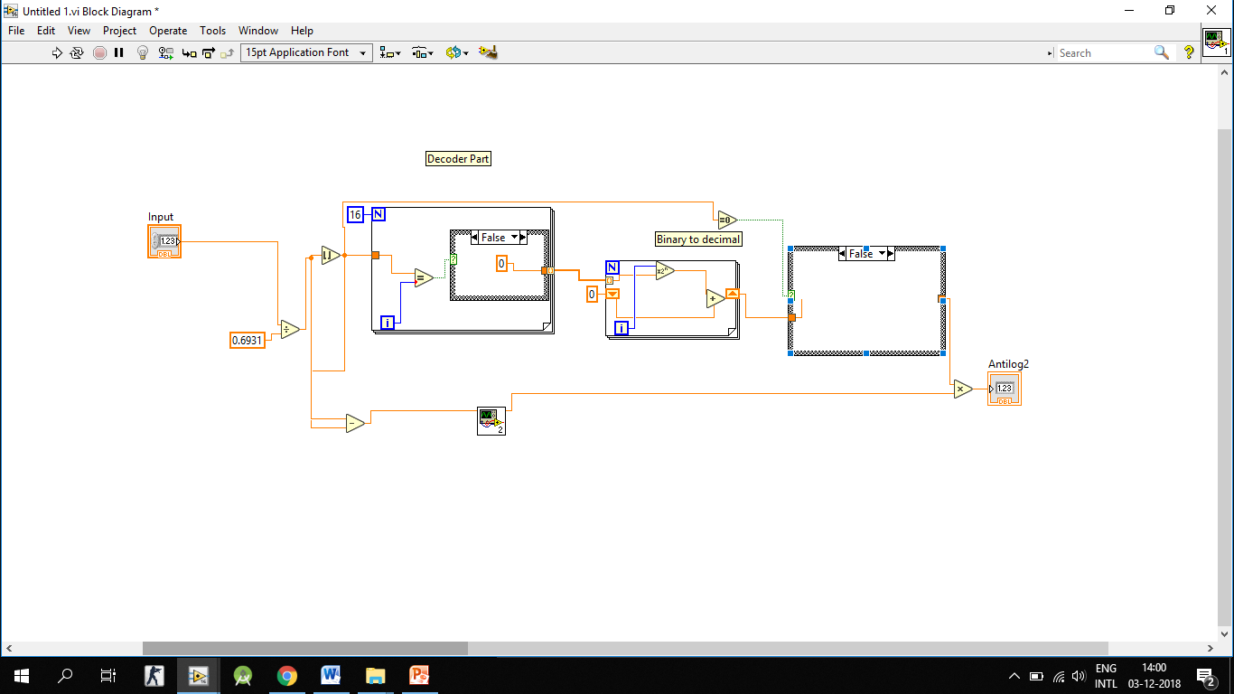
Results
From the above project it is seen that the above logic is less time consuming and it is more accurate.It can be implemented in hardware since the time complexity is very less when compared to the other methods
Logarithms are used to solve for the half-life decay constant, or unknown time in exponential decay problems. They are important in many branches of mathematics and the sciences and are used in finance to solve problems involving compound interest

Conclusion
The priotrity encode method of computing Natural log of a number is efficient , accurate and it can be easily implemented.

References:
https://ieeexplore.ieee.org/document/7975665
M.combet, H.Zonneveld, and L.Verbeek “Computation of the base
two logarithm of binary numbers” IEEE Trans Electronic
Computers,pp. 863-867, December 1965.

