**Project Name:** Image Recognition – Reading Text from Image

**Team Name:** WeSoft

**Team Members:** Deepiga Ravi, Anil, Anish

**Project Description:**

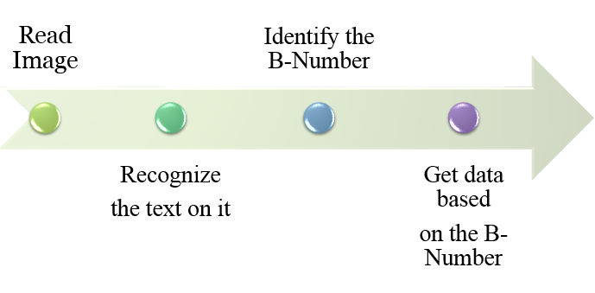

Screen Shot:

