Task 3: Architecture Design Challenge

The architectural design for Healthcare Analytics, comparing the legacy approach to the modern Big Data powerhouse.
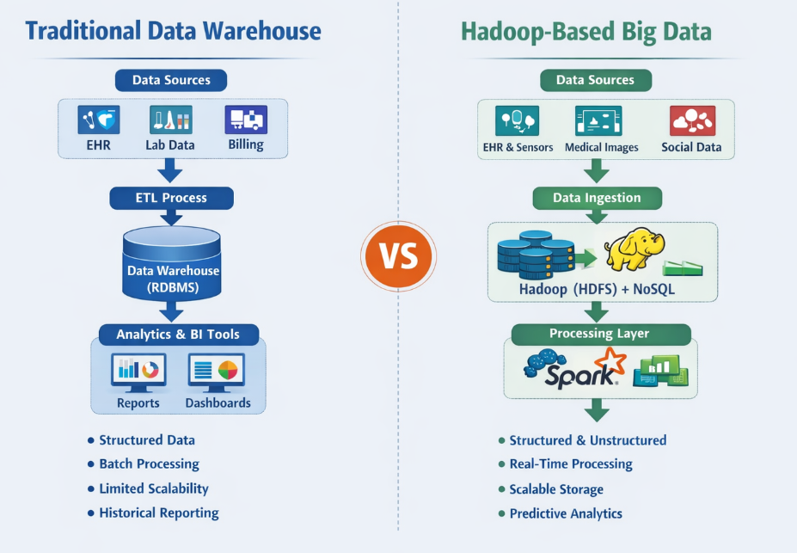
Traditional Data Warehouse Architecture
Data Sources
- Electronic Health Records (EHR)
- Laboratory and Pharmacy Systems
Storage Layer
- Centralized Relational Database (RDBMS like Oracle/MySQL)
- Structured tables (rows and columns)
- Predefined schema (Star/Snowflake schema)
Processing Layer
- ETL (Extract, Transform, Load) process
- Data cleaning and transformation before loading
- Batch processing (daily/weekly updates)
Analytics Layer
- BI dashboards and static reports
- Patient admission statistics
- Revenue and department performance reports
- Historical trend analysis (Descriptive analytics – “What happened?”)

Hadoop-Based Big Data Architecture
Data Sources
- EHR systems
- Wearable devices (heart rate, glucose monitors)
- Medical imaging (MRI, CT scans)
- Clinical notes and public health data
Storage Layer
- Apache Hadoop (HDFS – distributed storage)
- NoSQL databases like Cassandra
- Data Lake storing structured + unstructured data
Processing Layer
- Parallel processing using MapReduce
- Fast processing with Apache Spark
- Machine Learning models for disease prediction
Analytics Layer
- Real-time patient monitoring dashboards
- Predictive analytics (early disease detection)
- Clinical decision support systems
- Fraud detection and population health analysis

