**Prerequisites:**

1. Install Git
2. Node
3. Typescript – Install using: npm install typescript
4. Gulp: npm install --global gulp-cli

**Setup Environment:**

1. Clore Repo:

git clone --bare https://github.com/planetoftheweb/angular2.git .git

1. Issue git config – Switch bare repo to normal version

git config --bool core.bare false

1. Reset --

git reset –hard

git branch 🡪 Will show all the branches

4, To checkout 🡪 git checkout branch name

Nomenclature used is chapter_video_beginin or end

To go back to master: git checkout master

1. Npm install will download all the dependencies.
2. Then Run gulp that will setup the build automation for the project

Chapter 2:

What is Angular JS2

Very fast – can run 3-5 times faster than angular 1

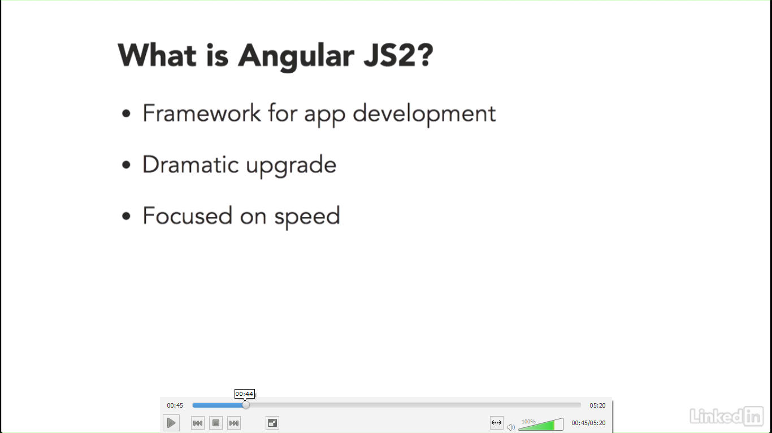

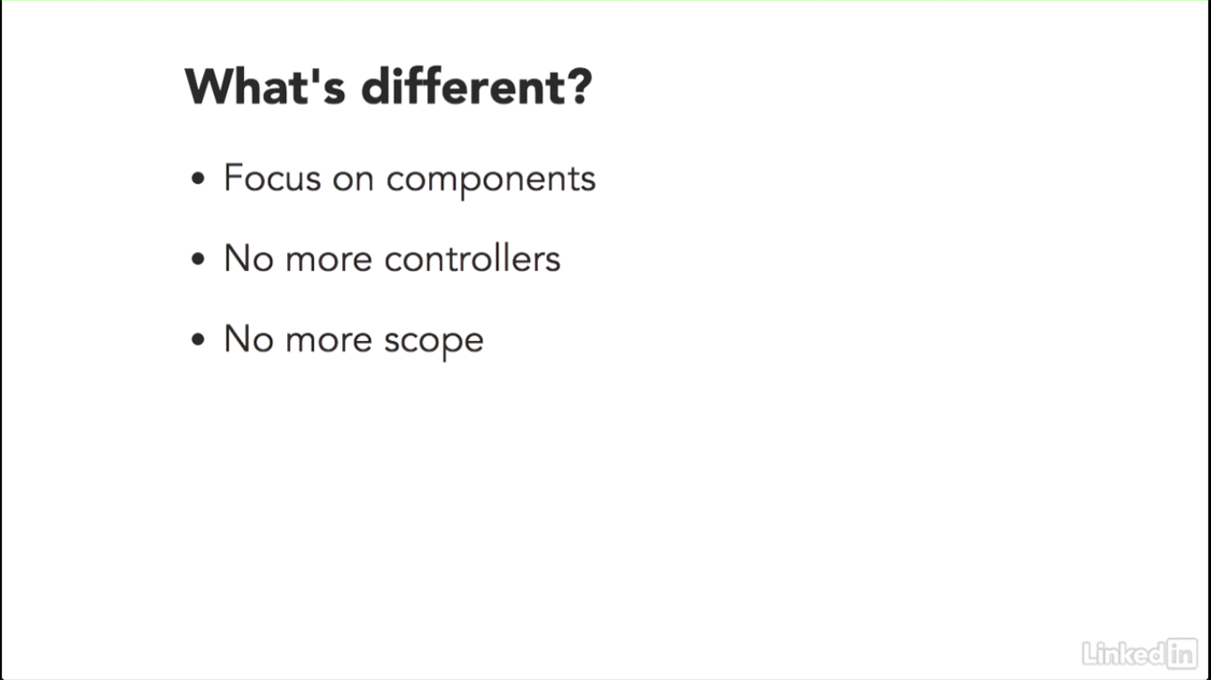

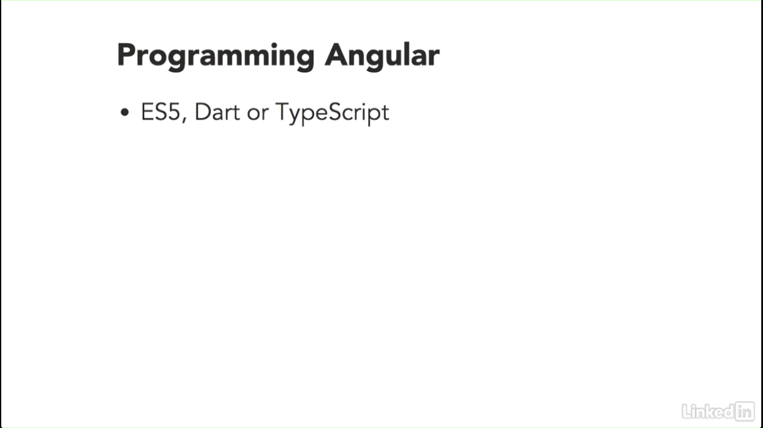

ES5 – Standard Javascript

DART – Language from Google

TypeScript – Language from Microsoft

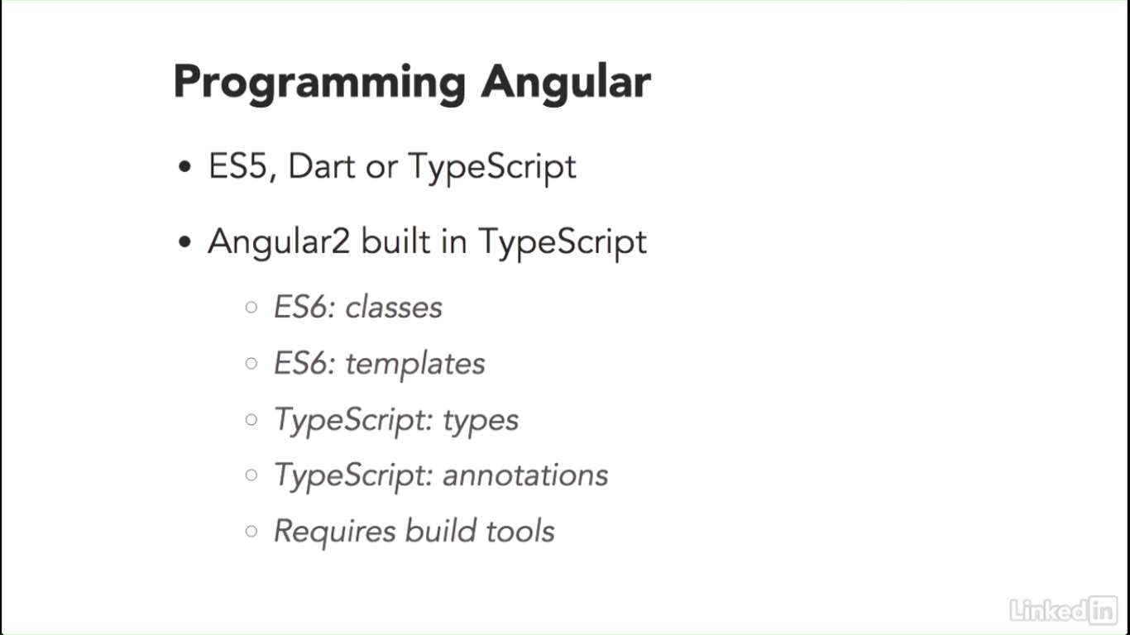

Annotations: Add metadata to your code

Currently Typescript is not supported in regular browsers. Hence build and compile tools are needed to convert typescript to javascript that browsers can process.

WebPAck or GulpJS can be used fro compilation

ES6 🡪 ECMA Script6

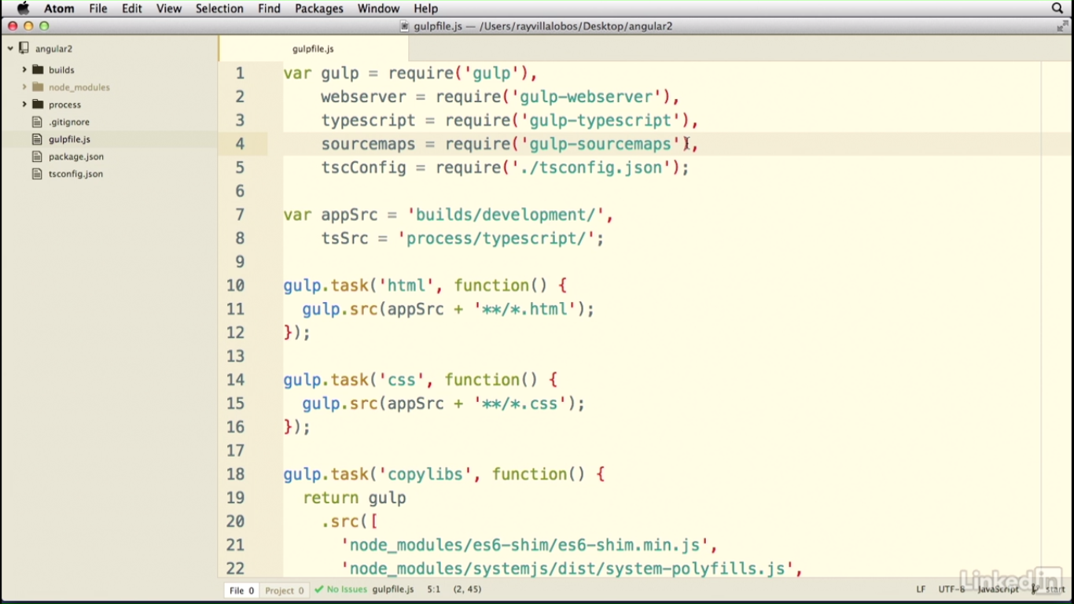

Some of the gulp plugins need to be configured including:

Gulp-webserver 🡪 this is where the angular2 code will run

Gulp-typescript 🡪 For compiling ts to js

Gulp-Sourcemaps 🡪 maps the errors in browser to typescripts and not generated javascripts

tscConfig 🡪

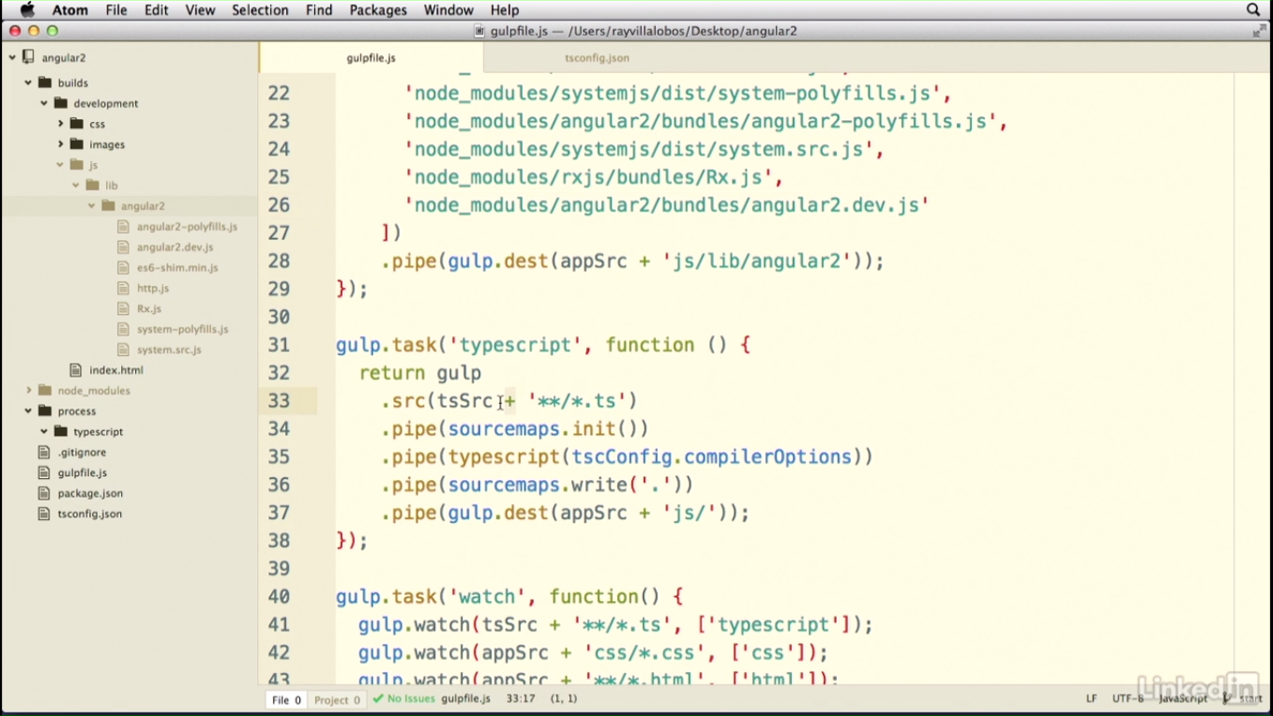

Watch 🡪 any typescript modification etc can be compiled as soon as changes are made

