AWP Experiment 7

Code:
clc
clear all
close all

k=2*pi;
d=0.5;

%broadside
N=[4 8 12]
for i=1:3
theta=0:(pi/180):2*pi;
beta=0;
psi=(k*d*cos(theta))+beta;
af=(1/N(i))*(sin(N(i)*psi*0.5)./sin(psi*0.5));
figure(1)
subplot(1,3,i)
polar(theta,af)
title(sprintf('Polar Plot for Broadside Array with %i elements',N(i)))
end

%endfire for O degree
N=[4 8 12]
for i=1:3
theta=0:(pi/180):2*pi;
beta=-1*k*d;
psi=(k*d*cos(theta))+beta;
af=(1/N(i))*(sin(N(i)*psi*0.5)./sin(psi*0.5));
figure(2)
subplot(1,3,i)
polar(theta,af)
title(sprintf('Polar Plot for 0 degree End Fire Array with %i elements',N(i)))
end

%endfire for O degree
N=[4 8 12]
for i=1:3
theta=0:(pi/180):2*pi;
beta=k*d;
psi=(k*d*cos(theta))+beta;
af=(1/N(i))*(sin(N(i)*psi*0.5)./sin(psi*0.5));
figure(3)
subplot(1,3,i)
polar(theta,af)
title(sprintf('Polar Plot for 180 degree End Fire Array with %i elements',N(i)))
end

Output:
For Broadside Array
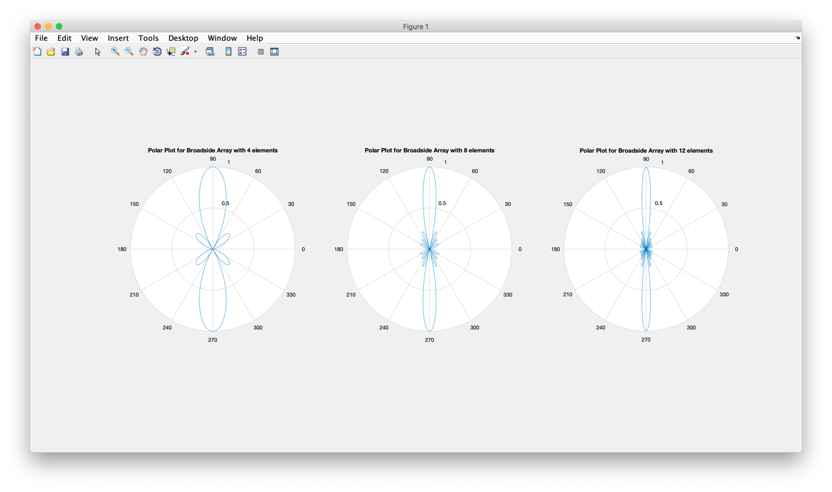
For End Fire Array for 0 Degrees
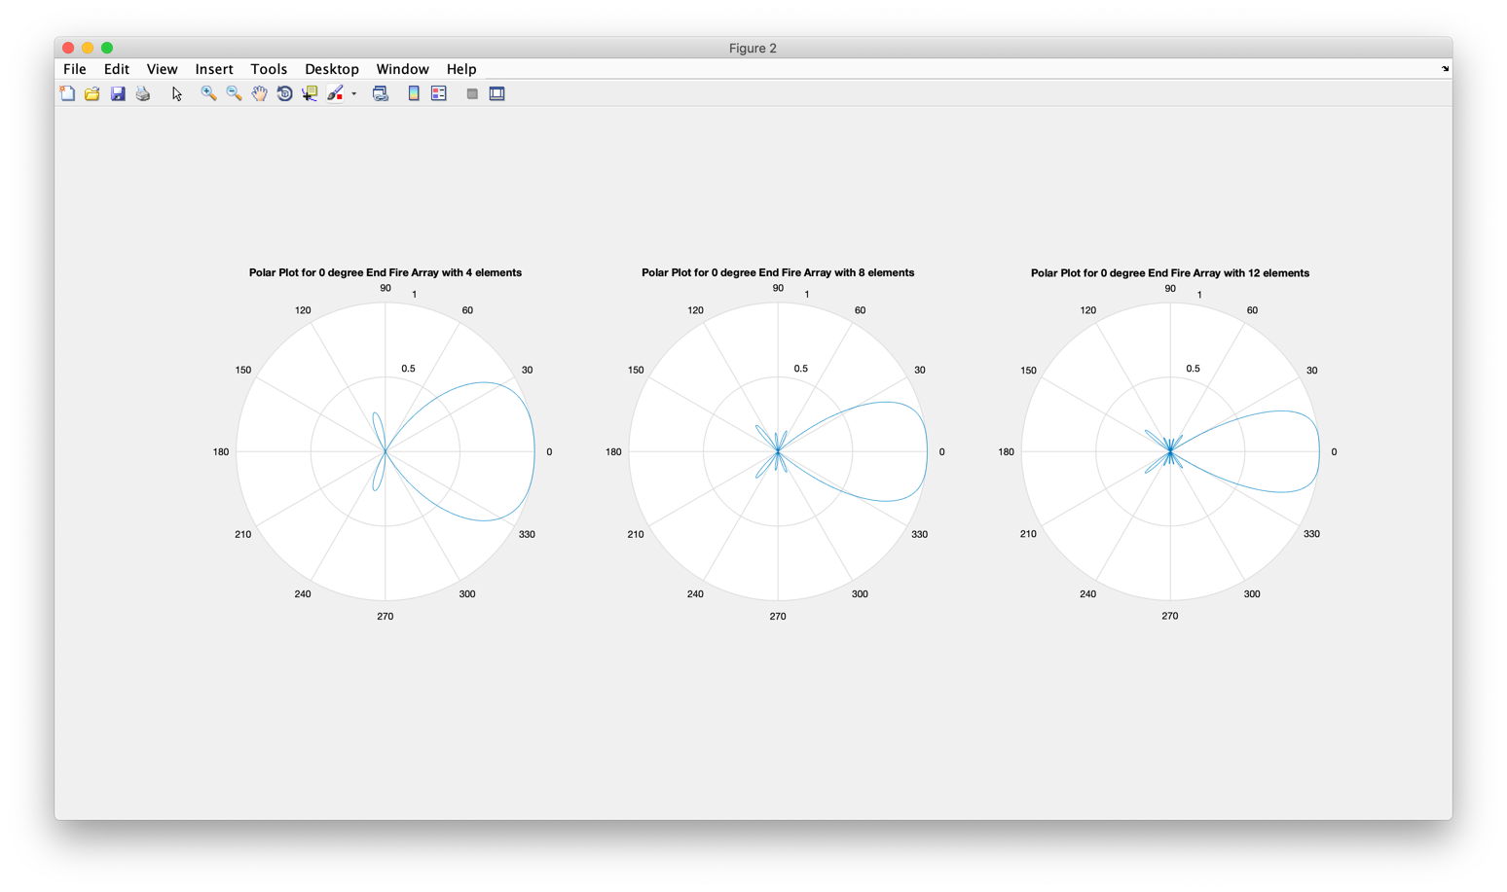

For End Fire Array for 180 Degrees
