 Tech Comm Templates

Business Requirements Document (BRD) Template

Project/Initiative

Month 20YY

Version X.XX

Company Information

# Document Revisions

|  |  |  |
| --- | --- | --- |
| Date | Version Number | Document Changes |
| 05/02/20xx | 0.1 | Initial Draft |
|  |  |  |
|  |  |  |
|  |  |  |
|  |  |  |
|  |  |  |
|  |  |  |
|  |  |  |
|  |  |  |

# Approvals

|  |  |  |  |  |
| --- | --- | --- | --- | --- |
| **Role** | **Name** | **Title** | **Signature** | **Date** |
| Project Sponsor |  |  |  |  |
| Business Owner |  |  |  |  |
| Project Manager |  |  |  |  |
| System Architect |  |  |  |  |
| Development Lead |  |  |  |  |
| User Experience Lead |  |  |  |  |
| Quality Lead |  |  |  |  |
| Content Lead |  |  |  |  |

# Introduction

## Project Summary

### Objectives

[These should describe the overall goal in developing the product, high level descriptions of what the product will do, how they are aligned to business objectives, and the requirements for interaction with other systems.]

* Deliver a Widget Interactive Naming System (WINS) that synchronizes naming and linking of all widgets in all systems across the enterprise.
* Avoid duplication of widget names and reduce time to production for existing projects.
* Support text searching on widget names or business descriptions.
* Sync widget names and changes to Windows and Linux platform administration tools.
* Tracks changes to widgets including new widgets, modified widgets, and widgets to be archived.

### Background

[Provide a brief history of how the project came to be proposed and initiated, including the business issues/problems identified, and expected benefit of implementing the project/developing the product.]

Timely and accurate synchronization of widget names will reduce development levels of efforts across the enterprise by eliminating duplicate names of widgets in development and deployed. Acme uncovered seriously high levels of errors across testing environments, production error messages, and increased rework due to lack of knowledge about widgets already in production.

#### Business Drivers

[List the business drivers that make development of this product important. These can be financial, operational, market or environmental.]

* Customers are looking for faster updates to information on the [product] website, and may consider competitors if needs are not met.
* Development group requires a scalable solution to track the widgets being deployed into all environments to better manage resources.

## Project Scope

[Describe what work is in scope for the project, and specifically what work is out of scope… beyond the current budget, resources and timeline as approved by the project stakeholders. This is designed to prevent “scope creep” of additional features and functions not originally anticipated.]

### In Scope Functionality

* Create name records for widgets by category
  + Supply Chain
  + Production Lines
  + Internal web apps
  + External web apps
* Ability to create/delete widget names restricted by role
* Search by name, team, date, last modified
* Synchronize widgets across product/operations lines
* Provide audit trail
* Reporting on new, modified, and archived widgets by time period and team

### Out of Scope Functionality

* Create widgets for subsidiary company product lines
* Search by approver, or rationale
* Archiving of widget objects

## System Perspective

[Provide a complete description of the factors that could prevent successful implementation or accelerate the projects, particularly factors related to legal and regulatory compliance, existing technical or operational limitations in the environment, and budget/resource constraints.]

### Assumptions

* Inventory of existing widgets completed by Q1.
* Testing data comprises scrubbed production data as of December 31.

### Constraints

* Impending changes to privacy regulations may impact data dictionary design.
* Timeline for enterprise platform updates will impact execution of testing plan.

### Risks

* Previously approved Q2/Q3 development projects may limit availability of development and QA resources, necessitating outsourcing or additional budget requisitions to meet the anticipated timeline.
* .

### Issues

# Business Process Overview

[Describe how the current process(es) work, including the interactions between systems and various business units. Include visual process flow diagrams to further illustrate the processes the new product will replace or enhance.

Use case documentation and accompanying activity or process flow diagrams can be used to create the description(s) of the proposed or “To-Be” processes.]

## Current Business Process (As-Is)

At any point during or after deployment of web apps or web sites (internal or external) to support business activities, development/support teams may create and deploy widgets.

1. CMS / database administrators for the employee portal use the CMS tool to create widgets. They can test widgets in the designated staging environment, then register them and deploy to production.
2. Development teams may deploy widgets to development and testing environments set up for their development projects. They must check widget code into and out of the source code repository according to their projects’ development schedule.

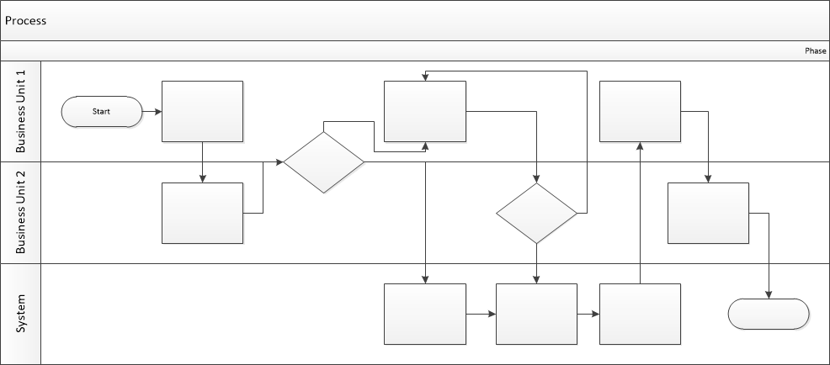

## Proposed Business Process (To-Be)

1. Technical Lead searches repository
2. If widget is not found, user creates a new widget name record.
3. WINS validates that all fields have been completed.
4. WINS confirms that no similar widgets exist
5. User confirms record to be created.



1. User searches repository to locate existing widget description.
2. WINS displays record
3. User selects Edit to open and modify record
4. WINS validates all fields completed correctly
5. User confirms changes.
6. WINS confirms changes and updates Audit table.



# Business Requirements

[The specific business requirements elicited from stakeholders should be listed, categorized by both priority and area of functionality to smooth the process of reading and tracking them. Include links to use case documentation, and other key reference material as needed to make the requirements as complete and understandable as possible. You may wish to incorporate the functional and non-functional requirements into a traceability matrix that can be followed throughout the project.]

The requirements in this document are prioritized as follows:

|  |  |  |
| --- | --- | --- |
| **Value** | **Rating** | **Description** |
| 1 | Critical | This requirement is critical to the success of the project. The project will not be possible without this requirement. |
| 2 | High | This requirement is high priority, but the project can be implemented at a bare minimum without this requirement. |
| 3 | Medium | This requirement is somewhat important, as it provides some value but the project can proceed without it. |
| 4 | Low | This is a low priority requirement, or a “nice to have” feature, if time and cost allow it. |
| 5 | Future | This requirement is out of scope for this project, and has been included here for a possible future release. |

## Functional Requirements

| **Req#** | **Priority** | **Description** | **Rationale** | **Use Case Reference** | **Impacted Stakeholders** |
| --- | --- | --- | --- | --- | --- |
| **General / Base Functionality** | | | | | |
| FR-G-001 | 1 | A new Master Widget repository shall be created to house the name records and links to the widget objects. | Single repository simplifies management of widget development across 30+ global development teams |  | Development teams  Infrastructure engineers |
| FR-G-002 | 1 | A widget shall be defined in the repository via a unique identifier and name combination. | ID+Name eliminates duplicate widget name records |  |  |
| FR-G-003 |  |  |  |  |  |
| FR-G-004 |  |  |  |  |  |
| FR-G-005 |  |  |  |  |  |
| **Security Requirements** | | | | | |
| FR-S-001 | 1 | Widget creation in the repository shall be limited to users with Team Lead or System Administrator, |  |  |  |
| **Reporting Requirements** | | | | | |
| FR-R-001 | 2 | The system shall generate a weekly Report of Widget Name Status Changes |  |  |  |
| **Usability Requirements** | | | | | |
| FR-U-001 | 1 | User interface for the WINS repository shall be responsive, allowing for proper display on tablet, laptop, and desktop devices. |  |  |  |
| **Audit Requirements** | | | | | |
| FR-A-001 | 1 | Any change to a widget name record shall be appended with user ID and date/time stamp. |  |  |  |

## Non-Functional Requirements

[Include technical and operational requirements that are not specific to a function. This typically includes requirements such as processing time, concurrent users, availability, etc.]

|  |  |
| --- | --- |
| **ID** | **Requirement** |
| NFR-001 | The WINS repository shall accommodate up to 100 users concurrently. |
| NFR-002 | The WINS repository shall be designated at Level 2 for availability and SLA purposes. |
| NFR-003 |  |
| NFR-004 |  |
| NFR-005 |  |

# Appendices

## List of Acronyms

[If needed, create a list of acronyms used throughout the BRD document to aid in comprehension.]

## Glossary of Terms

[If needed, identify and define any terms that may be unfamiliar to readers, including terms that are unique to the organization, the technology to be employed, or the standards in use.]

## Related Documents

[Provide a list of documents or web pages, including links, which are referenced in the BRD.]