**CS570 Artificial Intelligence**

**Spring 2012**

**Project 2a**

**Sanqing Yuan**

**Feb 25, 2012**

Before the game, the game board is blank with the first row showing the position of x, and the first column showing the position of y. There are two players in the game. One player drops X on the board and another player drops O on the board.

The game board before the game looks like:

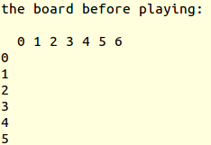

1. **Output showing the first few moves of a game.**

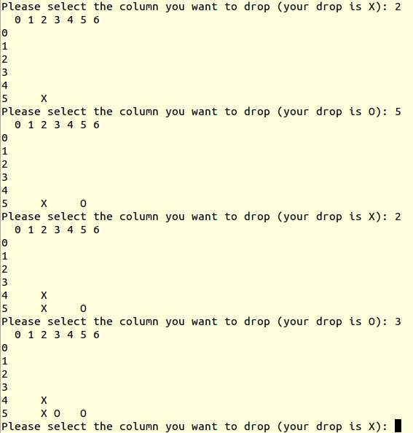

1. **Output showing how illegal moves are handled.**

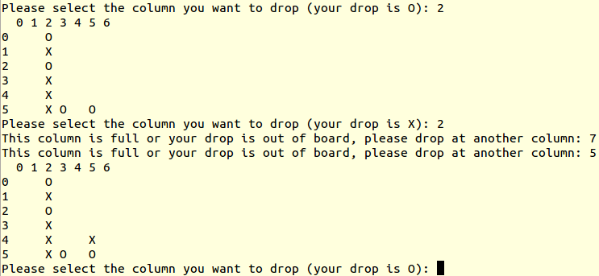

1. **Output showing a victory.**

