**Design and Simulation of an Automatic Temperature Control System using LPC2148 Microcontroller**

**19ELC301 Real Time Embedded Systems**

***Mini Project Report***

*Submitted by*

**CB.EN.U4ELC19036 Pradhumna Guruprasad**

**CB.EN.U4ELC19046 Sai Dheeraj D**

**CB.EN.U4ELC19052 Shreyas Nagesh**

November 21, 2021

**2021 - 2022**

DEPARTMENT OF ELECTRICAL AND ELECTRONICS ENGINEERING

AMRITA SCHOOL OF ENGINEERING

AMRITA VISHWA VIDYAPEETHAM

COIMBATORE

AMRITA SCHOOL OF ENGINEERING

AMRITA VISHWA VIDYAPEETHAM, COIMBATORE 641112.

DEPARTMENT OF ELECTRICAL AND ELECTRONICS ENGINEERING

# Declaration

We, **Pradhumna Guruprasad, Sai Dheeraj D, Shreyas Nagesh** hereby declare that project work entitled “**Automatic Temperature Control System using LPC2148 Microcontroller**”, is the record of the original work done by us and this written submission represents our work in our own words. To the best of our knowledge this work has not formed the basis for the award of any degree/diploma/associate ship/ fellowship or a similar award to any candidate in any University.

Wherever we have borrowed material from other sources, we have adequately cited and referenced the original sources. We also declare that we have not misrepresented or fabricated or falsified any idea/data/fact/source in our submission. We understand that any violation of the above will result in a grade of zero.

Pradhumna Guruprasad

CB.EN.U4ELC19036

Place: Bangalore

Date: 21/11/2021

Table of Contents

Declaration 2

Abstract 4

1. Introduction 5

2. Methodology 5

2.1 Construction 7

3. Design/ Logic 10

Results: 11

Conclusion 12

References 12

# Abstract

The objective of this project is to develop an automatic climate control system using LPC2148 microcontroller and interface an EEPROM along with it as memory. The system detects ambient temperature and gradually and smoothly brings the temperature of the room to the set temperature. This is accomplished by a PID controller. This project helps to remove the hassle of adjusting the temperature manually.

# Introduction

Manually adjusting the temperature of the room is a big hassle, especially in the nights. This project alleviates those pains and automatically brings the ambient temperature to the desired level quickly and smoothly. The desired temperature is stored in the external EEPROM interfaced to the microcontroller using the I2C protocol. Then, the PID controller accurately controls the cooling device in accordance with the amount of cooling required in the room. The virtual terminal simulates the display which shows the current temperature and the set temperature. This closed loop system works with the help of an LM35 temperature sensor, which has a high range of -50 to 150 degrees Celsius.

# Methodology

This mini project mainly includes a closed loop system in which the feedback element is the actual temperature of the environment that is to be monitored. On basis of this feedback, the temperature of the system can be easily maintained within the set temperature. The basis of this project is to replace manual settings of fan in accordance with temperature so that it detects temperature variation automatically and control the temperature of the system. The application dictates that temperature settings are usually kept constant for long periods of time. The circuit present the design, construction, development, and control of automatic switching electric fan. The idea is based on the problem occurs in human’s life now-a-days by improving the existing technology. The microcontroller (LPC2148) based automatic fan system is applied to upgrade the functionality to embed automation feature. The electric fan will automatically switch on according to the environmental temperature change. The circuit is using a microcontroller to control the fan according to the temperature variations. The system measures the temperature from the integrated circuit, where it will control the fan according to the setting values in the programming. Also, the temperature of the system is measured using sensor. This value is provided to the microcontroller. The microcontroller then provides the signal increase or decrease the input voltage given to the fan such that the temperature of the system can be maintained within the required set temperature.

*Fig.1 Block Diagram*

*Fig.2 Circuit Diagram*

## Construction

**DRIVER:**

A Microcontroller digital logic output pin supplies only 10mA of current. External devices such as high-power relays can require >100mA and they need more voltages. In order to control such devices which, use high DC current, a transistor-based driver circuit is used to amplify current to the required levels. If the voltage and current levels are in perfect range, the transistor acts like a high-current switch controlled by the lower current digital logic signal. It amplifies the voltage from micro-controller i.e., 5V to 12V.

**UART:**

UART stands for Universal Asynchronous Receiver/Transmitter. It’s not a communication protocol like SPI and I2C, but a physical circuit in a microcontroller, or a stand-alone IC. A UART’s main purpose is to transmit and receive serial data. It finds a wide range of applications. In this project it is used to show temperature. UARTs transmit data asynchronously, which means there is no clock signal to synchronize the output of bits from the transmitting UART to the sampling of bits by the receiving UART. Instead of a clock signal, the transmitting UART adds start and stop bits to the data packet being transferred. These bits define the beginning and end of the data packet, so the receiving UART knows when to start reading the bits. When the receiving UART detects a start bit, it starts to read the incoming bits at a specific frequency known as the baud rate. Baud rate is a measure of the speed of data transfer, expressed in bits per second (bps). UART transmitted data is organized into packets. Each packet contains 1 start bit, 5 to 9 data bits (depending on the UART), an optional parity bit, and 1 or 2 stop bits.

**RELAY:**

Relay is a switching device used to perform switching action. The relay before fan is used switching of fan and the relay before heater is used switching of heater.

**MICROCONTROLLER:**

In this project LPC2148 micro-controller is used. LPC2148 controller is cheap, fast and easy for programming than other micro-controllers.

**SENSOR:**

In this project LM35 temperature sensor is used. LM35 temperature sensor can read up to -55°C to 150°C.

**MATERIALS REQUIRED:**

# Design/ Logic

The circuit presents the design, construction, development, and control of automatic temperature control. The idea is based on the problem occurs in human's life nowadays by improving the existing technology. The LPC2148 based automatic temperature control system is applied to upgrade the functionality to embed automation feature. The Fan/AC will turn on automatically when the temperature falls above the temperature set point accordingly. The system monitors the temperature from the LM35 temperature sensor, where it will control the Fan/ AC according to the setting values in the programming. The system indicates the temperature from the LPC2148, and it will display it on the UART based Virtual Terminal.

Step 1: Read the setpoint temperature from EEPROM AT24C512 which is set by the user.

Step 2: Read the current temperature.

Step 3: Find the error and use the PID Controller to generate the PWM output.

Step 4: According to the range send the PWM to Fan/ AC.

Step 5: Repeat Steps 1 through 4 continuously.

The circuit is a closed loop circuit. PID Controller checks the error and determines the PWM output at a particular instance to maintain the temperature set point given by user.

In this system, the temperature to be maintained is given by the user. If the temperature goes above the range the PID Controller generates a PWM output which determines the Duty Cycle of the Fan/ AC Module. In each time instance the current temperature is displayed on the UART Virtual Terminal.

The temperature sensor gives the analog output voltage based on the temperature of the room. This analog voltage is fed to the A/D converter. The A/D converter then converts the analog input voltage from the temperature sensor into equivalent binary bits. The converted binary data from the A/D converter is applied to microcontroller. The microcontroller reads binary data from A/D converter, convert it to suitable form and performs different operations based on the value of temperature read from A/D converter. The UART Virtual Terminal is used to display the data given by microcontroller. Microcontroller uses a PID Controller to generate a PWM output which is duty cycle which determines the ON time of Fan/AC to maintain the desired temperature.

# Results:

In this project 3 outputs as produced:

1) EEPROM:

The temperature value from the sensor is written in the EEPROM to create a safe space for values to be stored in without being altered. The value written is then sent used by the PID algorithm which then generates a PWM signal to control the motor. All the values read from the sensor, written into EEPROM and the temperature at every instance of time (for continuous monitoring of temperature flow) is displayed in the virtual terminal. The result produced from the virtual terminal is prove that EEPROM is working and the value from sensor is read to EEPROM.

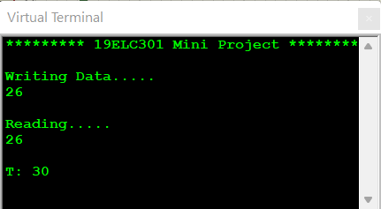

**PWM WAVEFORM:**

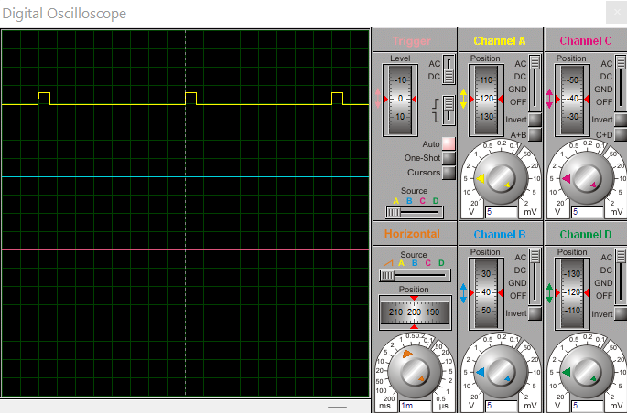

2) Actuator – motor:

The motor in the project is used to showcase the working of cooling mechanism in accordance with the ambient temperature. The motor is controlled by the PWM waveform based on the result from PID controller. The duty cycle from the PWM wave is the on time for the motor as the sensor value goes up the PWM waveform becomes 0 which is the input to motor and then the motor gradually stops.

**Motor output:**

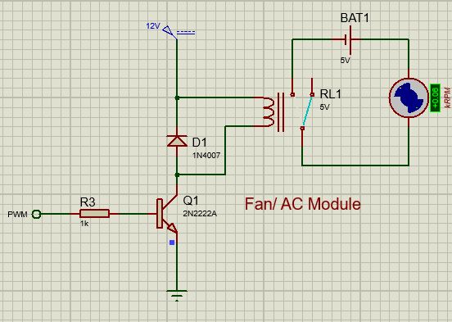

# Conclusion

The project is used to maintain temperature at a constant rate using PID controller. This project can be further developed by implementing the best use of PID controller and EEPROM. For example, we can use the EEPROM to store the binary data of a fingerprint and PID controller for controlling certain output based on fingerprint, However, the project can be used for numerous applications by changing the actuator and algorithm.

# References

1. <https://www.electronicwings.com/arm7/lpc2148-i2c>
2. <https://binaryupdates.com/pwm-in-lpc2148-arm7/>
3. <http://www.ocfreaks.com/interfacing-lm35-sensor-lpc2148/>
4. <https://cs140e.sergio.bz/notes/lec4/uart-basics.pdf>
5. <https://www.8051projects.net/wiki/AT24xxx_I2C_EEPROM_Interfacing>