Automatic beverage vending machine

**19ELC212 Microcontrollers and Applications**

***Mini Project Report***

*Submitted by*

**CB.EN.U4ELC19046 SAI DEERAJ.D**

May 12, 2021

**2021 - 2022**

**Declaration**

We, **K.S. Naveen Kumar Reddy**, **Sai Deeraj .D** hereby declare that project work entitled “**Automatic beverage vending machine**”, is the record of the original work done by us and this written submission represents our work in our own words. To the best of our knowledge this work has not formed the basis for the award of any degree/diploma/associate ship/ fellowship or a similar award to any candidate in any University.

Wherever we have borrowed material from other sources, we have adequately cited and referenced the original sources. We also declare that we have not misrepresented or fabricated or falsified any idea/data/fact/source in our submission. We understand that any violation of the above will result in a grade of zero.

Sai Deeraj.D

CB.EN.U4ELC19046

Place: Coimbatore

Date: 12-05-2021

Table of Contents

Abstract 4

1. Introduction 5

2. Methodology 5

3. Design/ LogiC 6

4. RESULTS 7

References 8

# 

# Abstract

The automatic beverage vending machine is designed as an advancement of usual vending machines. The system we presented could store the data of choice of beverage that a person is most interested in , we approached this using a PIC16F877A microcontroller. The programming process has been accomplished using the standard application MPLAB X IDE v5.45 with the support of PROTEUS v8.0 for simulating the entire system and collected data of choice of individuals could further be used to reduce the wastage.

# Introduction

The choice of beverages like coffee, milk, and tea for a person will not change frequently and this project is developed based on it. Though sometimes the diversity of choice is necessary to add some fun to our senses most people prefer to have the same beverages only daily basis so storage of these choices can reduce our time that is wasted near vending machines and this data could preferably be used to reduce the wastage. The soul of our project lies here.

# Methodology

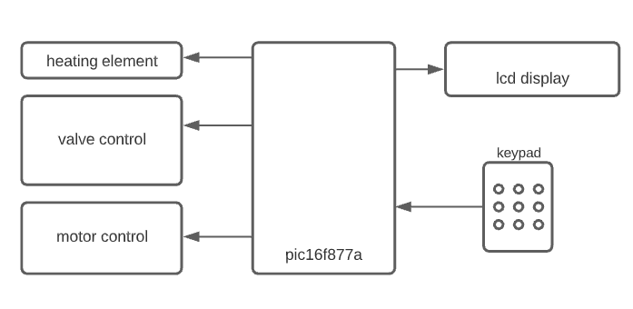

Fig 1 block diagram representation of the system.

i)LCD display and keypad

LCD and keypad are used as interactive elements. They perform functions of collection of data and choice of selection from the user among the choices displayed on the LCD.

ii)Valve control

For the valve control, we choose servo motors to emulate the gate valve mechanism with the help of pulse width modulation. The control wire of the servo motor is directly connected to the output pin of the microcontroller. This pin is then provided with the required angular displacement of the motor.

iii)Motor control

The output of the microcontroller cannot drive the Dc motor so a driver module is necessary to not only drive the DC motor and also to prevent the damage of the microcontroller from the back

emf that is being produced during its running. So for this purpose L293D is used as the driver for the dc motor.

At first welcome message is displayed to greet the user then we use an lcd to communicate with the user and get their desired choices using the keypad. After getting the choice we move to the valve control to perform actuation to get pour beverage (tea and milk) which is prefilled into the container but if the user wants coffee then we switch between valve(milk and coffee powder) and motor control(for mixing) to get the users beverage ready once done coffee is then poured into container using valve control. while performing all the above functions a heating element is switched on simultaneously to warm up the beverage. At the end user is provided to save the choice for faster checkout if done then next time preferred beverage starts on its own without the intervention of the user.

**DESIGN/LOGIC**

**DESIGN:**

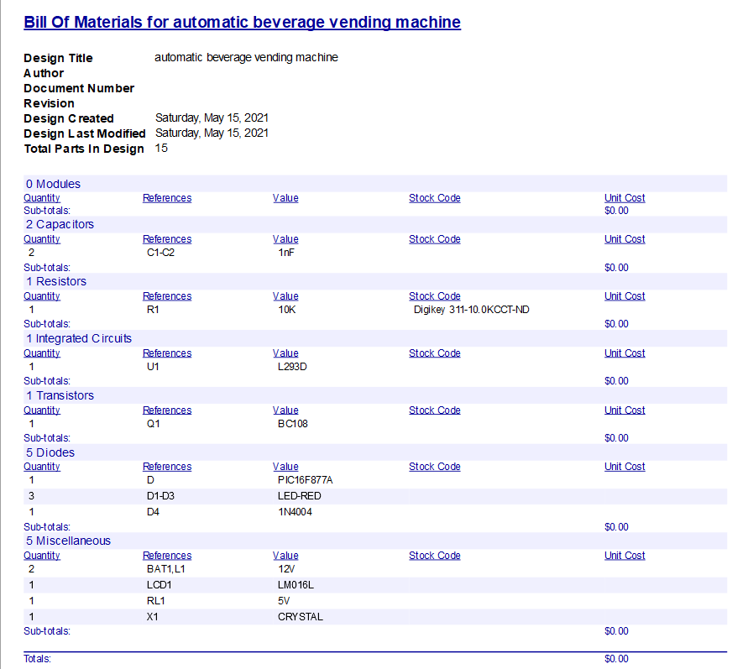

LCD configuration used is a 16x2 display with 8 bit operation mode this is directly connected to controller and all the user communication to the pic microcontroller is done using lcd as the intermediate communicator.

L293D is a push-pull four channel driver with diodes this is used to make the motor. Due to current coming out of pic microcontroller is very low we need an IC to operate the dc motor. A DC motor here is used because of its high efficiency than a servo motor for the purpose of mixing the coffee grains and milk.

BC108 a transistor of npn configuration is used to power the relay which in turn turns on the heater for keeping the beverages warm. Here BC108 is used due to correct coming out of pic microcontroller is low. specifically BC108 is used due to its high power output.

A resistor of 10Kohm is connected to the base of the transistor to control the current such that only sufficient amount is flowing through transistor making it to operate as a switch. We can also arrive at this value by using kirchhoff's law.

PWM controlled servo motor is used as valve due to its low power consumption and best locomotory movement. we control this motor by provide certain pulses to movement at the specific angle in the code we used 800 to 1700 microsecond to control motor to 0 to 180 degree angle

**LOGIC:**

STEP 1: checking for id verification using employers id number

STEP 2: if matching then:

                       heater on

                       STEP 3: logging in into account then selecting choices

                       STEP 4: based on the user’s choice making the desired item

                       STEP 5: option to save user’s choice (yes/no)

                       STEP 6: logging out

else:

displaying thank you

STEP 7: checking for id verification using employers id number

STEP 8: if id matches and the same person is logging again and option to save is

selected as yes then:

          heater on

           either preparing saved order or getting new order (choice to user)

        if saved order is selected then:

                        preparing saved order

          else:

                        repeat step 3, step 4, step 5, step 6

STEP 9: else if id matches and the same person is logging again and option to save is

selected as no then:

                repeat step 3, step 4, step 5, step 6

else if id matches and is a first time user:

          repeat step 3, step 4, step 5, step 6

else: displaying thank you

**RESULTS**

|  |  |
| --- | --- |
| EMPLOYEE ID NUMBER | DISPLAY INITIALIZATION |
| 1234 | 1/0 |
| 5678 | 1/0 |
| 1028 | 1/0 |
| 7923 | 1/0 |
| 5210 | 1/0 |
| 2964 | 1/0 |
| 5791 | 1/0 |
| 0024 | 1/0 |

**NOTATION:**

ID MATCHED -1

ID MISMATCHED – 0

**NOTE: TEA AND MILK ARE PREFILLED .TEA HERE IS PREFILLED TO SERVE USER THE BEST EXPERIENCE THAN FOLLOWING SOME INSTANT PROCESS**

|  |  |  |  |  |  |  |  |  |
| --- | --- | --- | --- | --- | --- | --- | --- | --- |
| DISPLAY | EMPLOYEE  CHOICE | DC MOTOR | COFFEE  GRAINS | TEA | ONLY MILK | MILK | MIXING CHAMBER  VALVE  (COFFEE) | RESULT |
| 1 | COFFEE | ON | ON | OFF | ON | OFF | ON | Coffee comes out from valve named mixing chamber |
|  | TEA | OFF | OFF | ON | OFF | OFF | OFF | Tea comes out from the valve named TEA |
|  | MILK | OFF | OFF | OFF | ON | OFF | OFF | Milk comes out from the valve named ONLY MILK. |
|  | SELECTION  THAT IS NOT IN CHOICES | OFF | OFF | OFF | OFF | OFF | OFF | NO OPERATION PERFORMED.  Displays: “THANKYOU” |
| 0 | - | - | - | - | - | - | - | “THANKYOU” |

**CONCLUSION**

This project can be used in the office as well as any real-life situations pertaining to such an environment that is available to that of an office setup. By further improving the project and making it capable of using biometric analysis of a company's data our project can work more efficiently. This type of system is mainly designed to save the delay of waiting in a queue in a regular canteen without compromising the quality of beverage. The system uses small servo motors and a dc motor which consumes very less power than those which are used these days. We can also improvise are project such that each time we process coffee the bill will be deducted automatically from your paycheck. By doing this it takes are project to a next level by satisfying clients without any limitation for their quench to beverage thirst. With the slight modification in our project we can limit our waiting time in the billing counter to minimum. Our heating mechanism that we have used in our project is one of the efficient ways to contain heat of beverages using limited current. Our project makes the best competition to today's beverage machines.

# References

1. <https://www.elprocus.com/h-bridge-motor-control-circuit-using-l293d-ic/>
2. <https://circuitdigest.com/article/servo-motor-working-and-basics>