**Smart Automatic Emergency Lights**

**19ELC201 Sensor and Sensor Circuit Design**

***Mini Project Report***

*Submitted by*

**CB.EN.U4ELC19046 Sai Deeraj D**

October 08, 2020

**2020 - 2021**

**Contents**

1. Abstract 3

2. Introduction 4

3. Methodology 5

4. Circuit design 6

5. Implementation, Results and Discussion 8

6. Conclusion 9

7.. References 10

**Abstract**

Studies show that manual lighting systems waste greater than 40% of the energy as compared to their automatic counterparts **[6]**. Energy conservation is the need of the hour now. Therefore, our project’s aim is to create an automatic emergency lighting system. The user need not worry about manually turning on and turning off the lights as our system takes care of this automatically. The system senses the ambient light intensity in the room and the availability of electricity from the grid. Using these 2 parameters, the system turns on the bulb at appropriate times. If the room is sufficiently dark, the light will turn on, and similarly, if there is a power cut or a power shutdown, the lights will be turned on. This system helps to conserve energy and adds convenience in the user’s life at a low cost since it has only low cost components and expensive microcontrollers are absent.

**Introduction**

In this modern era, automated technology plays an important role in everyday life. Most of the things that we see in our daily life are automated from our normal household appliances to machines in big industries. So, this project depicts a basic idea about how a simple automated circuit can be created, using some prominent sensors like LDRs and hall effect sensors. These are analog sensors. The whole system is set up with the help of op-amps, BJTs, and resistors. LDR is a very simple resistive sensor, ie. its output will be in the form of resistance. It is widely used in many applications like street lamps. In many advanced technologies, we can see lots of components that are based on the hall-effect sensor. This sensor is a 4-pin sensor; 2 are used for applying the hall voltage (VH) and 2 pins for output which will also be in form of voltage which is taken across the plate through which the magnetic field passes. The motive of the project is to implement a system which will monitor the change between day and night, then turn on light when it’s dark enough and additionally when there is an emergency situation where the power supply gets cut, the system detects that and turns on the emergency lamp. When power from the grid is available, the battery which powers the op-amps, bulbs, and BJTs will be charging. When the power supply is cut, this battery is used to power these components. Emergency systems of this kind that are in the market are quite expensive. Since our circuit is designed using low-cost components like op-amps and BJTs and there is no microcontroller present, the cost goes down.

**Methodology**

Our design helps to detect when there is low ambient light or no power and turn on the emergency lamps automatically. The schematic block diagram of our circuit is shown in Fig. 1.

To detect the AC grid, we connect the grid to an inductor. This inductor generates a magnetic field. When the flux density crosses 250 Gauss, i.e when the power supply is present, the hall effect sensor provides a very low output voltage which signifies that power is present. This voltage is sent to a comparator circuit which determines whether power is present or not.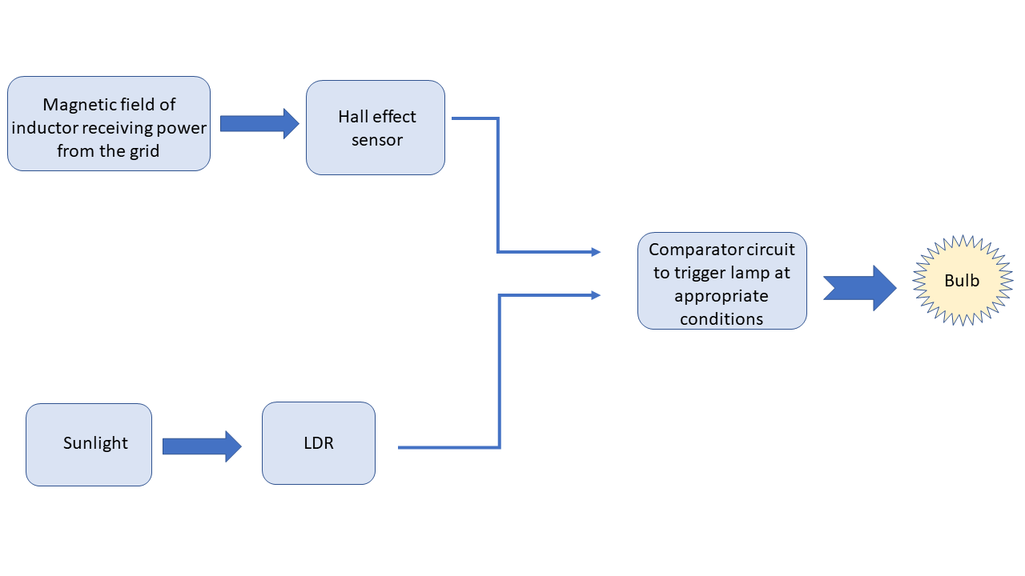

Simultaneously, the LDR detects the brightness of ambient light and it outputs the value as a resistance value. A comparator op-amp is used to check whether the ambient light has crossed the set threshold value of 5% of the total resistance or around 10 lux. If it has crossed it, the comparator sends its signal to another comparator which also determines the state of the power supply.

If any one of the conditions to turn on the light has been met, the final comparator powers the bulb.

Thus, the bulb glows when either there is no electricity from the grid, or when the ambient brightness is low.

Either 5 v or <1 1 k load resistor 5 and 1 at that point it changes r16 2.7 v 100 load resistor 200k ohm dark resistance 5% glow 10k random getting dsome voltagw drop 4.5 v 10k ohm beta factor bjt switch so voltage does not graduly increade 40.5 ohm to ensure 3 vdro[ 6 ohm main compartor summing value minimum valr 6 v to go bulb

**Circuit Design**

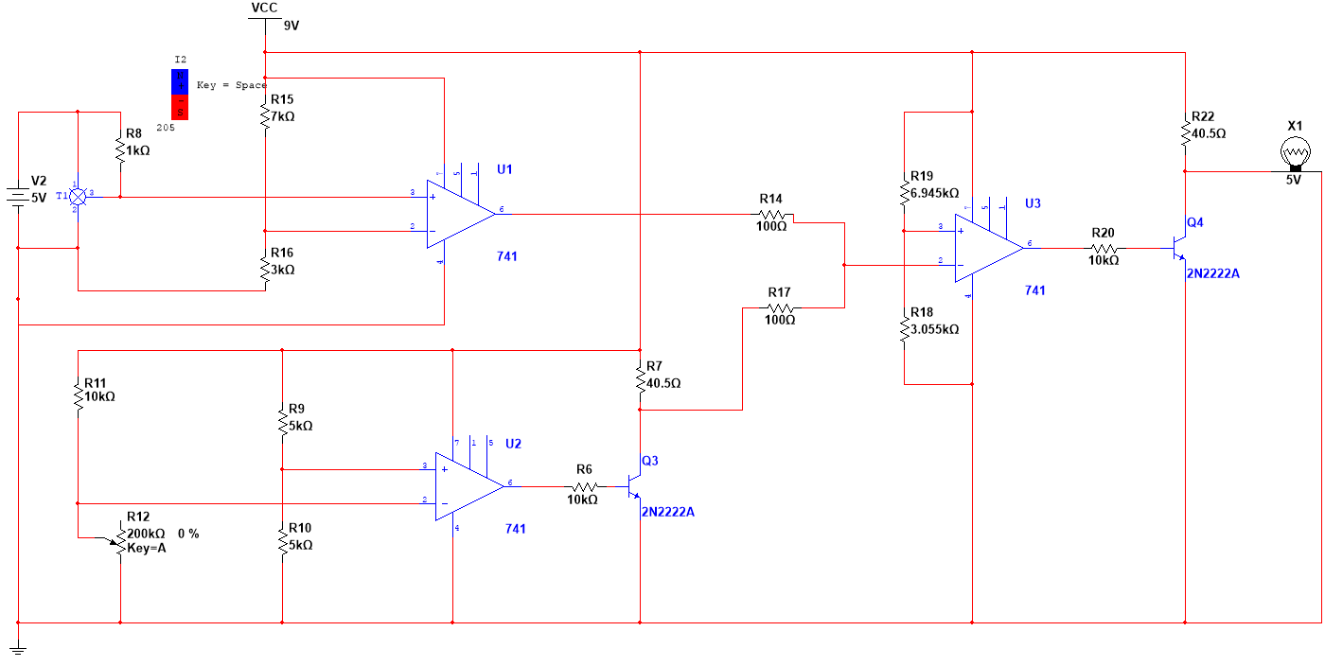

6 %We have used 2 sensors in this circuit and interfaced them appropriately to achieve the desired output.

The first sensor is the hall effect sensor which detects the presence of magnetic fields due to the AC grid. The sensor used is OHN3030U **[2]**. This sensor has a max BOP value of 250 Gauss. After crossing this threshold value, the voltage that will be received at the output terminal will be VOL which lies in the range of 100 - 400mV as given in the datasheet.

The second sensor is the LDR which is used for detecting the ambient light intensity. The manufacturer part number is PGM5516 **[1]**. Its resistance varies between 5 - 10kΩ at a brightness of 10 lux and has a dark resistance of 200kΩ.

The op-amps used in our circuit are LM741. It has a differential input voltage of 30V and an input voltage of 15V. The BJTs which we used in our circuit are 2N2222A.

***Circuit design of LDR***

***Voltage divider***

V = 10kΩ / (10kΩ+10kΩ) * 9V

= 4.5V

Therefore, to get half the voltage drop across each resistor, R9 = R10.

R9 = R10 = 5kΩ

***Design of Collector resistor R7***

IB = (VB - VBE) / RB = (8.113-0.7) / 10kΩ

= 741µA

β = 100

IC = IB x β

= 74.1mA

VRC = IC x RC

= 3V

RC = R7 = 40.5Ω=Vrc/ic

***Circuit design of hall effect sensor***

The hall effect sensor gives an output of 5V when the magnetic flux is below 205G, i.e. when electricity is absent. When this limit is crossed, the voltage falls to 18mV. Thus we chose a voltage value in between these 2 values as a trigger point for the op amp. This voltage value was taken as 2.7V **[4]**.

R15 = (2.7V / 9V) * 10kΩ 1 and 5

= 3kΩ

R16 = 10kΩ - 3kΩ

= 7kΩ

***Circuit design of op-amp comparator to trigger bulb***

***Voltage divider***

When both grid power is present and the ambient light is sufficiently bright, the voltage is 2.69V. The minimum summed voltage is obtained when only electricity from the grid is available and there is sufficient light. This voltage happens to be 2.746V. Therefore we designed the voltage divider to provide a voltage of 2.75V to the comparator so that once this voltage is crossed, the light turns on.

R20 = (2.75V / 9V) * 10kΩ

= 3.05kΩ

R19 = 10kΩ - 3.05kΩ

= 6.945kΩ

***Design of Collector resistor R22***

IB = (VB - VBE) / RB = (8.113-0.7) / 10kΩ

= 741µA

β = 100

IC = IB x β

= 74.1mA

VRC = IC x RC 6 v input 5 v 9 v

= 3V

RC = R22 = 40.5Ω

**Implementation Results and Discussion**

There are two main conditions by which this system works, one is the availability of grid supply which will be detected by hall-effect sensor OHN3030U. when the magnetic field due to AC supply reaches the required value the output from the hall-effect sensor will be low in the order of milli-volts so, no supply will be given to the output device ie. the lamp. The second condition should be satisfied to turn the bulb on again, it the LDR circuit where, if the room is dark enough the resistance will increase and once the op-amp comparator gets required voltage on both terminals will give out some significant voltage that will be enough to turn on the lamp.

|  |  |  |  |
| --- | --- | --- | --- |
| S. No. | Grid status | Condition of ambient light | Output (bulb) status |
| 1 | Electricity from grid not available | Low brightness | Bulb glows |
| 2 | Electricity from grid available | Low brightness | Bulb glows |
| 3 | Electricity from grid not available | High brightness | Bulb glows |
| 4 | Electricity from grid available | High brightness | The bulb does not glow |

gri

Our prototype circuit uses a magnet to generate the magnetic field instead of an AC source passing through an inductor. This demonstrates the magnetic effect of current and detection of this current through a hall effect sensor. The LDR in our circuit is modelled using a potentiometer of the same resistance as their behaviour are similar **[3]**.

When this circuit is done without an op-amp, ie. with only BJT and potential dividers it gives us an undesirable output. This because of the loading effect, when another resistance (resistance provided by BJT) is added to a potential divider this affects the voltage given out by the potential divider. to get past this problem an op-amp is added due to its high impedance which isolates potential divider and BJT **[5]**.

The values that are required to design the required components, the op-amp configuration and the potentiometer values that have been used as a light sensor are discussed and calculated to produce the desired output. When the resistance of the LDR is greater than 5% of its dark resistance, the light gets triggered. 5% of the dark resistance equates to around 10 lux of ambient brightness. This is an efficient brightness level to toggle on the bulbs. To produce light at 5% we use a voltage follower and an LDR modelled as a potentiometer. Our system does not need any microcontrollers or any programming to work. It is a simple hardware-based solution which is much more reliable and cost effective as compared to other methods.

To avoid voltage spikes to our sensor we can use clippers and signal conditioning circuits to make our circuit free of limitations.

**Conclusion**

This system can be used in situations where there are needs for conserving power as the primary objective. By further improving the circuit and making it capable of using renewable resources like solar energy, it can become very eco-friendly also. The system also detects grid supply voltage which makes it easier to detect flaws and conserve power with close monitoring systems. The system uses sensors and op-amps which are off low cost, economical and draws less power with no accord on efficiency. This system can be used in emergency lamps, street lights and traffic signals. This system can also be used to save accidents on highways and other congested places.

**References**

[1] <http://lednique.com/opto-isolators-2/light-dependent-resistor-ldr/>

[2] <https://www.instructables.com/Hall-Effect-Sensor-NI-Multisim/>

[3] Potentiometer working - <http://eeeforum.weebly.com/uploads/1/0/2/5/10254481/lecture7.pdf>

[4] “Measurement Instrumentation and Sensors Handbook” 2nd Edition By John g Webster *section - 48 (48.1, 48.2)*

[5] “The Art Of Electronics” -2nd Edition Paul Horowitz. *section-2 (2.02)*

[6]https://docs.lib.purdue.edu/cgi/viewcontent.cgi?article=1031&context=ihpbc#:~:text=The%20results%20showed%20that%20savings,compared%20to%20automatic%20lighting%20control.&text=Lighting%20control%20can%20result%20in,buildings%20with%20large%20glass%20facades.