Java实验报告四
- 代码如下：
JLab0401.java
public class JLab0401{
public static void main(String[] args){
Rectangle myRect = new Rectangle(2.5d,8.7d) ;
double theArea;
theArea = myRect.area();
System.out.println("My rectangle has area" +theArea);
}
}
Recatangle.java代码如下：
public class Rectangle{
double width,length;
public Rectangle(double width,double length){
this.width = width;
this.length = length;
}
public double area(){
double a;
a = length * width;
return a;
}
}
注：开始的时候始终没有用new，C++的老毛病了，后来发现怎么都过不了，然后怀疑是包的问题，后来发现不存在这个原因，所以后来发现了没有用new，改正后解决了。

2.修改后的代码如下：
public class JLab0401{
public static void main(String[] args){
Rectangle myRect = new Rectangle(2.5d,8.7d) ;
double theArea;
theArea = myRect.area();
System.out.println("My rectangle has area " +theArea);
System.out.println("rectangle's width " + myRect.width);
System.out.println("rectangle's length " +myRect.length);
}
}
结果如下：输出长度和宽度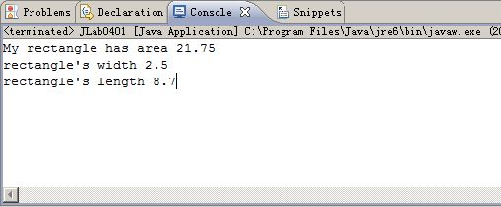

4.添加了setwidth和setlength方法后的，修改后的代码如下：
public class JLab0401{
public static void main(String[] args){
Rectangle myRect = new Rectangle() ;
myRect.setLength(10.8d);
myRect.setWidth(3.6d);
double theArea;
theArea = myRect.area();
System.out.println("My rectangle has area " +theArea);
System.out.println("rectangle's width " + myRect.width);
System.out.println("rectangle's length " +myRect.length);
}
}

public class Rectangle{
double width,length;
public void setWidth(double width){
this.width = width;
}
public void setLength(double length){
this.length = length;
}
public double area(){
double a;
a = length * width;
return a;
}
}
注意去掉了原来那个有参数的构造函数，因为要调用无参数的构造函数。截图如下：
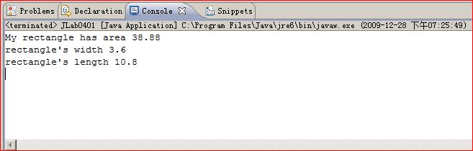
5，修改rectangle的构造函数，这样在构造的时候就能够输出信息，而不用改变main方法。代码如下：
public class Rectangle{
double width,length;
public Rectangle(double width,double length){
this.width = width;
this.length = length;
System.out.println("rectangle's width " + this.width);
System.out.println("rectangle's length " +this.length);
}
public double area(){
double a;
a = length * width;
return a;
}
}
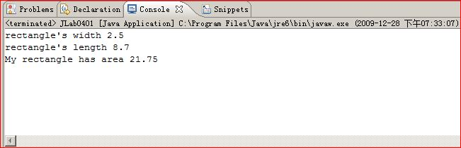
从图中可以看到，是先构造的时候输出相应的长和宽的信息。

6.编写的Cirecle类如下：
public class Circle {
public double radius;
public Circle(){
radius = 1;
}
public Circle(double r){
radius = r;
}
public double area(){
return (radius * Math.PI * Math.PI);
}
public double circumference(){
return (radius * 2 * Math.PI);
}
public String toString(){
String s = new String("Circle with radius" + this.radius);
return s;
}
public void setRadius(double r){
this.radius = r;
}
public double getRadius(double r){
return this.radius;
}
}
7.调用相关方法的验证代码如下：
public class JLab0401B {

public static void main(String[] args) {
Circle myCircle1 = new Circle();
Circle myCircle2 = new Circle(2.5d);
System.out.println("the area is " + myCircle1.area());
System.out.println("the radius is " + myCircle1.getRadius());
System.out.println("the circumference is "+ myCircle1.circumference());
System.out.println("the radius is " + myCircle2.getRadius());
myCircle2.setRadius(3.6d);
System.out.println("after change the myCircle2's radius is " + myCircle2.getRadius());
String s = myCircle2.toString();
System.out.println(s);
}

}
输出的有关结果是
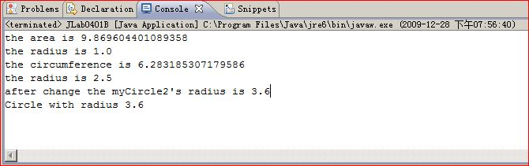

2代码如下：
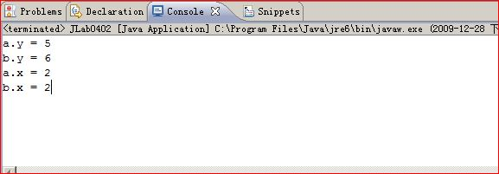
和预测 的结果一样。类变量是每一个类都有的，而实例变量是一个实例所拥有的特征的。这里实例变量直接输出它的值，而类变量是每一个实例都可以修改的，所以是最终的那个结果2.

