Test Plan
Test against Design Spec | Test & Test Data | Expected Results | Actual Results | Action Taken
Ensure cell formatting is correct | Check the “formatting” dialogue to ensure it is the correct type, depending on the data in the cell. Click on the cell 'Room Information'!C4 and ensure that it formats correctly. | Depending on the data inside the cell, the correct formatting should automatically apply. | Same as expected. 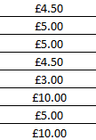 | No action needed.
Ensure drop down validation works as expected. | Click on one of the validated cells, and make sure that a drop down arrow appears. Click on one of the options, and ensure that it appears in the cell. | When a validated cell is clicked, a drop down menu should appear with appropriate selections. When clicked, these should go into the cell. | Same as expected. 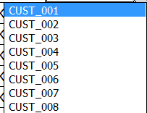 | No action needed.
Ensure spreadsheet dynamically alters calculations depending on data. | Change the ‘cleaning services’ drop down for a customer, and check the ‘total cost’ cell. | When a more expensive option is chosen, the total cost should change to reflect this addition, and vice-versa. | Same as expected. | No action needed.
Ensure macros go to the appropriate pages. | Go to the main page and click on one of the macro navigation buttons. | When the button is clicked, the button should take the user to the appropriate page. | Macros failed, because they were linked incorrectly.  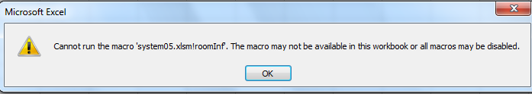 | Relinked up to correct pages.
Ensure that all formulas work correctly. | Check the formula bar for samples of cells. Navigate to the affected cell, and check they work. | All formulas should work correctly, without any errors. VLOOKUP formulas should find and change the information. SUM formulas should calculate numbers together. CONCANTENATE formulas should join strings and formulas together. COUNTIF should find the number of values in a range. | All work as expected.  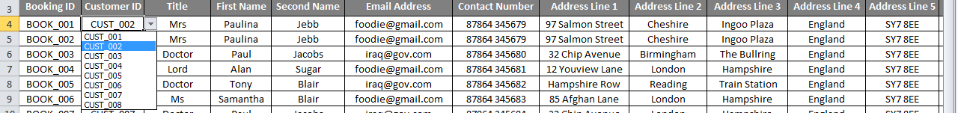 | No action needed.
Ensure conditional formatting works correctly. | Go to con. formatted cell, and change the value to something else. | Depending on whether a room is “Available” or “Not available”, the colour of the cell should change to provide a graphical representation of this. Depending on whether the departure date is before the arrival date, the cell will highlight appropriately. | 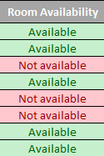Same as expected | No action needed.
Ensure mail merge works | I will run the mail merge document and press the arrow buttons. | The document should incorporate the data from the spreadsheet, and recreate itself with the appropriate data. | 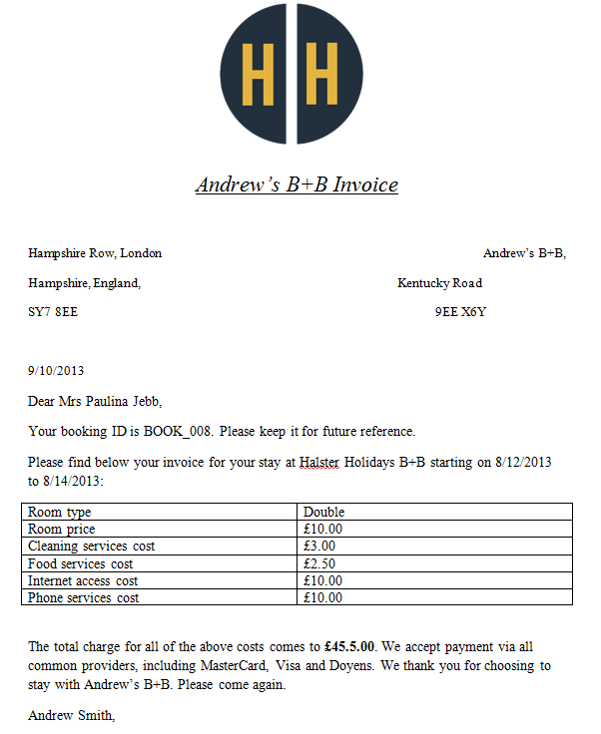 | No action needed.
Ensure cells can’t be messed up. | I will attempt to change something in a locked cell. | Protected cells should not allow users to edit them. | 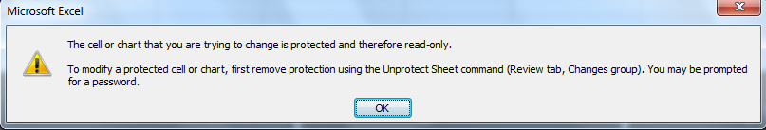 | No action needed.

