Possible Solutions in Database Software
For the task I have been given, there are two types of software that would work most effectively: database software and spreadsheet software. Databases have many distinct advantages over spreadsheets, but also several disadvantages. One main advantage over spreadsheets is that they allow for greater flexibility – in this example, every single function is listed singularly, something which can contribute to lowering levels of confusion.
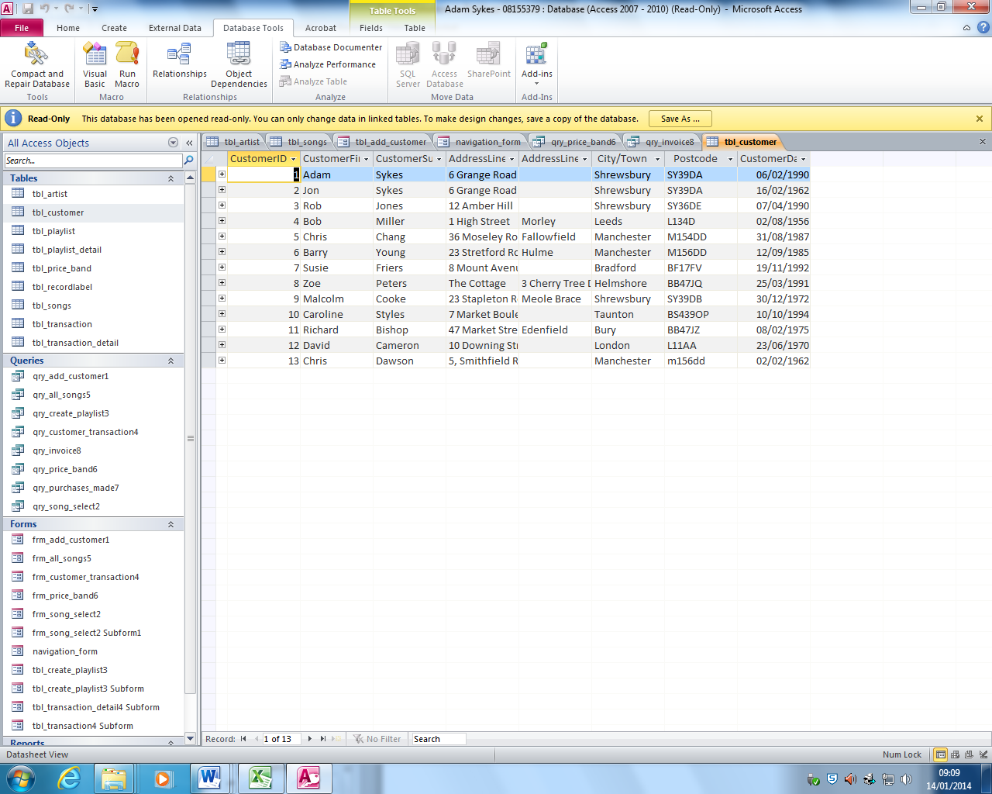
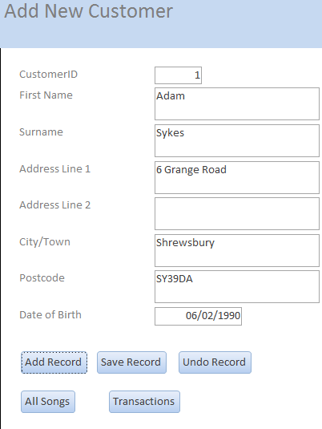
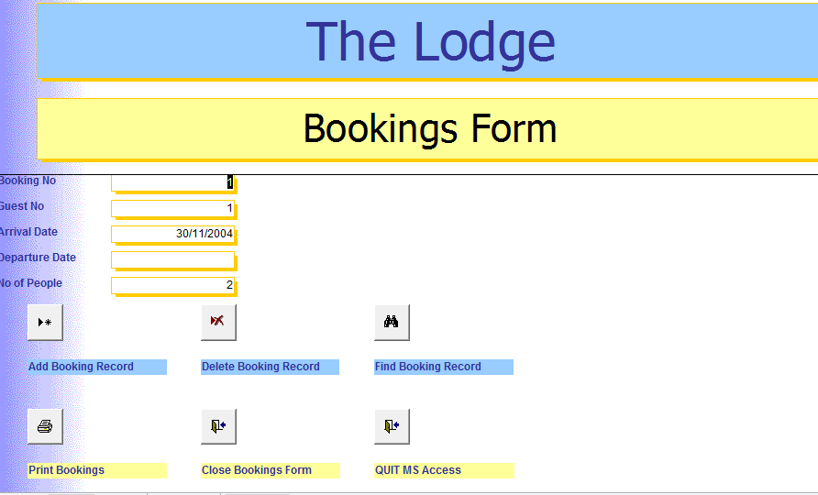
Perhaps the single largest advantage they hold over spreadsheets, however, is the ability to run queries to filter and sort data. With queries, the user can find almost anything in the spreadsheet instantly, as well as easily add to and change the data in a far easier way than with a spreadsheet. This allows the user to gather data from different tables, and gather it into one, making it easy to view certain pieces of data. In addition, databases allow for greater flexibility in user interface design, something which can easily lead to more professional looking products. For example, databases allow specific views to be created for each individual function, whereas spreadsheets force the user to edit the raw data by hand, making it easier to input data. Of course, one could easily create such a feature in spreadsheet software using Visual Basic for Applications, but this requires programming knowledge, a skill that many people have yet to pick up. Databases can feature more advanced front-end interfaces, as evidenced by the screenshot left. They can make use of buttons and labels in a looser manner than spreadsheets, using forms – making it easier to input data. They also feature advanced sorting functionality – queries can be used to gather data from different tables, and gathering it into one, making it easy to view certain pieces of data. Access also allows reports to be created. This works much like mail-merge in Word and Excel – data is taken from the database and inputted automatically into a preformatted report. The advantage of this over spreadsheet software is that it is self-contained: only the one application is needed.
Whilst databases are hugely effective at organising and sorting data, they lack the ability to perform complex calculations. Spreadsheet applications contain the ability to use functions, something that makes it far easier to calculate things. The brief I have been given incorporates such automatic calculations, meaning database software would not be wholly appropriate.

