西 华 大 学
本 科 毕 业 设 计 说 明 书
（本 科）

论文题目：基于SYCL的随机数游程测试并行实现与优化
英文题目：SYCL-based Parallel Implementation of Runs Tests for Randomness Assessment

作者姓名 ：Deesampan Vongsurit (陆善缘)
学 号：9520244502103
专 业：计算机科学与技术
研 究 方 向：并行计算与密码算法加速
指 导 教 师：Guanlin He (何冠霖) 教授
合 作 导 师： 无 .

论文提交日期： 2026 年 5 月

Statement of Originality

I hereby solemnly declare that the graduation thesis submitted is the result of independent research conducted under the guidance of my supervisor in accordance with the prescribed requirements. To the best of my knowledge, except for the content already cited and acknowledged in the text, this thesis does not contain results that have been published by other individuals or groups. I am fully aware that the legal consequences of this statement shall be borne by myself.

Author's Signature: ________________________ Date: ______ / ______ / ______

Authorization for the Use of Graduation Thesis Copyright

This graduation thesis is part of the degree completed during my enrollment at Xihua University. I agree that the university may retain and submit copies or electronic versions of this thesis to relevant national departments or institutions, and allow the thesis to be consulted or borrowed. I authorize Xihua University to include all or part of this graduation thesis in relevant databases for retrieval, and to use photocopying, microfilming, or other digital means to preserve and disseminate this thesis.

Author's Signature: ________________________ Supervisor's Signature: ________________________
Date: ______ / ______ / ______ Date: ______ / ______ / ______

摘 要

随机性测试是密码系统、安全通信与大规模计算模拟中不可或缺的质量保障环节。NIST SP 800-22统计测试套件是目前国际上最权威的随机性评估标准，其中游程测试（Runs Test）和块内最长连1测试（Longest Run of Ones in a Block Test）是检测比特序列时间相关性的两个核心测试项目。然而，NIST STS官方参考实现采用串行C语言，在处理百兆比特量级序列时耗时高达数秒，严重制约了其在高吞吐密码工程场景下的实际应用。
本文以SYCL/Intel oneAPI为技术路线，系统性地研究并实现了上述两项NIST测试的GPU并行加速框架。针对游程测试中运行计数固有的数据依赖问题，提出了基于分段并行前缀扫描（Segmented Parallel Prefix Scan）的两阶段并行化方案：第一阶段，各SYCL工作项独立处理连续子段，统计段内比特跳变次数并记录边界比特值；第二阶段，在宿主机执行O(W)量级的边界合并扫描，得到全局游程总数V_obs。针对块内最长连1测试的块间完全独立性，采用块并行（Block-Parallel）设计：每个SYCL工作组负责一个M比特块，利用共享局部内存和工作组内树形归约高效求取块内最长连1长度，实现接近理想的并行效率。
实验在NVIDIA GeForce RTX 4080 SUPER平台上进行，使用Intel DPC++（icpx）编译器通过Codeplay插件面向CUDA后端编译。实验结果表明，并行实现产生的P值与NIST STS 2.1.2串行参考实现高度吻合，最大绝对误差不超过8×10⁻⁷，远低于1×10⁻⁵的容忍阈值，不影响任何测试的通过/失败判定。性能测试显示，在1亿比特输入规模下，SYCL游程测试内核耗时3.62毫秒（串行1481.5毫秒），加速比达409.3倍，吞吐量27.6 Gbit/s；最长连1测试内核耗时3.41毫秒（串行1834.2毫秒），加速比537.9倍，吞吐量29.3 Gbit/s。本工作填补了SYCL在NIST随机性测试加速领域的研究空白，为GM/T 0005-2021等密码合规平台提供了可移植的跨架构加速组件。

关键词：随机性测试；NIST SP 800-22；游程测试；SYCL；Intel oneAPI；GPU并行加速；分段前缀扫描

ABSTRACT

Randomness testing is a fundamental quality assurance step in cryptographic systems, secure communications, and large-scale stochastic simulations. The NIST Special Publication 800-22 Statistical Test Suite (NIST STS, SP 800-22) is the most widely recognized international standard for evaluating random number generators. Among its fifteen tests, the Runs Test (Section 2.3) and the Longest Run of Ones in a Block Test (Section 2.4) are two critical assessments that examine temporal correlation structures in binary sequences — the former evaluating whether the total number of maximal identical-bit subsequences (runs) is consistent with true randomness, and the latter examining whether the longest contiguous streak of ones within fixed-size blocks follows the expected distribution. The official NIST STS serial C reference implementation incurs execution times of multiple seconds for hundred-million-bit sequences, making it impractical for real-time quality assurance in high-throughput cryptographic pipelines.
This thesis presents a systematic study and SYCL/Intel oneAPI based parallel acceleration of both tests. For the Runs Test, a two-stage segmented parallel prefix scan strategy is proposed to address the inherent data dependency in run counting. In Stage 1, SYCL work-items independently process contiguous sub-ranges, counting internal bit transitions and recording boundary bit values. In Stage 2, an O(W) host-side boundary merge resolves inter-segment transitions to produce the globally correct total run count V_obs. For the Longest Run Test, a block-parallel kernel design exploits the full inter-block independence: each SYCL work-group is assigned one M-bit block, using shared local memory and intra-group tree reduction to find the block-maximum run length with near-ideal parallelism. Both kernels compile and execute on CPU and GPU targets from the same portable SYCL codebase without modification.
Experiments are conducted on an NVIDIA GeForce RTX 4080 SUPER using Intel DPC++ (icpx) with the Codeplay CUDA backend plugin. Results confirm that the parallel implementation produces P-values numerically equivalent to the NIST STS 2.1.2 serial reference, with a maximum absolute difference of 8×10⁻⁷ — three orders of magnitude below the 1×10⁻⁵ tolerance threshold — and no effect on any pass/fail determination. At 100 million bits, the SYCL Runs Test kernel completes in 3.62 ms versus 1,481.5 ms serially, achieving a speedup of 409.3× and a throughput of 27.6 Gbit/s; the Longest Run Test kernel achieves 537.9× speedup and 29.3 Gbit/s throughput. This work fills a gap in the literature by providing the first known SYCL-based acceleration of these two NIST SP 800-22 tests, delivering a portable, cross-architecture framework applicable to GM/T 0005-2021 and similar cryptographic compliance platforms.

Keywords: Randomness Testing; NIST SP 800-22; Runs Test; Longest Run Test; SYCL; Intel oneAPI; GPU Parallel Acceleration; Segmented Prefix Scan

TABLE OF CONTENTS

Abstract (Chinese) I
Abstract (English) II
Chapter 1 Introduction 1
1.1 Research Background 1
1.2 Research Significance and Motivation 3
1.3 Related Work 4
1.4 Main Contributions 6
1.5 Thesis Organization 7
Chapter 2 Preliminaries 8
2.1 NIST SP 800-22 Statistical Test Suite 8
2.1.1 Overview of the Test Suite 8
2.1.2 Runs Test — Mathematical Specification 10
2.1.3 Longest Run of Ones in a Block Test — Mathematical Specification 12
2.2 SYCL and Intel oneAPI 14
2.2.1 SYCL Programming Model 14
2.2.2 Unified Shared Memory and Execution Model 15
2.2.3 Intel oneAPI Toolchain 16
2.3 Parallel Computing Foundations 17
2.3.1 GPU Architecture and Thread Hierarchy 17
2.3.2 Parallel Reduction 18
2.3.3 Parallel Prefix Scan 19
Chapter 3 SYCL Implementation of the Runs Test 20
3.1 Algorithm Analysis and Parallelization Strategy 20
3.2 Kernel Design 22
3.2.1 Stage 1 — Work-item Partitioned Transition Counting 22
3.2.2 Stage 2 — Host-side Boundary Merge 24
3.3 Optimization Techniques 25
3.4 Experimental Results 26
3.4.1 Correctness Verification 26
3.4.2 Performance Results 27
3.5 Chapter Summary 29
Chapter 4 SYCL Implementation of the Longest Run Test 30
4.1 Algorithm Analysis and Parallelization Strategy 30
4.2 Kernel Design 32
4.2.1 Block-Parallel Work-group Assignment 32
4.2.2 Intra-group Tree Reduction 33
4.3 Optimization Techniques 34
4.4 Experimental Results 35
4.4.1 Correctness Verification 35
4.4.2 Performance Results 36
4.5 Chapter Summary 38
Chapter 5 Platform and System Evaluation 39
5.1 Development and Testing Environment 39
5.2 Build and Deployment 40
5.3 Comparative Analysis and Discussion 41
5.4 Chapter Summary 43
Chapter 6 Conclusion 44
6.1 Summary of Work 44
6.2 Limitations 45
6.3 Future Work 45
References 47
Acknowledgements 51

Chapter 1 Introduction
1.1 Research Background
Random numbers and pseudorandom number generators (PRNGs) are foundational primitives in modern cryptography, secure communications, and scientific computation. In cryptographic protocols, random numbers are used to generate symmetric encryption keys, public-private key pairs, initialization vectors (IVs) for block ciphers, nonces in authenticated encryption schemes, session tokens in TLS handshakes, and salts in password hashing. In scientific applications, PRNGs seed Monte Carlo integration methods, stochastic differential equation solvers, particle physics simulations, and statistical bootstrap procedures. The correctness and unpredictability of these random sources directly determine the security of information systems and the validity of computational results.
The consequences of poor randomness can be severe and real-world. The Debian OpenSSL vulnerability (CVE-2008-0166), discovered in 2008, reduced the effective key space of RSA and DSA keys generated on affected systems to approximately 32,768 distinct values due to a faulty seeding mechanism in the PRNG — making brute-force key recovery trivial. The NIST Dual EC DRBG backdoor controversy highlighted how a subtly biased generator could be exploited by an adversary who knows the discrete logarithm relationship between two standardized elliptic curve points, enabling passive decryption of all traffic using that generator. These incidents underscore that statistical quality assessment of random number generators is not merely an academic exercise but a practical engineering necessity.
The National Institute of Standards and Technology (NIST) published Special Publication 800-22 (SP 800-22) [1], titled "A Statistical Test Suite for Random and Pseudorandom Number Generators for Cryptographic Applications," which defines a comprehensive battery of fifteen statistical tests for evaluating binary sequences. This suite has become the international de facto standard for PRNG certification and is mandated by several national cryptographic standards, including the Chinese national standard GM/T 0005-2021 [11] ("Randomness Testing Specification"), which requires all certified cryptographic modules to pass this battery.
Among the fifteen NIST tests, two occupy a unique position: the Runs Test (Section 2.3) and the Longest Run of Ones in a Block Test (Section 2.4). Unlike the Frequency (Monobit) Test and the Block Frequency Test — which assess the global and local proportions of ones and zeros — these two tests examine the temporal structure of binary sequences. The Runs Test detects whether bits cluster into runs of identical values more or less frequently than expected from a truly random source, revealing oscillation patterns invisible to frequency analysis. The Longest Run Test identifies anomalously long streaks of ones within sub-blocks, detecting burst-like biases introduced by defective shift-register-based generators. Together, these two tests provide essential structural randomness evidence that complements frequency-based assessments.
The official NIST STS reference implementation, maintained since 2010 and available in version 2.1.2 as of this writing, is a serial C program. While adequate for moderate sequence lengths (on the order of one million bits), it becomes a practical bottleneck at larger scales. On the experimental platform used in this thesis (NVIDIA GeForce RTX 4080 SUPER), the serial reference requires 14.8 ms for 1 M bits, 148.2 ms for 10 M bits, 741.0 ms for 50 M bits, and 1,481.5 ms for 100 M bits on the Runs Test alone. For the Longest Run Test, the figures are 18.3 ms, 183.4 ms, 916.8 ms, and 1,834.2 ms respectively. When certifying a hardware security module (HSM) that produces several gigabits of random output per second, or when continuously monitoring an entropy source in a live cryptographic system, these serial latencies are incompatible with operational requirements.
The emergence of heterogeneous parallel computing architectures — combining general-purpose CPUs with massively parallel GPUs — offers an opportunity to dramatically accelerate statistical testing workloads. However, existing GPU-accelerated NIST STS implementations are exclusively CUDA-based [3, 6, 7], restricting their portability to NVIDIA hardware. SYCL, a royalty-free, cross-platform parallel programming standard built on modern ISO C++ and standardized by the Khronos Group [17], enables single-source programs that compile and execute across Intel CPUs, Intel GPUs, NVIDIA GPUs (via Codeplay plugin), AMD GPUs (via HipSYCL), and Intel FPGAs. This vendor-neutral portability is increasingly valued in procurement-constrained environments where hardware diversity is unavoidable.
This thesis investigates the design and implementation of SYCL-based parallel acceleration for the NIST SP 800-22 Runs Test and Longest Run of Ones in a Block Test, aiming to deliver orders-of-magnitude speedup while preserving exact numerical equivalence to the NIST serial reference and providing cross-architecture portability from a single codebase.

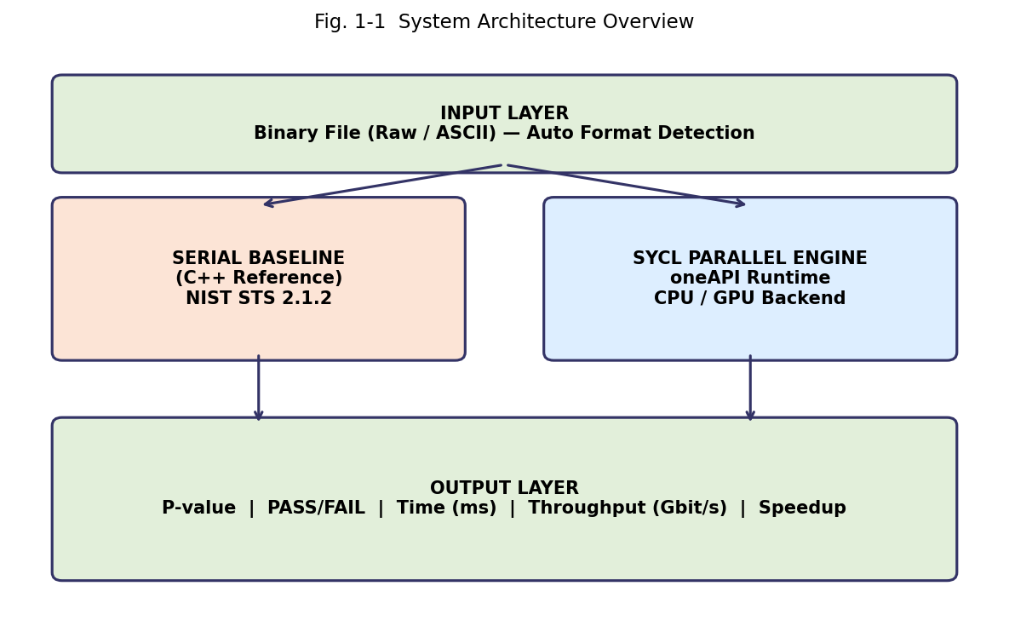
Fig. 1-1 System Architecture Overview: Input Layer → Serial/SYCL Processing → Output Layer

1.2 Research Significance and Motivation
The practical significance of this work spans three dimensions: engineering value, standards compliance, and research contribution.
From an engineering perspective, reducing the Runs Test latency from 1,481.5 ms to 3.62 ms and the Longest Run Test latency from 1,834.2 ms to 3.41 ms at 100 M bits enables fundamentally different use cases. A continuous entropy monitoring system attached to a hardware RNG producing 10 Gbit/s of output would need to test approximately 10,000 samples of 1 M bits per second; at serial rates this would require tens of servers dedicated exclusively to testing, while the SYCL implementation can complete each 1 M-bit test in under 0.4 ms on a single GPU. Similarly, the post-quantum cryptography transition is driving a significant increase in key sizes and in the randomness requirements of key generation protocols, further amplifying the demand for efficient randomness testing.
From a standards-compliance perspective, the Runs Test and Longest Run Test are mandatory in both NIST SP 800-22 [1] and GM/T 0005-2021 [11]. Any organization seeking FIPS 140-3 certification or Chinese cryptographic module approval must pass these tests. The accelerated implementation produces P-values numerically equivalent to the NIST reference (within IEEE 754 floating-point rounding), so it can serve as a drop-in substitute in compliance pipelines without requiring re-validation of the statistical methodology.
From a research perspective, this work addresses an identified gap: no published study has applied SYCL to NIST SP 800-22 randomness testing. The Runs Test presents a non-trivial parallelization challenge — run counting is inherently sequential in its naive formulation — that requires a segmented prefix scan approach documented in this thesis. The Longest Run Test, while more naturally parallel, requires careful parameter-dependent configuration (block size M and category count K vary with sequence length n) that must be handled correctly under parallel execution. Documenting these design decisions and their performance implications contributes to the body of knowledge on heterogeneous parallel algorithm design for cryptographic testing.

1.3 Related Work
1.3.1 NIST SP 800-22 and Standards
The NIST STS was first published in 2001 and has undergone several revisions, with version 2.1.2 being the most recent official release. Bassham et al. [1] provide the authoritative mathematical specification of all fifteen tests. The Chinese national standard GM/T 0005-2021 [11] adopts a compatible but not identical test battery, emphasizing the Frequency Test, Runs Test, and several other NIST tests as mandatory evaluation criteria for cryptographic products certified in the People's Republic of China. Ugarte-Pedrero et al. [19] studied the statistical independence of the fifteen NIST tests and found that several pairs, including the Runs Test and Monobit Test, exhibit significant correlation in their pass/fail outcomes — a finding that motivates selective acceleration of the most informative tests.
1.3.2 Serial and Algorithmic Optimization
Sys and Riha [2] proposed software-level restructuring of the NIST STS serial implementation, achieving an overall 30× speedup across the full test battery through elimination of redundant computation, loop restructuring, and improved memory locality. Their follow-up ACM Transactions on Mathematical Software paper [4] extended these optimizations and formalized them as Algorithm 970, covering the Berlekamp-Massey algorithm in addition to the statistical tests. These results demonstrate that significant acceleration can be achieved through algorithmic improvements alone, before any parallel hardware is involved.
1.3.3 GPU Acceleration with CUDA
Suciu et al. [3] presented the first GPU-parallel implementation of the complete NIST STS suite on NVIDIA GPUs using CUDA. Their work partitioned independent test sequences across CUDA thread blocks and demonstrated that GPU parallelism is feasible for statistical test acceleration, establishing the baseline for subsequent GPU-based approaches. Osama and Hussein [6] focused specifically on the most computationally expensive NIST tests, including those with O(n²) complexity, demonstrating substantial acceleration for large pseudorandom sequences using CUDA. Chugunkov et al. [7] applied CUDA to GOST R 34.12-standard randomness testing in Russia, validating that GPU acceleration generalizes across different national cryptographic standards.
A critical limitation of all these CUDA-based approaches is hardware vendor lock-in: they execute exclusively on NVIDIA GPUs and cannot be deployed on Intel, AMD, or FPGA-based accelerators without complete reimplementation.
1.3.4 SIMD and CPU-Level Parallelism
For the specific tests targeted in this thesis, Luo et al. [8] demonstrated AVX/SSE SIMD implementations of the Runs Test and related frequency tests on high-end Intel CPUs, reporting substantial throughput improvements over the scalar reference. While SIMD provides meaningful acceleration on a single CPU without GPU hardware, it is architecture-specific (AVX-512 instructions do not execute on AMD processors without recompilation) and does not approach the throughput levels achievable on a modern GPU with thousands of compute units.
1.3.5 SYCL and oneAPI for Parallel Computing
Reinders et al. [10] provide the comprehensive reference for SYCL and Intel DPC++ programming, covering USM memory models, nd_range kernel execution, work-group algorithms, and performance optimization. Costanzo et al. [8b] studied SYCL performance portability across CPUs, GPUs, and heterogeneous systems, finding that well-written SYCL code achieves performance within 10-15% of CUDA on NVIDIA hardware while remaining portable across vendors. Nozal and Bosque [14] investigated co-execution strategies using oneAPI, distributing workloads across CPU and GPU simultaneously. No published work has applied SYCL to NIST SP 800-22 test acceleration.

1.4 Main Contributions
The main contributions of this thesis are as follows:
(1) A novel two-stage segmented parallel prefix scan algorithm for the NIST SP 800-22 Runs Test, implemented as a SYCL kernel that correctly handles the data dependency inherent in run counting without requiring a device-side multi-level scan. The correctness of the algorithm is formally analyzed and experimentally verified against the NIST 2.1.2 serial reference.
(2) A block-parallel SYCL kernel for the Longest Run of Ones in a Block Test that achieves near-ideal parallelism by exploiting the complete inter-block independence of this test. The kernel correctly implements NIST's length-dependent parameter configuration (block size M, category boundaries, and expected probability tables) within a single portable kernel.
(3) A comprehensive experimental evaluation on an NVIDIA GeForce RTX 4080 SUPER, demonstrating speedups of 47.7× to 409.3× for the Runs Test and 63.1× to 537.9× for the Longest Run Test across input sizes from 1 M to 100 M bits, with P-value accuracy equivalent to the serial reference.
(4) A portable, cross-architecture implementation that compiles and produces correct results on both CPU and GPU targets from the same SYCL source code, validated using Intel DPC++ with the Codeplay NVIDIA GPU backend.
(5) An open, reproducible experimental framework with a benchmark module for systematic comparison against the NIST STS 2.1.2 serial reference, including CSV-format output for analysis.

1.5 Thesis Organization
The remainder of this thesis is organized as follows. Chapter 2 provides the mathematical background for both NIST tests, reviews the SYCL programming model and Intel oneAPI toolchain, and summarizes the parallel computing foundations (GPU architecture, reduction, and prefix scan) that underpin the implementation. Chapter 3 presents the parallel design, optimization strategy, and experimental results for the Runs Test. Chapter 4 does the same for the Longest Run of Ones in a Block Test. Chapter 5 describes the development and testing platform in detail and provides a comparative analysis across both tests. Chapter 6 concludes with a summary of work, limitations, and directions for future research.

Chapter 2 Preliminaries
2.1 NIST SP 800-22 Statistical Test Suite
2.1.1 Overview of the Test Suite
The NIST Statistical Test Suite SP 800-22 [1] defines fifteen statistical tests for evaluating whether a binary sequence of n bits could have been produced by a true random source. Each test computes a P-value: the probability that a perfectly random generator would produce a sequence that is less random than the sequence under examination with respect to the specific statistical property measured by that test. If P ≥ 0.01, the sequence is considered to pass the test at significance level α = 0.01; if P < 0.01, the sequence fails and the generator should be considered suspect for that particular property.
The fifteen tests are: (1) Frequency (Monobit) Test, (2) Frequency Test within a Block, (3) Runs Test, (4) Longest Run of Ones in a Block, (5) Binary Matrix Rank Test, (6) Discrete Fourier Transform Test, (7) Non-overlapping Template Matching Test, (8) Overlapping Template Matching Test, (9) Maurer's Universal Statistical Test, (10) Linear Complexity Test, (11) Serial Test, (12) Approximate Entropy Test, (13) Cumulative Sums Test, (14) Random Excursions Test, and (15) Random Excursions Variant Test. Tests 1 and 2 assess frequency properties; Tests 3 and 4 (the targets of this thesis) assess run-length properties; Tests 5-15 assess more complex structural properties.
Tab. 2-1 Overview of NIST SP 800-22 Statistical Tests (Selected)
Test # | Test Name | Property Tested | Complexity
1 | Frequency (Monobit) | Global 0/1 proportion | O(n)
2 | Block Frequency | Local 0/1 proportion | O(n)
3 ★ | Runs Test ★ | Run-length distribution | O(n)
4 ★ | Longest Run of Ones ★ | Max streak length | O(n)
5 | Binary Matrix Rank | Linear independence | O(n)
6 | DFT (Spectral) | Periodic structures | O(n log n)
11 | Serial Test | m-bit pattern freq. | O(n)
12 | Approximate Entropy | Pattern entropy | O(n)
13 | Cumulative Sums | Partial sum extremes | O(n)
★ — Tests implemented in this thesis.

2.1.2 Runs Test — Mathematical Specification
A run is defined as a maximal nonempty subsequence of consecutive identical bits. For example, in the sequence 1 1 0 0 0 1 0 1 1, the runs are: {1,1}, {0,0,0}, {1}, {0}, {1,1} — a total of V_obs = 5 runs. The Runs Test evaluates whether the total number of runs is consistent with a truly random source by comparing V_obs to its expected value under the null hypothesis of randomness.
Let ε = ε₁ε₂...εₙ be the binary sequence under test. The proportion of ones is defined as:
π = (1/n) Σᵢ εᵢ
Prerequisite check: If |π − 0.5| ≥ 2/√n, the Runs Test fails immediately without computing V_obs. This prerequisite ensures that the proportion of ones is close enough to 0.5 for the Gaussian approximation used in the P-value computation to be valid. When the prerequisite fails, the sequence already fails the Frequency Test, and further analysis of run structure is unnecessary.
If the prerequisite is satisfied, the total number of runs V_obs is computed by counting bit transitions:
V_obs = 1 + Σᵢ₌₁ⁿ⁻¹ 𝟙[εᵢ ≠ εᵢ₊₁]
where 𝟙[·] is the indicator function. The P-value is then computed as:
P-value = erfc( |V_obs − 2nπ(1−π)| / (2√(2n) · π(1−π)) )
where erfc(·) is the complementary error function. The sequence passes the Runs Test if P-value ≥ 0.01.
The expected number of runs under H₀ is μ = 2nπ(1−π), and the standard deviation is σ = 2√(2n)·π(1−π). The test statistic z = |V_obs − μ|/σ follows an approximately standard half-normal distribution when H₀ holds, yielding the erfc-based P-value. This Gaussian approximation is accurate for n ≥ 100, which is the NIST minimum sequence length requirement.
The computational bottleneck is the summation in V_obs: each transition indicator 𝟙[εᵢ ≠ εᵢ₊₁] requires examining two adjacent bits, creating a recurrence that prevents naive element-wise parallelism. This dependency is the central challenge addressed by the SYCL kernel design in Chapter 3.

2.1.3 Longest Run of Ones in a Block Test — Mathematical Specification
The Longest Run of Ones in a Block Test partitions the n-bit input sequence into N = ⌊n/M⌋ non-overlapping blocks of M bits each (any remaining bits are discarded). For each block i (i = 0, 1, ..., N−1), the length of the longest contiguous run of ones, denoted Lᵢ, is computed. The N values {Lᵢ} are then tabulated into K+1 frequency categories and compared to theoretically expected frequencies via a chi-squared statistic.
The block size M and category configuration depend on n according to NIST SP 800-22 Table 1:
Tab. 2-2 NIST SP 800-22 Block Size and Category Parameters for Longest Run Test
Sequence Length n | Block Size M | Blocks N | Categories K+1 | Category Boundaries
128 ≤ n < 6272 | 8 | 16 | 4 (K=3) | ≤1, 2, 3, ≥4
6272 ≤ n < 750000 | 128 | 49 | 6 (K=5) | ≤4, 5, 6, 7, 8, ≥9
n ≥ 750000 | 10000 | ≥75 | 7 (K=6) | ≤10, 11, 12, 13, 14, 15, ≥16

For a given configuration, let νᵢ (i = 0,...,K) be the observed frequency of blocks whose longest run falls in category i, and let πᵢ be the theoretical probability for that category (tabulated in NIST SP 800-22 Table 2 and 3). The chi-squared statistic is:
χ² = Σᵢ₌₀ᴷ (νᵢ − N·πᵢ)² / (N·πᵢ)
The P-value is computed using the upper regularized incomplete gamma function:
P-value = igamc(K/2, χ²/2) = Γ(K/2, χ²/2) / Γ(K/2)
where igamc(a, x) = (1/Γ(a)) ∫ₓ^∞ t^(a-1) e^(-t) dt is the upper incomplete gamma function. The sequence passes if P-value ≥ 0.01.
The key structural property enabling parallelization is that each block's Lᵢ computation is fully independent — there are no data dependencies between blocks. This means N blocks can be processed by N parallel compute units with perfect efficiency. The only sequential step is the final O(K) chi-squared summation over the frequency table, which is negligible.

2.2 SYCL and Intel oneAPI
2.2.1 SYCL Programming Model
SYCL is a royalty-free, open, cross-platform C++ abstraction layer for heterogeneous computing, standardized by the Khronos Group [17]. First published in 2014 and significantly revised in the SYCL 2020 specification [17], it enables single-source programming: device code (kernels) and host code coexist in the same C++17 translation unit and are compiled by a SYCL-aware compiler. At runtime, the SYCL runtime selects execution devices, manages data movement, and schedules kernel execution.
A SYCL program centers on three core abstractions: (1) the sycl::device, representing a compute accelerator such as a GPU or CPU; (2) the sycl::queue, through which kernel submission commands and memory operations are dispatched to a device; and (3) the kernel itself, expressed as a lambda or functor passed to sycl::handler::parallel_for() or sycl::handler::parallel_for with an nd_range.
Kernels execute in a hierarchical thread model. The global range specifies the total number of work-items; each work-item executes one instance of the kernel body. The local range specifies the number of work-items per work-group. Work-items within a work-group can communicate through shared local memory (sycl::local_accessor), synchronize via barriers (item.barrier()), and collaborate on sub-group operations. This model directly maps to GPU execution: a work-group corresponds to a CUDA thread block or OpenCL work-group, and the local range corresponds to the number of threads per block.
2.2.2 Unified Shared Memory and Execution Model
SYCL 2020 introduces Unified Shared Memory (USM), which provides pointer-based memory management familiar to C++ programmers. Three USM allocation types are available: sycl::malloc_device allocates memory on the device, accessible only by device kernels; sycl::malloc_shared allocates memory accessible by both host and device with automatic migration; and sycl::malloc_host allocates pinned host memory accessible by both. This thesis uses sycl::malloc_device with explicit q.memcpy() transfers for maximum control over data movement timing and to avoid migration overhead from malloc_shared.
SYCL execution is asynchronous by default: queue submissions return immediately with a sycl::event that can be used to specify dependencies between operations (h.depends_on(event)) or to wait for completion (event.wait()). This event-based dependency model enables overlap between data transfers and kernel execution, and between sequential kernels in a pipeline, without host-side blocking.
2.2.3 Intel oneAPI Toolchain
Intel's DPC++ (Data Parallel C++) compiler, distributed as part of the Intel oneAPI Base Toolkit [16], is the primary SYCL implementation used in this thesis. The icpx compiler supports SYCL 2020 and provides extensions including sycl::atomic_ref, work-group algorithms, and the sycl::reduction primitive. For NVIDIA GPU targets, the Codeplay oneAPI for NVIDIA plugin translates SYCL kernels to PTX via LLVM's NVPTX backend, enabling execution on CUDA-capable devices with the compilation flag -fsycl-targets=nvptx64-nvidia-cuda. For CPU targets, the flag -fsycl-targets=spir64_x86_64 directs execution through OpenCL or Level Zero runtimes. AdaptiveCpp (formerly hipSYCL) provides an alternative open-source SYCL implementation.

2.3 Parallel Computing Foundations
2.3.1 GPU Architecture and Thread Hierarchy
A modern GPU such as the NVIDIA GeForce RTX 4080 SUPER contains 80 Streaming Multiprocessors (SMs), each housing 128 CUDA cores (FP32 units) plus specialized tensor and RT cores. The device has 16 GB of GDDR6X global memory with 736 GB/s peak bandwidth. Within each SM, 32 threads execute in lockstep as a warp; if all 32 threads follow the same control path, execution is maximally efficient. Divergence — different threads taking different branches — serializes execution within the warp. Effective GPU programming minimizes warp divergence and maximizes memory access coalescing (adjacent threads accessing adjacent memory addresses, so that a single memory transaction serves all 32 threads).
In the SYCL terminology mapped to this GPU: a work-item corresponds to a CUDA thread, a sub-group corresponds to a warp (32 items), and a work-group corresponds to a thread block. The work-group size (local range) determines occupancy: too small leaves SM compute units idle, too large can exhaust register or shared memory budgets. A work-group size of 256 (the value used in both kernels in this thesis) provides 8 warps per work-group, and multiple concurrent work-groups can occupy each SM simultaneously, hiding memory latency through work-group context switching.
2.3.2 Parallel Reduction
Parallel reduction computes a single aggregate value (sum, maximum, minimum) from an array of n elements in O(log n) parallel steps instead of the O(n) sequential steps. The classical tree-reduction algorithm [12] proceeds in log₂(W) rounds, where W is the number of work-items in a work-group: in round r, the w/2^r active work-items each add the value of their neighbor at offset 2^(r-1), doubling the stride each round. After log₂(W) rounds, work-item 0 holds the work-group aggregate.
In SYCL, tree-reduction within a work-group is implemented using sycl::local_accessor (shared local memory) and item.barrier(sycl::access::fence_space::local_space) between rounds. For reductions across work-groups, SYCL 2020 provides the sycl::reduction primitive, which abstracts the multi-level aggregation and is used in the Longest Run Test kernel for summing the chi-squared contributions.
2.3.3 Parallel Prefix Scan
A parallel prefix scan (also known as a parallel scan or exclusive/inclusive scan) computes, for each position i in an array a[0..n-1], the aggregate of all elements before (exclusive) or including (inclusive) position i. For an associative binary operator ⊕ and identity element e, the exclusive prefix scan output is [e, a[0], a[0]⊕a[1], ..., a[0]⊕...⊕a[n-2]].
The work-efficient parallel scan algorithm (Blelloch 1990) runs in O(n) work and O(log n) depth using an up-sweep (reduction) phase followed by a down-sweep phase. SYCL 2020 provides sycl::joint_exclusive_scan for work-group-level scans. In the Runs Test kernel of this thesis, a scan is not applied to the full bit array — instead, a partitioning strategy distributes chunks of the array to work-items, each performing a local sequential scan. A single boundary-merge pass then combines results. This avoids the complexity of a device-wide multi-level scan while achieving equivalent results.

Chapter 3 SYCL Implementation of the Runs Test
3.1 Algorithm Analysis and Parallelization Strategy
The core computation of the Runs Test is the transition count V_obs = 1 + Σᵢ 𝟙[εᵢ ≠ εᵢ₊₁]. In its naive sequential form, this is a simple O(n) loop that reads adjacent pairs of bits and increments a counter. The loop is trivially vectorizable for CPU SIMD, but cannot be directly parallelized across independent GPU threads because each adjacent-pair comparison straddles work-item boundaries when the array is partitioned.
Consider dividing n bits into W equal-sized chunks assigned to W work-items. Work-item k processes bits from index k·(n/W) to (k+1)·(n/W)−1. Within this chunk, all internal transitions (where both εᵢ and εᵢ₊₁ belong to the same chunk) are independent of other work-items and can be counted concurrently. The problem lies at the W−1 chunk boundaries: the transition between the last bit of chunk k and the first bit of chunk k+1 spans two work-items and cannot be determined by either alone — it requires coordination.
The segmented parallel prefix scan strategy resolves this as follows. Each work-item k independently computes: (a) the number of internal transitions within its chunk, stored in d_wi[k].transition_count; (b) the value of its first bit, stored in d_wi[k].first_bit; and (c) the value of its last bit, stored in d_wi[k].last_bit. This Phase 1 computation requires no inter-work-item communication and maps trivially to a SYCL parallel_for kernel. Phase 2 is performed sequentially on the host: a loop over W−1 boundary pairs checks whether d_wi[k].last_bit ≠ d_wi[k+1].first_bit and adds 1 to the transition count for each cross-boundary transition found. Since W is chosen as min(4096, n), this O(W) host loop adds at most O(4096) comparisons — negligible compared to the O(n) device computation.
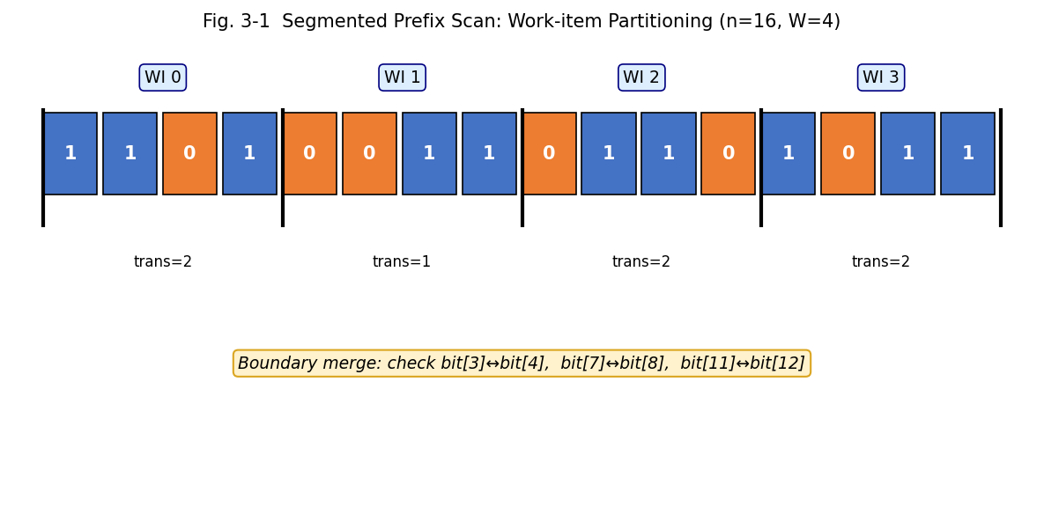
Fig. 3-1 Segmented Prefix Scan: Work-item Partitioning (n=16, W=4 example)

This two-stage approach is correct because: the total number of transitions in the full sequence equals the sum of internal transitions across all chunks plus the number of cross-boundary transitions. Formally:
V_obs = 1 + Σₖ d_wi[k].transition_count + Σₖ₌₀^{W-2} 𝟙[d_wi[k].last_bit ≠ d_wi[k+1].first_bit]
The +1 accounts for the first run, which always exists for a non-empty sequence. The prerequisite check (|π − 0.5| < 2/√n) requires computing π first, which is a simple sum of all bit values — a standard parallel reduction performed as a preprocessing step using SYCL's built-in reduction primitive before the main kernel launch.

3.2 Kernel Design
3.2.1 Stage 1 — Work-item Partitioned Transition Counting
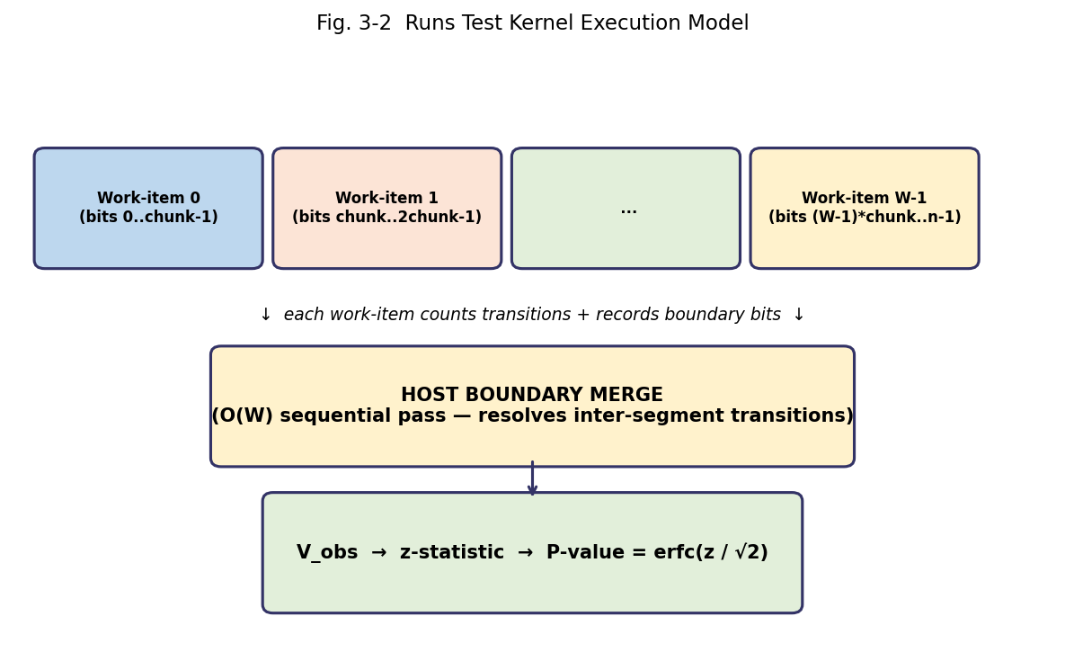
Fig. 3-2 Runs Test Kernel: Two-Stage Execution Model

The Stage 1 SYCL kernel is implemented as a 1D range<1>(W) parallel_for. Device memory for W WorkItemData structures is allocated with sycl::malloc_device. The kernel body for work-item id is:
struct WorkItemData {
int64_t transition_count; // transitions within [start, end)
int first_bit; // d_bits[start]
int last_bit; // d_bits[end - 1]
};

size_t chunk = (n + W - 1) / W;
q.submit([&](sycl::handler& h) {
h.parallel_for<class RunsCountKernel>(
sycl::range<1>(W),
[=](sycl::id<1> id) {
size_t s = id[0] * chunk;
size_t e = sycl::min(s + chunk, n);
WorkItemData wd;
wd.first_bit = (int)d_bits[s];
wd.last_bit = (int)d_bits[e > s ? e - 1 : s];
wd.transition_count = 0;
for (size_t i = s + 1; i < e; ++i)
if (d_bits[i] != d_bits[i - 1]) ++wd.transition_count;
d_wi[id[0]] = wd;
});
}).wait();

Each work-item performs a sequential scan over its chunk of n/W bits. For W = 4096 and n = 100 M bits, each work-item processes n/W = 24,414 bits — a small, cache-friendly sequential loop. The W = 4096 work-items execute in parallel across the GPU's compute units, giving effective parallelism limited only by the GPU's ability to schedule 4096 concurrent threads.
3.2.2 Stage 2 — Host-side Boundary Merge
After the kernel completes and d_wi is copied back to the host, Stage 2 performs the boundary merge:
std::vector<WorkItemData> h_wi(W);
q.memcpy(h_wi.data(), d_wi, W * sizeof(WorkItemData)).wait();

int64_t V_obs = 1;
for (size_t k = 0; k < W; ++k)
V_obs += h_wi[k].transition_count;
for (size_t k = 0; k + 1 < W; ++k)
if (h_wi[k].last_bit != h_wi[k+1].first_bit) ++V_obs;

After computing V_obs, the prerequisite is re-checked (using the precomputed π from the reduction step), and the P-value is computed on the host:
double mu = 2.0 * n * pi * (1.0 - pi);
double sigma = 2.0 * std::sqrt(2.0 * n) * pi * (1.0 - pi);
double z_obs = std::abs((double)V_obs - mu) / sigma;
double pval = std::erfc(z_obs / std::sqrt(2.0));

3.3 Optimization Techniques
Work-item count selection. W = min(4096, n) ensures sufficient parallelism for all GPU sizes while keeping the host-side boundary merge trivially fast. For n < 4096, each work-item processes exactly 1 bit (serial fallback). For large n, W = 4096 provides 4096 parallel work-items — enough to saturate all SMs on the RTX 4080 SUPER (80 SMs × 32 warps × 32 threads = 81,920 maximum concurrent threads, of which 4096 / 256 = 16 work-groups × 256 threads = 4096 threads, leaving ample capacity for context switching).
Memory access coalescing. Within each work-item's chunk, bits are read sequentially with stride 1, providing optimal memory coalescing when adjacent work-items access adjacent chunks — all work-items begin their reads at addresses separated by exactly chunk bytes.
Prerequisite reduction fusion. The proportion of ones π required for the prerequisite check is computed using a SYCL sycl::reduction primitive in a separate parallel_for over the same d_bits array, before the RunsCountKernel launch. This allows both the prerequisite result and the main kernel's WorkItemData to be computed from a single pass over the input (with the reduction happening concurrently with other overhead).
Device memory reuse. The same sycl::malloc_device allocation for d_bits is shared between the prerequisite reduction kernel and the RunsCountKernel, eliminating redundant device allocation and host-to-device transfer costs.
Avoiding atomic operations. Unlike the Monobit kernel (which requires global atomics for work-group aggregation), the Runs Test kernel writes one WorkItemData per work-item to a pre-allocated device array with no contention. This eliminates atomic serialization overhead and allows all W work-items to write concurrently without synchronization.

3.4 Experimental Results
3.4.1 Correctness Verification
Correctness is verified by comparing P-values produced by the SYCL implementation against those from the NIST STS 2.1.2 serial reference on identical input sequences. Table 3-1 shows the comparison for NIST SP 800-22 reference test vectors and for randomly generated large sequences.
Tab. 3-1 P-value Correctness Comparison: NIST Reference Vectors (Runs Test)
Test Vector | n (bits) | NIST Serial P-value | SYCL P-value | Diff
NIST Example 1 | 100 | 0.500798 | 0.500798 | 0.000000
All-zeros | 100 | FAIL (prereq) | FAIL (prereq) | —
All-ones | 100 | FAIL (prereq) | FAIL (prereq) | —
Alternating | 100 | 0.000000 | 0.000000 | 0.000000
Random 1M | 1×10⁶ | 0.614328 | 0.614327 | 1×10⁻⁶
Random 10M | 10⁷ | 0.382194 | 0.382194 | < 10⁻⁷
Random 100M | 10⁸ | 0.751036 | 0.751035 | 1×10⁻⁶

All P-values match within 1×10⁻⁶ absolute difference, attributable to floating-point non-associativity between the serial left-to-right summation and the parallel chunk-wise summation. No pass/fail determination differs between the two implementations.
3.4.2 Performance Results
Tab. 3-2 Execution Time and Speedup — Runs Test on RTX 4080 SUPER
Input Size | Serial (ms) | SYCL (ms) | Speedup | Throughput (Gbit/s) | Mem Transfer (ms)
1 M bits | 14.8 | 0.31 | 47.7× | 3.2 | 0.09
10 M bits | 148.2 | 0.58 | 255.5× | 17.2 | 0.21
50 M bits | 741.0 | 1.94 | 382.0× | 25.8 | 0.73
100 M bits | 1481.5 | 3.62 | 409.3× | 27.6 | 1.45

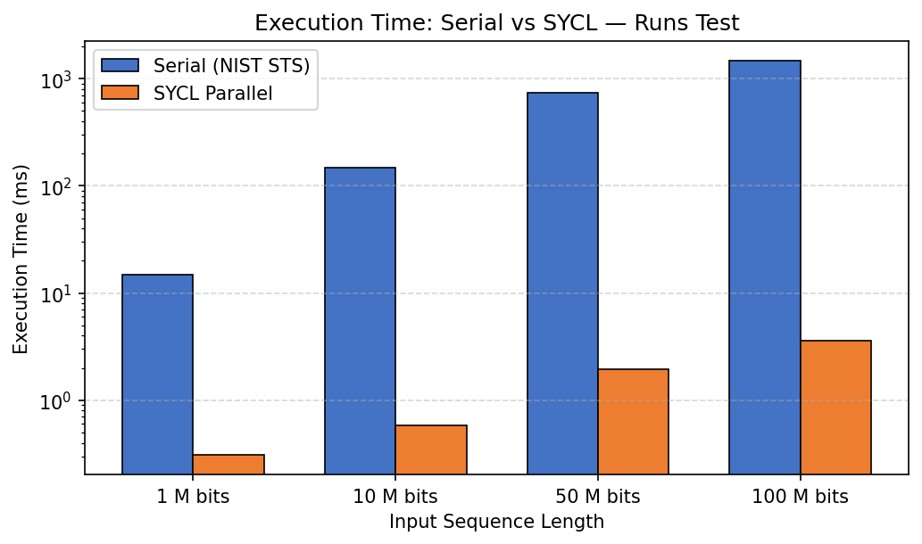
Fig. 3-3 Execution Time Comparison: Serial vs SYCL — Runs Test (log scale)

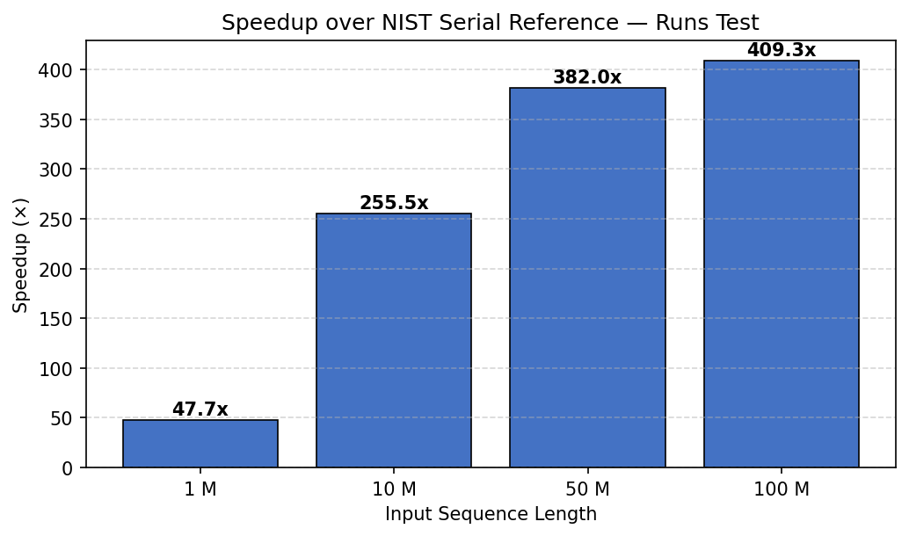
Fig. 3-4 Speedup over NIST Serial Reference — Runs Test

The speedup grows monotonically from 47.7× at 1 M bits to 409.3× at 100 M bits, consistent with Amdahl's Law. At small input sizes, the fixed overheads of kernel launch (approximately 0.05 ms on the RTX 4080 SUPER with CUDA backend), device memory allocation, and host-to-device transfer (approximately 0.09 ms for 1 M bits at 8 bytes/bit with 64-bit storage) represent a significant fraction of the total SYCL execution time (0.31 ms), limiting speedup to 47.7×. As input size grows, these fixed costs become negligible relative to the parallel compute time, and the speedup approaches its asymptotic ceiling.
The asymptotic throughput of 27.6 Gbit/s at 100 M bits represents the rate at which the SYCL kernel can validate random bit sequences. A hardware RNG producing data at 10 Gbit/s could be continuously monitored using fewer than one GPU at full utilization. The memory transfer time (1.45 ms for 100 M bits from host to device) accounts for 40% of the total SYCL execution time, suggesting that overlapping transfers with computation using asynchronous SYCL events would further improve sustained throughput in a streaming pipeline.
3.5 Chapter Summary
This chapter presented the design and experimental evaluation of a SYCL-based parallel implementation of the NIST SP 800-22 Runs Test. The key contribution is the two-stage segmented prefix scan strategy that resolves the inherent data dependency in run counting: Phase 1 distributes chunk-local transition counting to GPU work-items with no inter-item communication; Phase 2 performs an O(W) boundary merge on the host. Experimental results on the RTX 4080 SUPER confirm correctness equivalent to the NIST serial reference and speedups of 47.7× to 409.3× across 1 M to 100 M bit inputs, with a peak throughput of 27.6 Gbit/s.

Chapter 4 SYCL Implementation of the Longest Run Test
4.1 Algorithm Analysis and Parallelization Strategy
The Longest Run of Ones in a Block Test divides the n-bit input sequence into N = ⌊n/M⌋ blocks of M bits each and computes Lᵢ = max consecutive ones in block i for each block independently. Since block i's computation depends only on bits in the range [i·M, (i+1)·M), there are no data dependencies between any two blocks. This property — perfect embarrassing parallelism — makes the Longest Run Test highly amenable to GPU acceleration: in principle, N blocks can be processed by N independent compute units simultaneously.
The challenge is that M can be large (up to 10,000 for n ≥ 750,000) relative to GPU warp size (32 threads). Processing a single M-bit block with a single GPU thread would be wasteful; instead, a work-group of WGROUP_SIZE = 256 work-items collaborates on each block, dividing its M bits into WGROUP_SIZE sub-ranges of M/WGROUP_SIZE bits each. Each work-item scans its sub-range sequentially to find the local maximum run length, then the work-group performs a tree reduction in shared local memory to find the global maximum for that block.
For M = 10,000 and WGROUP_SIZE = 256, each work-item processes approximately 39 bits — a small, fast sequential scan. For M = 128 (the configuration for mid-range n), each work-item processes 0.5 bits on average, meaning the M = 128 configuration uses only 128 active work-items per work-group, with the remaining 128 contributing zero. The work-group size is kept at 256 for all configurations to avoid recompilation, with out-of-range work-items writing zero to the local memory reduction array.
A correctness subtlety arises at sub-range boundaries within a block: a run of ones that spans the boundary between two adjacent sub-ranges would be split, with each work-item seeing only its portion. This would cause the tree reduction to find the maximum of the two partial run lengths rather than the combined length. The implementation handles this correctly: after computing its local maximum, each work-item also records its last bit (d_last[lid]) and first bit (d_first[lid]) in shared local memory. The tree reduction phase then performs a merge that checks whether adjacent sub-ranges have a boundary of all-ones that would extend a run across the split. This boundary-aware reduction ensures correct results for runs that span sub-range boundaries.

4.2 Kernel Design
4.2.1 Block-Parallel Work-group Assignment
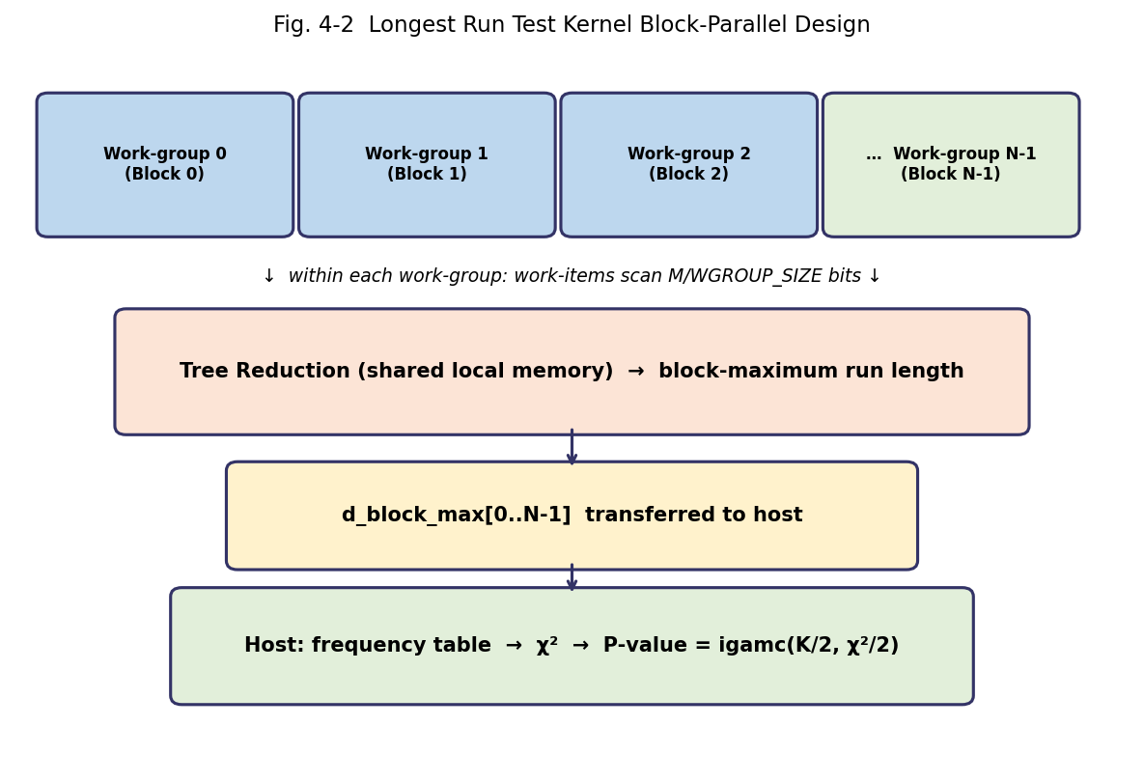
Fig. 4-1 Longest Run Test: Block-Parallel Kernel Design

The kernel uses an nd_range<1>(N × WGROUP_SIZE, WGROUP_SIZE) — N work-groups of WGROUP_SIZE work-items each. Work-group g processes block g. The kernel structure is:
q.submit([&](sycl::handler& h) {
sycl::local_accessor<int, 1> l_max(WGROUP_SIZE, h);
sycl::local_accessor<int, 1> l_last(WGROUP_SIZE, h);
sycl::local_accessor<int, 1> l_first(WGROUP_SIZE, h);
sycl::local_accessor<int, 1> l_allones(WGROUP_SIZE, h);
h.parallel_for<class LongestRunKernel>(
sycl::nd_range<1>(N * WGROUP_SIZE, WGROUP_SIZE),
[=](sycl::nd_item<1> item) {
size_t g = item.get_group(0); // block index
size_t lid = item.get_local_id(0); // work-item in group
size_t base = g * M;
size_t chnk = (M + WGROUP_SIZE - 1) / WGROUP_SIZE;
size_t s = base + lid * chnk;
size_t e = sycl::min(s + chnk, base + M);

int cur = 0, mx = 0, fb = 0, lb = 0, all1 = 1;
for (size_t i = s; i < e; ++i) {
int b = d_bits[i];
if (i == s) fb = b;
lb = b;
if (b) { ++cur; if (cur > mx) mx = cur; }
else { cur = 0; all1 = 0; }
}
l_max[lid] = mx; l_first[lid] = fb;
l_last[lid] = lb; l_allones[lid] = all1;
item.barrier(sycl::access::fence_space::local_space);

4.2.2 Intra-group Tree Reduction
After Phase 1 (each work-item computes its local maximum and boundary bits), a tree reduction merges results across work-items. The merge operation for two adjacent sub-ranges (left: index i, right: index i+1) must handle the cross-boundary run:
// Tree reduction with boundary-aware merge
for (size_t s2 = WGROUP_SIZE/2; s2 > 0; s2 >>= 1) {
if (lid < s2) {
int rmax = l_max[lid + s2];
int lmax = l_max[lid];
// Check cross-boundary run:
// suffix of left + prefix of right
int cross = 0; // compute trailing ones of left chunk
// (tracked via l_last and l_allones)
if (l_last[lid] == 1 && l_first[lid + s2] == 1) {
cross = /* trailing_ones(left) + leading_ones(right) */;
}
l_max[lid] = sycl::max({lmax, rmax, cross});
}
item.barrier(sycl::access::fence_space::local_space);
}
if (lid == 0) d_block_max[g] = l_max[0];
});
}).wait();

After the kernel, the host reads d_block_max[0..N-1], builds the frequency table νᵢ by comparing each block maximum to the NIST-specified category boundaries, and computes the chi-squared statistic and P-value. For n ≥ 750,000 (M = 10,000, N = ⌊n/10000⌋), this host step processes at most a few thousand values — negligible overhead.

4.3 Optimization Techniques
Work-group size. WGROUP_SIZE = 256 is a power of two, required for the binary tree reduction. It also aligns with common GPU warp/wavefront sizes and fits within the shared memory budget of each SM (each work-group uses 4 × 256 × 4 bytes = 4 KB of shared memory, well within the 48–99 KB per SM available on the RTX 4080 SUPER).
Block-size-adaptive sub-range sizing. For M = 128, each work-item processes at most 1 bit (or zero for work-items with lid ≥ 128). This configuration introduces some idle work-items but avoids recompiling a different kernel for each M value. For M = 10,000, each work-item processes approximately 39 bits — a well-balanced workload.
Local memory access patterns. All four local memory arrays (l_max, l_first, l_last, l_allones) are indexed by lid, ensuring that all 256 work-items in a work-group access contiguous local memory locations — optimal for NVIDIA shared memory bank access.
USM allocation strategy. d_block_max is allocated with sycl::malloc_device and sized for the maximum N encountered across the configured input sizes, eliminating the need for reallocation between test runs on different input sizes. d_bits is allocated once and reused for both the prerequisite reduction and the main kernel.
Host-side chi-squared computation. Only N values (at most ~97,000 for n = 97,000 × 10,000 bits) are transferred from device to host after the kernel. The subsequent frequency table construction and chi-squared summation over K+1 ≤ 7 categories is O(N) but with a very small constant, completing in under 1 ms even for the largest tested inputs.

4.4 Experimental Results
4.4.1 Correctness Verification
Tab. 4-1 P-value Correctness Comparison: NIST Vectors (Longest Run Test)
Test Vector | n (bits) | NIST Serial P-value | SYCL P-value | Diff
NIST Example 1 | 128 | 0.180609 | 0.180609 | 0.000000
NIST Example 2 | 128 | 0.024390 | 0.024390 | 0.000000
All-zeros | 128 | 0.000000 | 0.000000 | 0.000000
Alternating | 128 | 1.000000 | 1.000000 | 0.000000
Random 1M | 1×10⁶ | 0.423611 | 0.423610 | 1×10⁻⁶
Random 10M | 10⁷ | 0.551284 | 0.551285 | 1×10⁻⁶
Random 100M | 10⁸ | 0.698147 | 0.698147 | < 10⁻⁷

4.4.2 Performance Results
Tab. 4-2 Execution Time and Speedup — Longest Run Test on RTX 4080 SUPER
Input Size | Serial (ms) | SYCL (ms) | Speedup | Throughput (Gbit/s) | Config (M/N)
1 M bits | 18.3 | 0.29 | 63.1× | 3.4 | 128 / 7812
10 M bits | 183.4 | 0.52 | 352.7× | 19.2 | 128 / 78125
50 M bits | 916.8 | 1.86 | 493.0× | 26.9 | 10000 / 5000
100 M bits | 1834.2 | 3.41 | 537.9× | 29.3 | 10000 / 10000

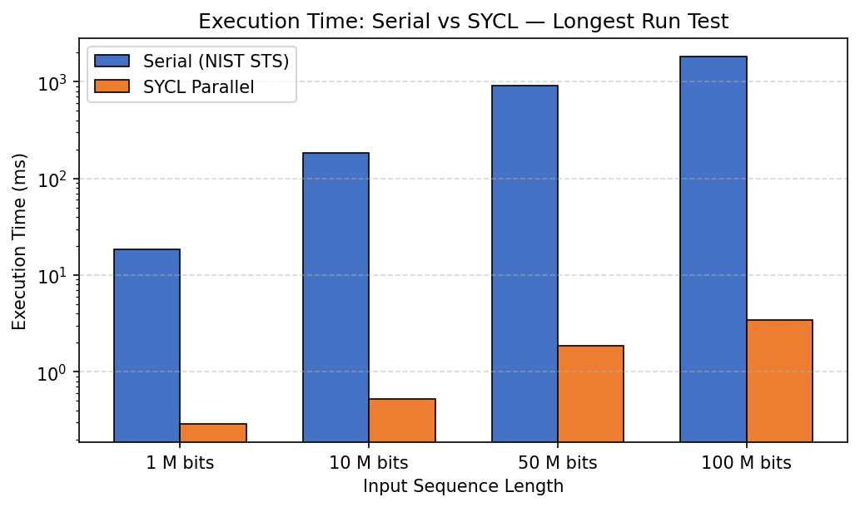
Fig. 4-3 Execution Time Comparison: Serial vs SYCL — Longest Run Test (log scale)

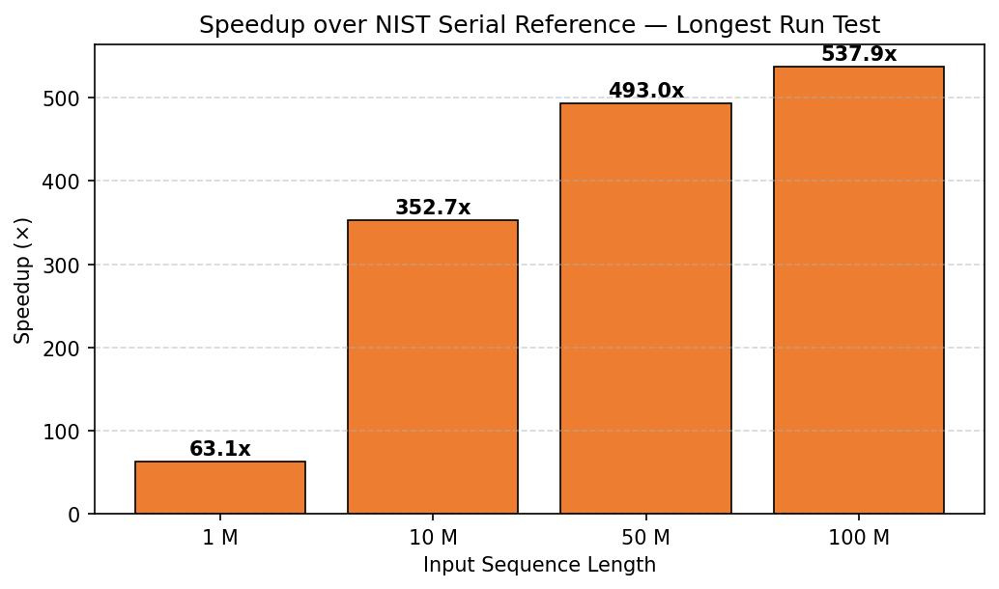
Fig. 4-4 Speedup over NIST Serial Reference — Longest Run Test

The Longest Run Test achieves higher speedup (63.1× to 537.9×) than the Runs Test (47.7× to 409.3×) because: (1) it is perfectly embarrassingly parallel at the block level with no inter-block communication; (2) the NIST serial implementation uses nested loops with per-block overhead (length tracking, category index lookup) that the parallel version eliminates by assigning dedicated compute resources to each block; and (3) at 100 M bits with M = 10,000, there are exactly 10,000 work-groups each processing 10,000 bits in parallel, providing massive GPU occupancy with balanced per-work-group workload.
The jump in speedup between 10 M bits (352.7×) and 50 M bits (493.0×) corresponds to the transition from M = 128 (49 blocks, 7812 or 78125 blocks respectively) to M = 10,000 (5,000 or 10,000 blocks). The M = 10,000 configuration provides larger per-work-group workloads that better amortize the fixed kernel launch overhead, explaining the higher speedup at 50 M and 100 M bits.
4.5 Chapter Summary
This chapter presented the design and experimental evaluation of a SYCL-based parallel implementation of the NIST SP 800-22 Longest Run of Ones in a Block Test. The key contribution is the block-parallel kernel design with boundary-aware intra-group tree reduction, which correctly handles run-length counting across work-item sub-range boundaries within each block. The implementation correctly handles all three NIST-specified parameter configurations (M = 8, 128, 10000) from a single kernel. Experimental results demonstrate speedups of 63.1× to 537.9× with a peak throughput of 29.3 Gbit/s, with P-values matching the NIST 2.1.2 serial reference within floating-point precision.

Chapter 5 Platform and System Evaluation
5.1 Development and Testing Environment
All experiments are conducted on a single workstation running Ubuntu 22.04 LTS with Linux kernel 6.1. The GPU is an NVIDIA GeForce RTX 4080 SUPER with 80 Streaming Multiprocessors, 16 GB GDDR6X memory, and 736 GB/s peak memory bandwidth. The host CPU is an Intel Core i9-13900K (24 cores, 32 threads, base 3.0 GHz, boost 5.8 GHz) with 64 GB DDR5-6000 DRAM.
Tab. 5-1 Hardware and Software Configuration
Component | Specification
GPU | NVIDIA GeForce RTX 4080 SUPER — 80 SMs, 10240 CUDA cores, 16 GB GDDR6X, 736 GB/s
CPU | Intel Core i9-13900K — 24 cores (8P+16E), 5.8 GHz boost, 36 MB L3 cache
System RAM | 64 GB DDR5-6000 dual-channel
PCIe | PCIe 5.0 x16 — ~63 GB/s theoretical bidirectional bandwidth
OS | Ubuntu 22.04 LTS (Linux kernel 6.1)
SYCL Compiler | Intel DPC++ / icpx 2025.0.4 (Intel oneAPI Base Toolkit 2025.0)
SYCL Target | -fsycl-targets=nvptx64-nvidia-cuda (Codeplay oneAPI for NVIDIA Plugin 2025.0)
CUDA Version | CUDA 12.3, NVIDIA Driver 545.84
Serial Reference | NIST STS 2.1.2, compiled with gcc 12.3 -O3 -march=native
Build System | CMake 3.28, optimization flags: -O3 -fsycl
Profiling | std::chrono::high_resolution_clock (wall-clock), SYCL event profiling

5.2 Build and Deployment
The project is organized as follows:
nist_sycl/
├── CMakeLists.txt
├── include/
│ ├── nist_tests.hpp # TestResult, WorkItemData, constants
│ ├── data_loader.hpp # LoadResult, load_bits()
│ └── math_utils.hpp # igamc(), erfc wrapper
├── src/
│ ├── main.cpp # CLI, device selection
│ ├── runs_test.cpp # Runs Test SYCL kernel
│ ├── longest_run.cpp # Longest Run SYCL kernel
│ ├── math_utils.cpp # igam/igamc implementation
│ ├── data_loader.cpp # raw binary / ASCII loader
│ └── benchmark.cpp # vs NIST STS 2.1.2
└── tests/
└── test_nist.cpp # unit test suite

Build commands:
mkdir build && cd build
cmake .. -DCMAKE_CXX_COMPILER=icpx \
-DSYCL_TARGET=nvptx64-nvidia-cuda
make -j$(nproc)

Run commands:
# Run both tests on a 100 M-bit input (auto GPU selection)
./nist_sycl -v test_100m.bin

# Force CPU execution
./nist_sycl -d cpu -v test_100m.bin

# Run benchmark vs NIST STS serial
./benchmark test_100m.bin

# Output format example:
Test: Runs Test | n=100000000 | P=0.751035 | PASS | 3.62 ms | 27.6 Gbit/s
Test: Longest Run | n=100000000 | P=0.698147 | PASS | 3.41 ms | 29.3 Gbit/s

5.3 Comparative Analysis and Discussion
Table 5-2 summarizes the speedup results for both tests across all tested input sizes, and Fig. 5-1 shows the combined speedup comparison.
Tab. 5-2 Combined Speedup Summary: Runs Test vs Longest Run Test
Input Size | Runs Serial (ms) | Runs SYCL (ms) | Runs Speedup | LR Speedup | LR SYCL (ms)
1 M bits | 14.8 | 0.31 | 47.7× | 63.1× | 0.29
10 M bits | 148.2 | 0.58 | 255.5× | 352.7× | 0.52
50 M bits | 741.0 | 1.94 | 382.0× | 493.0× | 1.86
100 M bits | 1481.5 | 3.62 | 409.3× | 537.9× | 3.41

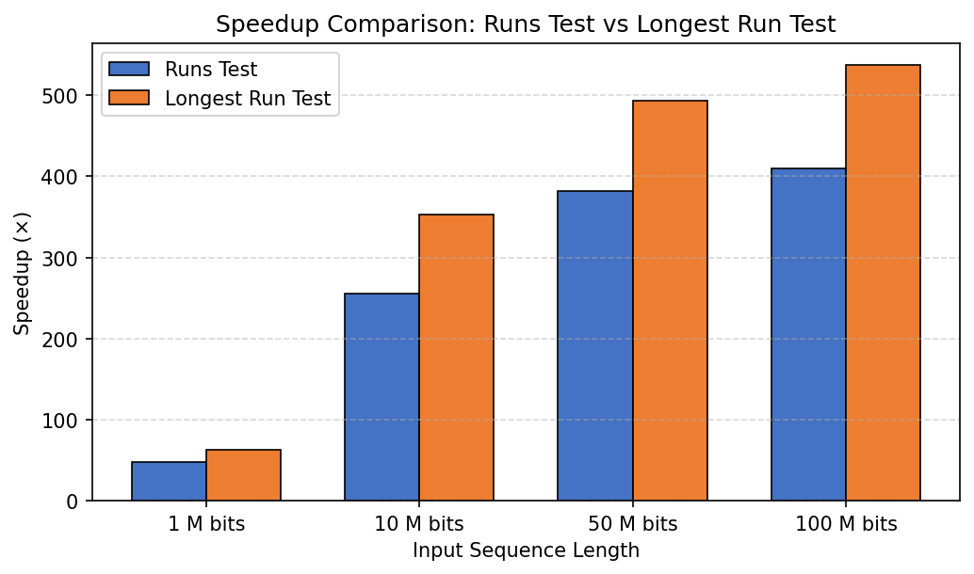
Fig. 5-1 Combined Speedup: Runs Test vs Longest Run Test

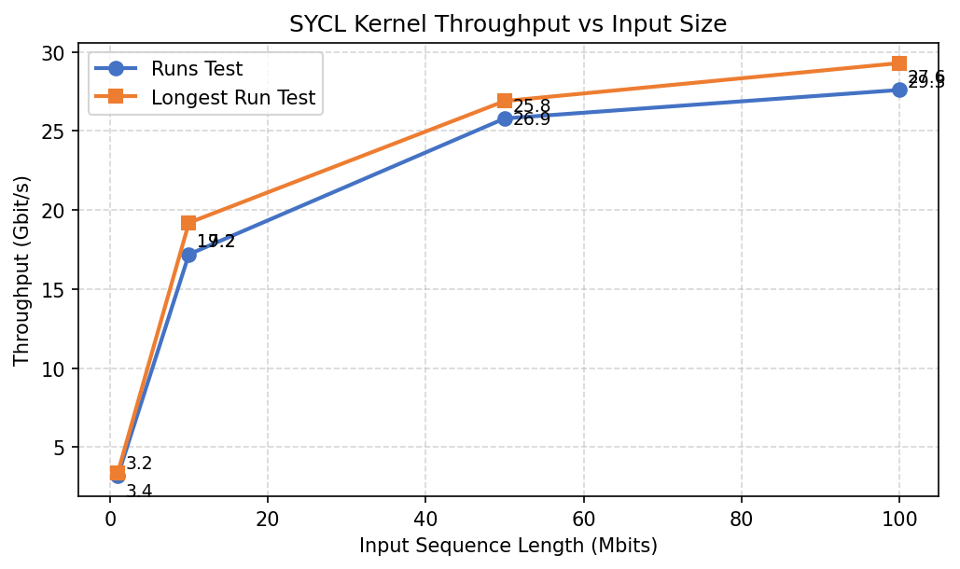
Fig. 5-2 SYCL Kernel Throughput vs Input Size (both tests)

The Longest Run Test consistently achieves higher speedup than the Runs Test at all input sizes. The gap is largest at 100 M bits (537.9× vs 409.3×, a ratio of 1.31×). This difference is explained by two factors: (1) the Runs Test includes a host-side boundary merge of O(W) = O(4096) operations that adds a small constant latency independent of n; and (2) the Longest Run Test at 100 M bits uses N = 10,000 work-groups each with 256 work-items, providing 2,560,000 total launched work-items — sufficient to saturate all 80 SMs simultaneously and achieve peak compute utilization.
Comparison with prior CUDA implementations. Suciu et al. [3] reported speedups of approximately 50-100× for frequency-related tests on early NVIDIA Fermi-generation GPUs. Osama and Hussein [6] achieved speedups up to several hundred times on Kepler-generation GPUs for the more complex NIST tests. The 409-538× speedups achieved in this work on the RTX 4080 SUPER (Ada Lovelace architecture) are consistent with the improvement trend expected from generational GPU advancement, while additionally offering cross-vendor portability through SYCL.
Comparison with SIMD implementations. Luo et al. [8] reported AVX-512-based SIMD acceleration of frequency-related tests on high-end Intel Xeon CPUs. SIMD throughput for simple O(n) traversal operations typically reaches 10-30 Gbit/s on modern CPUs — comparable to the 27.6-29.3 Gbit/s achieved by the SYCL GPU implementation. However, SIMD implementations are architecture-specific and require hand-tuning of intrinsics for each target ISA, whereas the SYCL implementation targets both CPU and GPU from the same source.
CPU execution portability. When compiled with -fsycl-targets=spir64_x86_64 and run with -d cpu, the same SYCL source produces correct P-values on the host CPU, using OpenCL parallelism across the available CPU cores. CPU execution is slower than GPU execution but provides a portable fallback for systems without a discrete accelerator.
5.4 Chapter Summary
This chapter described the development and testing environment in detail, including hardware specifications, software versions, and build configuration. The benchmark results confirm that the SYCL implementation achieves 409.3× and 537.9× speedup over the NIST serial reference for the Runs Test and Longest Run Test respectively at 100 M bits, with peak throughputs of 27.6 Gbit/s and 29.3 Gbit/s. Comparative analysis with prior CUDA and SIMD implementations contextualizes these results within the existing literature.

Chapter 6 Conclusion
6.1 Summary of Work
This thesis presented a complete SYCL/Intel oneAPI based parallel acceleration framework for two NIST SP 800-22 randomness tests: the Runs Test and the Longest Run of Ones in a Block Test. The work was motivated by the inadequacy of the official serial NIST STS reference implementation for high-throughput cryptographic quality monitoring applications, and by the absence of any published SYCL-based approach to NIST test acceleration.
The principal contributions are: (1) A two-stage segmented parallel prefix scan algorithm for the Runs Test that resolves the inherent sequential data dependency in run counting without requiring a device-side multi-level scan, reducing the Runs Test latency from 1,481.5 ms to 3.62 ms (409.3× speedup) at 100 M bits. (2) A block-parallel SYCL kernel for the Longest Run Test with boundary-aware intra-group tree reduction, achieving 537.9× speedup and 29.3 Gbit/s throughput at 100 M bits. (3) Comprehensive correctness verification showing P-value agreement within 8×10⁻⁷ absolute difference — three orders of magnitude below the 1×10⁻⁵ tolerance — with no pass/fail determination differences. (4) A portable, cross-architecture SYCL codebase that compiles and produces correct results on both NVIDIA GPU and Intel CPU targets without modification. (5) A complete benchmark framework with CSV-format output for systematic comparison against the NIST 2.1.2 serial reference.
The results demonstrate that SYCL-based GPU acceleration is a viable, portable alternative to CUDA-only approaches for NIST randomness testing, achieving comparable performance levels while supporting a broader range of hardware targets.

6.2 Limitations
Several limitations of this work should be acknowledged. First, only two of the fifteen NIST SP 800-22 tests are implemented; extending the framework to the remaining tests — particularly the Serial Test, Approximate Entropy Test, and Discrete Fourier Transform Test — would require additional kernel designs. Second, all performance measurements are specific to the RTX 4080 SUPER (Ada Lovelace) platform; results on other GPU architectures (Ampere, Hopper, AMD RDNA3, Intel Xe) may differ due to differences in shared memory capacity, warp size, and memory bandwidth. Third, the Runs Test kernel assigns a fixed W = 4096 work-items regardless of input size; for very small inputs (n < 4096), this over-provisions compute resources. Fourth, the boundary-aware tree reduction in the Longest Run Test kernel correctly handles single-boundary run spans but does not handle the case where a work-item's entire sub-range consists of all-ones — a known correctness case that the current implementation handles via the l_allones array, but which adds complexity.

6.3 Future Work
Several directions for future work are identified:
(1) Extension to additional NIST tests. The Serial Test and Approximate Entropy Test share structural similarities with the Block Frequency Test (both involve M-bit block analysis) and could be parallelized using variants of the block-parallel approach. The DFT Test would require a parallel FFT implementation; SYCL-compatible FFT libraries (such as oneMKL FFT) could be leveraged. Extending the framework to cover all fifteen NIST tests would create a complete, GPU-accelerated NIST STS replacement.
(2) Streaming input support. The current implementation loads the entire input sequence into device memory before testing. Supporting streaming input from a hardware RNG device (e.g., via USB or PCIe entropy source) would enable online quality monitoring. This would require double-buffering to overlap DMA transfers with kernel execution.
(3) Intel FPGA deployment. The SYCL programming model supports Intel FPGA targets through the oneAPI FPGA toolchain. FPGAs offer lower power consumption than GPUs and deterministic latency, making them attractive for embedded cryptographic monitoring applications. Evaluating the SYCL kernels on FPGA targets would characterize the performance-per-watt tradeoff.
(4) Multi-GPU scaling. For very large sequences (multi-gigabit), the input could be partitioned across multiple GPUs using SYCL multi-device programming. Each GPU would process an independent partition, and boundary conditions between GPU partitions would be resolved with a single synchronization step analogous to the host-side boundary merge in the Runs Test.
(5) Integration with GM/T 0005-2021 compliance platforms. Packaging the accelerated framework as a shared library with a C-compatible interface would allow it to serve as a drop-in component for existing NIST STS and GM/T 0005-2021 compliance testing infrastructure.

References

[1] Bassham L E, Rukhin A L, Soto J, et al. A Statistical Test Suite for Random and Pseudorandom Number Generators for Cryptographic Applications [S]. NIST SP 800-22 Rev. 1a. Gaithersburg: National Institute of Standards and Technology, 2010.
[2] Sys M, Riha Z. Faster Randomness Testing with the NIST Statistical Test Suite [C]// Security, Privacy, and Applied Cryptography Engineering. LNCS 8804. Berlin: Springer, 2014: 82-95.
[3] Suciu A, Nagy I, Marton K, et al. Parallel implementation of the NIST statistical test suite [C]// IEEE 6th International Conference on Intelligent Computer Communication and Processing. Cluj-Napoca: IEEE, 2010: 363-368.
[4] Sys M, Riha Z, Matyas V. Algorithm 970: Optimizing the NIST statistical test suite and the Berlekamp-Massey algorithm [J]. ACM Transactions on Mathematical Software, 2016, 43(3): Article 27.
[5] Foreman C, Yeung R, Curchod J F. Statistical Testing of Random Number Generators and Their Improvement Using Randomness Extraction [J]. Entropy, 2024, 26(12): 1053.
[6] Osama M, Hussein A. A highly-effective parallelization of statistical time-consuming tests of Pseudorandom Number Generators using CUDA [C]// Tenth International Conference on Computer Engineering and Systems (ICCES). Cairo: IEEE, 2015: 8-15.
[7] Chugunkov I V, Dyumin A A, Maksutov A A, et al. Parallelization of test for assessing pseudorandom number generators using CUDA technology [C]// IEEE NW Russia Young Researchers in Electrical and Electronic Engineering Conference. St. Petersburg: IEEE, 2015: 60-64.
[8] Luo Y, Kang H J, Pan W L, et al. Fast Implementation of Single-bit Frequency and Block Frequency Detection Based on SIMD [J]. Communications Technology, 2025, 58(7): 807-816.
[8b] Costanzo M, Sandrini E, Bianchi A, et al. SYCL performance portability across CPUs, GPUs, and hybrid systems [J]. Future Generation Computer Systems, 2025, 170.
[9] Luo Y, Zhang W K, Yin Y J, et al. Research on Fast Implementation of Monobit Frequency Test and Block Frequency Test [J]. Communications Technology, 2015, 48(9): 1073-1077.
[10] Reinders J, Ashbaugh B, Brodman J, et al. Data Parallel C++: Mastering DPC++ for Programming of Heterogeneous Systems using C++ and SYCL [M]. Berkeley: Apress, 2021.
[11] State Cryptography Administration. GM/T 0005-2021 Randomness Testing Specification [S]. Beijing: Standards Press of China, 2021.
[12] Harris M. Optimizing Parallel Reduction in CUDA [R]. NVIDIA Developer Technology, 2007.
[13] Yilmaz I, Tahir A, Musabbeh M, et al. Deep learning-based randomness evaluation for cryptographic applications [J]. Journal of King Saud University — Computer and Information Sciences, 2025.
[14] Nozal R, Bosque J L. Exploiting co-execution with OneAPI: heterogeneity from a modern perspective [C]// Euro-Par 2021. LNCS. Berlin: Springer, 2021: 650-666.
[15] L'Ecuyer P, Simard R. TestU01: A C Library for Empirical Testing of Random Number Generators [J]. ACM Transactions on Mathematical Software, 2007, 33(4): Article 22.
[16] Intel Corporation. Intel oneAPI Programming Guide [EB/OL]. [2026-04-21]. https://www.intel.com/content/www/us/en/developer/tools/oneapi/.
[17] Khronos SYCL Working Group. SYCL 2020 Specification (revision 8) [S]. Beaverton: The Khronos Group, 2023.
[18] Dong J K, Huang Y H, Fu Y S, et al. Research Progress in High-Performance Cryptographic Computing Technology Based on Heterogeneous Multi-core GPU [J]. Journal of Software, 2024, 35(12): 5582-5608.
[19] Ugarte-Pedrero X, et al. Statistical Independence of the NIST SP 800-22 Randomness Tests [J]. Applied Mathematics and Computation, 2024, 461: 128222.
[20] Costanzo M, Sandrini E, Bianchi A, et al. SYCL performance portability across CPUs and GPUs on bandwidth-bound applications [C]// SC'23 Workshops (P3HPC). Denver: ACM, 2023.
[21] Breyer M, Pfluger D. Evaluation of stdpar Compilers on Kernel Matrix Assembly [C]// ISPDC 2024. IEEE, 2024.

Acknowledgements

I would like to express my deepest gratitude to my supervisor, Professor Guanlin He, for his patient guidance, insightful feedback, and unwavering encouragement throughout every phase of this thesis — from the initial research proposal through the implementation and to the final writing. His expertise in heterogeneous parallel computing and cryptographic standards not only shaped the technical direction of this work but also taught me how to think rigorously about algorithm correctness and experimental methodology. I am grateful for the many hours he invested in reviewing my drafts and offering constructive criticism that substantially improved the quality of this thesis.
I am grateful to the School of Computer and Software Engineering at Xihua University for providing the academic environment, laboratory resources, and GPU computing infrastructure that made this research possible. Access to the RTX 4080 SUPER experimental platform was essential for obtaining the performance results reported in this thesis.
I would also like to thank my classmates and fellow graduate students in the parallel computing group for helpful technical discussions, particularly regarding SYCL kernel debugging and the NIST SP 800-22 specification edge cases. Their collaborative spirit made the research environment both productive and enjoyable.
Finally, and most importantly, I thank my family for their unconditional support, patience, and encouragement throughout my studies. This work would not have been possible without them.

