**Development of Electrical Engineering**

**Introduction**

This report outlines the development of the profession of electrical engineering starting from the seventeenth century down to the 1920’s. Although electrical engineering was not offered as a university degree until the late nineteenth century, the works of numerous scientists laid the foundation that the profession is built on today. It was Sir Isaac Newton who once said “If I have seen further it is by standing on the shoulders of giants.” With each scientist and inventor in the field building on the work and discoveries of the preceding scientists, this quote holds true for many contributors to the development of electrical engineering as well. Whether it was Andre-Marie Ampere building on the work of Hans Christian Orsted, Michael Faraday building on the work of Ampere, or James Maxwell building on the contributions of Faraday in the 1800’s, the field of electrical engineering would not be as it is today without these scientists standing on the shoulders of the ones that came before.

Breakthroughs in electrical engineering began roughly in the seventeenth century. The major contributor of the century being William Gilbert, who published his work on electricity and magnetism in 1600 and invented the first ever electroscope in the same year. Charles Coulomb formulated his law regarding the electric force between two charges and continued the work on electrostatics in the eighteenth century. Coulomb’s law is arguably the breakthrough of the century because of its incredible impact on the electrical engineering is studied and practiced today.

Although significant breakthroughs in electrostatics began in the seventeenth and eighteenth centuries, it was in the nineteenth century that the study of electricity intensified immensely. The nineteenth century includes the birth of electrodynamics, the invention of the electric battery, and groundbreaking discoveries by experimentation. All courtesy of the brilliant minds of Alessandro Volta, Georg Simon Ohm, Gustav Kirchhoff, and many more. In fact, it was in the late nineteenth century that electrical engineering began to be offered as a university degree.

The twentieth century

**Development in the Seventeenth Century**

The discovery of electricity is believed to go way back to 600 B.C. when Thales, one of the seven Sages of Greece had the knowledge that rubbed amber attracted light objects such as paper and feathers. However, significant breakthroughs in electricity started in 1600 by English physician William Gilbert. Gilbert published his book titled *De Magnete* in 1600. Gilbert discovered that it was not only amber that could attract light objects when rubbed but rather many other objects had the same property. William Gilbert derived the name electricity from the Greek work for amber, and is known today as the father of electricity. Gilbert’s work and discoveries was the foundation for the field of electrostatics. Gilbert also invented the versorium

The invention seen in Figure 1 is a needle constructed out of metal which is able to pivot on a pedestal. It is very similar to compass needle but unmagnetized [2, Cambridge]. The needle is attracted to charged bodies and brought near it, will turn towards the charged object [2, Cambridge]. Versorium can distinguish between charged and uncharged objects. Very similar to a magnetic compass, but influenced by electrostatic forces rather than magnetic forces. The differences between these two different forces were poorly understood and Gilbert performed a series of experiments to prove their separatism which is one of the reasons he was given credit as the first father of electrical engineering.

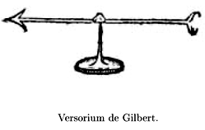

*Figure 1: Caption*

**DEVELOPMENT IN THE EIGHTEENTH CENTURY**

**Coulomb’s Law**

Perhaps the most significant contribution to the development of electrical engineering in the eighteenth century was the development of Coulomb’s law by French physicist Charles-Augustine De Coulomb in 1783. Coulomb’s work on electrostatics is still very relevant to the way we study and practice electrical engineering today. His law describes the force interacting between static electric charges and is still taught in all introductory physics courses. Coulomb’s law states that the electric force between two charges is directly proportional to the product of the magnitude of the charges, and inversely proportional to the square of the distance between them. The mathematical representation of the law is shown below:

$$F_{e}=\frac{k\left(q_{1}q_{2}\right)}{r^{2}}$$

Where *k* is known as Coulomb’s constant and has a value of 8.99x109 with units of $\frac{Nm^{2}}{C^{2}}$. Coulomb’s constant can also be written in the following form

$$k_{e}=\frac{1}{4πϵ_{0}}$$

Where the value $ε_{0}$ is the permittivity of free space and has a value of 8.85x10-12. The charges q1 and q2 are measured in Coulombs, which is the SI unit of charge named in Charles Coulomb’s honour. Coulomb came upon his discovery through experiments with what is known as a torsion balance. A diagram of the apparatus is shown in Figure 2. Coulomb’s torsion balance consists of a glass case at the bottom closed by a lid. A glass tube emerges from the lid, which is then closed with a suspension head. A torsion fiber which holds a horizontal needle is suspended from the suspension head.

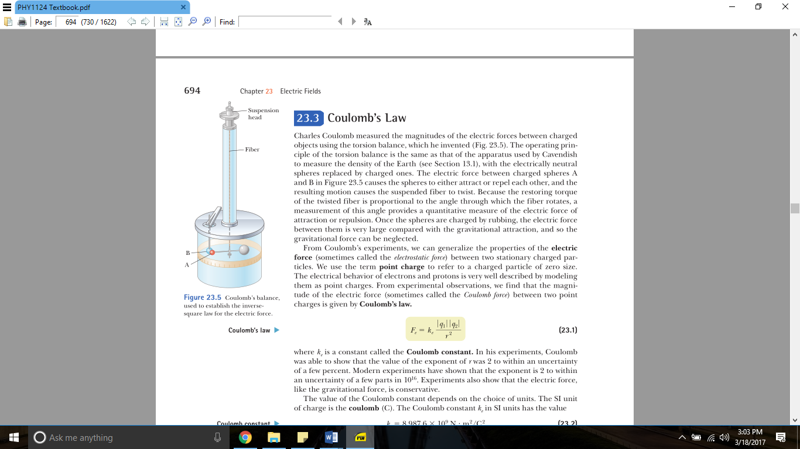.

*Figure 2: Caption*

The discoveries and inventions made by Coulomb in the eighteenth century were huge breakthroughs in the field of physics and electrical engineering. Coulomb’s law provided scientist with a tool for calculating the net electric force between two charges, and the law has the following properties: Like charges repel each other and unlike charges attract, and the attraction or repulsion acts along the line between the two charges. Coulomb’s law would also go on to be an incredibly useful tool for physicists.

**DEVELOPMENT IN THE NINETEENTH CENTURY**

**Background**

The nineteenth century is arguably the most significant period when it comes to the development of electrical engineering. Some of the most fundamental laws in the field of electrical engineering were developed in the nineteenth century. By the later part of the century, numerous scientists and inventors helped shape the world we live in today. The scientists and inventors that made major contributions to the discoveries and inventions of the nineteenth century include the likes of Alessandro Volta, Georg Simon Ohm, and Gustav Kirchhoff.

**Alessandro Volta**

When it comes to the development of electrical engineering, the nineteenth century got off to a great start right away with the invention of the first electric battery in the year 1800. Italian physicist Alessandro Volta had experimented with electricity for many years in the late eighteenth century, however it was not until 1800 that Volta provided the first source of continuous current. Known as the voltaic pile, the first electric battery was a groundbreaking discovery. Volta put together a pile of alternating metal disks, separated by what is now known as electrolytes. The pile built by Volta consisted of zinc and silver disks. There was a steady current produced when a wire was connected to both ends of the pile and the field of electrodynamics was born. Volta discovered that the amount of current produced varied depending on the different types of metal used in the pile. He also found that the more disks added to the stack resulted in a greater current. The invention of the electric battery helped many other scientists discover even more groundbreaking results in the field.

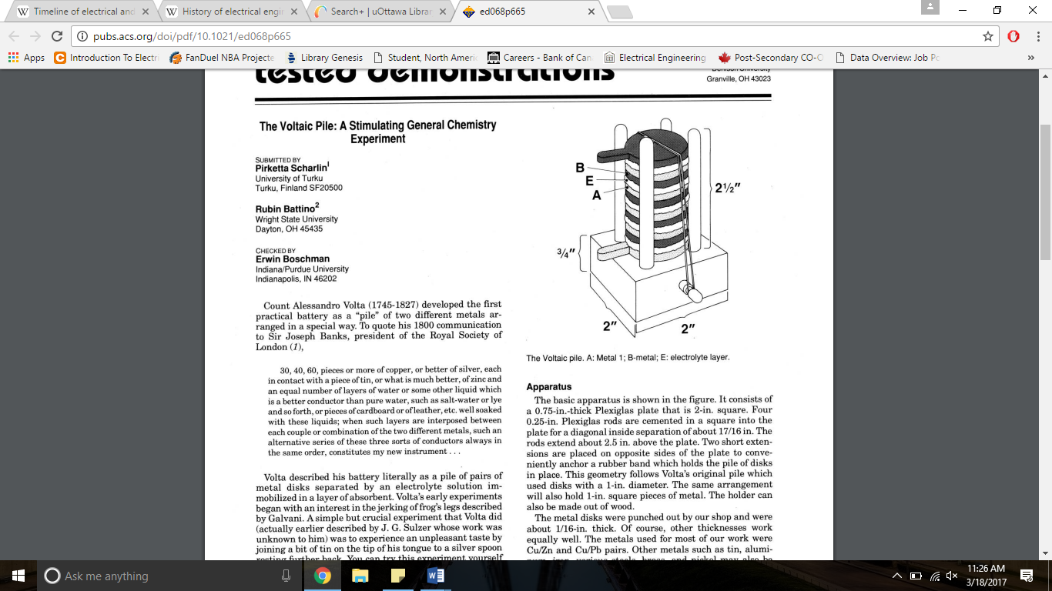

*Figure 3: Caption*

The apparatus of Volta’s battery is shown above in Figure 3. “A” and “B” are metals, and “E” is an electrolyte layer. The unit volts (V) used to measure the potential difference across an element is named after Alessandro Volta. Thanks to Alessandro Volta, for the first time ever scientists could produce a steady electric current.

**Georg Simon Ohm & Ohm’s Law**

Discovered in 1827 by German physicist Georg Simon Ohm, Ohm’s law may be the most fundamental law in all of electrical engineering. Ohm realized that the voltage across most materials is directly proportional to the current through the material. Georg Simon Ohm published his work in 1827 and stated Ohm’s law in the following mathematical representation:

$$V=IR$$

As simple as that mathematical relationship between current and voltage is, it is that equation which is used today in almost any electrical circuit analysis by electrical engineers. The variable *V* represents the voltage applied across the material. Voltage is also known as the potential difference and is measured in units of volts (V). It is a measurement of how much energy is required per unit charge. Therefore, one volt is equal to one joule (J) per coulomb (C).

$$1V=1\frac{J}{C}$$

The variable *I* represents the current through the material, measured in units of amperes (A). The current is a measurement of the rate at which the charge passes a fixed point. Therefore, one ampere (A) is equal to one coulomb (C) per second (s), mathematically written as

$$1A=1\frac{C}{s}$$

Finally, the variable *R* represents the resistance of the material, measured in units of ohm’s (Ω) in honour of Georg Simon Ohm. Resistance is the physical property of an element or device that impedes or resists the flow of current. The unit of resistance is equal to one volt per ampere. The mathematical representation is

$$1Ω=1\frac{V}{A}$$

Although Ohm’s law is taught today in virtually any introductory physics or engineering textbook, it was not an easy road for Ohm to prove his discovery. Ohm’s work was ridiculed by physicists at the time and received no credit for his work.

**Kirchhoff’s Laws**

Ohm’s law provides electrical engineers of today with a basic mathematical tool for analyzing electric circuits. In 1845, another German physicist by the name of Gustav Kirchhoff experimentally determined two more laws that would greatly simplify electric circuit analysis, Kirchhoff’s current law (KCL) and Kirchhoff’s voltage law (KVL). KCL states that the algebraic sum of all the currents at any node in a circuit must equal 0. In other words, all of the current entering a node must be equal to all of the current that is exiting that node. KVL states that the algebraic sum of the voltages around a closed loop in a circuit is equal to zero for all time. Like Ohm’s law, these two laws developed by Kirchhoff are so fundamental to electrical engineering that they are taught in virtually all introductory textbooks today. For a better visualization, consider the following example of Kirchhoff’s current law in Figure 4. The current *I1* is entering a node that branches off in two directions. Ultimately *I1* will split into two different currents labelled as *I2* and *I3*. This is written mathematically as:

$$I_{1}= I_{2}+ I_{3}$$

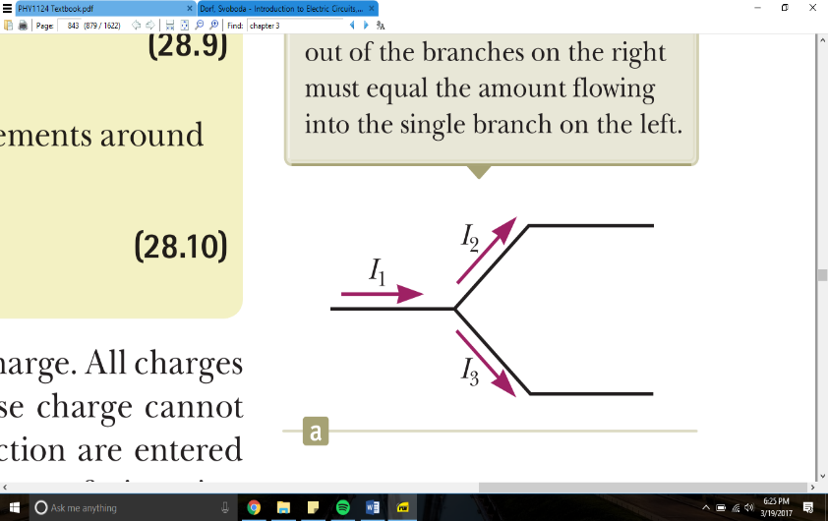

*Figure 4: Caption*

For an example of KVL applied in a problem, consider the circuit shown in Figure 5. As shown in the circuit, the current *I* is going in a clockwise direction. The direction of the current is the analyzers choice but it will change the signs in your equation depending on the direction you choose. So whichever direction that is chosen, make sure it is consistent with the equation. As the current travels in a clockwise direction, the voltage drops and voltage rises of each element is put into the equation. For resistors, use Ohm’s law to express the voltage in terms of the current and the resistance. The equation derived from completing a KVL in this circuit is

$$I*R_{1}+12V+ {I*R}_{2}=0$$

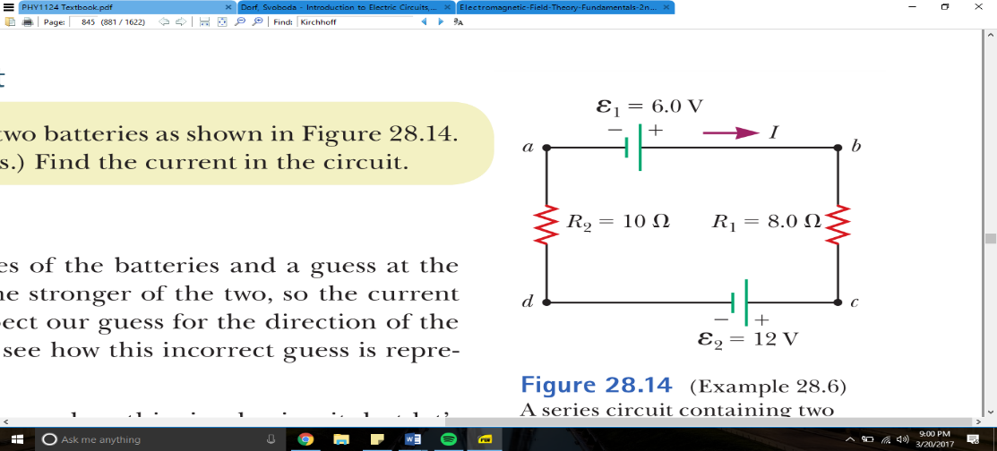

*Figure 5: Caption*

Kirchhoff’s rules are just as fundamental to circuit analysis as Ohm’s law is. Without these laws, circuit analysis would be much more difficult and who knows what electrical engineering would be like today.

**DEVELOPMENT IN THE TWENTIETH CENTURY**

**References**

<http://pubs.acs.org/doi/pdf/10.1021/ed006p1726>