* Activity 1

* Activity 2

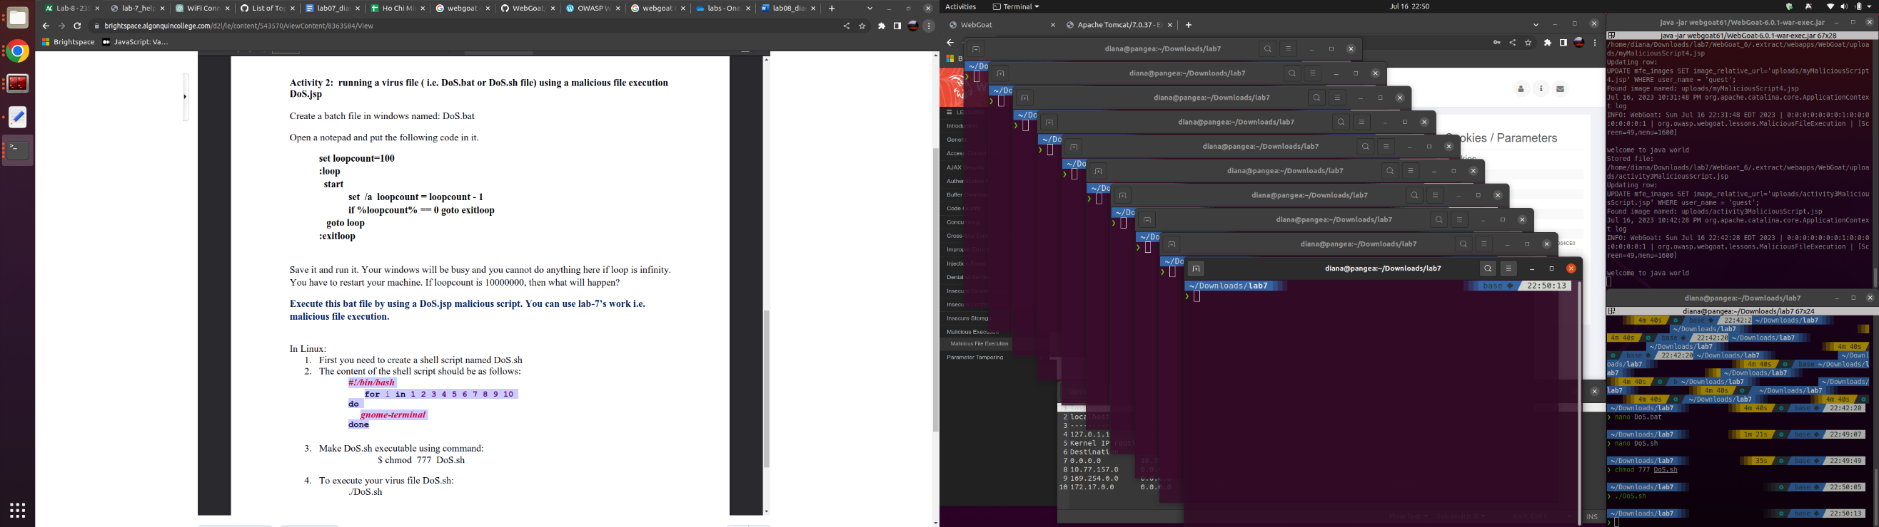

If loopcount is 10,000,000, then it will create 10,000,000 terminals. It could cause the program to crash.