1. Apache Installation

Step 1.1

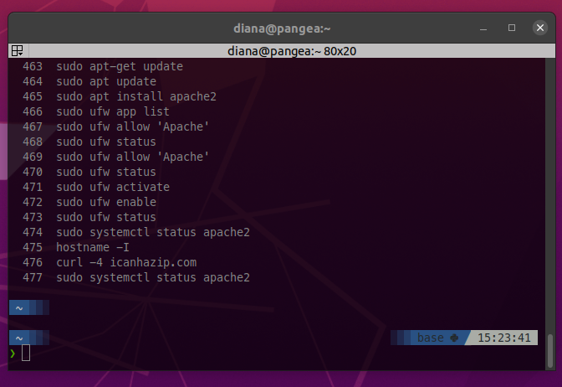

Step 1.2

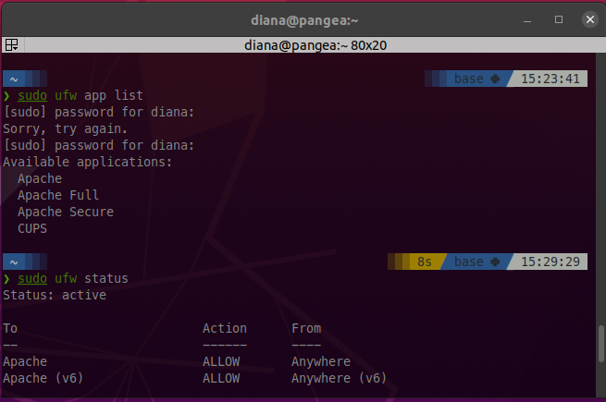

Step 1.3

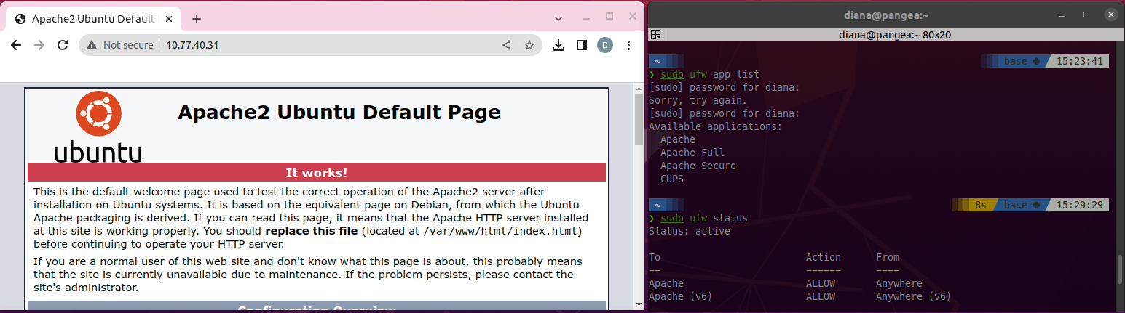

Step 1.4

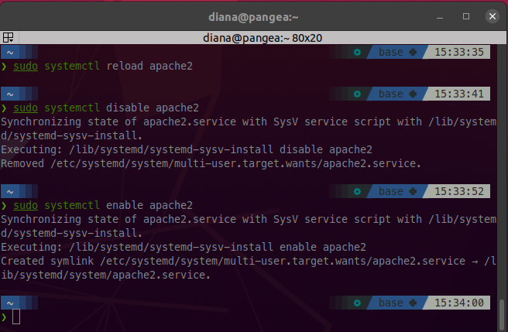

1. Hosting Personal Web Page

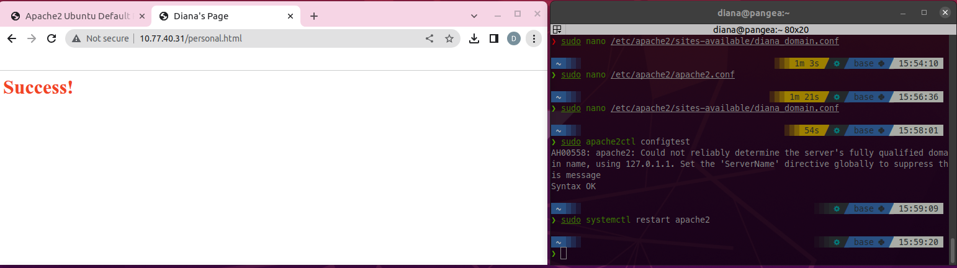

1. Hardening apache2 web server

Step 3.1 Hide Apache Version and Operating System

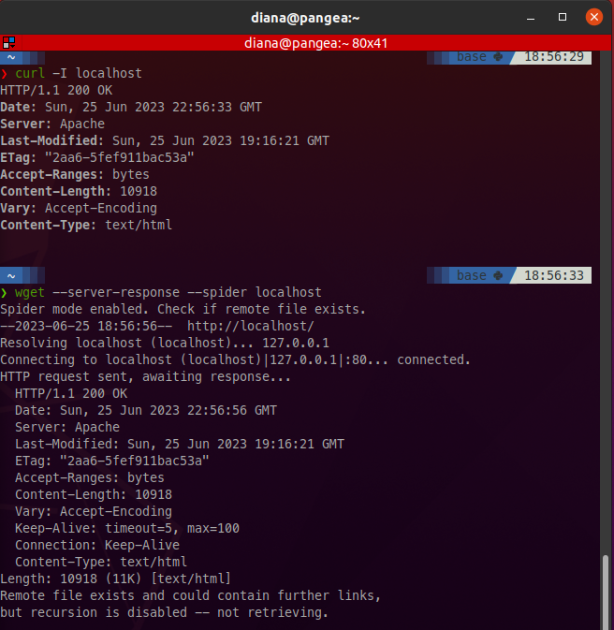

Step 3.2 Disable Directory Listing and FollowSymLinks

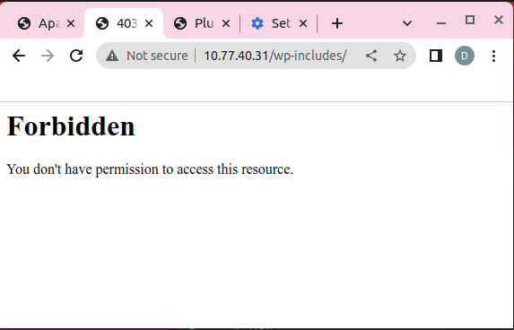

Step 3.3 Secure Apache using mod_security and mod_evasive Modules

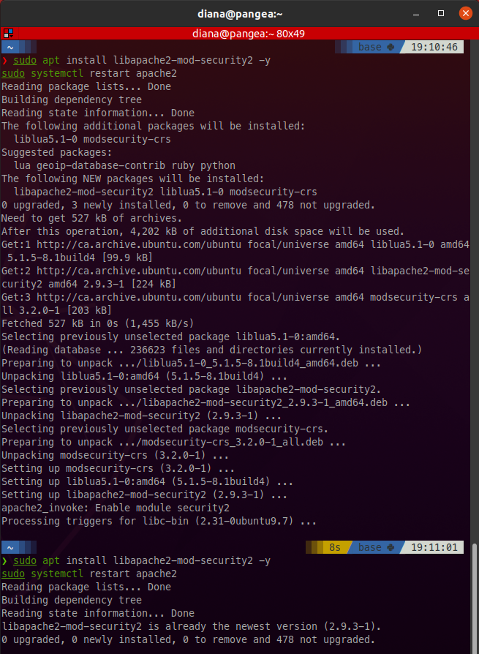

Step 3.4 Limit Request Size

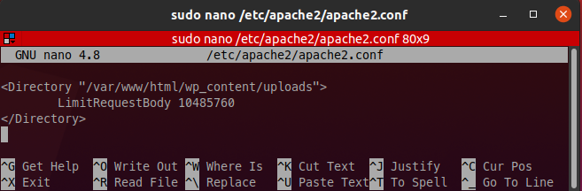

Step 3.5 Disable TRACE HTTP Request

