**AWS S3 BUCKETS:**

Major 5 advantages of the S3 buckets: Also includes performance as well.

What can I store in the S3.

S3 can store anything related to .jpg, .mp4., .csv and other files as well.

Application Logs files, User database which may be more than 3 or 4 TB.

S3 BUCKETS are accessible using the HTTP and can be accessed from anywhere in this world.

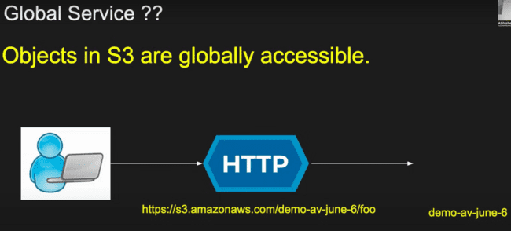

You can store anything in the S3 buckets. Example: a movie and shared with multiple people across the globe.

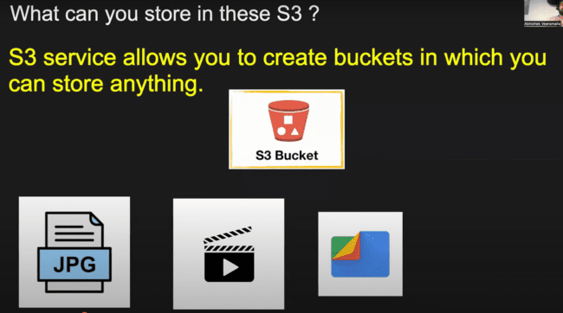

Each object should not be more than 5 TB.

S3-> Create Bucket.

Need to provide the unique name, as it is accessible globally. Also, the S3 buckets are globally accessible, but still we need to bound them to some region as shown below:

By default, public access is off, if we disable this one, the AWS would issue a warning message.

Other fields would be same and will discuss in future.

And Server-side encryption would be available by default.

After that S3 bucket would be created:

Open that instance and upload anything in that bucket.

Click upload:

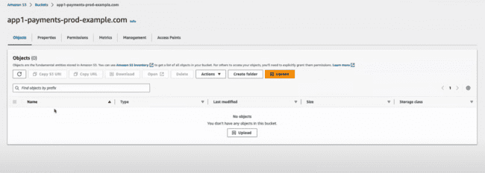

Upload anything:

That page would be uploaded in the S3 bucket as:

**IMPORTANT: If we have saved the Database dump in the S3 and S3 goes down or the specific region where S3 has been stored goes down…….?**

There is one number which is used while working with S3.

Anything which has been uploaded in S3 indicates as OBJECT.

This means that S3 is this much reliable.

This means that if you upload even billions of records, there is chance that only 0.0001 percent of object can be deleted, others would be reliable, this has been guaranteed by the S3. **And that is because of replication mechanism of the S3.**

**It creates the multiple copies of the uploaded file in the multiple datacenters and multiple zones, so that data would never gets destroyed or deleted. And deletion of data is very rare in the S3 bucket.**

Other Characteristics of S3:

Benefits and Advantages of S3. Five major advantages.

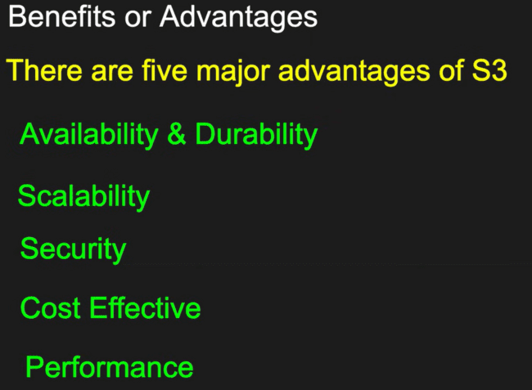

There is multi part upload of the file, which we can upload like uploading the 100 MBs file in one go, 100 MBs in other go, instead of uploading the whole 1 GB of file.

**SIZE should not reach more than 5 TB.**

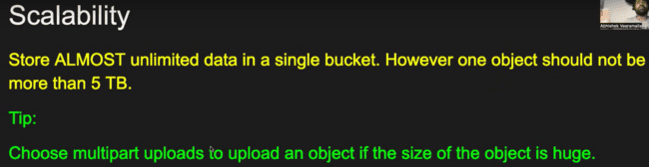

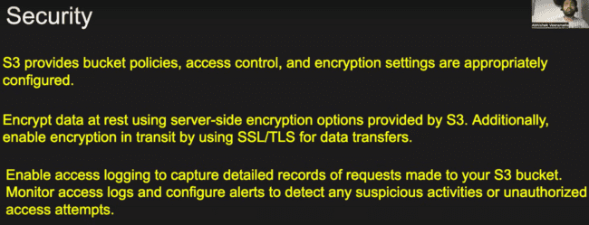

Storage classes are like: If you want high input output like quick upload and quick download, then storage would be costly and if you don’t bother about the input, output, then that solution be less costly.

Version control in S3 buckets:

S3 -> Buckets -> select the file.

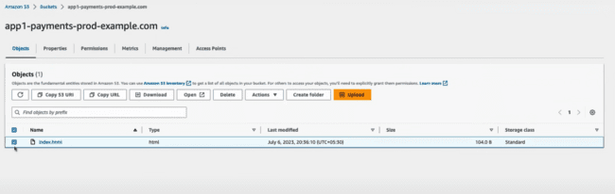

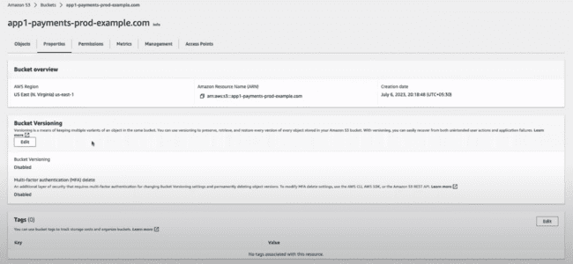

Click on the Edit and make the bucket versioning enabled as shown below:

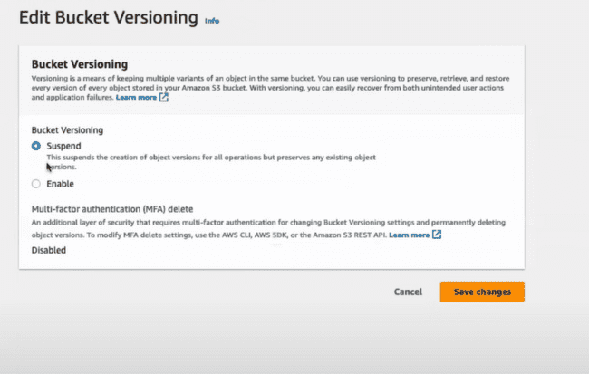

Save:

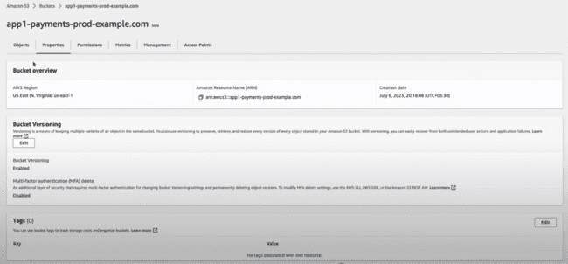

After making the versioning enabled, when we try to upload the index.html file again, we would be able to see its version.

After changing the index.html and upload the file again, we’ll be able to see the versions of this file. Under Versions:

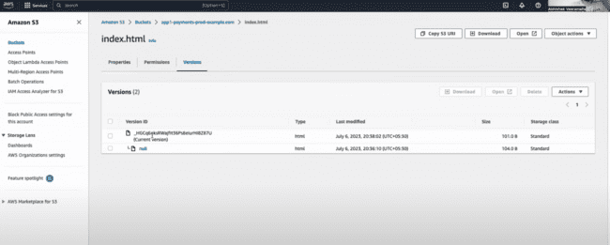

Tags: Basically, used for identifying the resources and to uniquely identifying the resources. Like, when someone says, please give me s3 bucket associated with the SPECIFIC TAG.

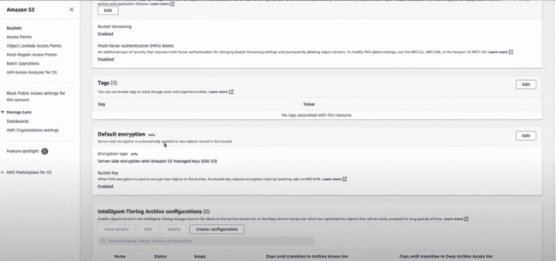

Edit and add new tag.

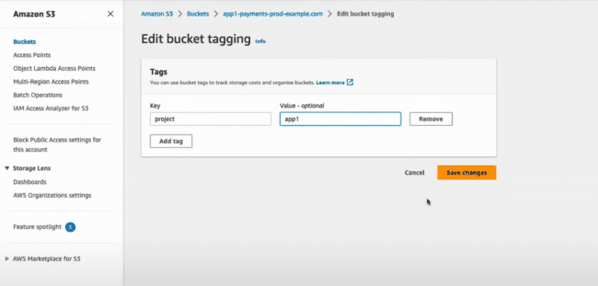

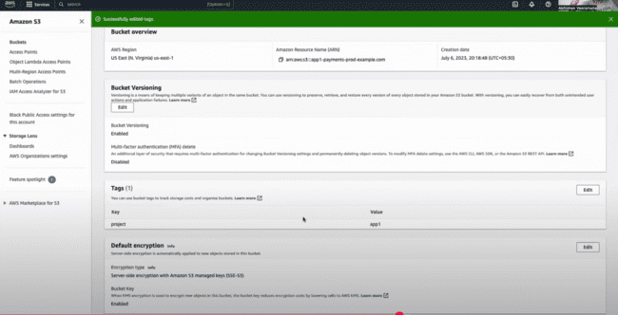

Access logging is by default disabled. Enabling this feature means who is logging into this bucket, what kinds of actions they are performing, and revoke someone access as well.

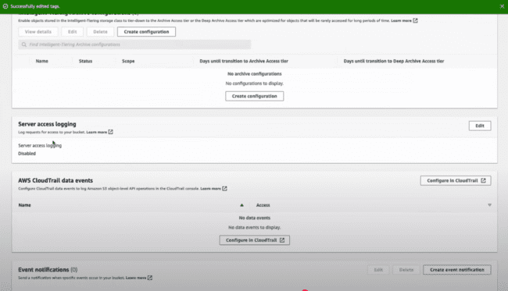

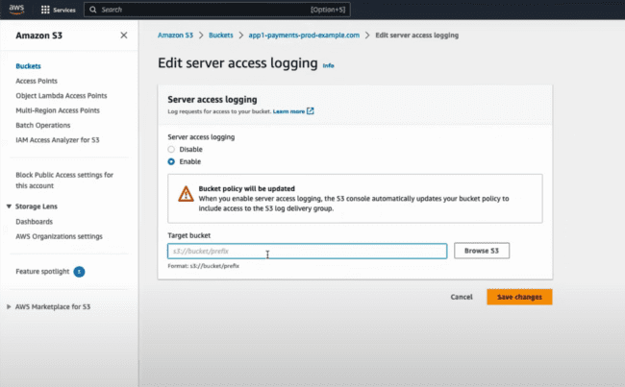

To use the EVENT NOTIFICATIONS, we need to understand the LAMBDA EXPRESSIONS:

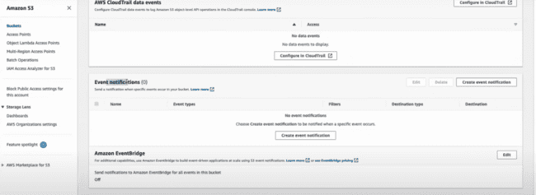

Object Lock: Like there is some sensitive information present on the OBJECT and no one can change that, we can lock the object.

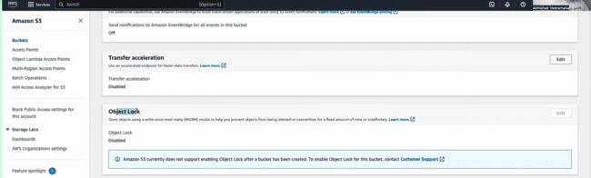

STATIC WEBSITE HOSTING: How to host the static websites using the S3 buckets.

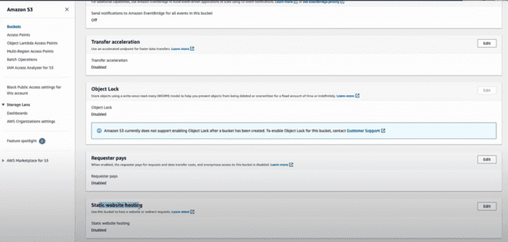

BUCKET PERMISSIONS:

Example: restricting the access to the currently created S3 bucket and providing the access to all other buckets.

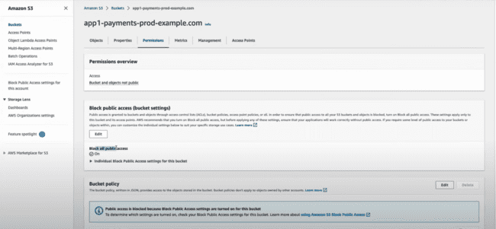

**IMPORTANT: if someone has created the IAM user and provided the access to the all the S3 buckets, but in the bucket permissions, we can revoke that access.**

Firstly, creating the IAM user:

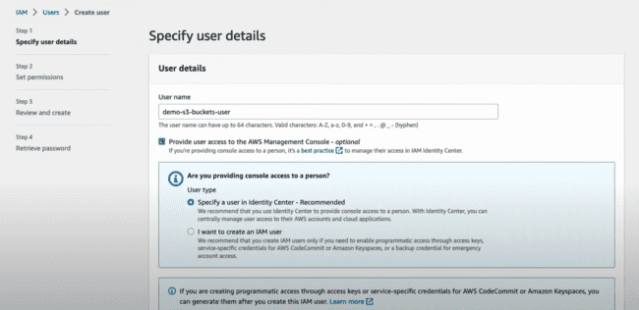

Now attaching the policy of S3 buckets directly, but firstly, we’ll not be giving any policy, and make sure that S3 bucket access is not there.

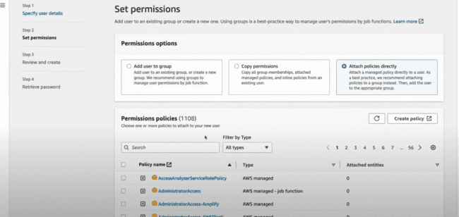

Without any permissions:

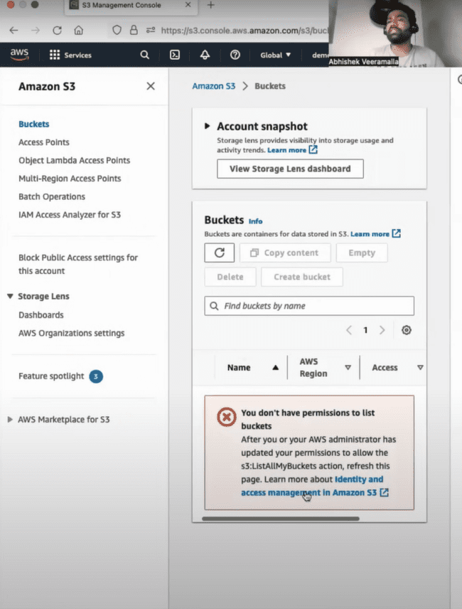

After giving the S3FullAccess, the user would be able to see the following:

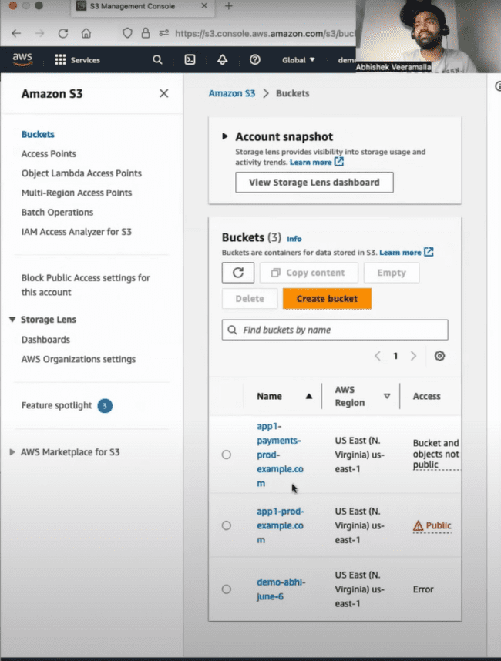

Now any user can access the bucket, so we need to revoke the permissions for specific bucket.

Under S3 Buckets-> Permissions-> Need to update this bucket policy.

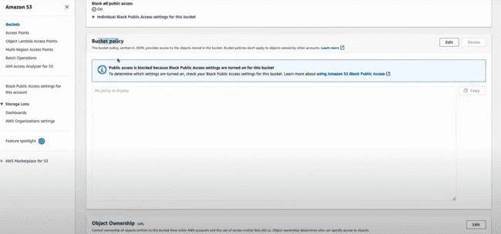

Click Edit-> 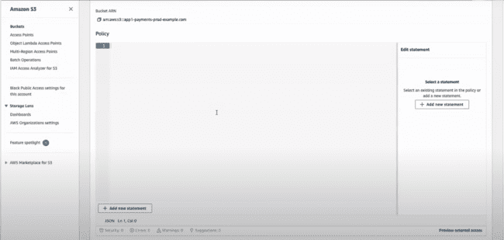

Click on the “+ Add new statement”:

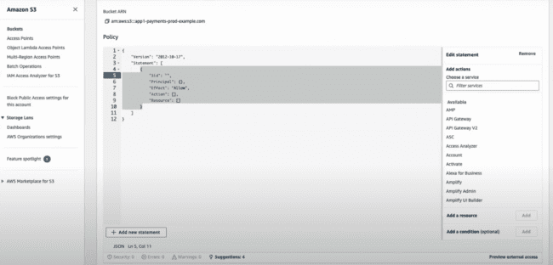

Sid is name, any can be given.

Principal: To whom we can perform this action against.

Effect: Deny or allow.

Actions: what type of action we need to perform. For this one, search for the service: S3

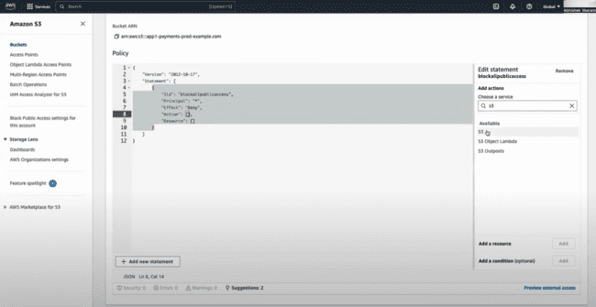

All actions or specific action, you need to perform.

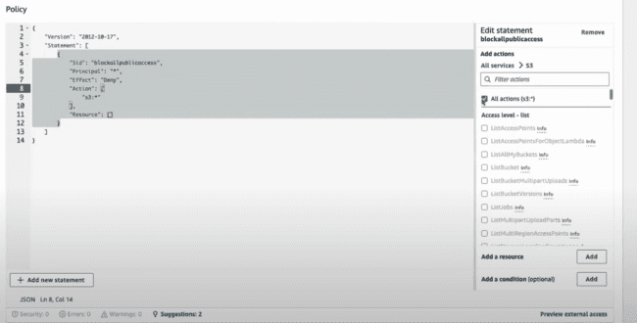

Resource: which S3 bucket this would be, we need to provide. Select from the right bar “Add a resource”

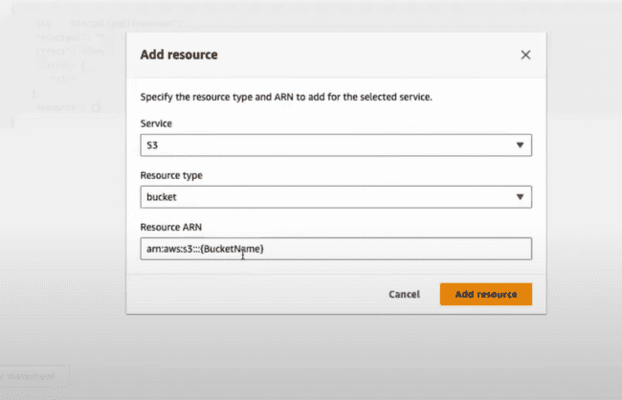

Write name of the bucket in place of “(Bucket Name)”.

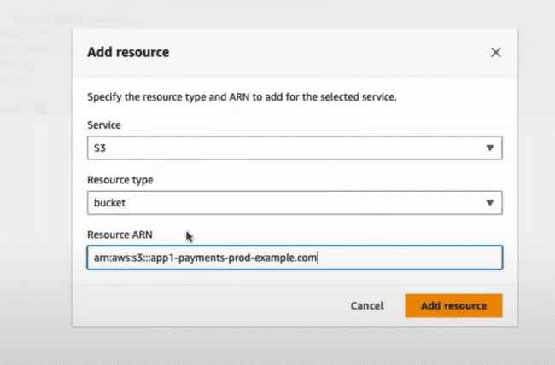

This would be added.

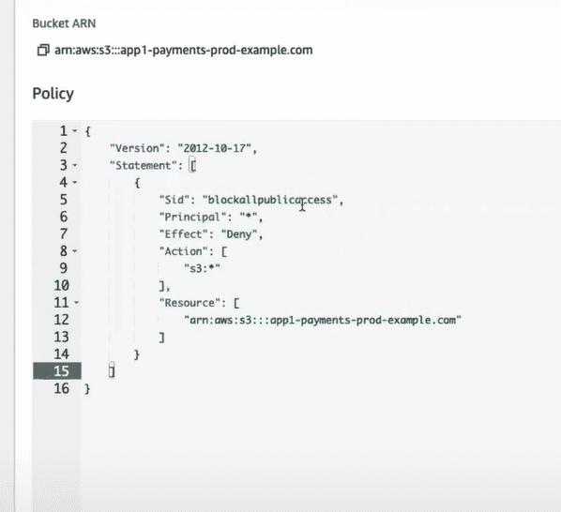

Now for the above one, everyone is blocked, but you need to add permission that your account won’t be blocked. So, for this one, we need to “Add a condition(optional)”:

Condition key is aws:PrincipalArn and we need to provide the StringNotEquals or StringEquals and add the value.

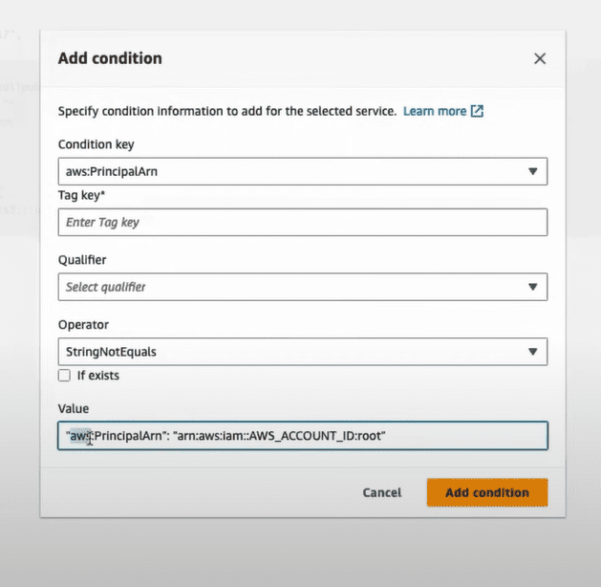

We just need to replace the AWS_ACCOUNT_ID with the user account number.

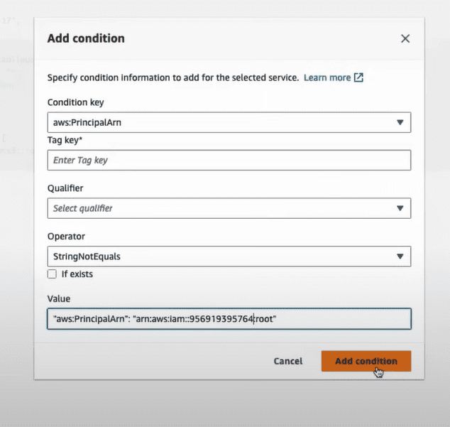

Final condition would be:

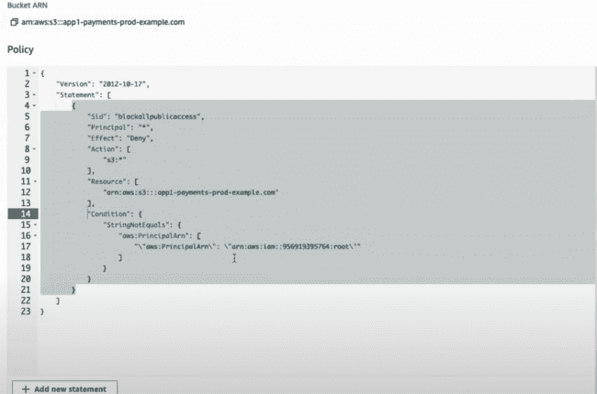

For the above condition, we need to update the resource in the request as for the bucket and for the resources inside the bucket.

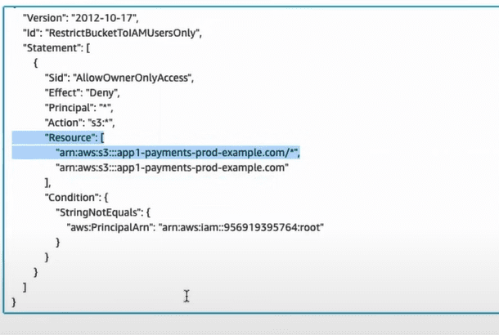

For the DEMO user, he would not be able to access the bucket as shown below:

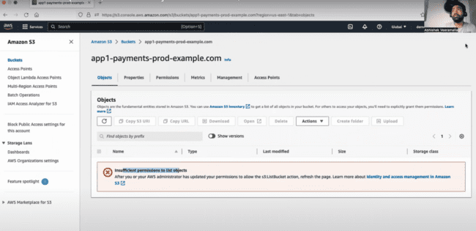

**After restriction, we need to check how to HOST the static website using the S3.**

Edit and make this enabled for the static website hosting:

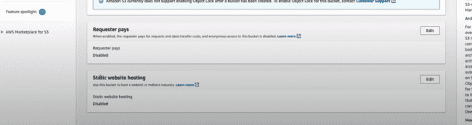

Check the following: Enable, Host a static website.

Index Document: index.html

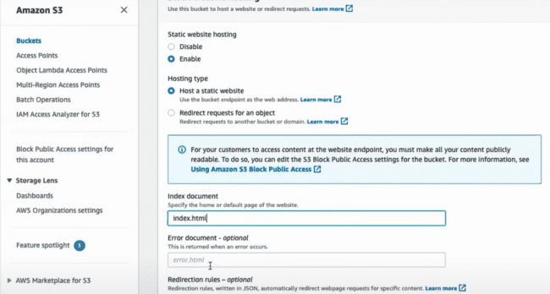

Also under the permissions, unblock the public access.

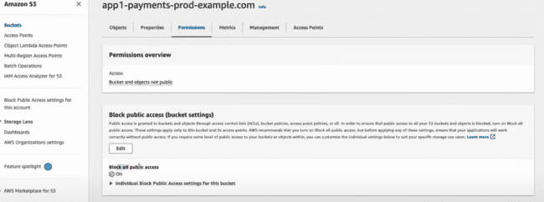

Edit -> uncheck this one -> Save changes.

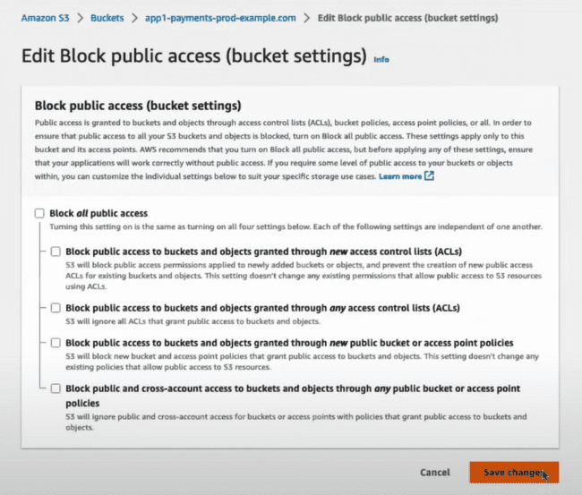

**There might be one condition that in your account, this check box would be disabled for you to uncheck this box, in that case, we need to make sure that from the organizational level this need to be uncheck.**

Remove the previous bucket policies:

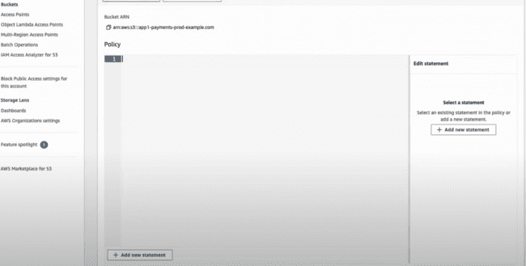

But the access is still denied:

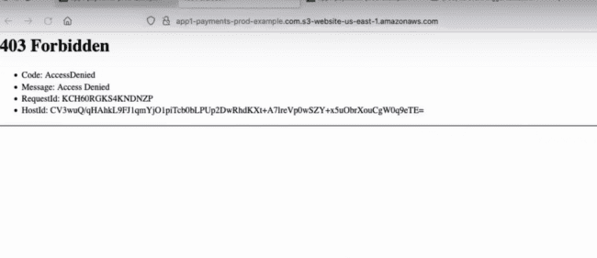

Now for this one, you need to add a new policy for **all object access for everyone on the internet.**

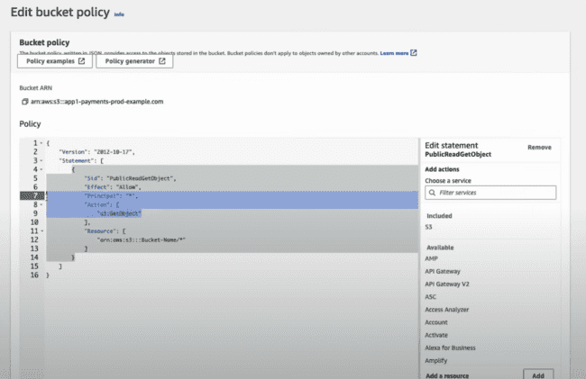

Action: s3.GetObject is the object access for everyone on the internet.

And need to update the bucket name only for this one.

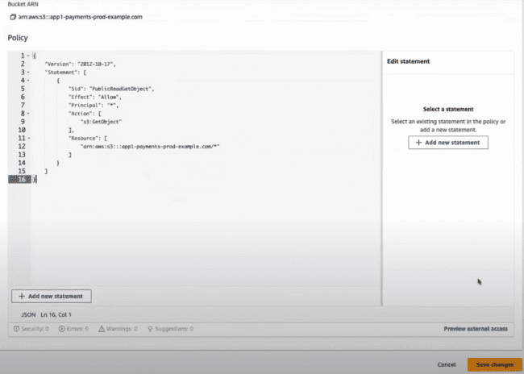

Now, when you access the site, you would be able to load the URL.

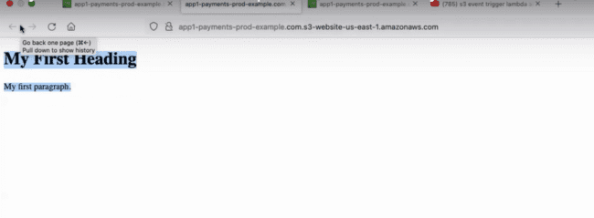

**When you would be using the javascript for the static hosting which is doing the API calls, then you need to enable the CORS, as not enabling this one, browser would reject the request.**

HOW AWS is cost effective:

Deleting the previous versions after 5 or 10 days, or need to send out the previous versions to the S3 Glacier which would reduce the cost