**JENKINS:**

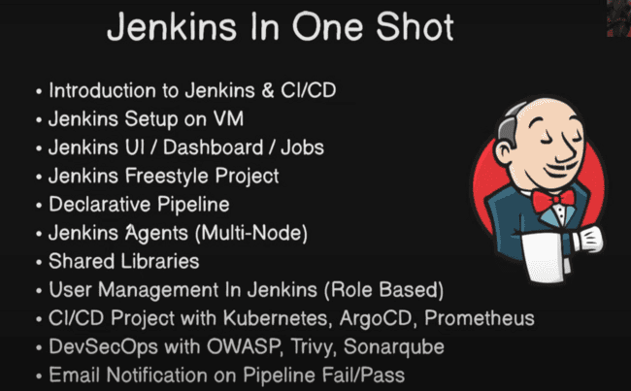

Developer writes the code and pushes the code to the GitHub and build on the DOCKER and then deploy to the EC2 cluster or on the Kubernetes, then it is getting monitored using the Prometheus.

This process is called Continuous integration and continuous deployment.

Jenkins is the tool which is used in automating this whole process and limits the time to the market.

These are the four things that are involved in the CI/CD are:

Jenkins setup on the VM can be done on anywhere: on AZURE, AWS, GCP or DOCKER as well.

In the AWS, we need to create an EC2 server and click on the Launch instance as shown:

The server name would be Jenkins-master:

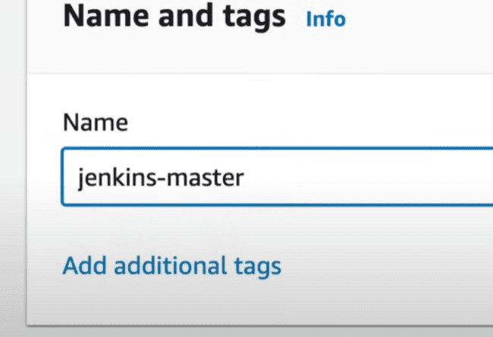

And we need to use the Ubuntu as OS and we can select the instance type as t2.micro:

But if you need to do more work, like creating the server and agents, so need to take that, as it contains more RAM may be 4GB which is t2.medium.

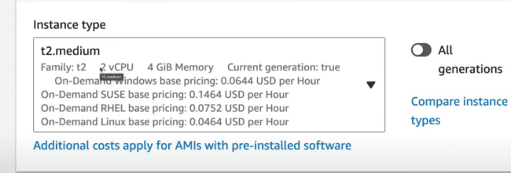

After that we need to create a new key value pair:

And use the following configuration:

Make all these checkboxes allow:

We can make the storage more at 15 GB, as shown:

After that, click on the Launch instance.

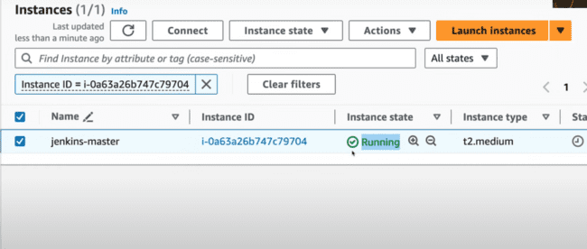

To connect this instance, we need to click on the Connect.

Now we this, we can connect the VM, with this EC2 instance clicking the connect button. And the following screen would pop up.

Or Click Connect and select the SSH client.

Use the command “ls Jenkins-1-shot.pem” to locate the file, then make the key and private and then connect using the following command:

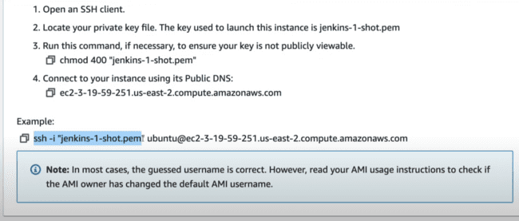

After that EC2 instance would be connected as shown below, Ip shown in the green color is IP of the AWS instance.

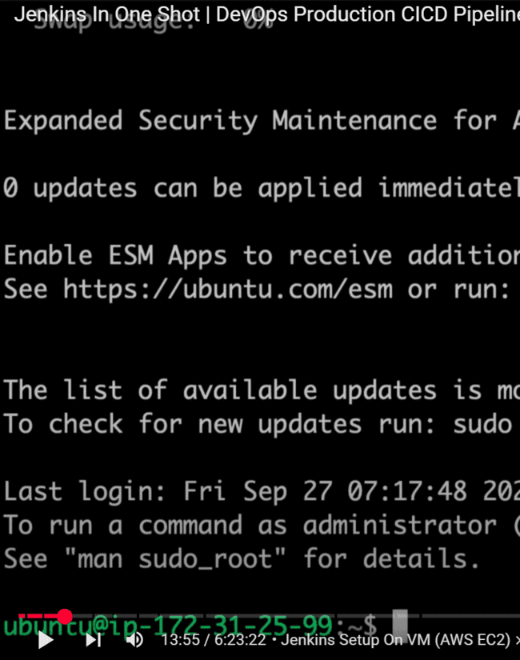

***IMPORTANT: sudo means as a super user, like we use in windows as “Run as a administrator”.***

sudo apt update means update the application package manager.

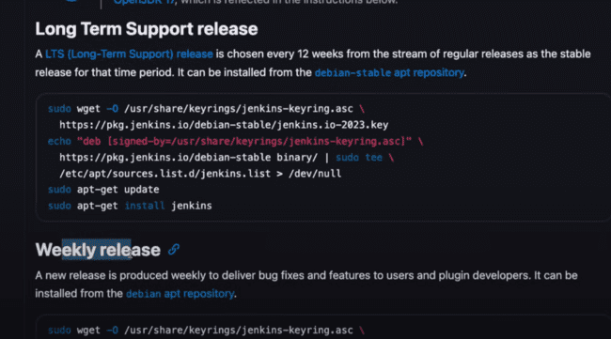

Long term support release is that, where there is release after long time and might be there are low bugs, but in the weekly release, there are bug fixes in the weekly release, and there may be chances of issues as well.

Following are the commands to install Jenkins on the ubuntu.

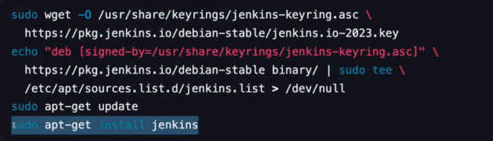

wgt -o means to get from the internet, which is located at the path described by “-o”

wgt -o <destination> <source>

echo means print.

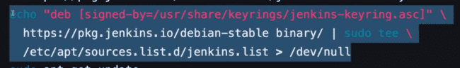

This command means signing the Jenkins key and adding the Jenkins list to the source list.

-**get:** to get the things from the internet.

Systemctl: system controller, like the services in Windows, which allows to start and stop the JENKINS.

* systemctl status jenkins

Now if you want to start the Jenkins, whenever you system starts use:

* sudo systemctl enable jenkins

Under AWS -> Details -> public IPv4 address:

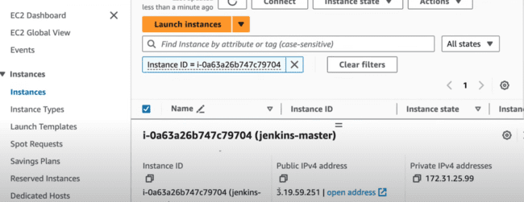

In this address Jenkins would be running, but still there would be an issue, as port has been blocked by the firewall:

Under EC2 instance -> Security -> security group:

And the edit the inbound rules:

And add a new rule:

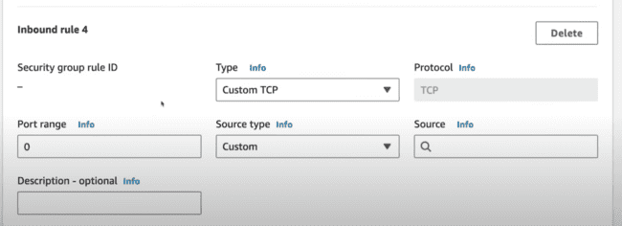

That anyone can access the 8080, anyone can access that or only your IP can be accessed as shown:

cat means to display the contents of the file.

JENKINS JOB:

Job is like creating a CI/CD pipeline, cloning a code, running a python script.

Creating a new job:

Types:

1. Freestyle project: you can do anything in this project.
2. Pipeline: this is like the declarative pipelines.
3. Multi-configuration project: use for different environments. Example: Testing, Staging, Production.
4. Folder: creating a new folder, where any operation would be performed.
5. Multi-branch pipeline: Like there are many branches as master, dev, release. This is used for that configuration.
6. Organization Folder: here you can create multiple jobs inside this organizational folder.

Creating a freestyle project:

Discard Old builds: One build is one cycle from code commit to deploy, whether that is failed or passed.

Discarding the old builds saves storage.

3 in below means it would delete builds 3 days old and keep only 2 means it would have maximum 2 builds.

Throttle means like when you accelerate the bike again and again.

Throttle builds means whenever you click multiple times, still it will remain at the one build……?

Source code Management means to pick the project from the github.

There are five types of build triggers as:

Trigger builds remotely means to use the script to run the build.

2nd point means, to execute this one, after one job ends.

3rd point means to executes this one periodically, using a CRON job.

4th and 5th mean, like when developer pushes to the git, job will run automatically, then we can use that part.

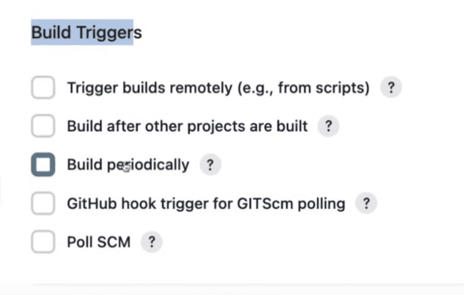

In this if you want to provide some environmental variables, then you need this part.

The most important thing is Build steps:

Execute shell->

**mkdir -p devops: -p is making a folder if not present, otherwise if present don’t make it.**

Click on the green button to schedule this build and click on the FirstJob:

And check for the build output:

Building in the workspace, is where it is creating the folder for the new job and then printing the output and the creating one new folder:

Pipeline means when you are trying to provide something from the source to destination. Example: you are sprinkling the water from tap to the garden and also adds some filter so that water would be purified on the way, then that is called stages, like code, build, test, deploy. These are the examples of filter.

Creating a new pipeline project named as CI/CD.

All other steps are same as that in the freestyle project, the major difference is we need to write the pipeline script as, you can print something and also creates a new folder as:

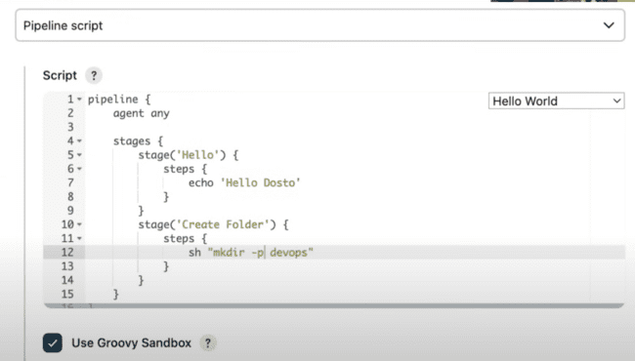

Stages are the various stages involved and under “steps” we can provide the steps we need to perform in the pipeline.

**IMPORTANT: sh means to execute the command on the shell. Like: sh “mkdir -p devops”**

And having name as “Create Folder”.

We need to Build this and then need to see the output as and check the console output as:

In the script, we have mentioned the **agent any,** which means agent and Jenkins is on the same server and build is also done here, but in the industry standard, the Jenkins would be hosted on the one server as MASTER and other nodes are running on the other server, which we can configured using the agents.

Under Jenkins -> Manage Jenkins.

As there is already a Jenkins server, so we can create a new instance using the EC2 and create a new agent.

Instance as “Jenkins-agent” -> t2.micro -> key, pair(Jenkins-1-shot) and in the network setting , SSH, HTTP, HTTPS needs to be ON and then launch instance.

Jenkins need not be installed on the agent, but java needs to be installed there. And connect using the same commands mentioned in the AWS connection tab.

Now two tabs needs to be opened for the MASTER and Agent and two needs to be connected using the SSH.

Two computers connect with each other using the public private key.

The master needs to have private key and agent need to give the public key to the master.

In the master, go to SSH and generate the key as following:

* Cd ~ ./ssh
* Ls

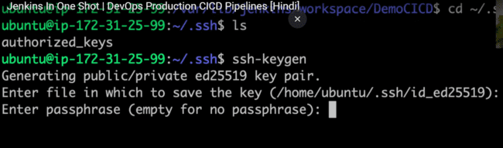

The key with .pub is public and other is private key.

Now we need to add this public key to the agent. And needs to view the contents of the public key as:

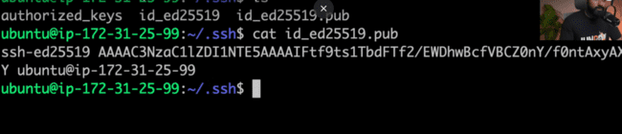

Before this, we need to create an agent in Jenkins:

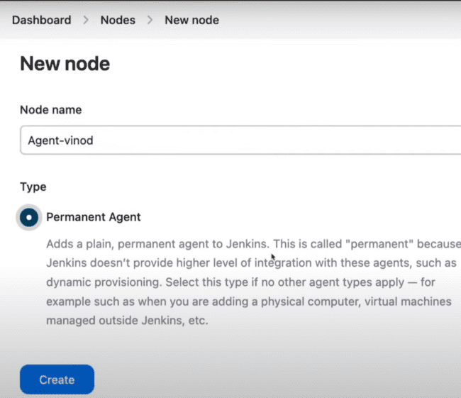

No of executors means how many jobs in one time, remote root directory is /home/ubuntu.

***LABELS: VERY IMPORTANT: we have used “agent any” so we need to use the name which we can use in place of any.***

Launch method: Launch agents via SSH.

Here we need to give the IP address of the agent which would be there in the AWS.

Then we need to use Add and then give the private key of the master there:

ID, description can be used any and username needs to be the name of the master.

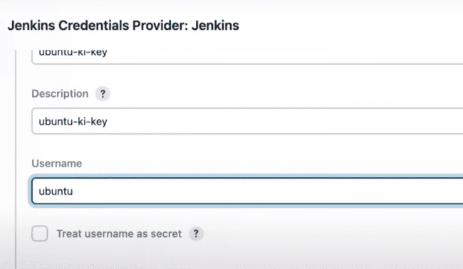

Under private key, we need to select enter directly and paste the private key for the master as shown which is taken from the master as:

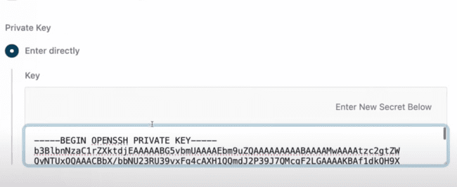

There are many statergies under and we can select Non verifying verification statergy.

Now we have added the private key in JENKINS, but not added the public key in agent, so if we save and connect, we will get the issue as:

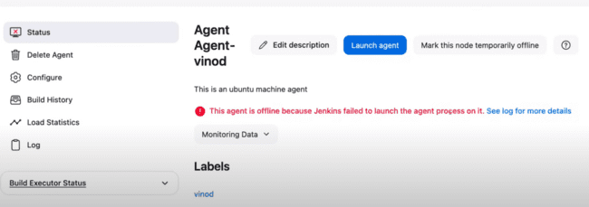

Need to use this public key in the agent:

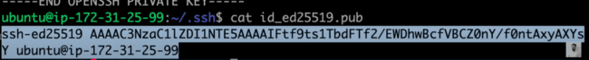

Under Authorized keys, we can add that:

After this we need to click on the Launch Agent again and then that will be connected.

And now we need to run this pipeline on that agent.

Under the DEMO CI/CD pipeline, we need to click on the Configure and then give the name of the agent as:

After running, this folder would be created for the same under the workspace folder.

***DECLARATIVE PIPELINE DEMO:***

Declarative pipeline for github project, so we need to provide the github repository name as:

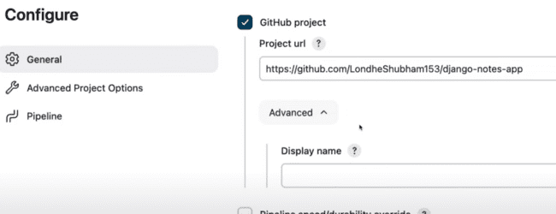

And if that is a private repository, then we need to configure using username and password.

We have checked this checkbox, as we want to trigger this pipeline, when there is commit in the github.

Structure of the pipeline:

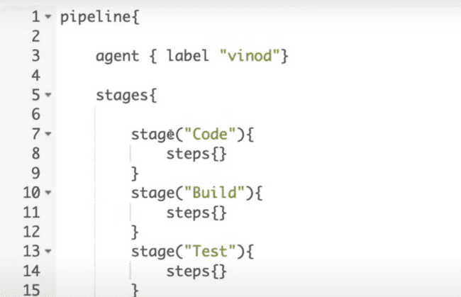

Pipeline stage view is the plugin name, where we want to display the view of the pipeline:

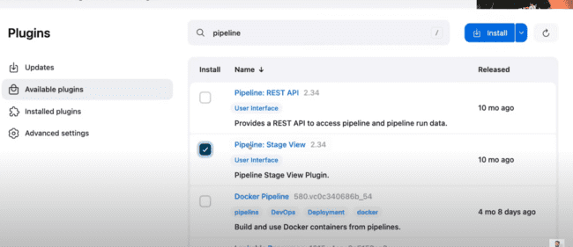

This is how it would be looking with this plugin:

