LINUX:

Three parts are there in Linux commands:

Command name + Options + Arguments

This is the short form of giving the command using the hypen -n, in the following case:

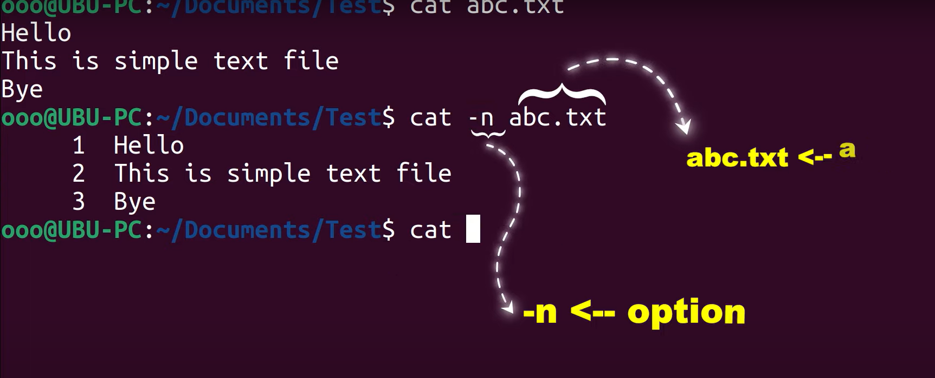

Or we can provide the full name using the double hyphen – and full name of the command as shown below:

Ncal provides the current calendar:

