COLLECTIONS

ARRAYLIST:
‘list.set(2, 50)’ will replace the element at the second index as shown below, will replace the index second from 5 to 50.
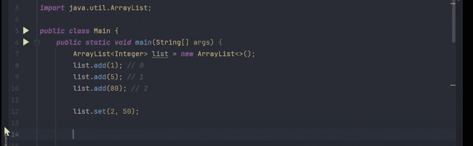

INTERNAL WORKING OF ARRAYLIST:



And inside the arraylist also, it has been shown:
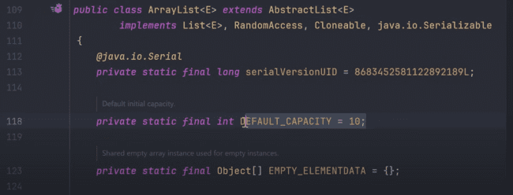
Adding elements in ARRAYLIST:
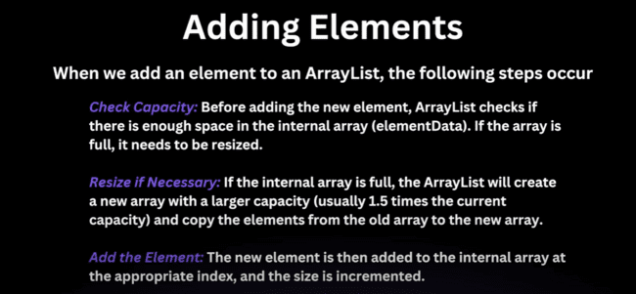

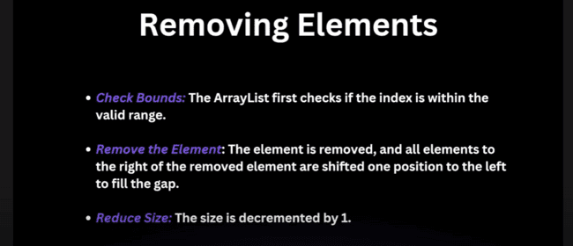
And we can create the arraylist with initial capacity as:
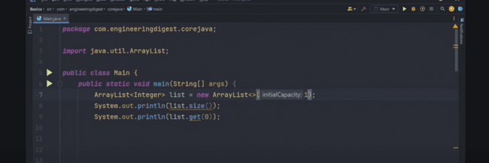
And there is no direct method to print the capacity of the Array list, but with REFLECTION we can do that. We will be picking up the value of elementData from the Array list using the reflection as:

With this code:
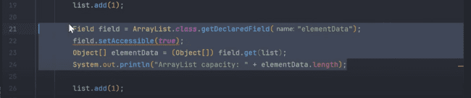
Initial capacity was 11, and when we add the 12th element, the capacity would be increased as:
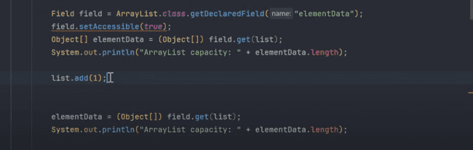
When we run this, capacity increases to 16:
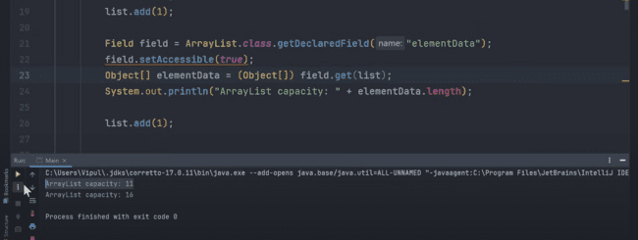
Now, if we have removed the 8 times, then still the capacity would be same:
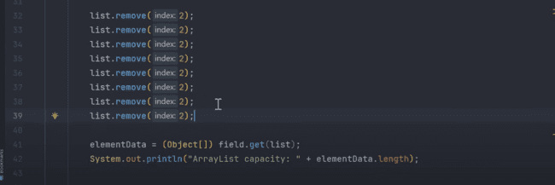
As:
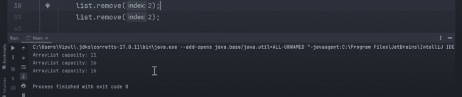
So, it does not shrink automatically, so we can do that using the ‘list.trimToSize()’:
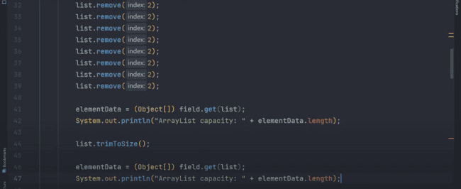
Size decreases to 4.
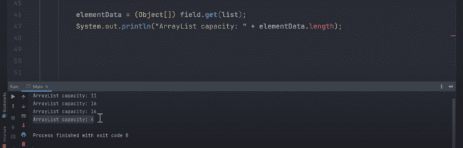
Multiple ways of creating the list:
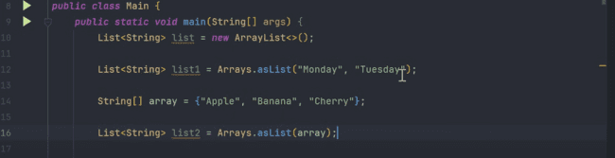

QUESTION: can we change the List to the ArrayList in the line number 12.
We cannot do that, as it is returning the LIST which is parent instead of ARRAYLIST.
If we print the classname of these lists, we can get:
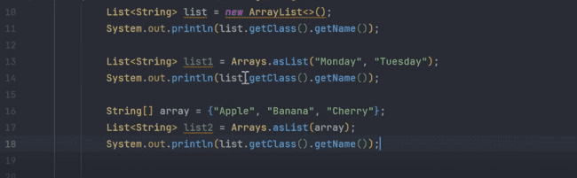
Would print:
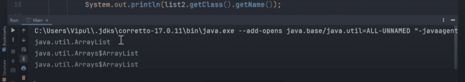
So, what is the meaning of the ‘java.util.Arrays$ArrayList’….?
This ‘Arrays$ArrayList’’ is a nested static private class, so we cannot add anything here, as it would leads to exception.
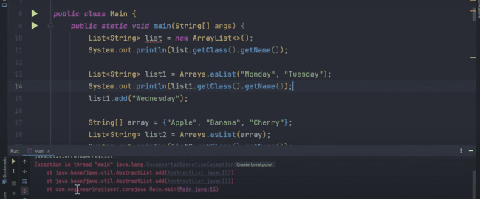
We cannot add or remove the elements in this list, we can only replace the elements. Arrays.asList returns the fixed sized list.

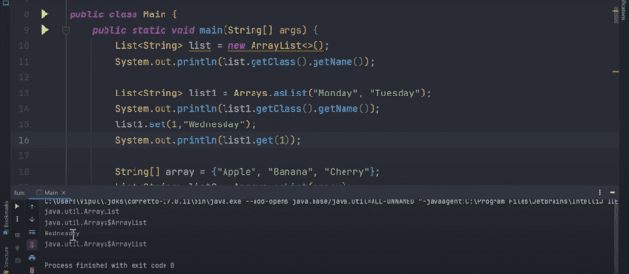
There is another method through which we can create the list which is ‘List.of()’ And the only difference between the asList() and List.of() is, in the asList(), we can replace the elements, but in the List.of(), we cannot do the replace also.
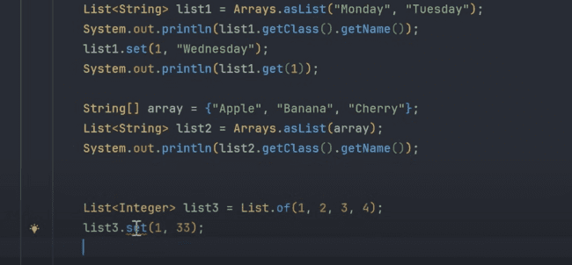
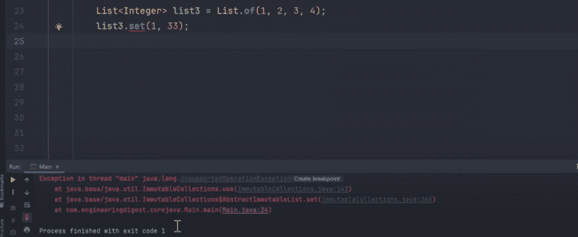

Another way is to pass the list in the constructor, which we can modify later as shown below:
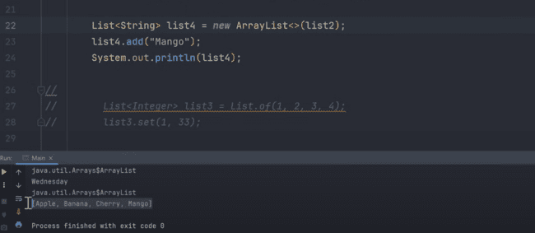
As, in the constructor, we can pass the collection, or we can pass the initial capacity.
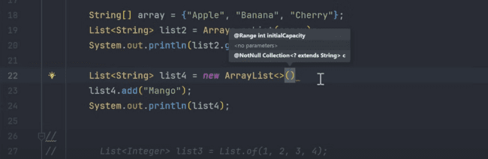
There is another method in which we can pass the collection as well as shown below:
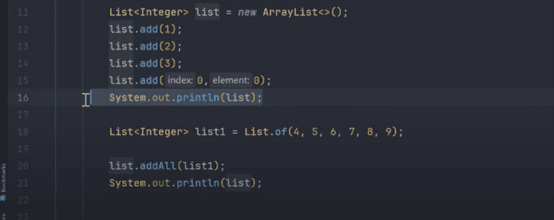
Result would be:
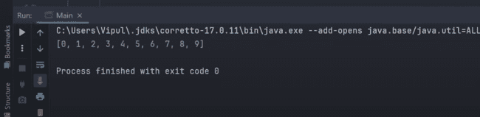

REMOVE method in the array list:
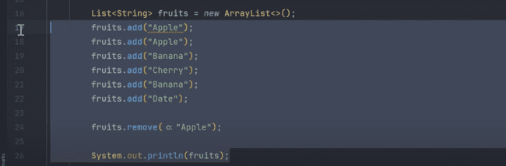
First occurrence of apple would be deleted:
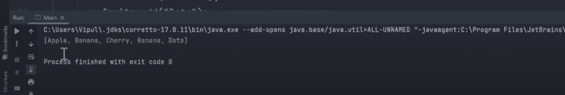

But, if we have the Integer list, and we try to remove, it will remove using the index, instead of value, In the following example, instead of removing the 1 from the list, index 1 which is 2 has been removed:
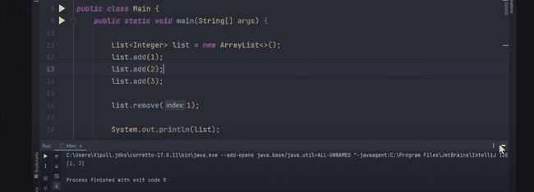
As remove method wants to get the class, then we need to pass like the following to remove the 1 from the list.

Following program will remove the 1 from the list:
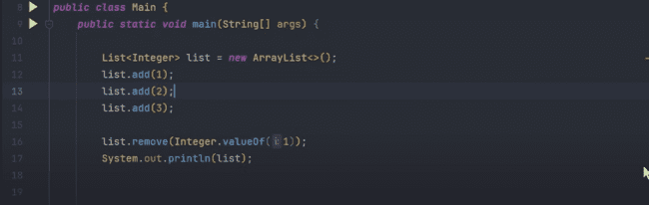
Result would be:
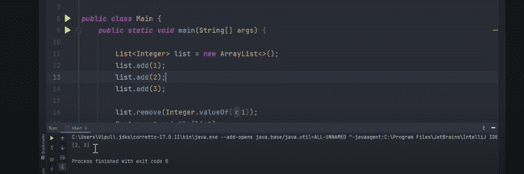

Converting the list to array:
We can mention the type of the array which we need to pass also instead of Object as:
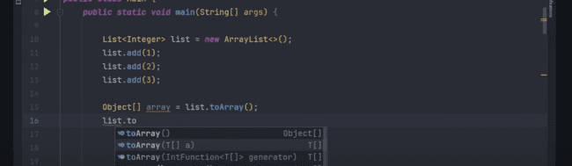

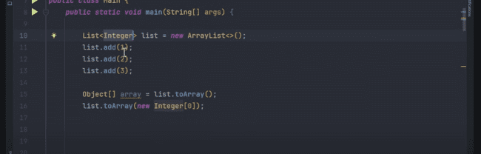
And why we have passed the 0 in the ‘list.toArray(new Integer[0])’ statement….?
When it checks that, the list already have the 3 elements, and 0 is passed in the initialization, so it would create a new array of 3 elements and it’s a convention.
Collections.sort(list) sorts the collection and internally it calls the list.sort(null)
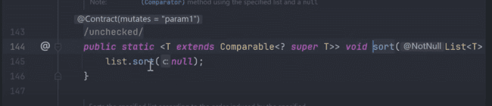
And it would sort also, when we pass list.sort(null).
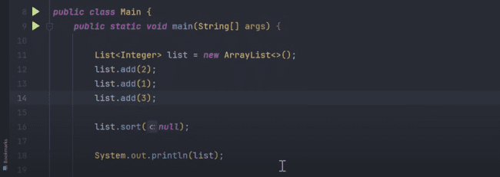
Output:
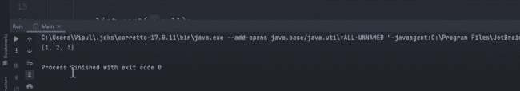
List.sort(null), sort using the COMPARATOR.


COMPARATOR:
It is a functional interface. And you can do the custom ordering with the help of that.
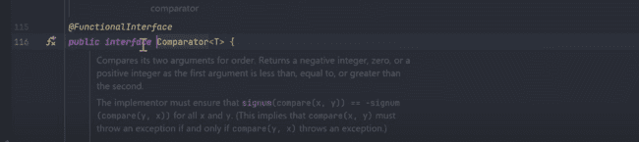
List.sort(null) means it is sorting in the ascending order, which is natural order sorting.
Now, we can sort the list of strings in the natural order using the following logic:
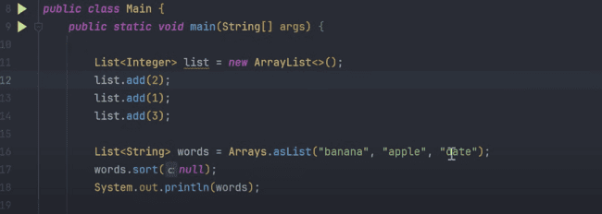
Output is, it sorts based on the ascending order:

Also, for printing list in the descending order, we need to do:
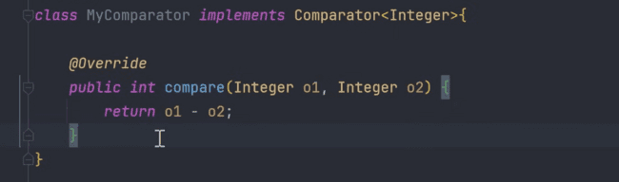
And need to pass like this:
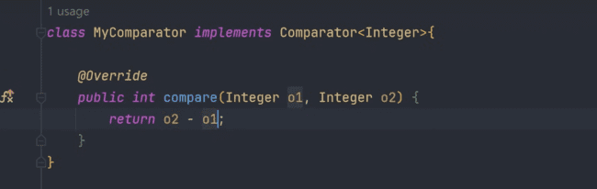
Descending order:
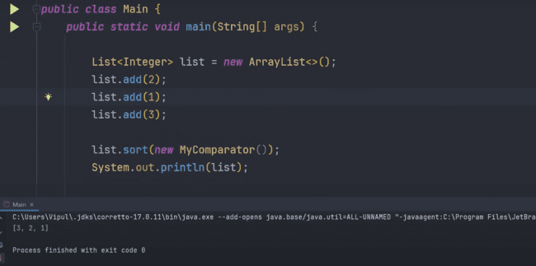
Now, if you want to sort based on word count, then we need to do that using the COMPARATOR.
O1 would come before the O2, when the O1 is less than O2 or length of O1 is less than O2 and would return the negative result.
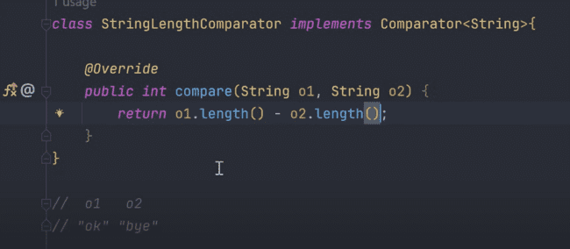
Then it would get sorted on the basis of length of the words.
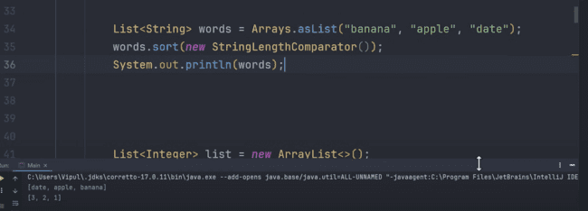
Or simply we can write using the Lambda expression as:
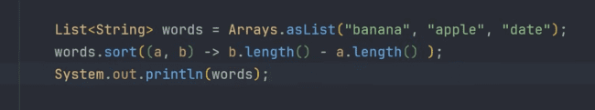
For the integers, we can do that using:
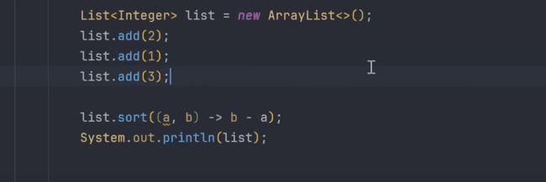
Example, there is one student class as:
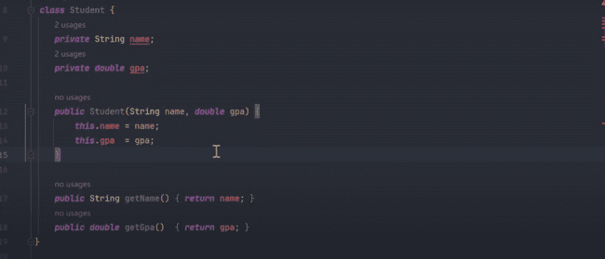
When we run this, we would get the exception:
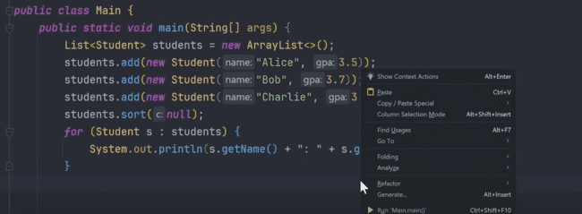
It would give the error as:
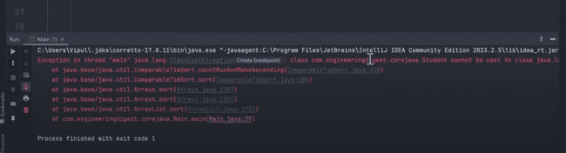
As, it is considering the natural sorting, so giving the error, but we can sort that using the comparator as:
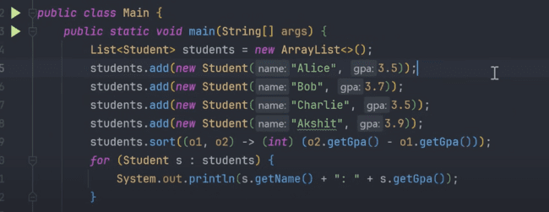
Output is not correct:
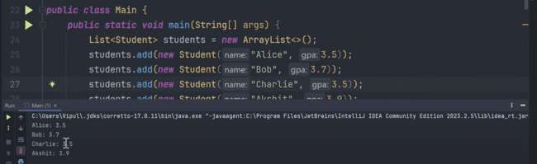
As we have type casted in the int, so fractions would become zero, that’s why the result is not correct.
We can replace the logic as:
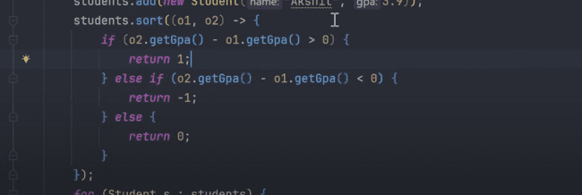
Output would be:
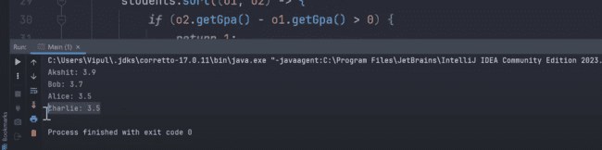
Now if we want to compare them on the grades first, and then if the grades are equal, then we need to compare them on the basis of name, then we can do like this one:
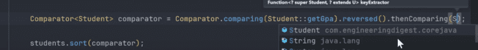
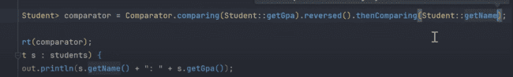
Alice would come first, and Charlie would be second:
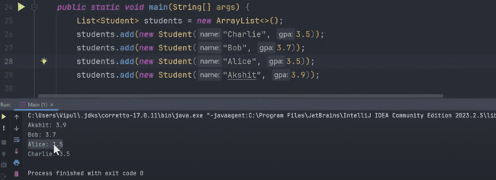
‘o1.getName().compareTo(o2.getName())’ would return negative, if o1 comes before o2 in the dictionary, and will return positive if the o1 comes after.
And we can do that in the else case to compare the students having same grade, so compare their names.
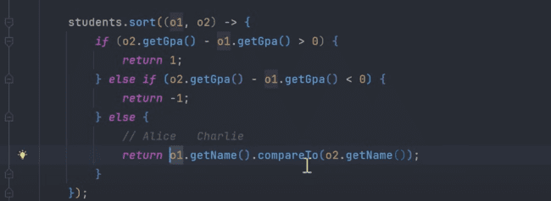
We can also provide the comparator in the Collections.sort() function as:
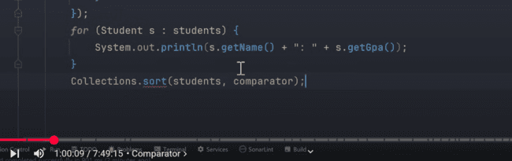

LINKEDLIST:


For simple list, if it has three nodes, then last element address would be null.
For circular, last node address would be pointing to first.
For doubly link list, Previous address of first would be null and next of last node would be null.
For doubly circular linked list, previous address of first would be pointing to third, while next of third node would be pointing to first.
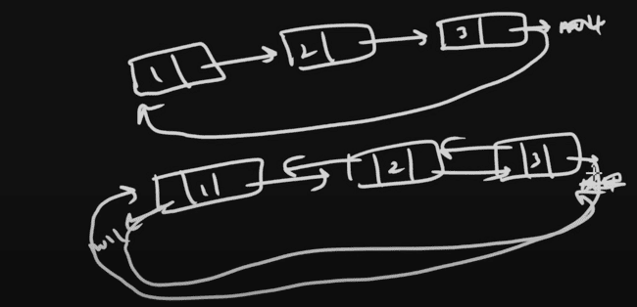
Linked list structure:
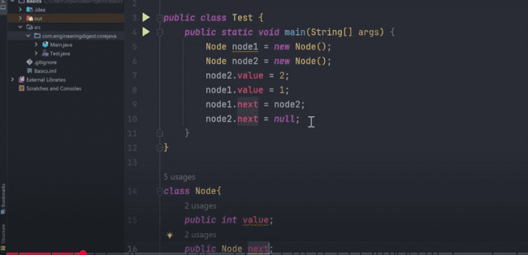

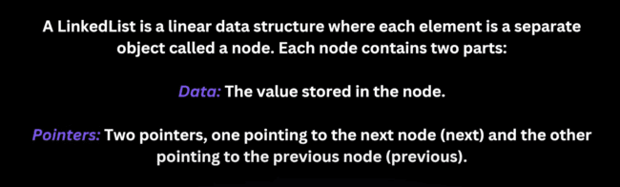
Linked list methods:
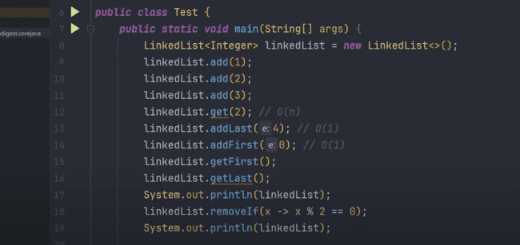
Now if we want to remove the list of elements from the linked list, then we need to use the:
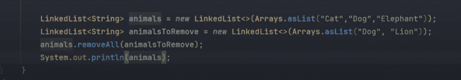
‘Dog’ and ‘Lion’ will be removed from the first list. But only dog would be removed, Lion is not there:
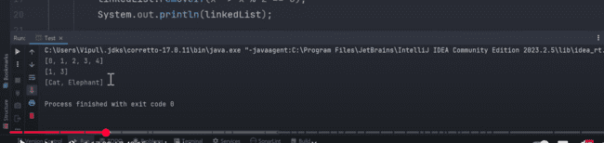
Now if we change the ‘LinkedList<Integer> list = new LinkedList<>()’ to
‘List<Integer> list = new LinkedList<>()’, then we would not able to access the child class methods as:
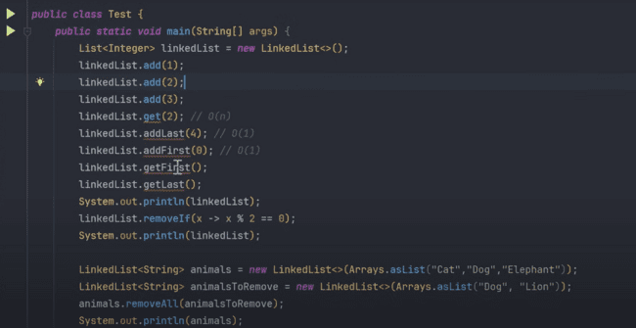

MAP:
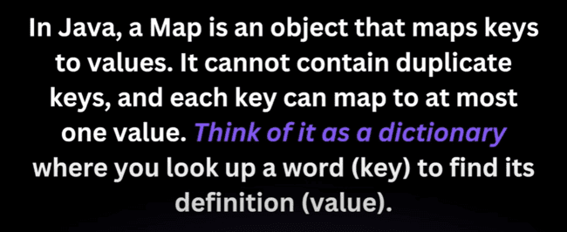
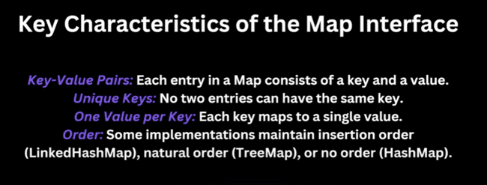
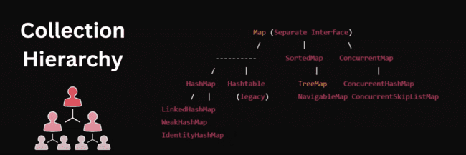
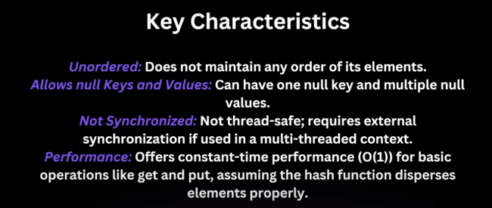
We can remove using the key and also with the combination of key and value as well.
Map is like this:
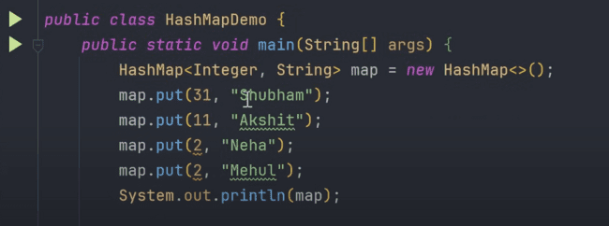
We can check, if the value is removed or not:
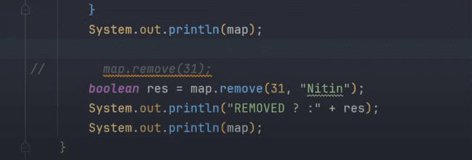
And if it did not match the combination, then it would print the false.
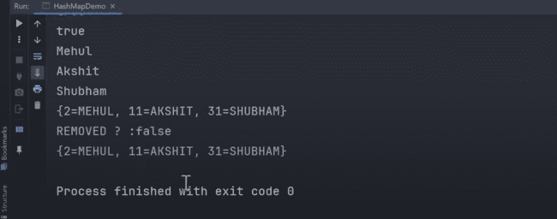
Now adding the element using put operation and getting the value using the get operation has the O(1) value.
For example, if we use the array to get the element, using the list.contains(32) in the following list, then complexity in that case is O(n), as it does the linear search.
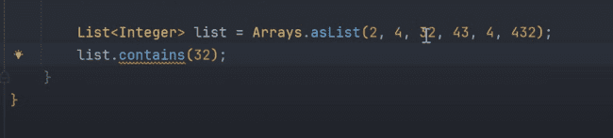
But if we use the same function in the map, then we can get O(1) time in that operation which is ‘map.containsKey(2)’:
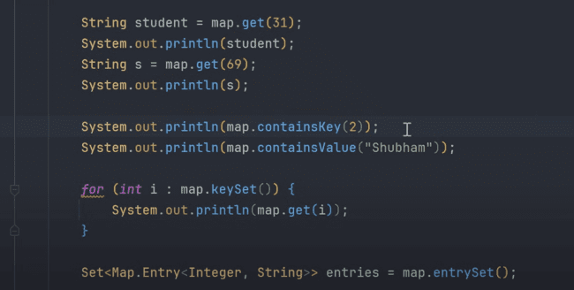

How these things are so fast, we need to check the internal working of the HASHMAP in that case.
Major there are four components of the HASHMAP.
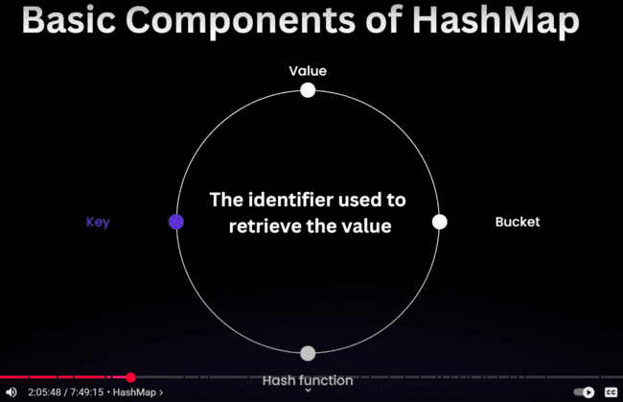

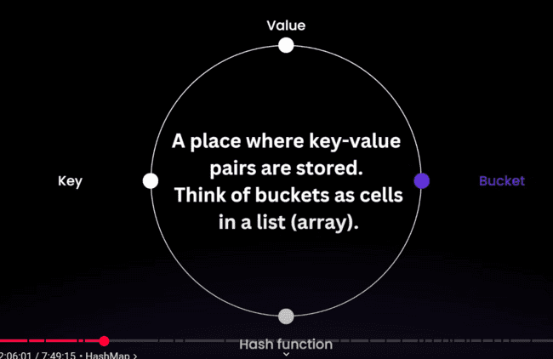
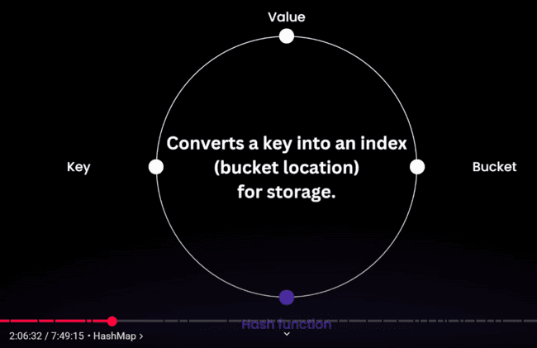
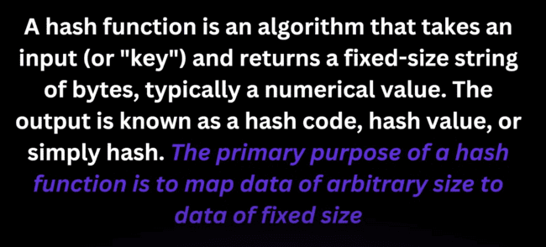


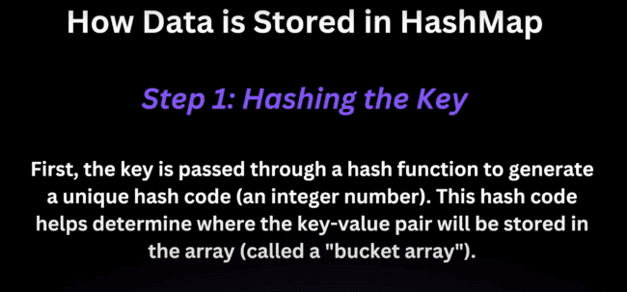

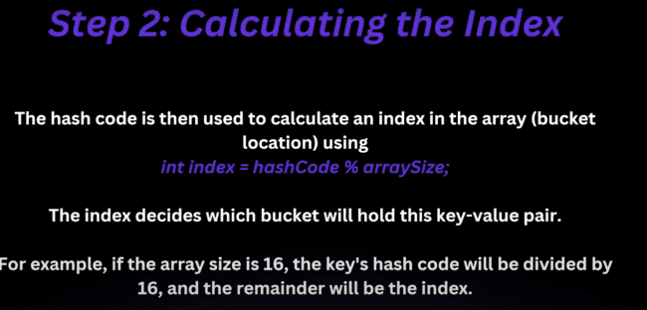

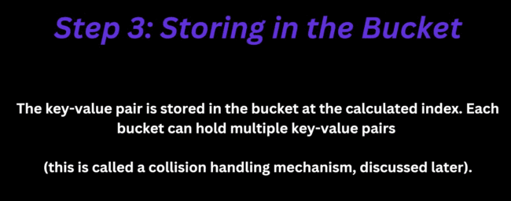
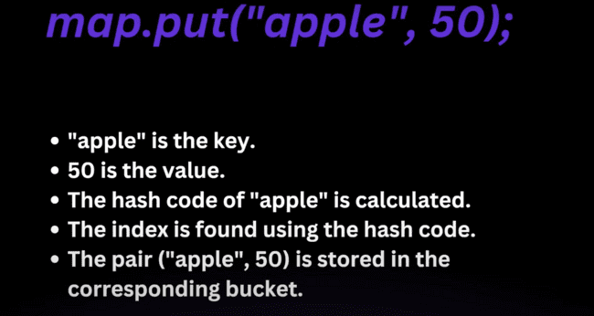
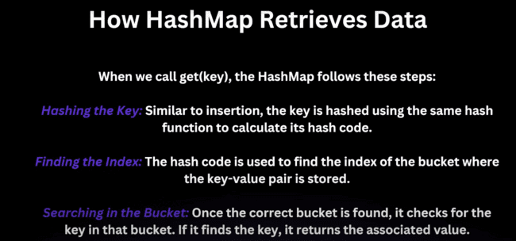

Now, all the key value pairs are stored in the buckets, which are annotated using some index and as the hash function can produce same finite output for some inputs, then this is the case of the collision, then what happens is:
Two or more elements have the same index and elements are stored using the Linked List and we need to compare the key value in that linked list as:
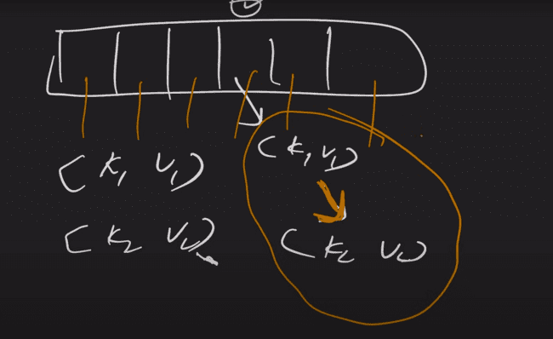
And it follows the structure shown as:
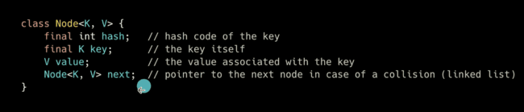
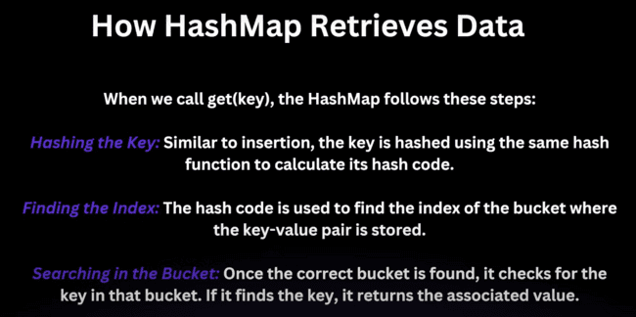

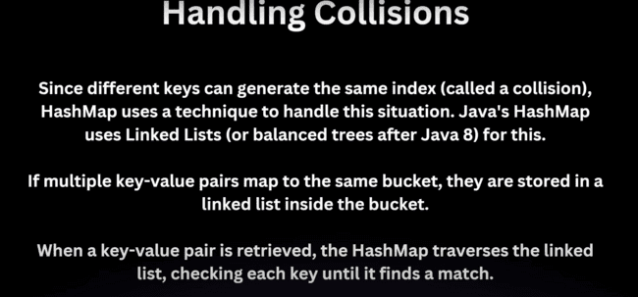

Now, also the hash function is very good, but in case of multiple collision, the linked list would grow to a large size, which would be very ineffective to search the element, if that is a large one and element is placed at the last. Which computes to O(n) time complexity.
So, if the number of collisions exceeds 8, then linked list would be converted to the Red Black tree which is also called as Balanced Binary Search Tree whose time complexity is O(logn)

HASHMAP RESIZING(REHASHING):
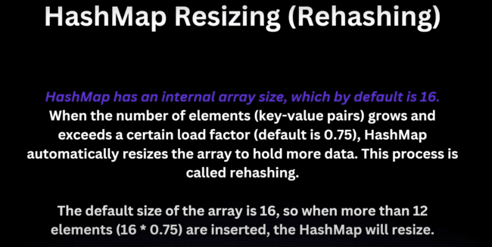
Whenever the internal size of the array becomes more than 12, the hashmap will resize. We can also provide the initial capacity and load factor during initialization:
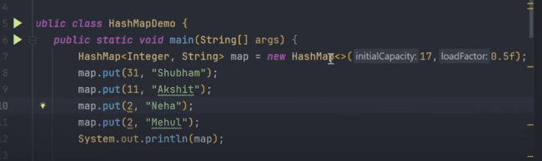
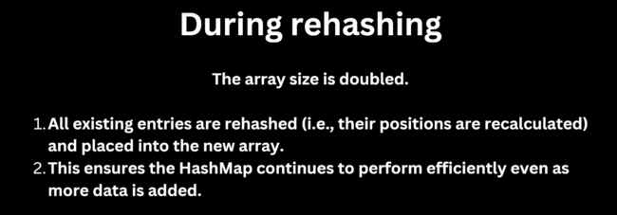


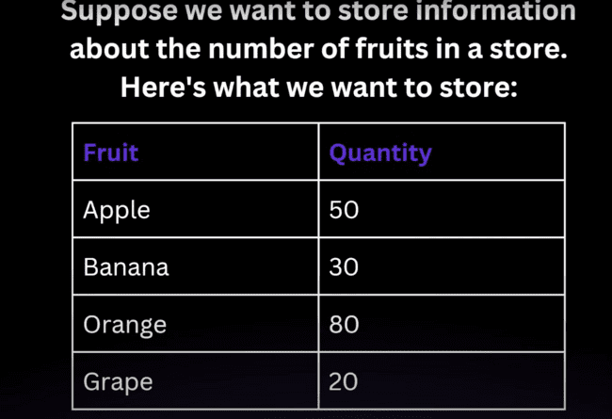
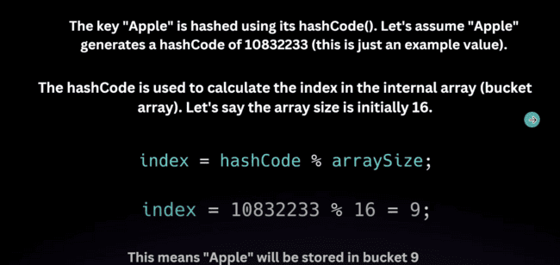
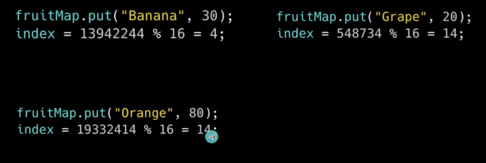
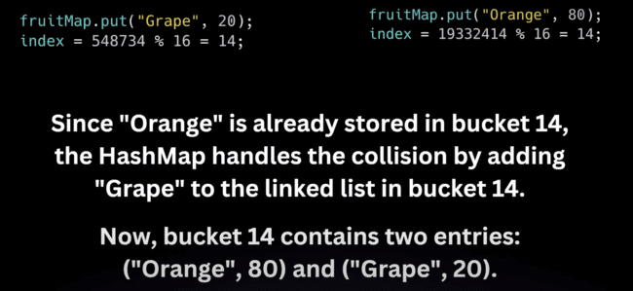

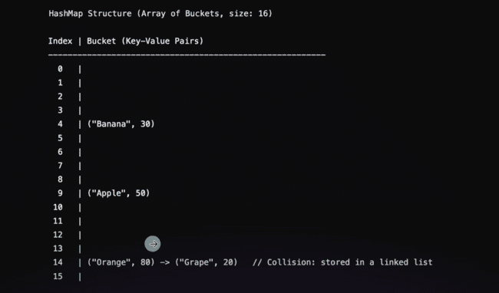

Now in the linked list, we can check the equality using the equals () method.
Now in case of simple String or Integer, we can check the equality using the equals method, but if there is a class with parameters, then how we need to check the equality.
Like there is one student with id and name and key is the student object with id and name and value is the marks.
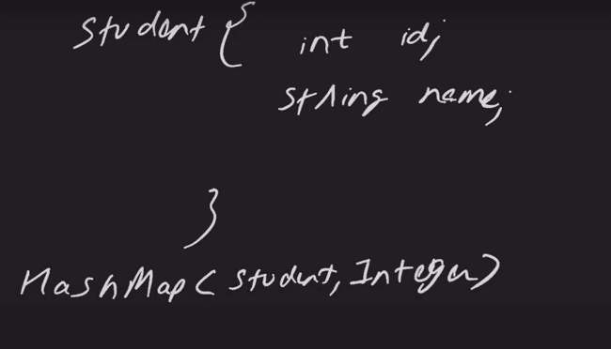
And the Hash map is having the following data:
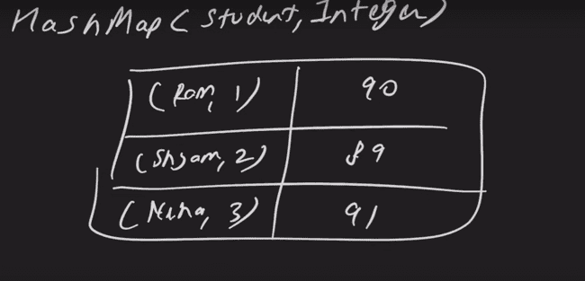
So, in this case, we need to override the hash code and the equals method.
Generally, with the hashcode generated using the hascode() method is the memory address related number generated and equals() would be checking the reference would be checking the reference or not.
Person class created:
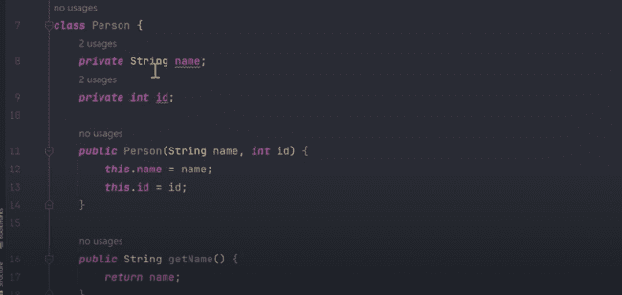
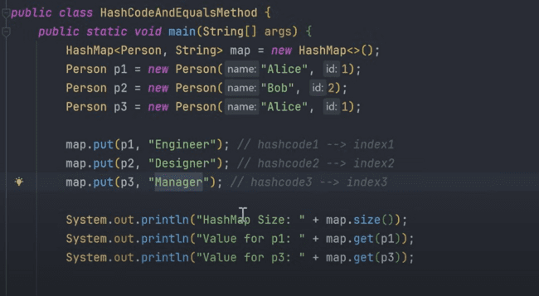
In the above case, if we store the Alice and then we want to get that, then we should get the Manger as the value, but as we have not overridden the hash code and equals method, so we will not be able to get the correct result.
Now size comes as 3 and the value has not changed, which is wrong.
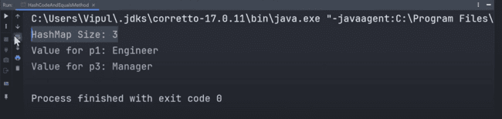
These are the pre-defined methods, so we need to override their functionality to make right use of them, as currently it is calling the super class HASHCODE and EQUALS method.
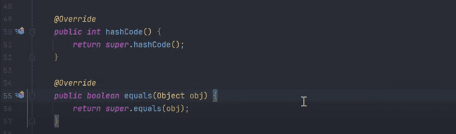
So, in this case, we need to check the id and the name of the person in the equals () method.
If current object is the object passed, we can return the true. And if the object is null then return false, or if the object class is not equal to the passed class, then we can return the false as well.
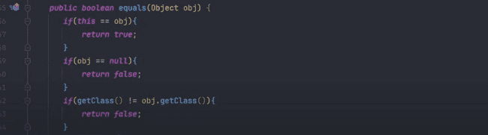
And person object equality, we can check like this:
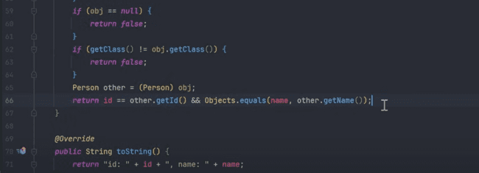
And in the hashcode() method, we can pass the Objects.hash(id, name) as:
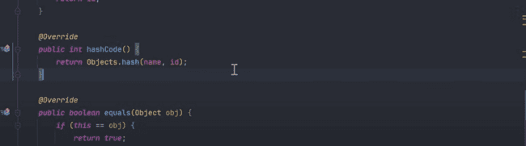
Now, if we check the map, then we can get the right output:
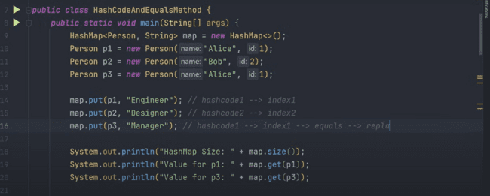
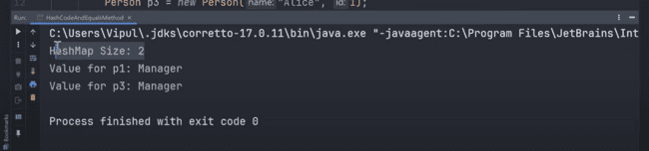
The complexity is O(logn) is the worst case, as collision occurs and we need to search in the red-black tree.
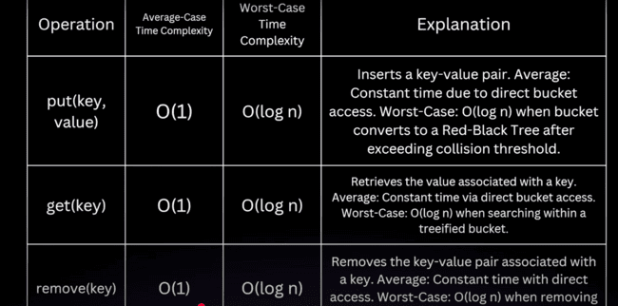
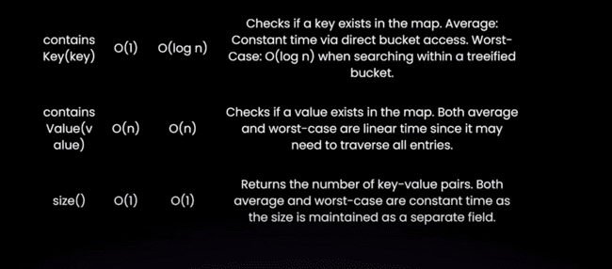
As there is not hashcode involves in the contains value retrieval, that’s why the complexity is O(n), as we need to traverse the whole list and there is linear search.
s

