09 June
Workspace cleanup step, There is one function which is cleanWs(), which is inbuild function of the JENKINS and it just deletes the workspace when build is done.
So, in this example, we are just cleaning the code before building.
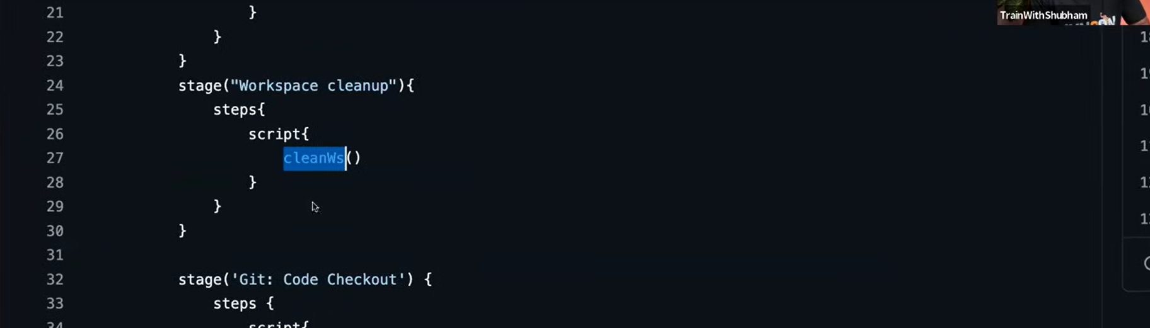
Code checkout stage is a shared library in the groovy named as code_checkout.groovy.
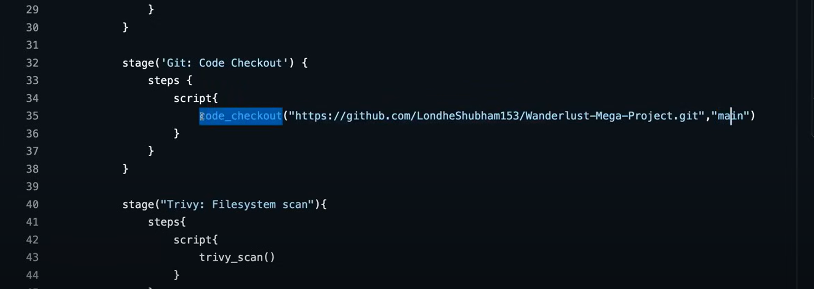
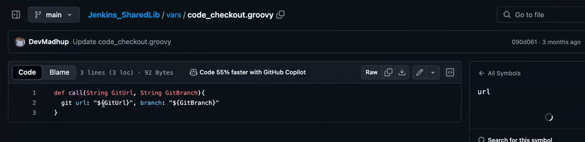

Next step is Trivy Filesystem scan:
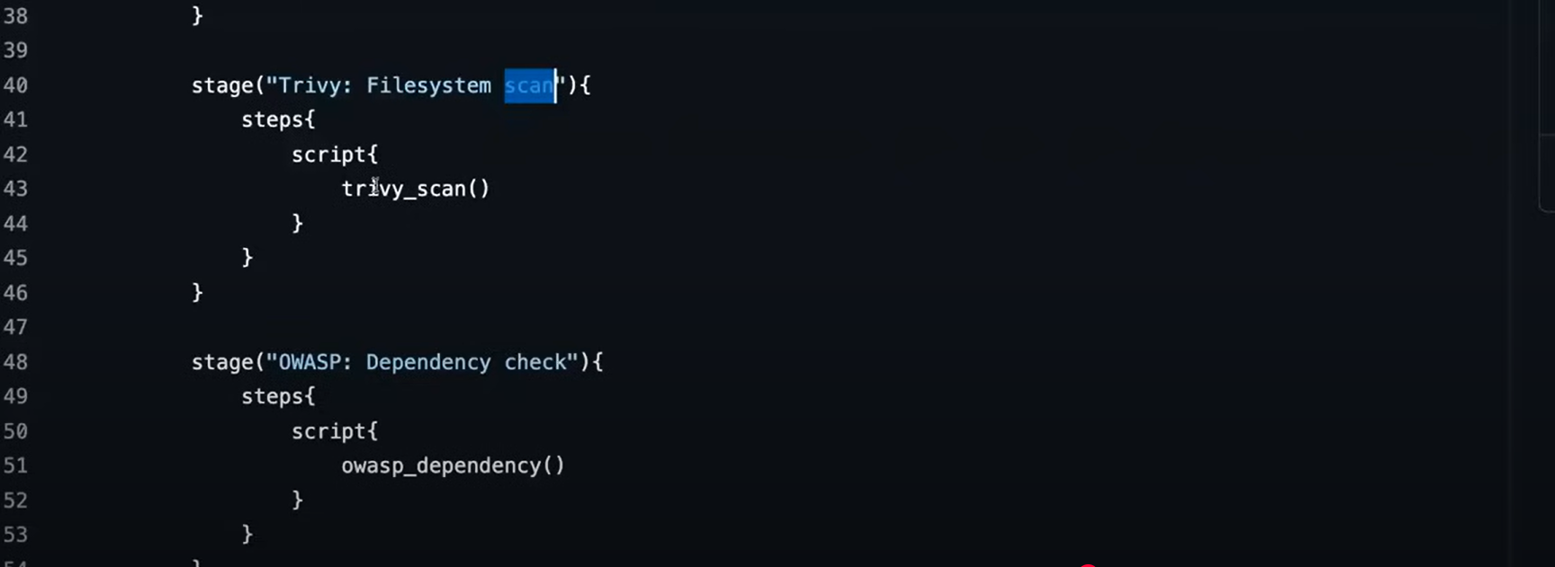
Which is there in the shared library as:
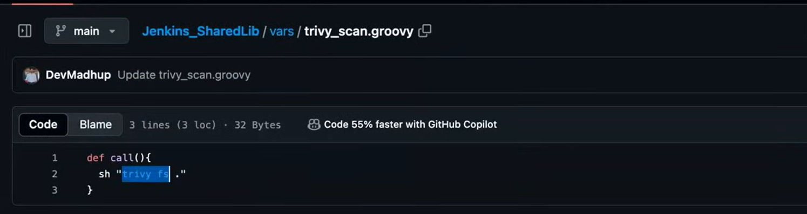

Next is OWASP dependency check:
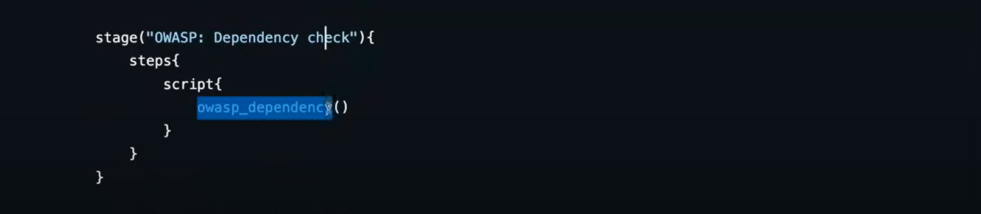
And the shared library of this file is following and which checks the current directory for the OWASP installation.
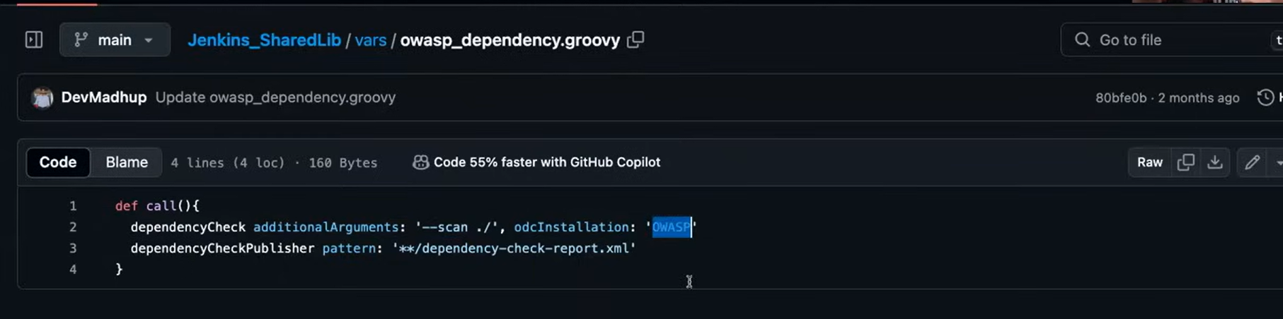
Now the question is from where this ‘OWASP’ keyword has come from…..?
As, when we have created the dependency of OWASP in JENKINS, we have given the name of that as OWASP.
After doing the dependency check, it generates the report with name as shown in the above screenshot as ‘dependency-check-report.xml’.
Other two steps are ‘SonarQube: Code Analysis’ and SonarQube: Code Quality Gates:
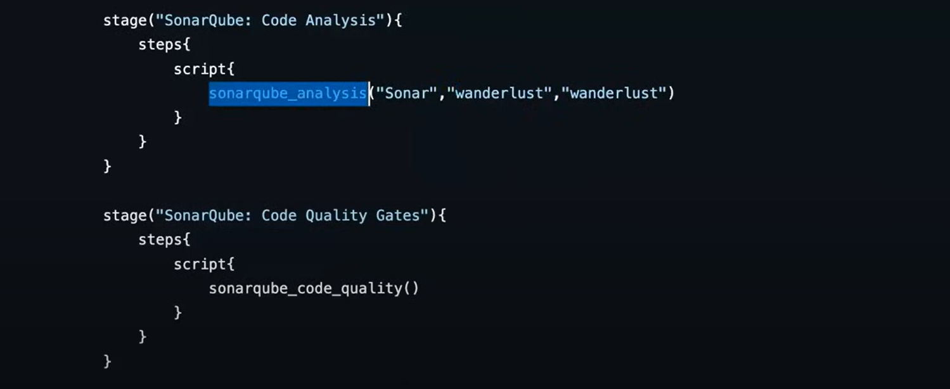
And the shared library of code analysis one is:
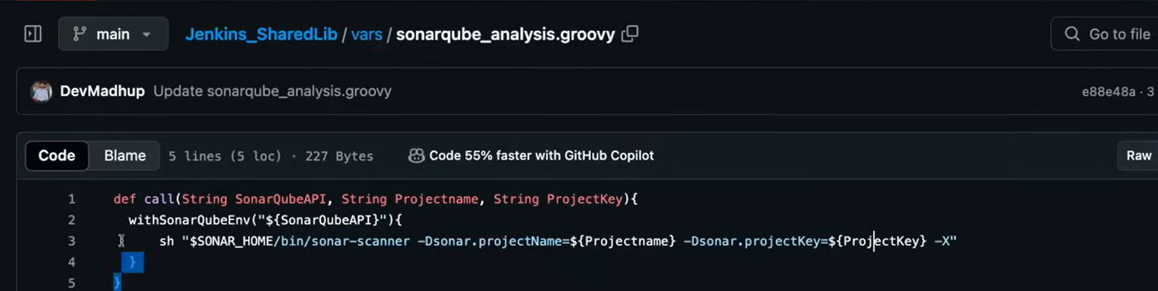
So, Sonar is the name used in this SonarQubeAPI, which has been setup in the JENKINS and it takes this project to the SONARQUBE server.
And whenever that project has been pulled by the SONARQUBE, then it scans that project using the SONAR SCANNER with the respective project name.
Next is SONAR QUBE QUALITY GATES:
There is one tab under the SONARQUBE quality gates which defines the metrics, code coverage which are already predefined in the SONARQUBE site.
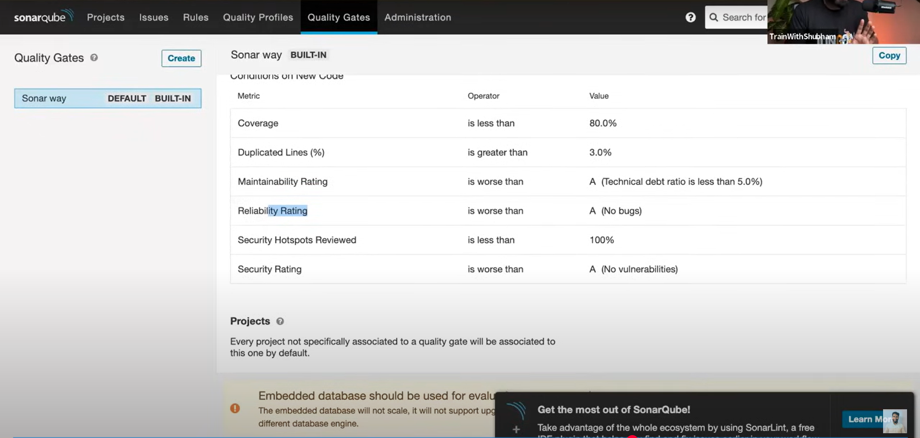
And in the shared library, we are just calling using the function ‘waitForQualityGate’ which is a groovy syntax for calling that function.
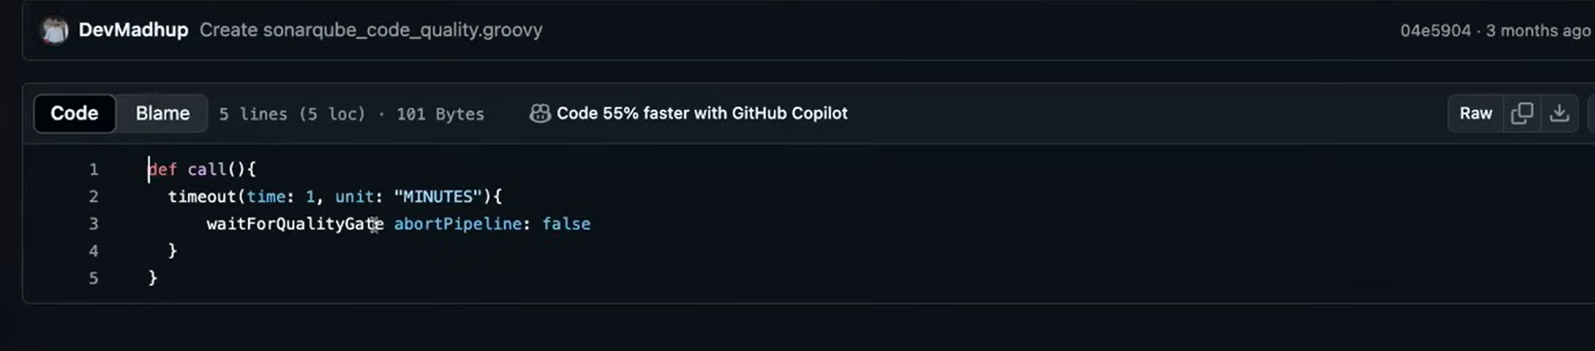
And all these syntaxes are predefined groovy syntax, which we can use in our code.
Other stages are:
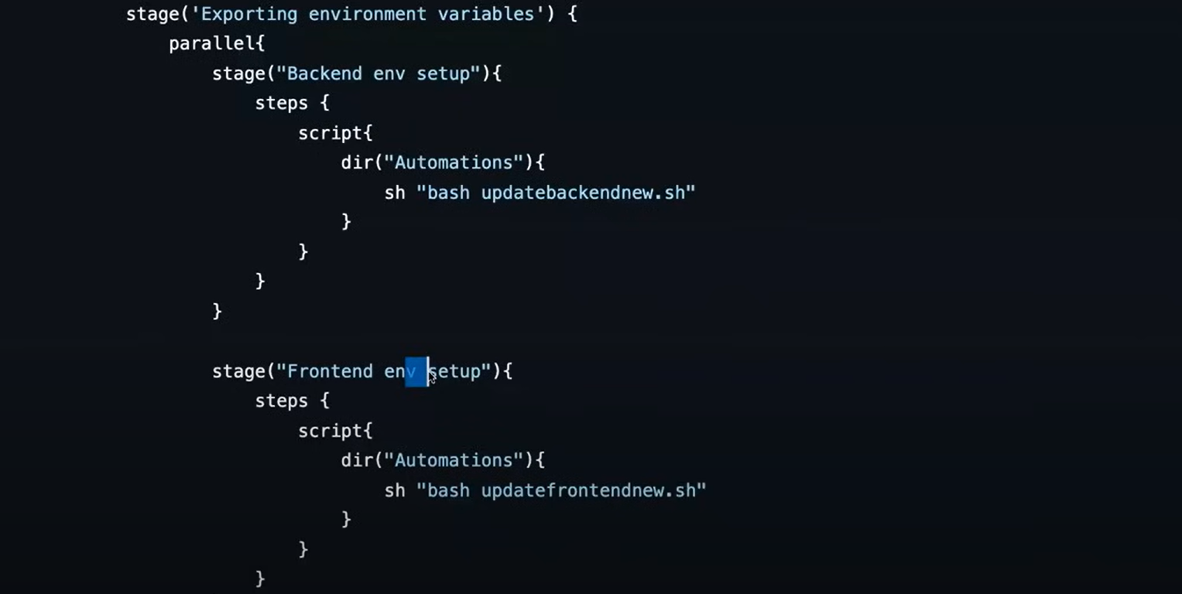
The parallel tag is used, so that these jobs can run parallelly to each other, which is done just to save the time.

