**2.Agra District Market Analysis(2020)**

**\*For the sake of the exercise will show major markets and trends for the first month i.e. January only**

**January**

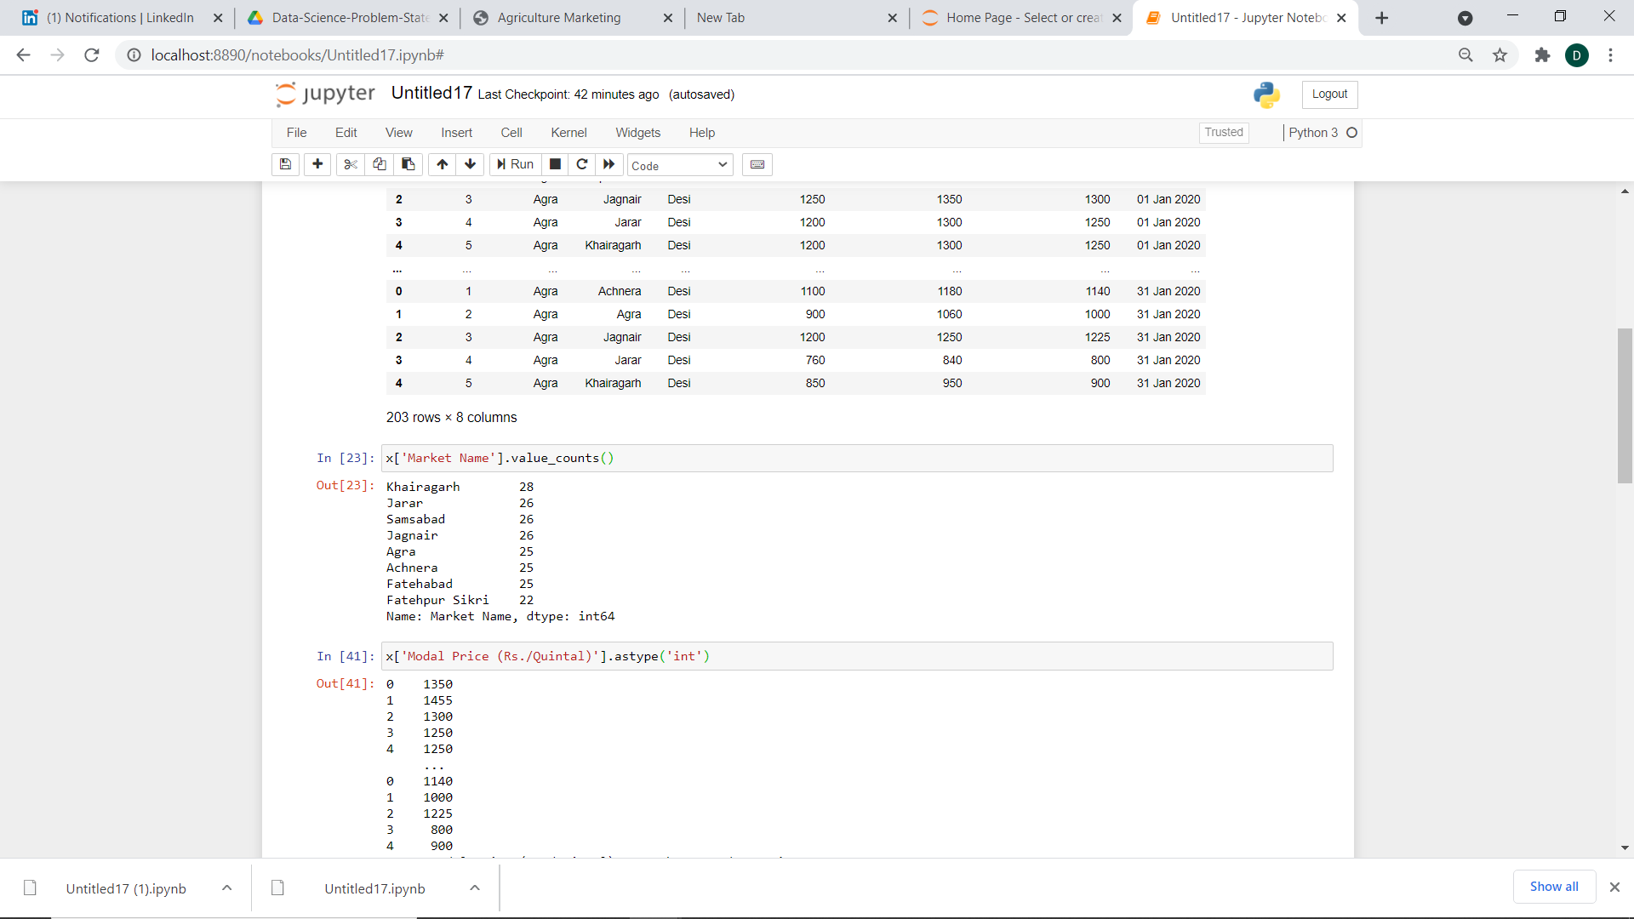

**Major Markets:**

1. Khairagarh
2. Jarar
3. Samsabad
4. Jagnair

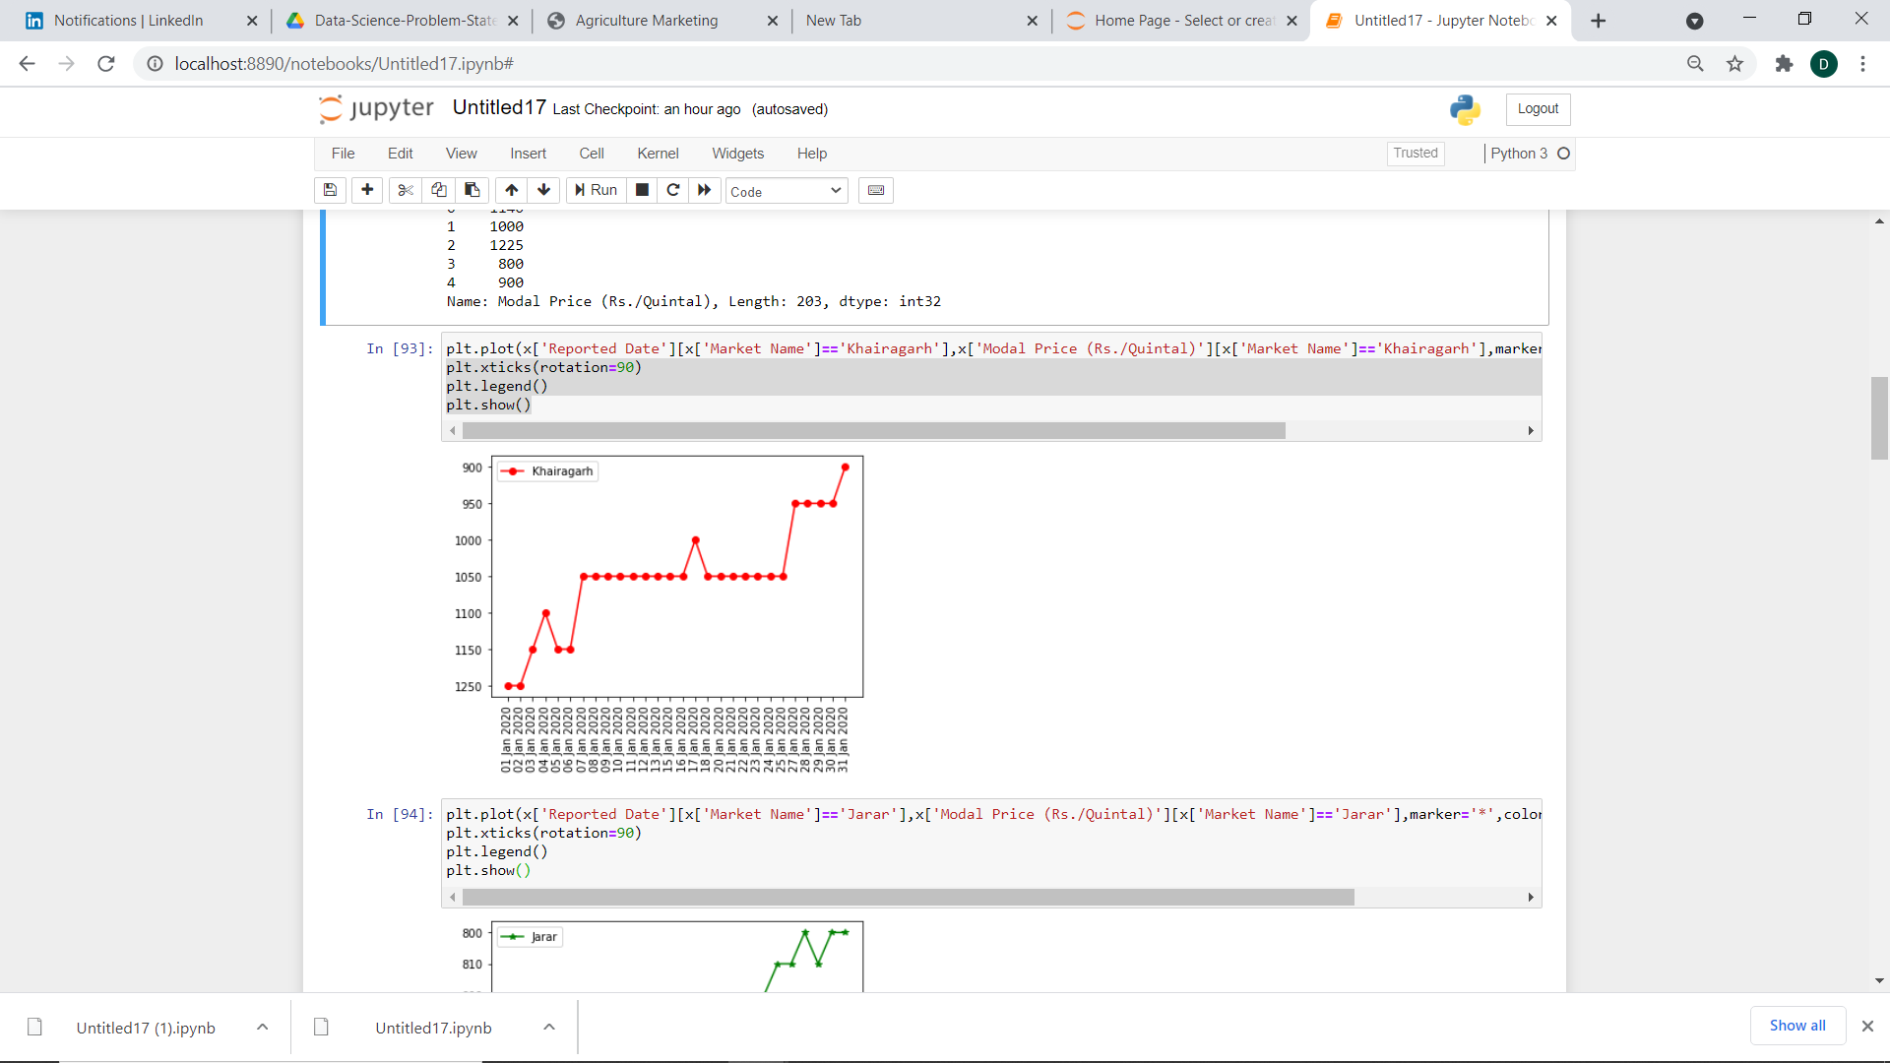

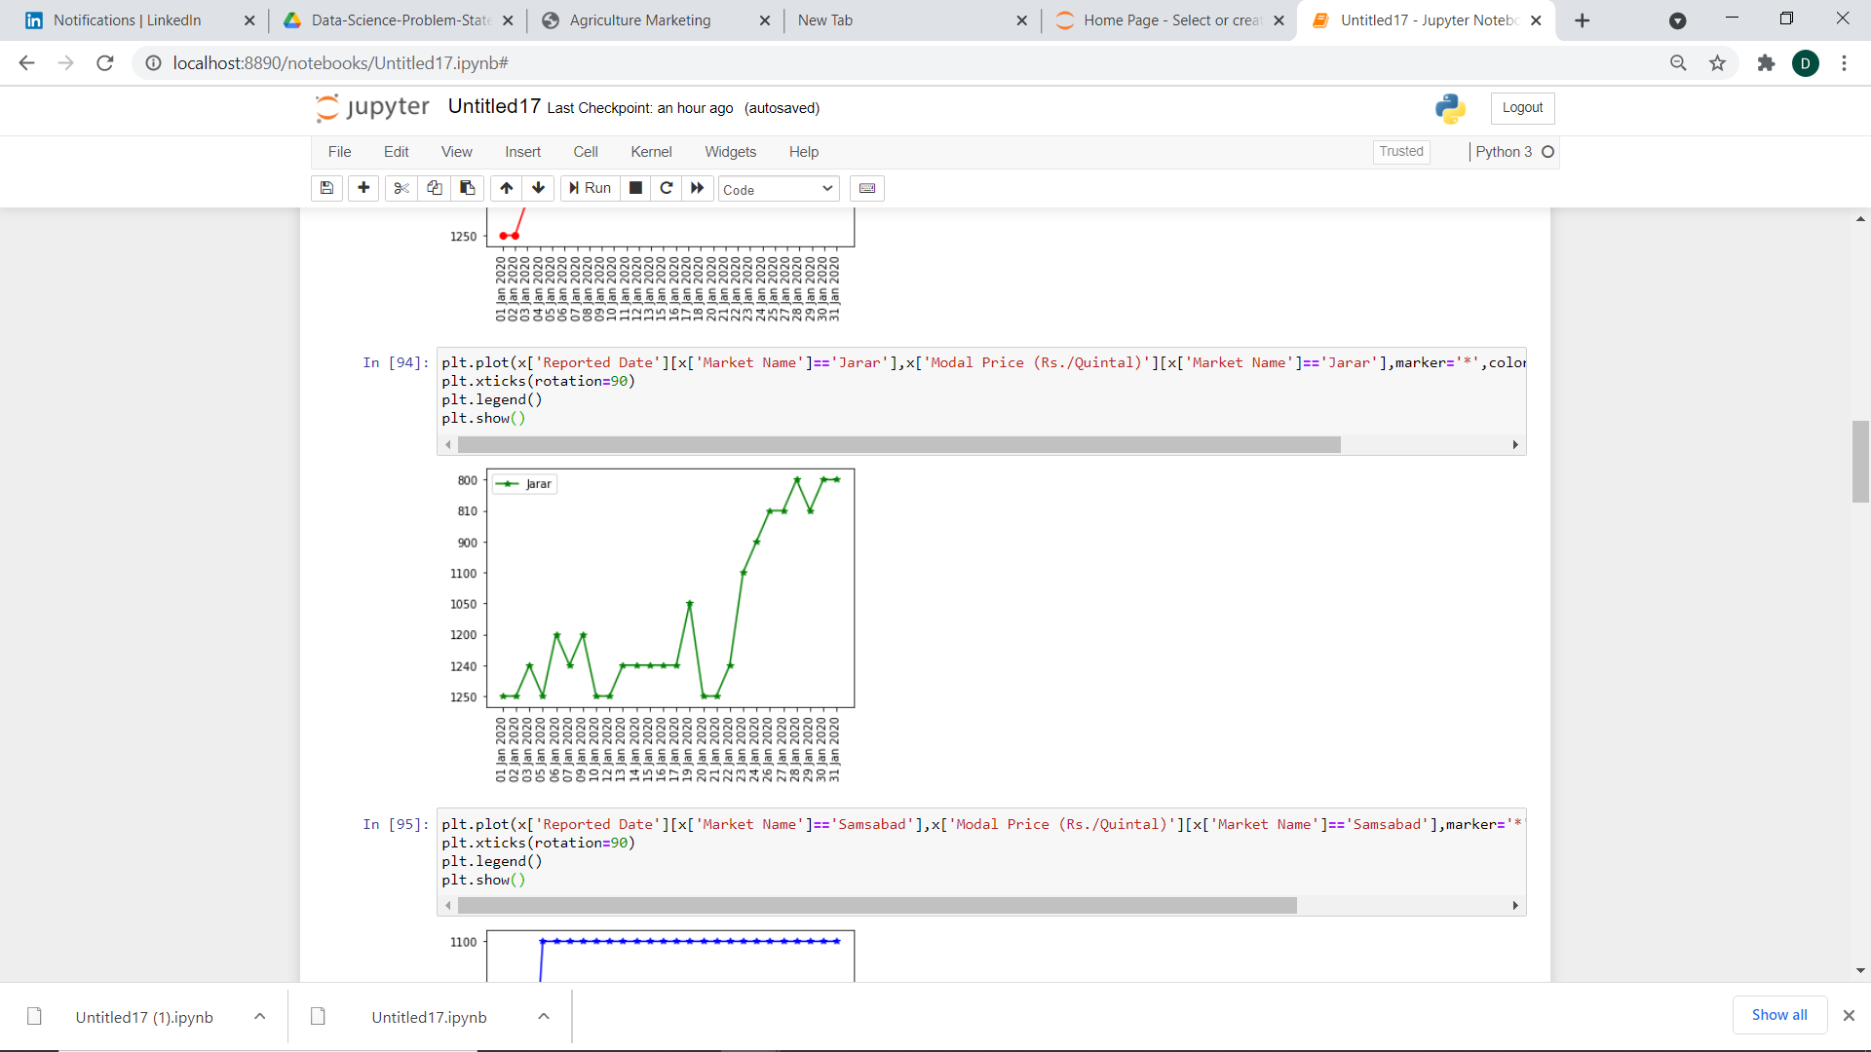

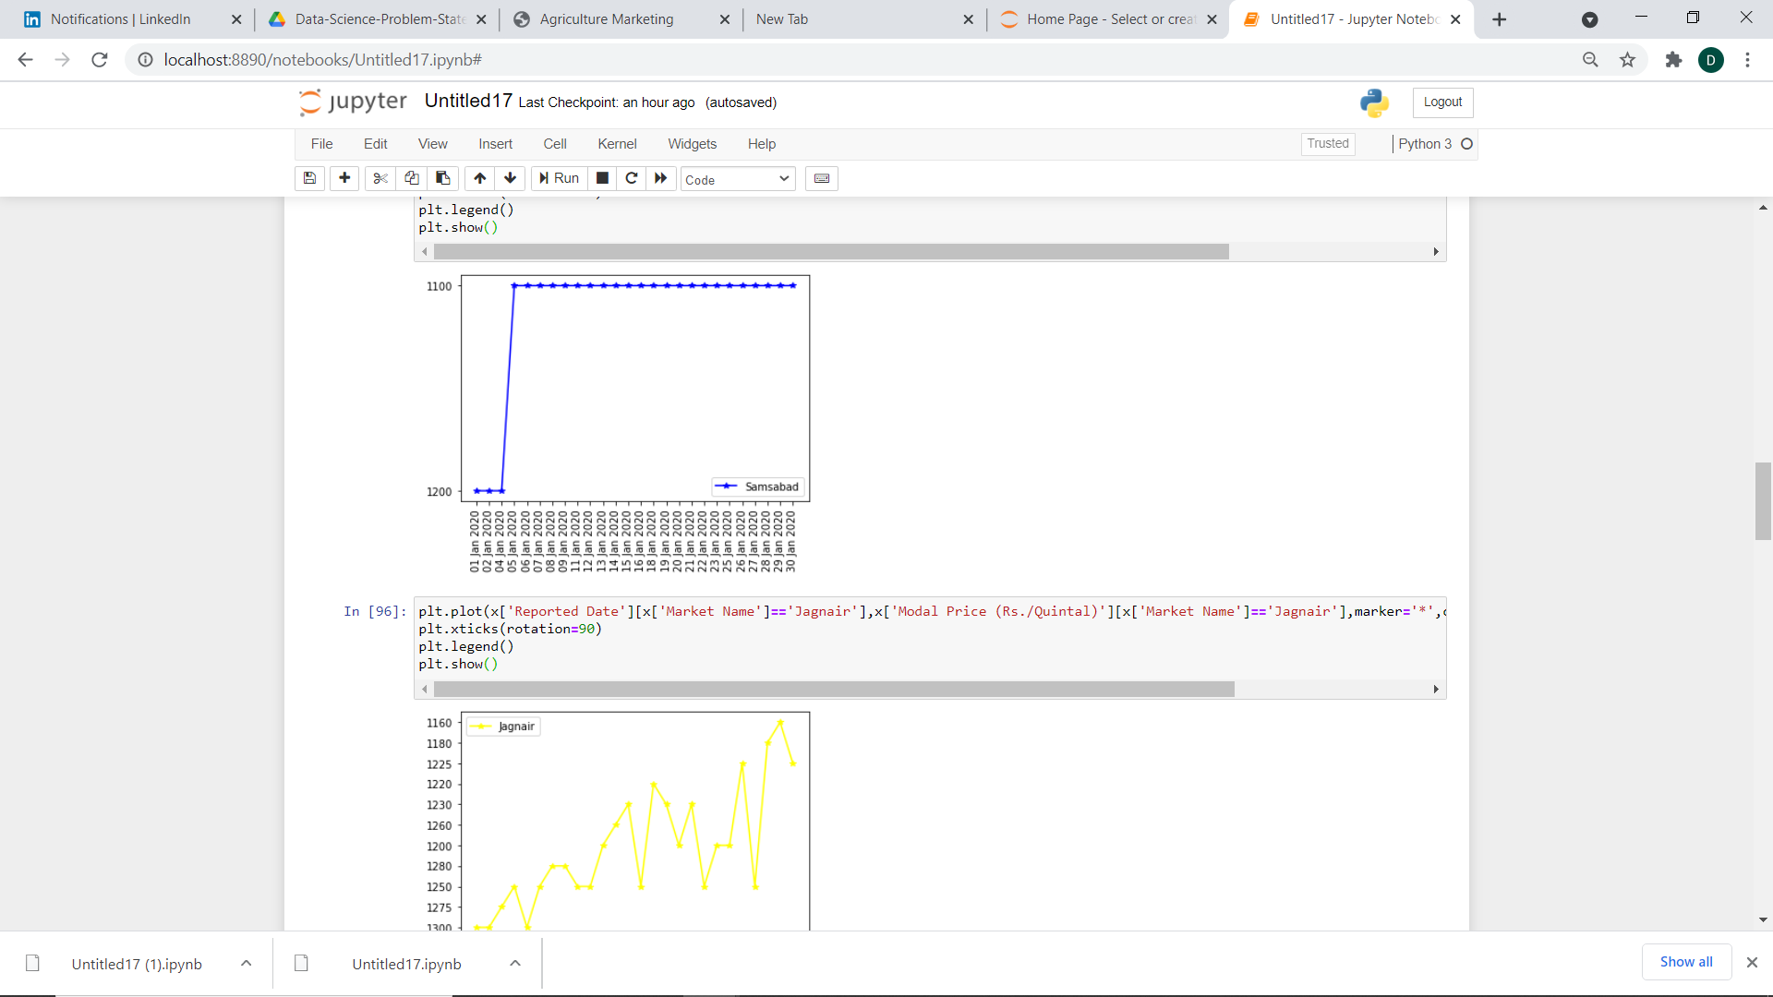

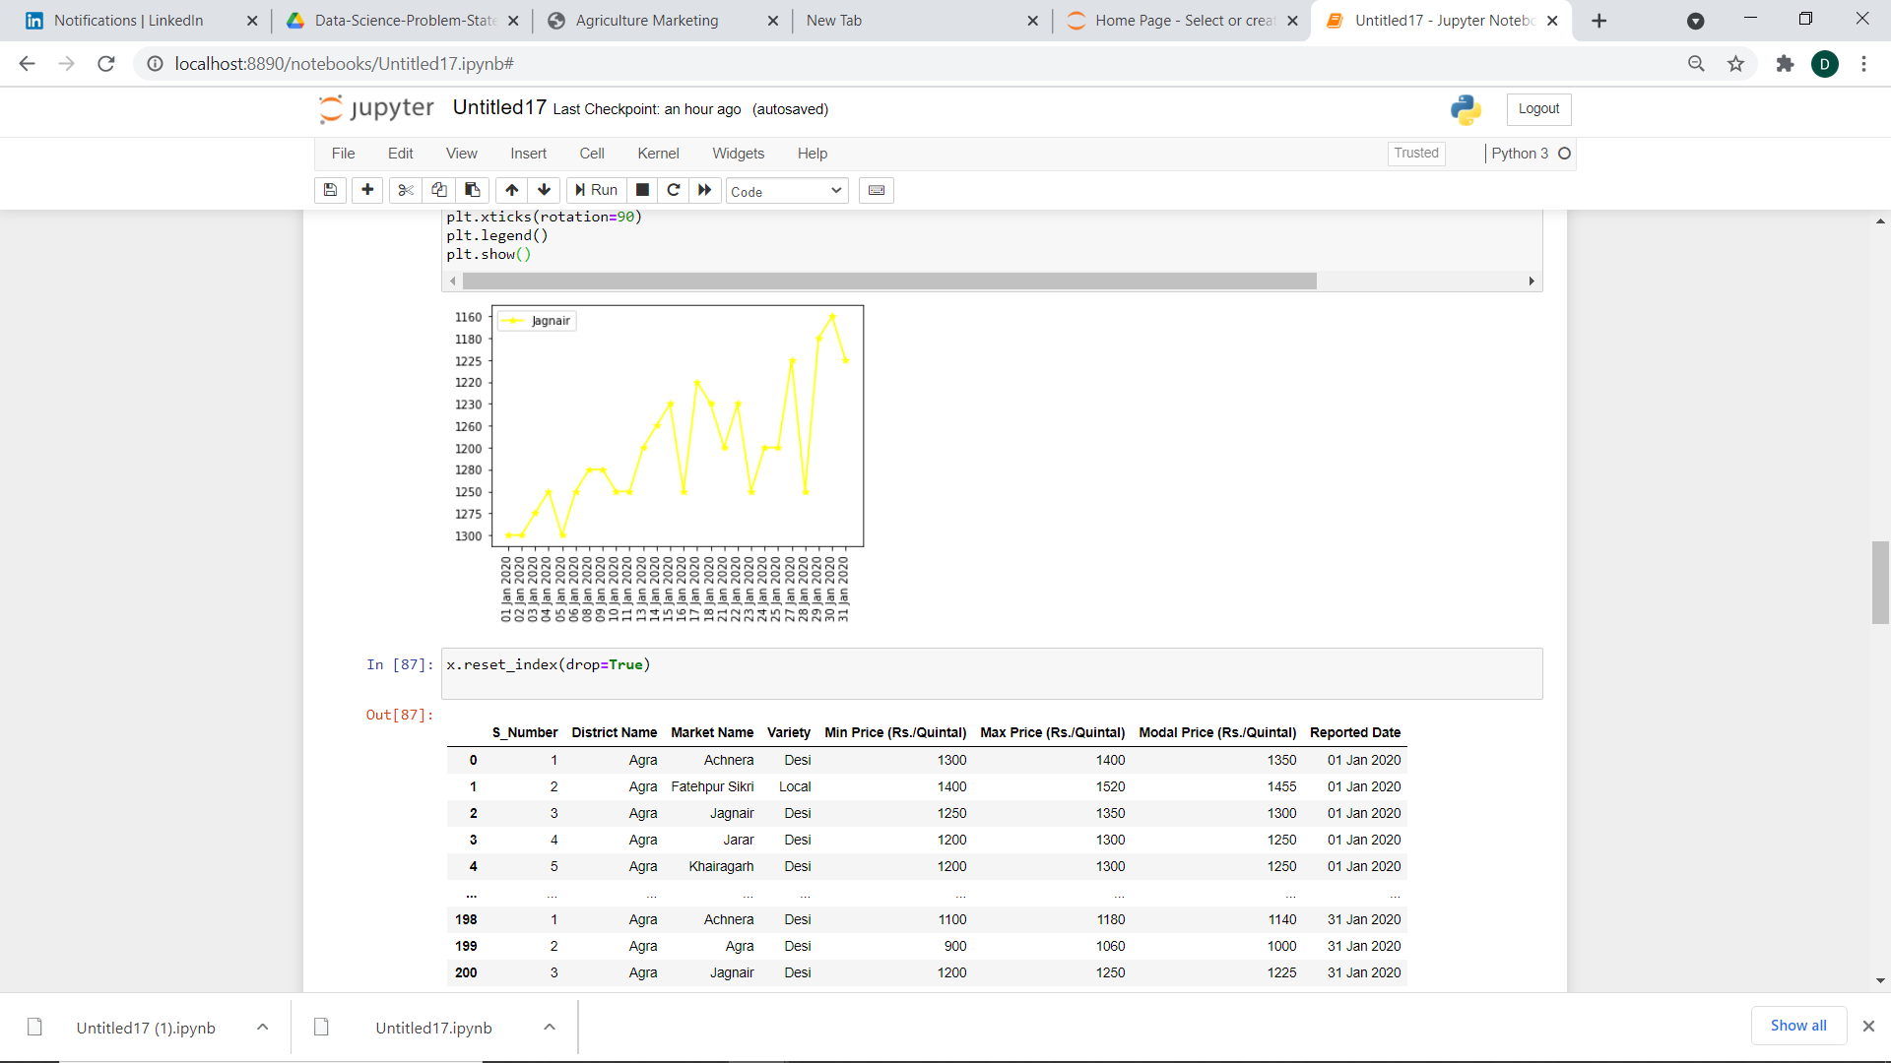

**These Plots shows Modal Price (Rs./Quintal) against the Reported Date/**

As we can see there is one common pattern between all these plots that all start with higher modal price at the starting and ends at lesser amount.

**3.** i) I would filter the features on the basis of what is required or necessary or can be used for further assessment of the model. Unnecessary columns will be dropped.

ii) I would use Modal Price, Average of Min Price and Max Price, Market Name, Reporting Date as my Features.

iii) This can be framed as a machine Learning Model to predict Modal Price For a particular market or as which Market will be more beneficial to go for on the basis of past behaviour.

iv) I would have used Linear Regression Model (with Regularization as it would be more prone to overfitting) with Gradient Descent optimizer as my algorithm.

v) J(z0,z1) = summation(i)(from 1 to m)( (hz(xi) – yi)^2)

z0 and z1 being parameters

x being feature(like Modal Price)

hz(xi) being predicted Feature(Price)

yi being actual Feature(Price)

vi) Multi Linear Regression or Polynomial Regression Model can be used here depending on the no. of features (like here min Price and Max Price can also be taken into consideration) and Complexity.