**ID: 1**

**Title:** Button in registration form

**Priority:** 4

**Description:** Incorrect registration button text

**Steps to reproduce:** 1.open <https://test.deviqa.xyz/>

2. You will see the wrong text on the button

**Expected result:** Button text = sign up

**Actual result:** Button text = sign in

**Status:** Open

**Reporter:** Andrey Chernenko

**Screenshot:** 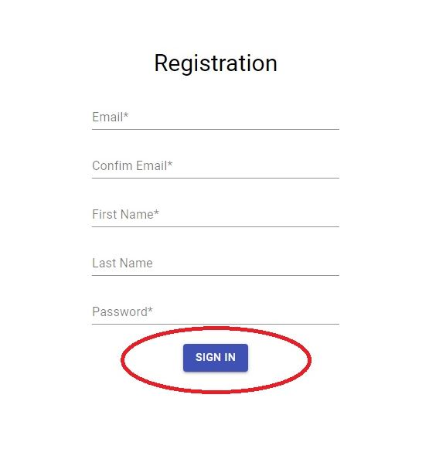

**ID: 2**

**Title:** Last Name field

**Priority:** 3

**Description:** The Last Name field does not contain an asterisk which indicates that the field is required

**Steps to reproduce:** 1.open <https://test.deviqa.xyz/>

2. You will see the name field does not contain an asterisk which indicates that the field is required

**Expected result:** Field contain asterisk

**Actual result:** Field does not contain an asterisk

**Status:** Open

**Reporter:** Andrey Chernenko

**Screenshot:** 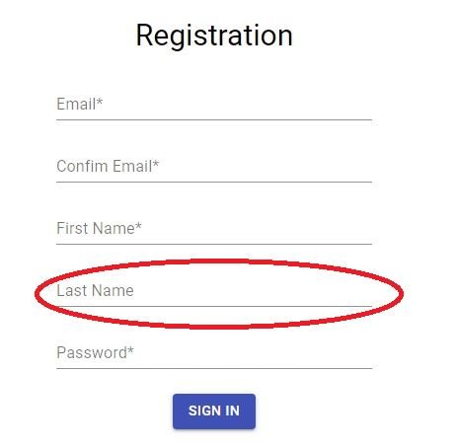

**ID: 3**

**Title:** Name field

**Priority:** 2

**Description:** The name field is not underlined in red when no data has been entered into it and the registration button has been pressed

**Steps to reproduce:** 1.open <https://test.deviqa.xyz/>

2. Fill in all fields except the name

**Expected result:** The field is underlined in red

**Actual result:** Field does not is underlined in red

**Status:** Open

**Reporter:** Andrey Chernenko

**Screenshot:** 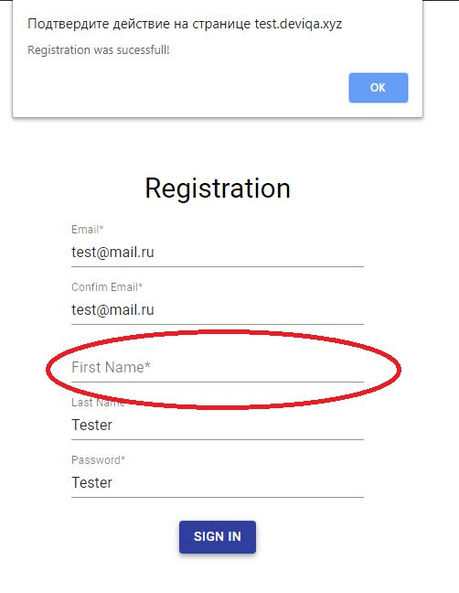

**ID: 4**

**Title:** Field Confrim Email

**Priority:** 1

**Description:** Email confirmation field does not check it

**Steps to reproduce:** 1.open <https://test.deviqa.xyz/>

2. Fill in email

3. Fill in check email another email

**Expected result:** The field does not turn red only when it matches the email field

**Actual result:** The field can accept any data

**Status:** Open

**Reporter:** Andrey Chernenko

**Screenshot:** 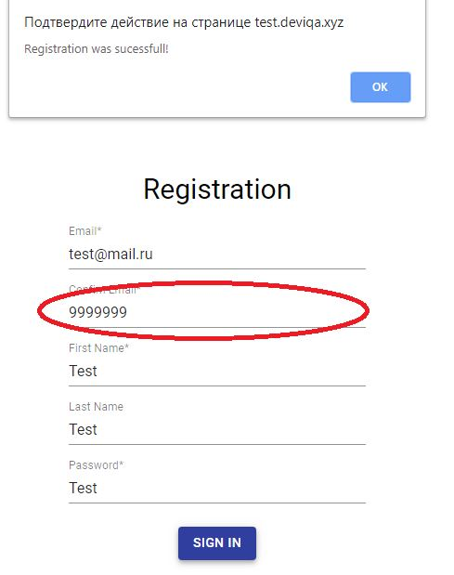

**ID: 5**

**Title:** Field Confrim Email

**Priority:** 4

**Description:** Spelling mistake

**Steps to reproduce:** 1.open <https://test.deviqa.xyz/>

2. Take a look at the inscription confirm email

**Expected result:** Text Confirm email

**Actual result:** Confim email

**Status:** Open

**Reporter:** Andrey Chernenko

**Screenshot:** 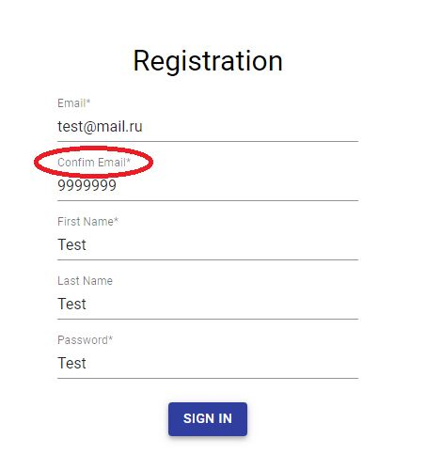

**ID: 6**

**Title:** Field Email

**Priority:** 2

**Description:** The field does not check the correctness of the address

**Steps to reproduce:** 1.open <https://test.deviqa.xyz/>

2. Fill in email with incorrect domain

**Expected result:** The field will turn red

**Actual result:** Email worked

**Status:** Open

**Reporter:** Andrey Chernenko

**Screenshot:** 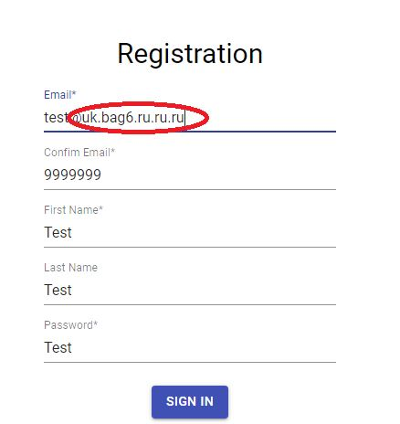

**ID: 7**

**Title:** Field Password

**Priority:** 3

**Description:** The field does not hide the password

**Steps to reproduce:** 1.open <https://test.deviqa.xyz/>

2. Fill in password

**Expected result:** Password must be hidden behind dots

**Actual result:** Password is visible

**Status:** Open

**Reporter:** Andrey Chernenko

**Screenshot:** 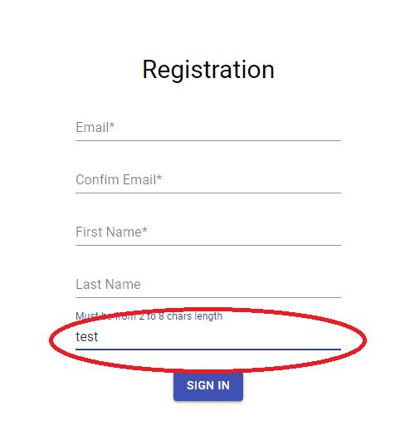

**ID: 8**

**Title:** Field Password

**Priority:** 3

**Description:** The field password must contain no more than 8 characters

**Steps to reproduce:** 1.open <https://test.deviqa.xyz/>

2. Fill in password

**Expected result:** Password no longer than 8 characters

**Actual result:** You can enter a password of any length

**Status:** Open

**Reporter:** Andrey Chernenko

**Screenshot:** 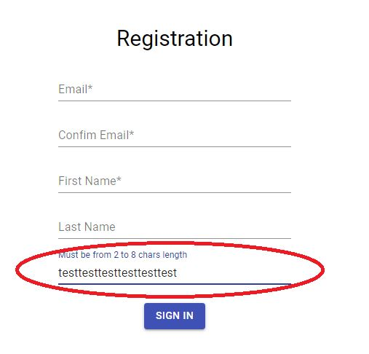

**ID: 9**

**Title:** Field First Name

**Priority:** 3

**Description:** The field does not check for entered data

**Steps to reproduce:** 1.open <https://test.deviqa.xyz/>

2. Fill in Name field 888

**Expected result:** There must be an error when entering characters other than letters

**Actual result:** You can enter any data in the name field

**Status:** Open

**Reporter:** Andrey Chernenko

**Screenshot:** 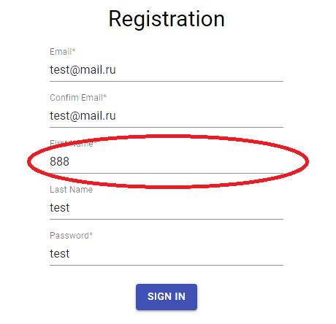

**ID: 10**

**Title:** Field LastName

**Priority:** 3

**Description:** The field does not check for entered data

**Steps to reproduce:** 1.open <https://test.deviqa.xyz/>

2. Fill in Last Name field 888

**Expected result:** There must be an error when entering characters other than letters

**Actual result:** You can enter any data in the last name field

**Status:** Open

**Reporter:** Andrey Chernenko

**Screenshot:** 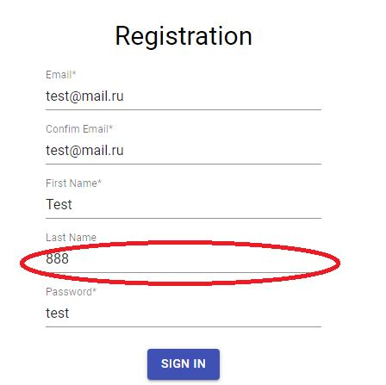

**ID: 11**

**Title:** Field First Name

**Priority:** 3

**Description:** You can enter an infinite number of characters

**Steps to reproduce:** 1.open <https://test.deviqa.xyz/>

2. Fill in Name field infinite characters

**Expected result:** The field should limit the number of characters

**Actual result:** You can enter an infinite number of characters

**Status:** Open

**Reporter:** Andrey Chernenko

**Screenshot:** 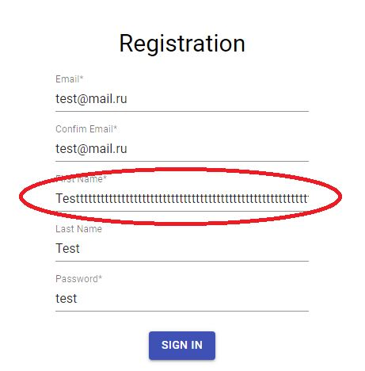

**ID: 12**

**Title:** Field Name

**Priority:** 3

**Description:** You can enter an infinite number of characters

**Steps to reproduce:** 1.open <https://test.deviqa.xyz/>

2. Fill in Last Name field infinite characters

**Expected result:** The field should limit the number of characters

**Actual result:** You can enter an infinite number of characters

**Status:** Open

**Reporter:** Andrey Chernenko

**Screenshot:** 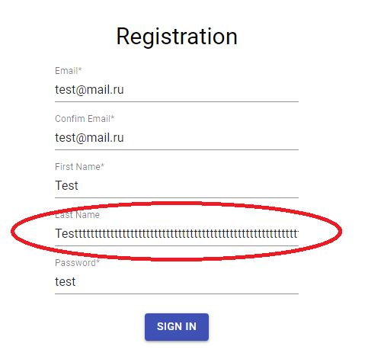

**ID: 13**

**Title:** Email field

**Priority:** 2

**Description:** You can enter email from numbers

**Steps to reproduce:** 1.open <https://test.deviqa.xyz/>

2. Fill in email field num

**Expected result:** The field should throw an error

**Actual result:** You can enter email only from numbers

**Status:** Open

**Reporter:** Andrey Chernenko

**Screenshot:** 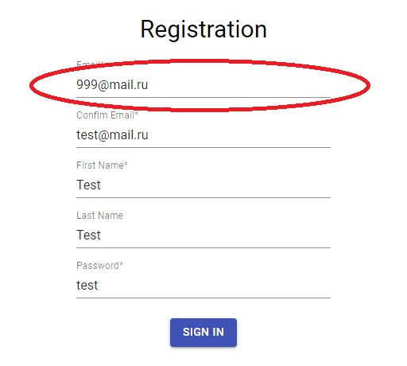

**ID: 14**

**Title:** No field confirm password

**Priority:** 2

**Description:** I think there should be a field confirm the password

**Steps to reproduce:** 1.open <https://test.deviqa.xyz/>

**Expected result:** There should be a field to confirm the password

**Actual result:** No field

**Status:** Open

**Reporter:** Andrey Chernenko

**Screenshot:** 