**ID:** 1

**Title:** Registration function

Severity: S2

Priority: P1

**Description:** After filling in all the fields and completing registration, an error appears, and the account appears in the admin panel, but without a password

**Steps to reproduce:** 1. Open <http://www.landingleader.com/>

2. At the top click Register

3. Fill in all required data correctly

4. Click on the register button at the bottom of the form

**Expected result:** Successful registration window

**Result:** Error

**Screenshot:** 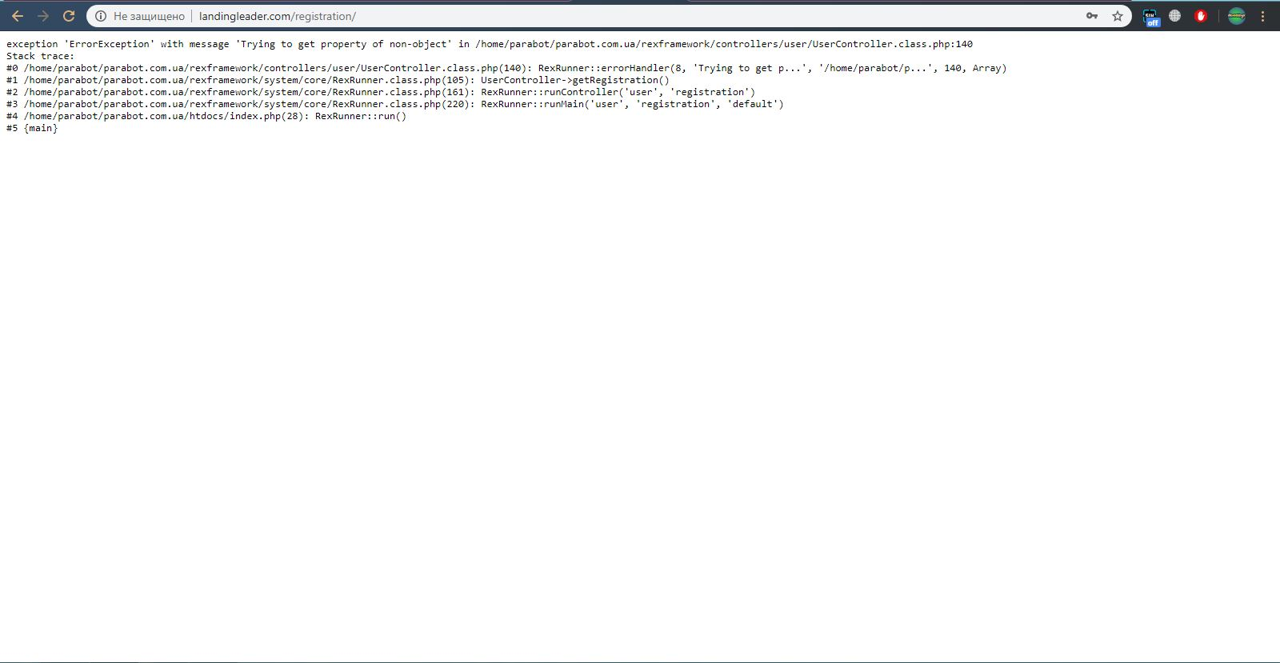

**ID:** 2

**Title:** Login function

Severity: S2

Priority: P1

**Description:** Unable to log into existing account. Most likely this is due to a broken registration function

**Steps to reproduce:** 1. Open <http://www.landingleader.com/>

2. At the top click Login

3. Enter your account details

4. Click on the Login button at the bottom of the form

**Expected result:** Login to your account

**Result:** Error

**Screenshot:** 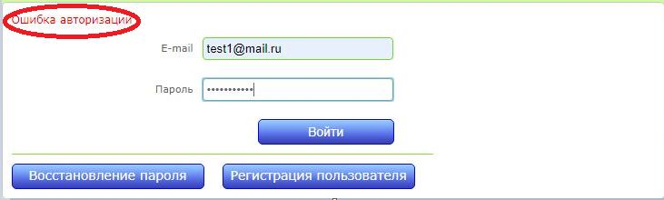

**ID:** 3

**Title:** Registration form

Severity: S2

Priority: P1

**Description:** Field validation does not work correctly, you can omit the required fields

**Steps to reproduce:** 1. Open <http://www.landingleader.com/>

2. At the top click Register

3. Fill in all fields except the city field; when filling in the e-mail field, do not enter @, in the re-enter password field,enter whatever

4. Click on the register button at the bottom of the form

**Expected result:** Data entry error message

**Result:** Registration

**Screenshot:**

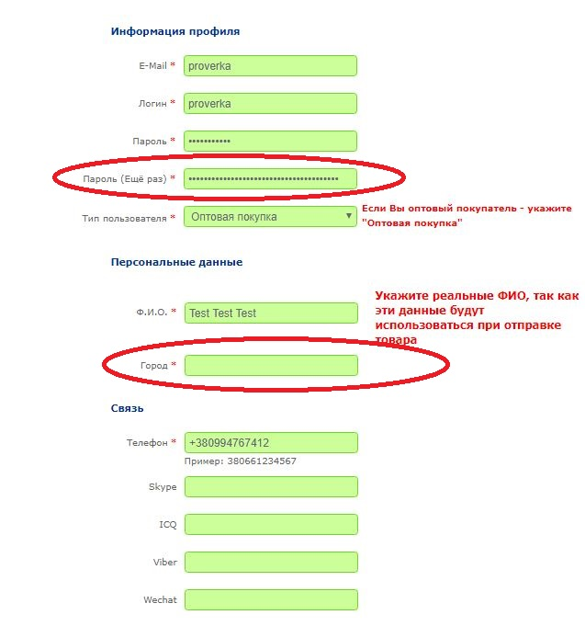

**ID:** 4

**Title:** Purchase form

Severity: S4

Priority: P2

**Description:** Incorrect location of information

**Steps to reproduce:** 1. Open <http://www.landingleader.com/>

2. Add any item to cart

3. After adding, click on the basket at the top of the page on the right

4. Enter the correct number

5. You will see how the help window overlaps the error information

**Expected result:** Clear visibility of error information

**Result:** Half of the text is hidden

**Screenshot:** 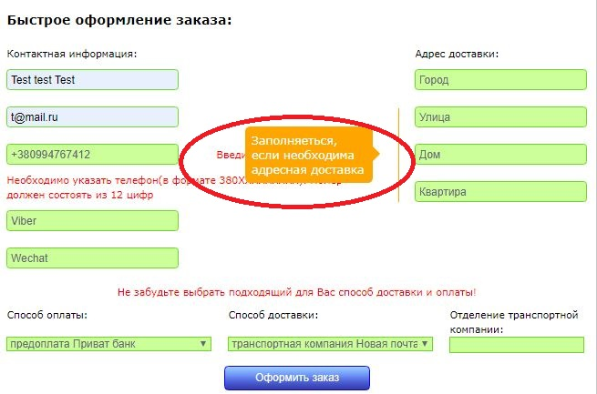

**ID:** 5

**Title:** Title on the slider

Severity: S5

Priority: P3

**Description:** Developers forgot to add a slide title

**Steps to reproduce:** 1. Open <http://www.landingleader.com/>

2. Scroll image slider

**Expected result:** Thematic title

**Result:** Visible test title

**Screenshot: **

**ID:** 6

**Title:** Links on slider pictures

Severity: S5

Priority: P3

**Description:** The developers most likely forgot to add transitions to the pages to which the pictures in the slider correspond. Maybe not a bug, because testing is done without reading the requirements and specifications

**Steps to reproduce:** 1. Open <http://www.landingleader.com/>

2. Click on any picture in the slider

**Expected result:** Go to page

**Result:** Page refresh

**Screenshot:** 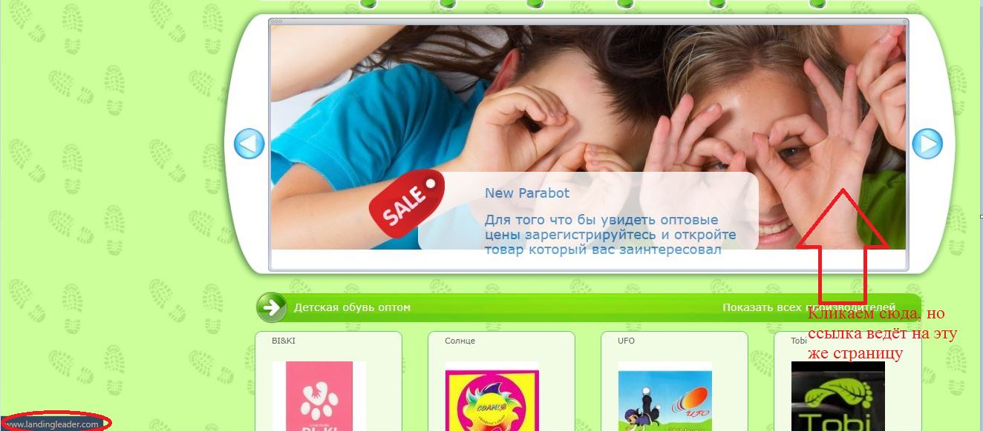

**ID:** 7

**Title:** Language version

Severity: S5

Priority: P3

**Description:** When switching to the Ukrainian version, 70% of the interface remains in Russian

**Steps to reproduce:** 1. Open <http://www.landingleader.com/>

2. Select another version at the top of the main page

**Expected result:** Full transition to the Ukrainian language

**Result:** 70% of the interface remains in Russian

**Screenshot:** 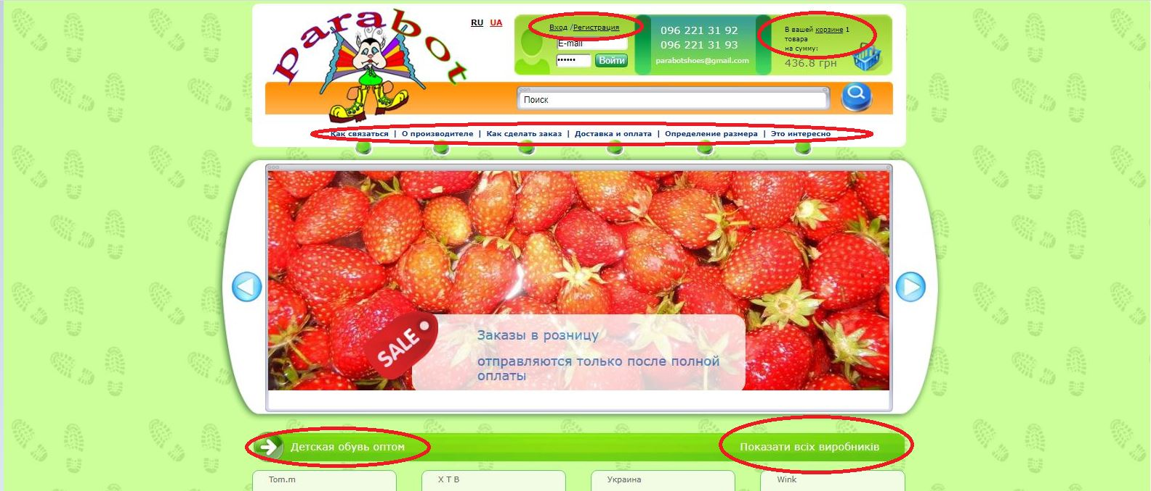

**ID:** 8

**Title:** Navigation menu

Severity: S5

Priority: P3

**Description:** When you hover over the text, the button below does not glow green, and the text is highlighted; and if you hover over the button below, it and the text will be highlighted

**Steps to reproduce:** 1. Open <http://www.landingleader.com/>

2. Move the cursor on the navigation menu

**Expected result:** Button and text highlighting

**Result:** only text is highlighted

**Screenshot:** 