📘 Generative AI Project using IBM Cloud – HEALTHAI
🔷 Project Documentation Format

- Introduction
  - Project Title: HEALTHAI: Intelligent Healthcare Assistant using IBM Granite (Generative AI with IBM Cloud) Team Members:
    - Koti Venkata Srinivasarao (Team Leader – Requirements gathering ,Interaction& Testing):
Contributed by assisting in prompt design, testing the AI model outputs across modules like Disease Prediction and Health Chat, and refining interactions with IBM Granite.

Kesani Santhosh Kumar (Team Member - Development , Integration , Deployment & documentation):
Led the complete development of the HEALTHAI application, including IBMGranite integration, Streamlit-based UI design, module creation, and model API
handling,project deployment

Kambhampati Dharaneeswar (Team Member - UI Structuring , Feature Enhancement & Testing):
Supported in designing user flow, organizing the Streamlit interface across all modules, and suggesting improvements in user interaction and feature behavior.

Kaja Bala Nithin Reddy (Team Member - Feature Enhancement ,Testing & documentation):
Supported in- Feature Enhancement of project, testing the project and helped in the documentation.

Project Overview
  - Purpose:
To build a Generative AI-based healthcare assistant using IBM Granite, capable of answering health queries, predicting diseases, suggesting treatments, and displaying analytics.

Features:

    - 💬 AI Health Chat using IBM Granite
    - o 🦠 Disease Prediction from user symptoms

      - 💊 Treatment Plan Suggestions
D Health Analytics Dashboard
      - 🦠 Centralized shared model for performance optimization

Architecture
  - Frontend:
Built using Streamlit for a clean and responsive web interface. Each feature is modularized for easy navigation via sidebar.

Backend & Model:
    - No traditional backend. All logic handled in Streamlit using Python.
    - Uses IBM Granite 3-2b Instruct model from IBM Watsonx: ibm-granite/granite- 3.2b-instruct
      - Supports both API and local model loading (granite/folder).

Shared Model Loader:
The shared_model.py file centrally loads and shares the AI model across modules to prevent memory crashes and redundancy.
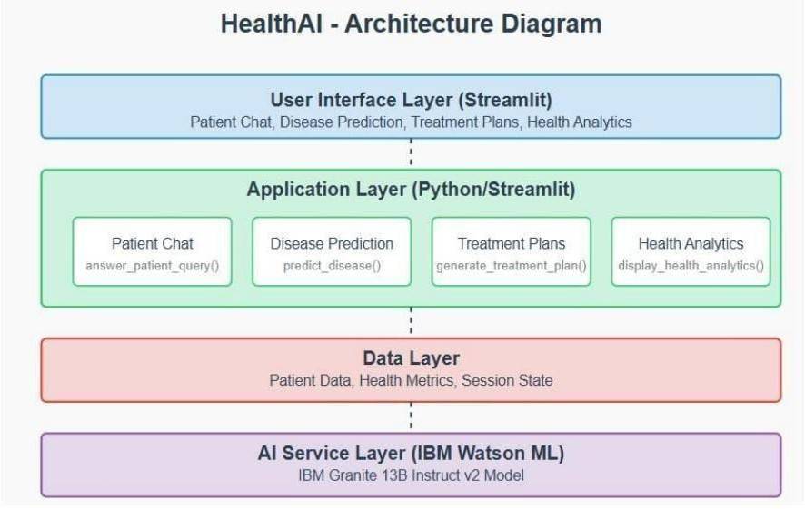

Setup Instructions

Prerequisites
  - Python 3.10+
  - pip
  - IBM cloud account and Streamlit Community Cloud account
  - Installed model files if using local (granite/ folder) Installation
git clone : https://github.com/deeven17/HealthCare_AI.git
cd Healthai :
pip install -r requirements.txt

Environment Variables
Create a .env file in the root folder:
IBM watsonx_API_Key= ESdPIiW78JY8LM32Vp6ujw_EVP1dySvqb5ZQ5lc7K4wi
✅ .env file must be excluded in .gitignore.

Folder Structure
Health-ai/
├── app.py # Main entry point
├── shared_model.py # Shared AI model instance
├── patient_chat.py # AI Health Chat module
├── disease_prediction.py # Disease Prediction logic
├── treatment_plans.py # Treatment Plan suggestions
├── health_analytics.py # Analytics module
├── requirements.txt # Python dependencies
├── .env # API token (not pushed to GitHub)
├── granite/ # [Optional] Local model folder
└── assets/ # Logos and screenshots

Running the Application

For IBM watsonx API:
streamlit run app.py

For Local Model:
Ensure granite/ folder contains the downloaded model and tokenizer files. In shared_model.py, update: model_path = "./granite"

API Documentation
Endpoint: https://eu-de.ml.cloud.ibm.com/ml/v1/text/chat?version=2023-05-29

Headers:
{
"Authorization": "Bearer <IBM _API_Key>", "Content-Type": "application/json"
}

Example Request:
{
"inputs": "What are the symptoms of diabetes?"
}

Example Response:
{
"generated_text": "Common symptoms of diabetes include frequent urination..."
}

Authentication
  - Streamlit cloud Secrets is securely stored the .env credentials.
  - .env is excluded via .gitignore
  - App is currently public and stateless (no user login)
  - HuggingFace or Firebase Auth can be added in future

User Interface

  - Built entirely with Streamlit
  - Sidebar for navigation
  - Text/chat inputs for interaction
  - Visual graphs and health tips in Analytics
  - Centralized theme and branding

Testing
  - ✅ Manual testing across all modules
  - ✅ Model tested with varied prompts and edge cases
  - ✅ Handled errors for invalid inputs and model timeouts

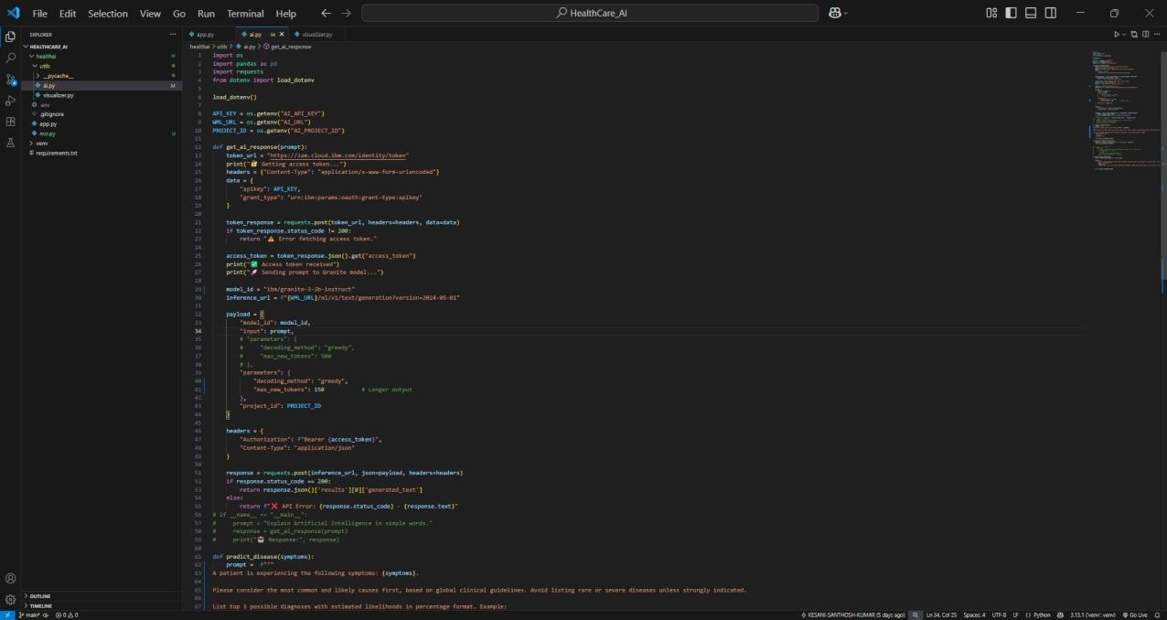
- Screenshots or Demo

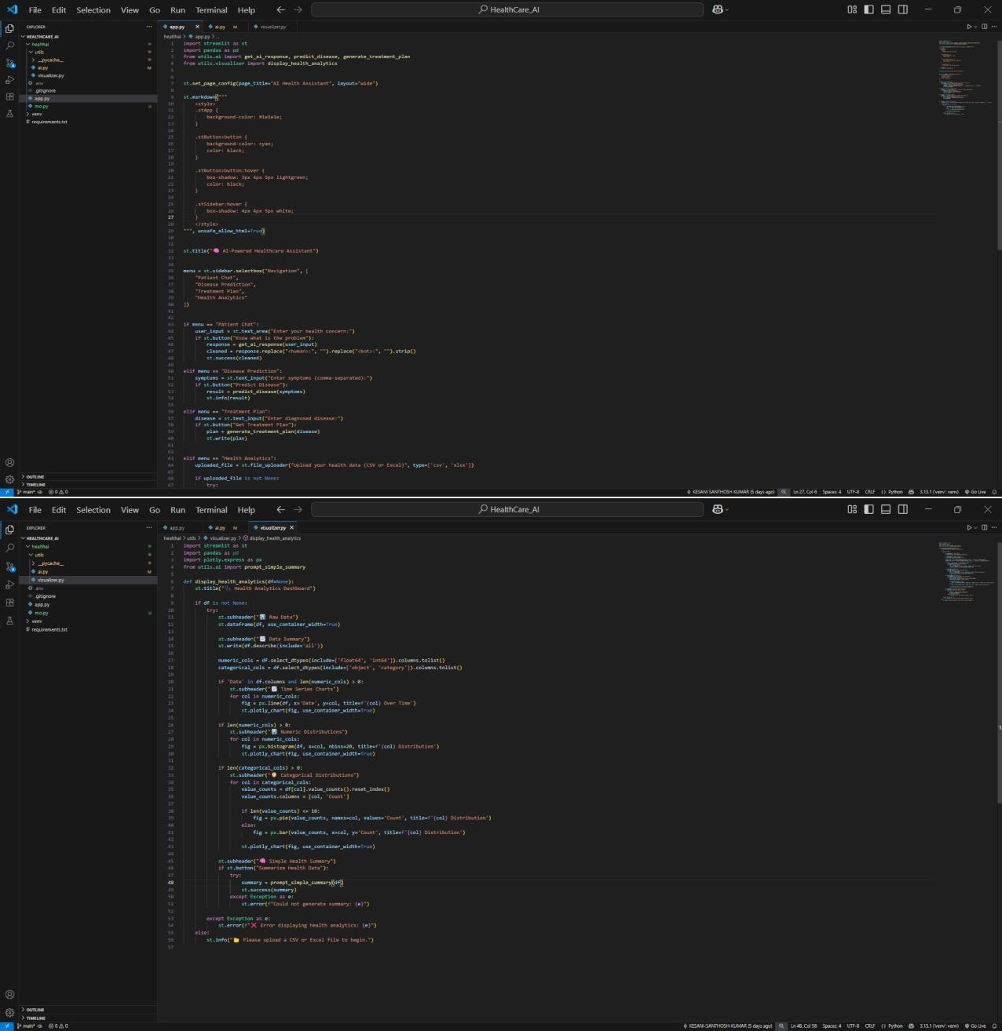
  - OUTPUT :

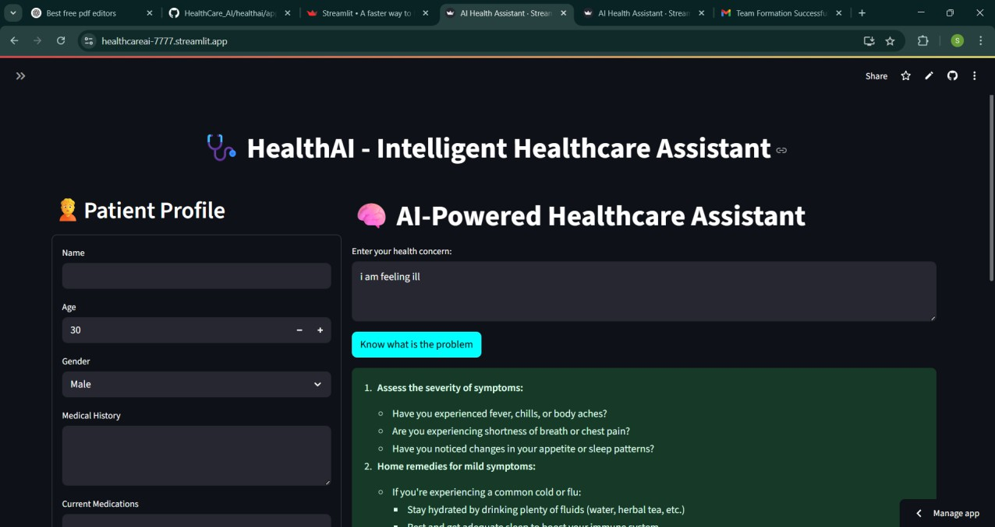
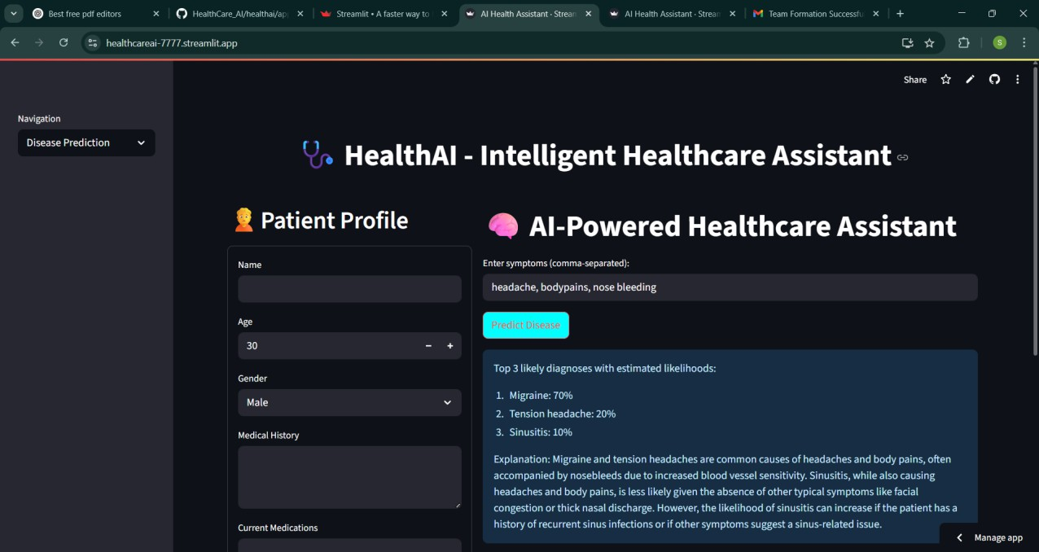

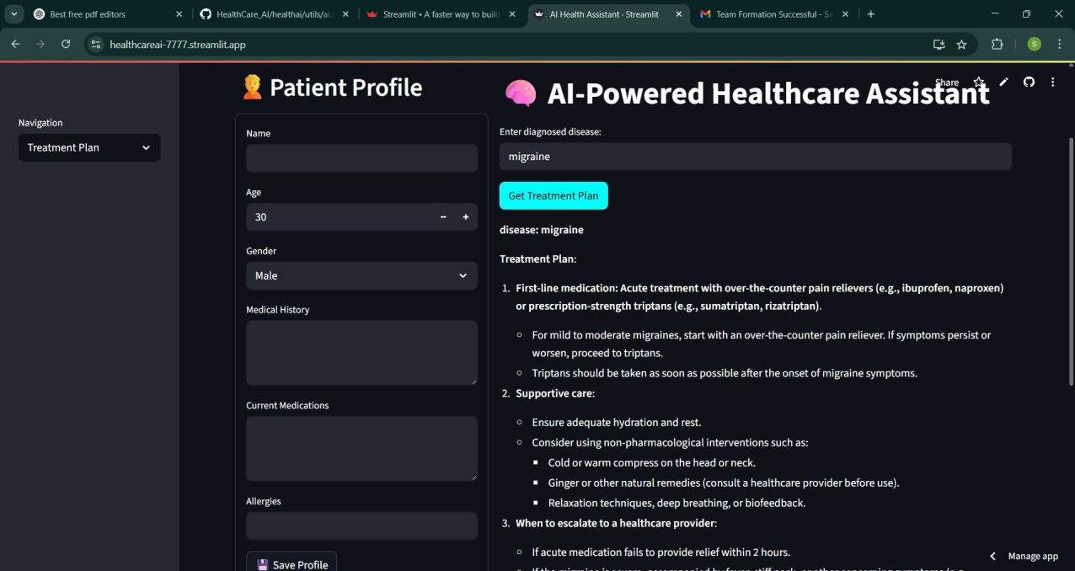
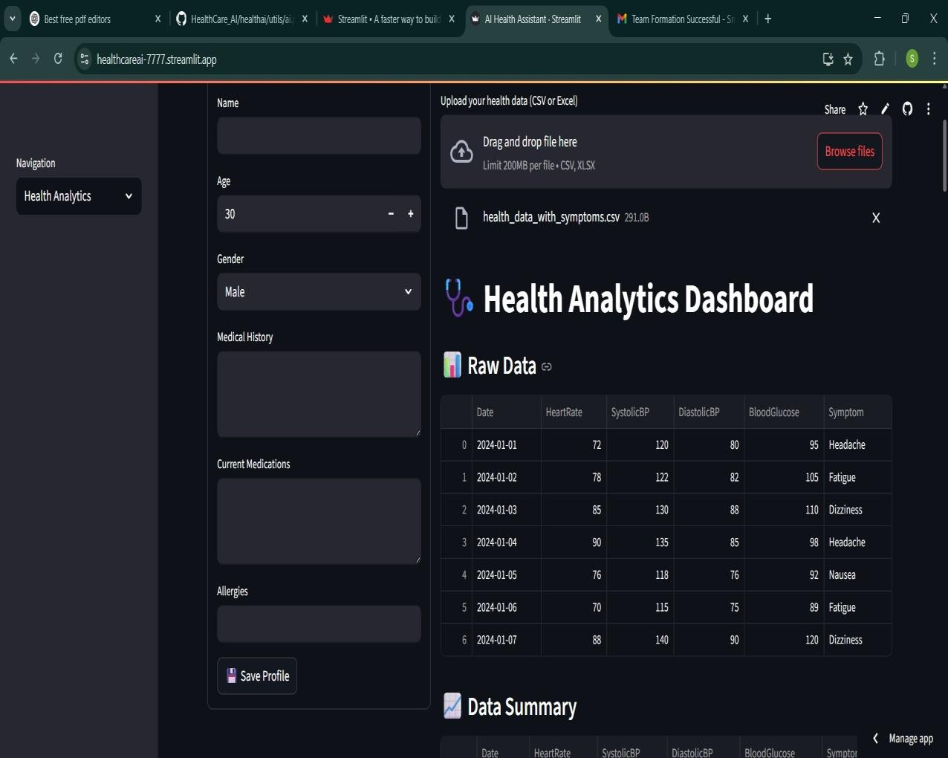

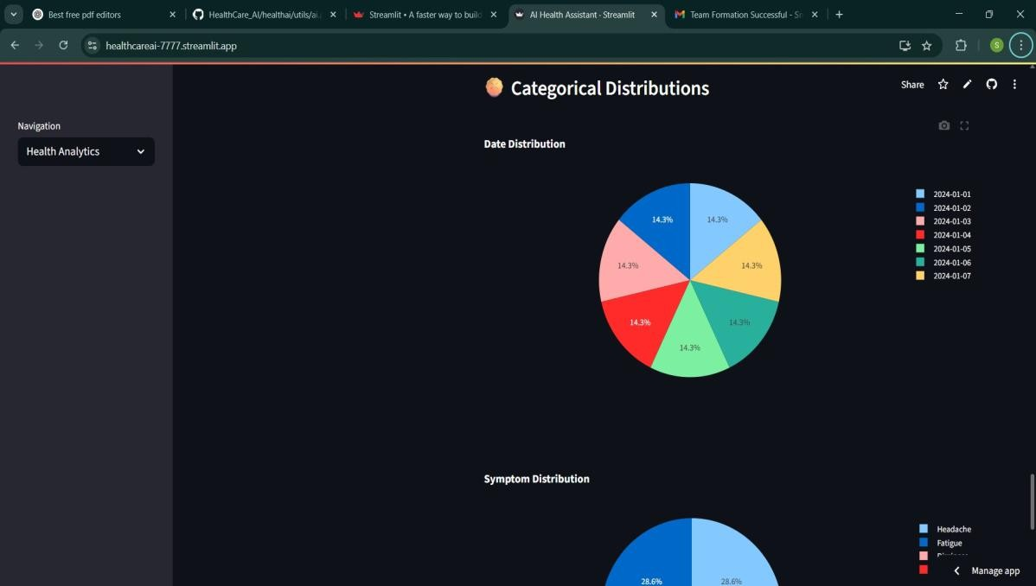

- Known Issues
  - 🦠 Generic model outputs due to lack of medical domain fine-tuning
  - 🦠 Internet dependency when using IBM watsonx.
  - 🦠 No data persistence (currently stateless app)

Future Enhancements

  - ✅ Add user authentication and patient record storage
  - ✅ Multilingual prompt support
  - ✅ Mobile version of the app
  - ✅ Integrate with real-time health APIs or EHRs

