EXPERIMENT 3: Decision Tree using ID3 Algorithm

Aim
To demonstrate the ID3 decision-tree algorithm using information gain, build a decision tree from a dataset, and classify a new sample.

Algorithm / Concept
ID3 selects the attribute with the highest Information Gain at each node. Entropy measures impurity: Entropy(S) = −Σ pᵢ log₂(pᵢ). Information Gain(A) = Entropy(S) − Σ (|Sᵥ|/|S|) Entropy(Sᵥ). The tree is expanded recursively until the samples in a node belong to one class or no useful attribute remains.

Dataset
The program uses the Iris dataset (150 flower samples, four numeric features, and three classes: setosa, versicolor, and virginica). The model uses entropy as the split criterion, which is the information-gain basis of ID3. Scikit-learn's DecisionTreeClassifier is used as an entropy-based ID3-style implementation.

Python Program
from sklearn.datasets import load_iris
from sklearn.model_selection import train_test_split
from sklearn.tree import DecisionTreeClassifier, plot_tree
from sklearn.metrics import accuracy_score
import matplotlib.pyplot as plt
iris = load_iris()
X, y = iris.data, iris.target
X_train, X_test, y_train, y_test = train_test_split(
X, y, test_size=0.25, random_state=42, stratify=y)
model = DecisionTreeClassifier(criterion="entropy", random_state=42)
model.fit(X_train, y_train)
y_pred = model.predict(X_test)
print("Accuracy:", round(accuracy_score(y_test, y_pred) * 100, 2), "%")
# Classify a new flower: [sepal length, sepal width,
# petal length, petal width] in centimetres
sample = [[5.1, 3.5, 1.4, 0.2]]
predicted = model.predict(sample)[0]
print("New sample classification:", iris.target_names[predicted])
plt.figure(figsize=(12, 7))
plot_tree(model, feature_names=iris.feature_names,
class_names=iris.target_names, filled=True)
plt.show()

Output Diagram
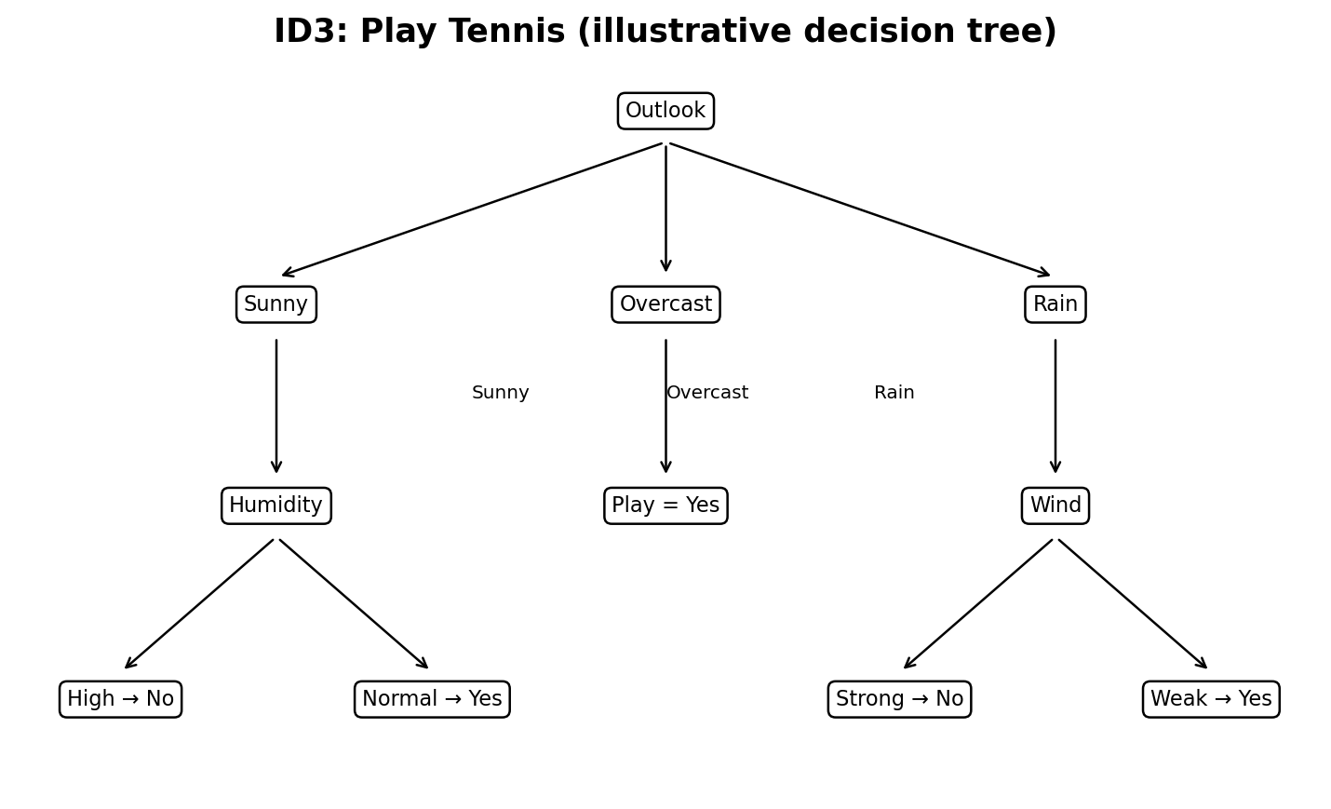
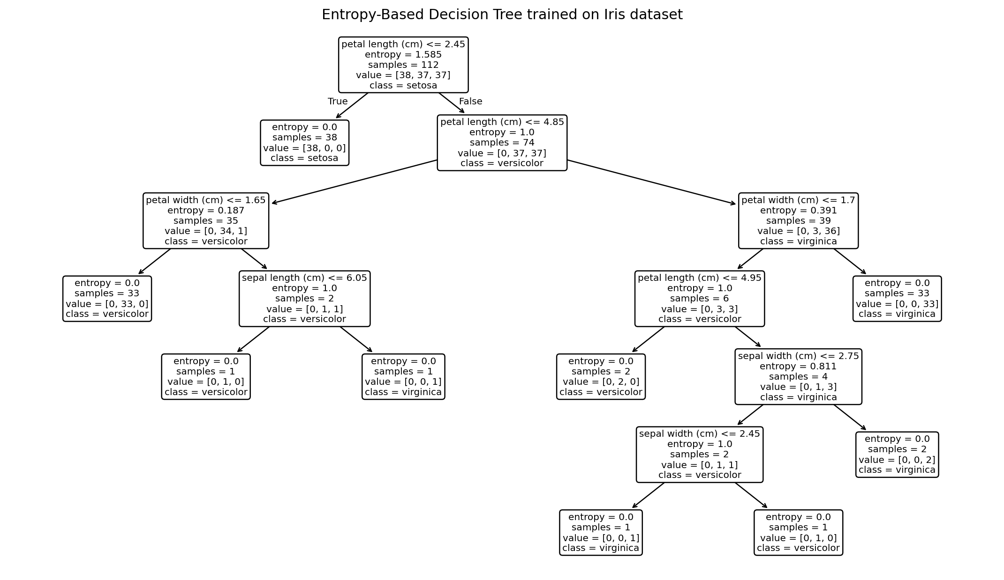

Sample Output
Test accuracy: 89.47%
New sample [5.1, 3.5, 1.4, 0.2] is classified as: setosa

Result
The entropy-based decision tree was trained successfully and used to classify a new flower sample.

EXPERIMENT 4: Artificial Neural Network using Backpropagation

Aim
To build and test an Artificial Neural Network (ANN) using the backpropagation learning algorithm.

Algorithm
1. Initialize weights and biases with small values.
2. Perform forward propagation to calculate the network output.
3. Calculate loss by comparing predicted labels with target labels.
4. Backpropagate gradients from the output layer toward the input layer.
5. Update weights and biases using the learning rate and gradients.
6. Repeat for multiple epochs until the model converges or the maximum iterations are reached.

Python Program
from sklearn.datasets import load_iris
from sklearn.model_selection import train_test_split
from sklearn.preprocessing import StandardScaler
from sklearn.neural_network import MLPClassifier
from sklearn.pipeline import make_pipeline
from sklearn.metrics import accuracy_score, confusion_matrix
import matplotlib.pyplot as plt
iris = load_iris()
X, y = iris.data, iris.target
X_train, X_test, y_train, y_test = train_test_split(
X, y, test_size=0.25, random_state=42, stratify=y)
# MLPClassifier trains using backpropagation
model = make_pipeline(
StandardScaler(),
MLPClassifier(hidden_layer_sizes=(8,), activation="logistic",
solver="lbfgs", max_iter=2000, random_state=42))
model.fit(X_train, y_train)
pred = model.predict(X_test)
print("Accuracy:", round(accuracy_score(y_test, pred) * 100, 2), "%")
print("Confusion matrix:\n", confusion_matrix(y_test, pred))
sample = [[5.1, 3.5, 1.4, 0.2]]
print("New sample class:", iris.target_names[model.predict(sample)[0]])

Output Diagram
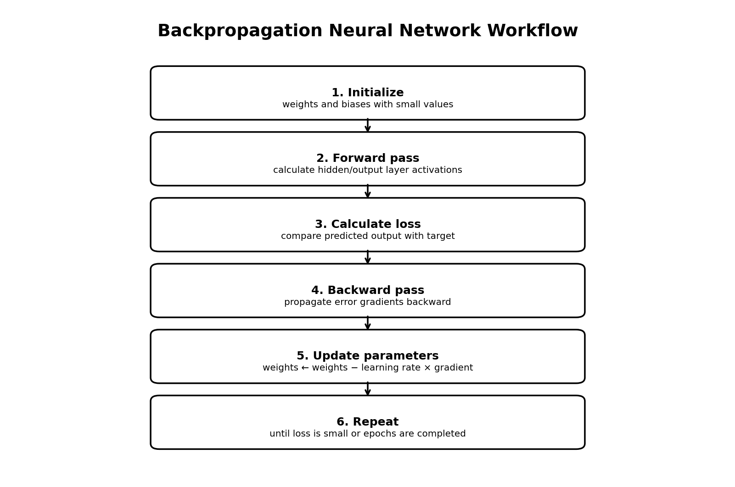

Confusion Matrix
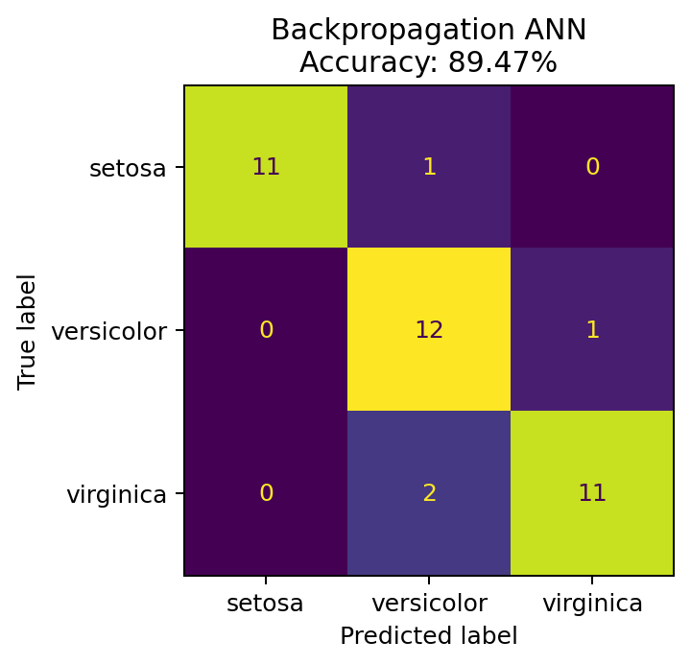

Sample Output
Test accuracy: 89.47%
The confusion matrix is shown above. Rows represent actual classes and columns represent predicted classes.

Result
The ANN was trained with backpropagation and evaluated on unseen test samples.

EXPERIMENT 5: K-Nearest Neighbours (K-NN)

Aim
To implement the K-Nearest Neighbours algorithm in Python and classify samples based on their nearest training examples.

Algorithm
1. Load a labelled dataset and split it into training and testing data.
2. Standardize the numerical features so that features with large scales do not dominate.
3. Select K (here K = 5).
4. Calculate the distance between the new sample and training samples (Euclidean distance is commonly used).
5. Select the K nearest samples and use majority voting to choose the predicted class.
6. Evaluate the predictions using accuracy.

Python Program
from sklearn.datasets import load_iris
from sklearn.model_selection import train_test_split
from sklearn.preprocessing import StandardScaler
from sklearn.neighbors import KNeighborsClassifier
from sklearn.pipeline import make_pipeline
from sklearn.metrics import accuracy_score, confusion_matrix
iris = load_iris()
X, y = iris.data, iris.target
X_train, X_test, y_train, y_test = train_test_split(
X, y, test_size=0.25, random_state=42, stratify=y)
model = make_pipeline(StandardScaler(),
KNeighborsClassifier(n_neighbors=5))
model.fit(X_train, y_train)
pred = model.predict(X_test)
print("Accuracy:", round(accuracy_score(y_test, pred) * 100, 2), "%")
print("Confusion matrix:\n", confusion_matrix(y_test, pred))
sample = [[5.1, 3.5, 1.4, 0.2]]
print("New sample class:", iris.target_names[model.predict(sample)[0]])

Output Diagram
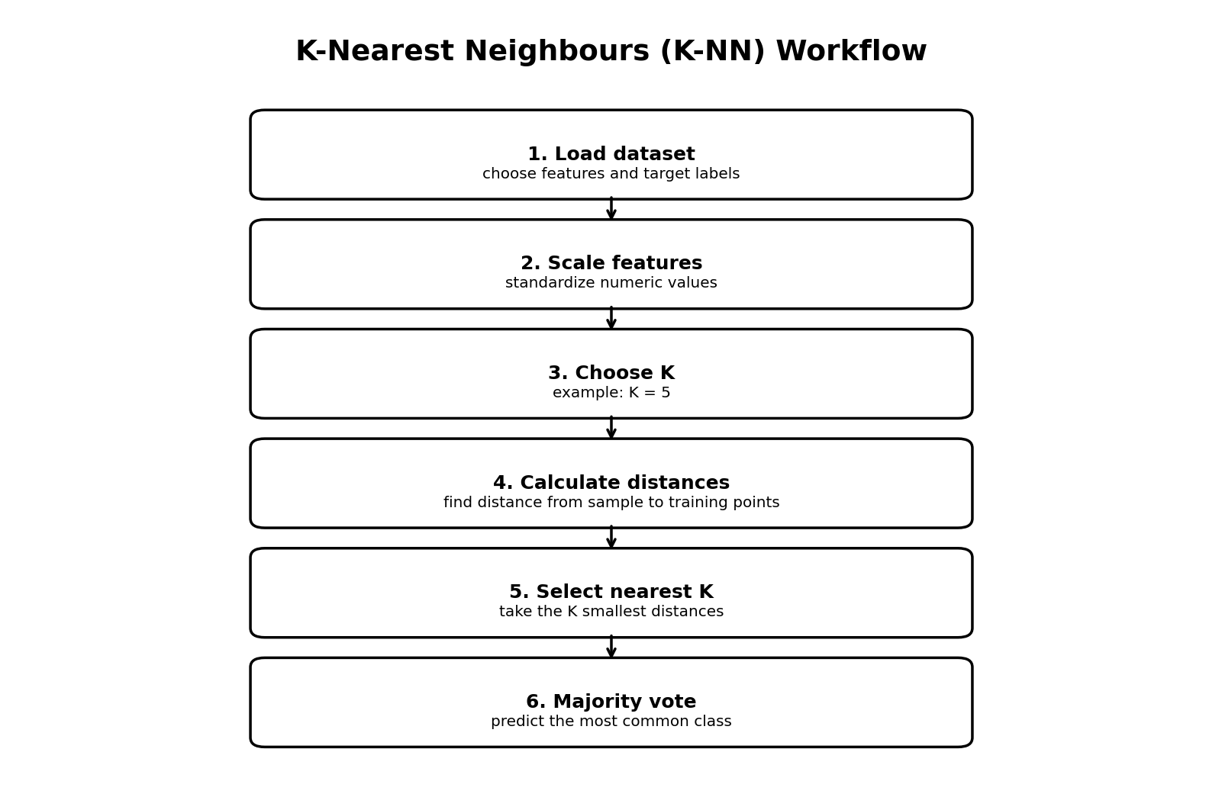

Confusion Matrix
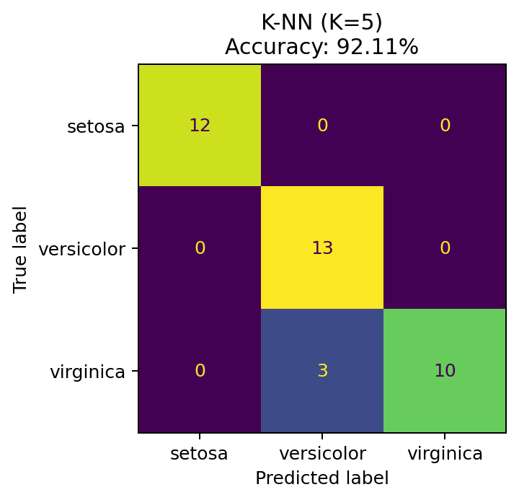

Sample Output
Test accuracy: 92.11%
K = 5 was used. The confusion matrix is shown above.

Result
The K-NN classifier was implemented successfully and classified test samples using majority voting among the five nearest neighbours.

EXPERIMENT 6: Naïve Bayes with Confusion Matrix and Accuracy

Aim
To implement the Naïve Bayes classification algorithm in Python and evaluate its performance using a confusion matrix and accuracy.

Algorithm / Concept
Naïve Bayes applies Bayes' theorem and assumes that features are conditionally independent given the class. Gaussian Naïve Bayes is appropriate for continuous-valued Iris features. The predicted class is the one with the highest posterior probability.

Python Program
from sklearn.datasets import load_iris
from sklearn.model_selection import train_test_split
from sklearn.naive_bayes import GaussianNB
from sklearn.metrics import confusion_matrix, accuracy_score
import matplotlib.pyplot as plt
from sklearn.metrics import ConfusionMatrixDisplay
iris = load_iris()
X, y = iris.data, iris.target
X_train, X_test, y_train, y_test = train_test_split(
X, y, test_size=0.25, random_state=42, stratify=y)
model = GaussianNB()
model.fit(X_train, y_train)
pred = model.predict(X_test)
cm = confusion_matrix(y_test, pred)
acc = accuracy_score(y_test, pred)
print("Confusion Matrix:\n", cm)
print("Accuracy:", round(acc * 100, 2), "%")
ConfusionMatrixDisplay(cm, display_labels=iris.target_names).plot()
plt.title("Naive Bayes Confusion Matrix")
plt.show()

Output Diagram
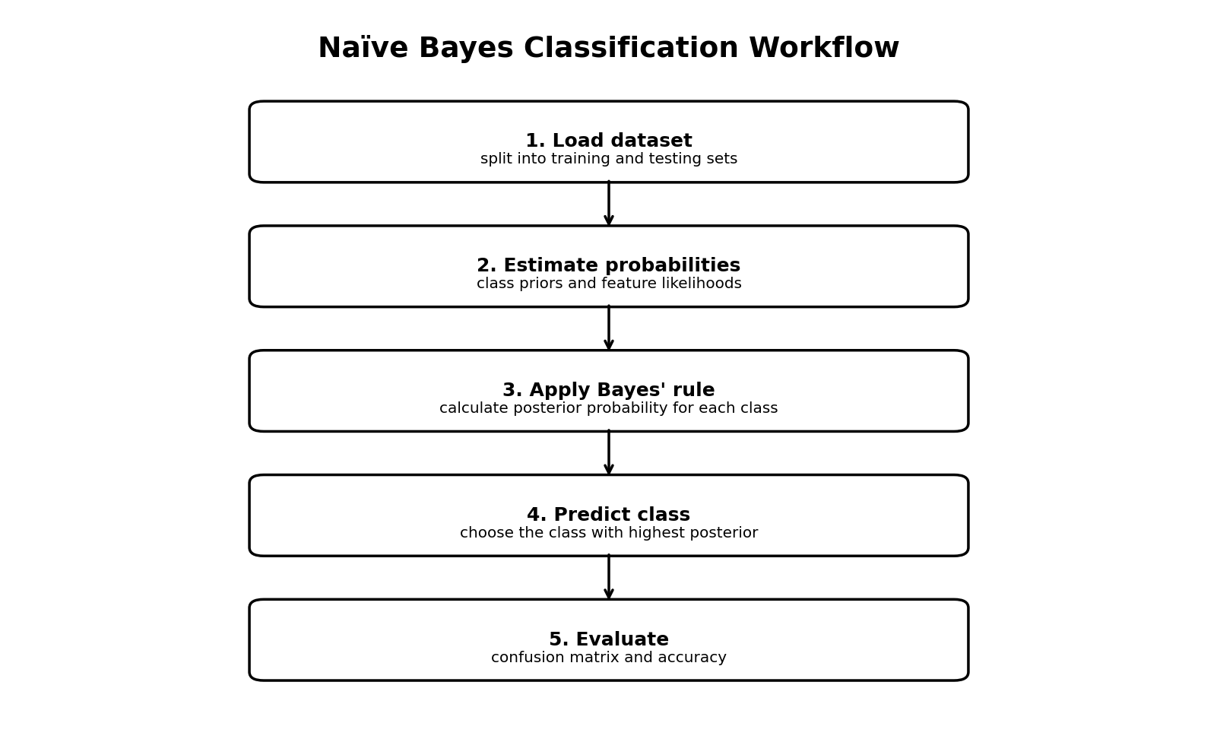

Confusion Matrix
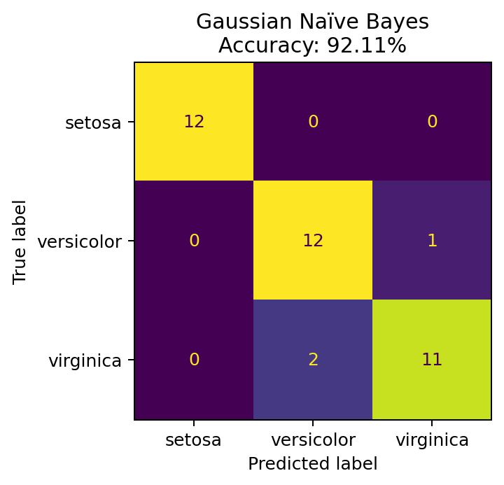

Sample Output
Confusion matrix (rows = actual classes; columns = predicted classes):
[[12 0 0]
[ 0 12 1]
[ 0 2 11]]
Accuracy: 92.11%

Result
The Gaussian Naïve Bayes algorithm was implemented successfully, and its performance was displayed using a confusion matrix and accuracy.

How to Run the Programs
1. Install Python 3.
2. Install the required libraries in a terminal: pip install scikit-learn matplotlib
3. Copy each experiment's program into a separate .py file.
4. Run a file using: python filename.py
5. The accuracy and class predictions appear in the terminal; diagrams and confusion matrices appear in a plot window.

Dataset Notes
The Iris dataset is included with scikit-learn, so no separate CSV download is required. It contains 150 samples, four measurements per sample, and three flower classes. A stratified split keeps class proportions similar in training and testing sets.

Important Note
Experiment 3 uses an entropy-based decision tree as an ID3-style demonstration. Scikit-learn's implementation is not a literal original ID3 implementation; it uses the same information-gain/entropy idea for split selection.

