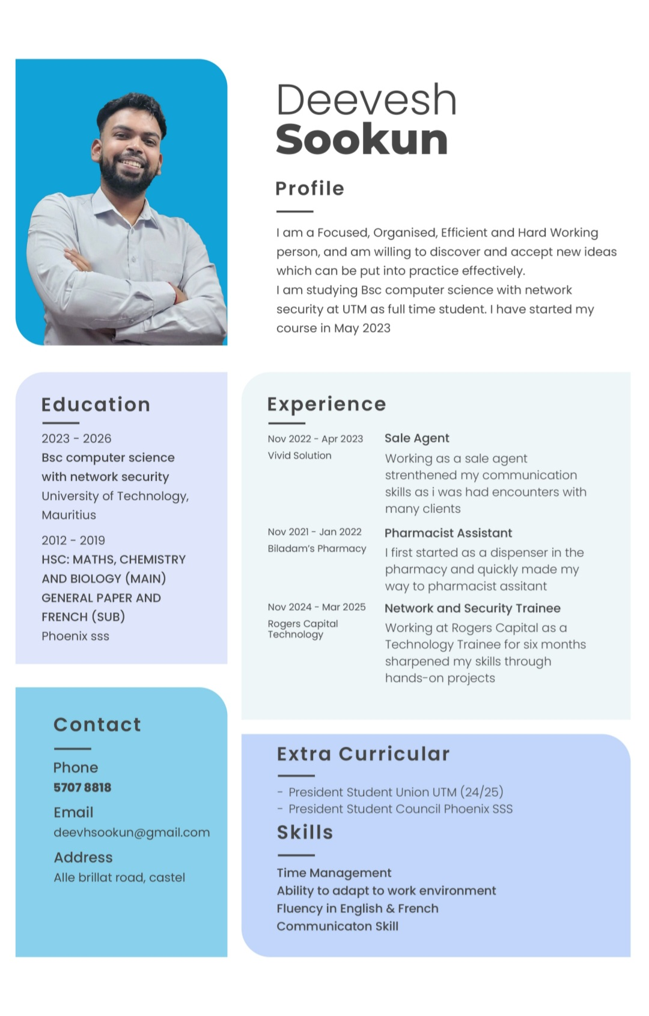
Programming Languages

- Python
- Java
- C / C++
- SQL
- JavaScript
- HTML5 / CSS3

Technical Skills

Software & Application Development
- Object-Oriented Programming (OOP)
- Application logic and workflow design
- Authentication and access control concepts
- File handling and data processing
- Error handling and logging

Web Development
- Responsive website development
- Frontend development (HTML, CSS, JavaScript)
- Forms, validation, and UI interaction
- Basic UI/UX principles
- Client-side security awareness (XSS prevention basics)

Databases & Systems
- SQL database design and querying
- Linux and Windows operating systems
- Command-line tools and scripting

Networking & Security
- Network fundamentals (TCP/IP, ports, protocols)
- Secure coding principles
- Network security awareness
- Basic penetration testing concepts
- Security-focused system configuration

Projects

Website Development Project
- Designed and developed a multi-page responsive website
- Implemented navigation menus, forms, and interactive elements
- Used HTML, CSS, JavaScript
- Applied basic client-side validation and clean UI design
- Focused on usability and structured layout


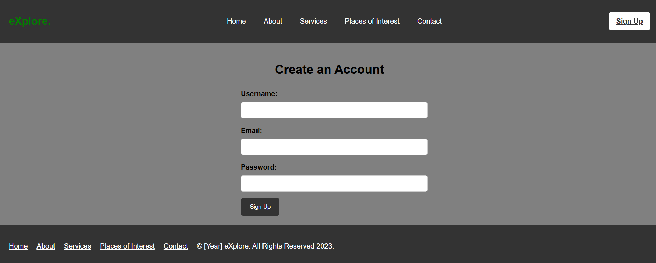

Application Development Project
- Developed a desktop/console application using Java/Python
- Implemented authentication logic and user input validation
- Integrated SQL database connectivity
- Used file I/O operations and structured exception handling
- Applied Object-Oriented Programming principles
Final year project
Developed CryptoTrade, a blockchain-based cryptocurrency trading web platform using React.js, HTML, CSS, Node.js, Express.js, and MongoDB, featuring real-time market updates via WebSockets, interactive data visualisation, secure transaction handling, and version control with Git.
