REQUIREMENT ANALYSIS PHASE
  - Customer Journey Map
Stages covered:
- Awareness & Registration
- Course Selection
- Enrollment Request
- Fee Payment
- Approval
- Instructor Assignment
- Reporting & Completion
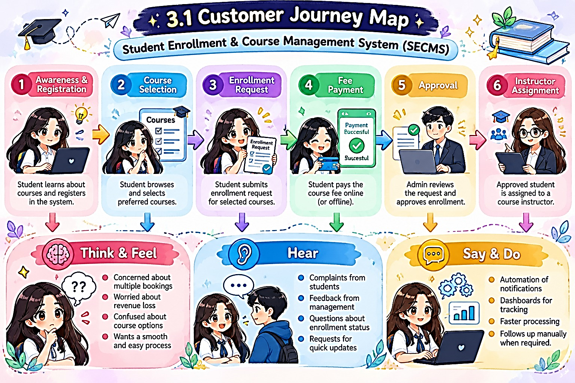

  - Solution Requirements
Functional Requirements
FR No | Epic | Description
FR-1 | Student Management | Manage student records
FR-2 | Course Management | Create and manage courses
FR-3 | Enrollment Processing | Request, approve, reject enrollments
FR-4 | Instructor Assignment | Auto-assign instructors
FR-5 | Reporting | Dashboards and reports

Non-Functional Requirements NFR-1: Usability
The system shall provide a simple, intuitive, and user-friendly interface that enables enrollment officers, administrators, instructors, and students to perform operations efficiently with minimal training. Navigation shall be organized through clearly labeled tabs, dashboards, and forms to reduce user effort and errors.
Examples:
- Quick student registration form
- One-click enrollment approval
- Role-based dashboards
NFR-2: Security
The system shall ensure the confidentiality, integrity, and protection of student and institutional data through secure authentication, authorization, and access controls. Sensitive information such as personal data, enrollment history, and academic records shall only be accessible to authorized users.
Examples:
- Only admins can modify course details
- Instructors view only assigned students
- Students cannot access other student records
NFR-3: Reliability
The system shall operate consistently and accurately without failures during enrollment processing, approvals, and reporting. Automation logic shall execute correctly to avoid duplicate or incorrect enrollments.
Examples:
- No duplicate course registration
- Accurate status updates after approvals
- Consistent report generation
NFR-4: Performance
The system shall provide fast response times for all operations to ensure smooth and uninterrupted user experience, especially during peak admission periods.
Examples:
- Quick dashboard refresh
- Fast search for student records
- No lag during bulk uploads
NFR-5: Scalability
The system shall support future growth in the number of students, courses, departments, and users without degradation in performance or functionality. It shall allow easy addition of new modules and features.
Examples:
- Add new departments without redesign
- Handle increased admissions annually
- Extend to mobile or portal integration.
NFR-6: Availability
The system shall be continuously accessible to users during institutional working hours and must minimize downtime. The platform shall support high availability for academic operations.
Examples:
- 24/7 cloud access
- Reliable during peak admission season
- Automatic backup of student records.
  - Data Flow Diagram
- User inputs student and enrollment data
- System validates and stores records
- Approval process routes data
- Reports and dashboards consume processed data.
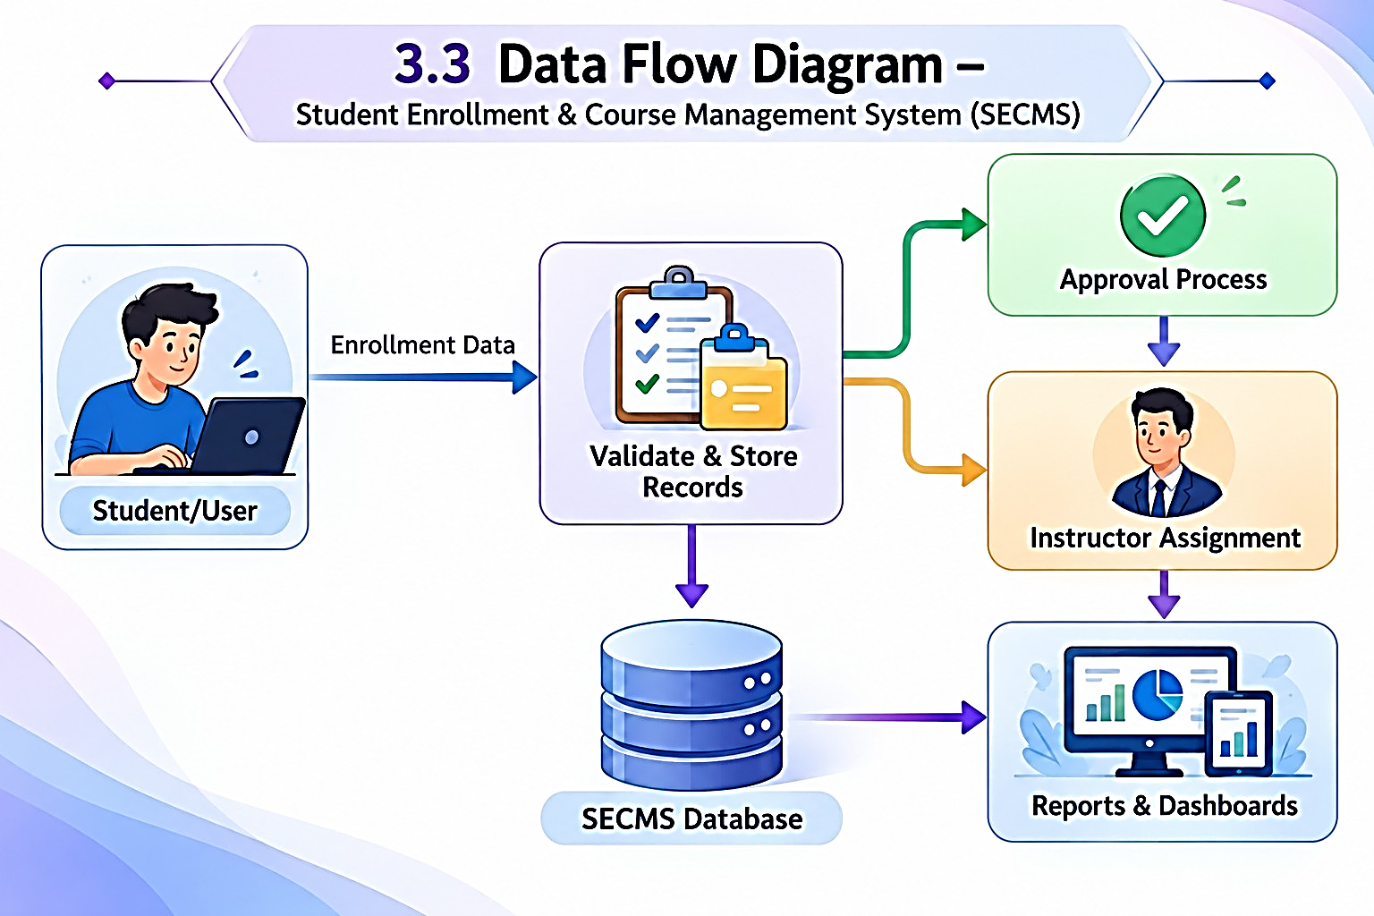
The system processes enrollment requests, validates data, routes approvals, assigns instructors, and generates reports.
3.4 Technology Stack
Layer | Technology
UI | Salesforce Lightning
Logic | Salesforce Flows
Database | Salesforce Objects
Automation | Validation Rules, Approval Process
Reporting | Reports & Dashboards

